What are they doing? Choose and write.

read sing talk play eat

1 | 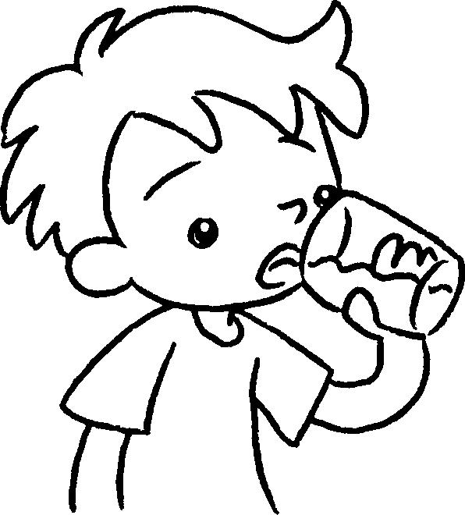  …  … | 2 | 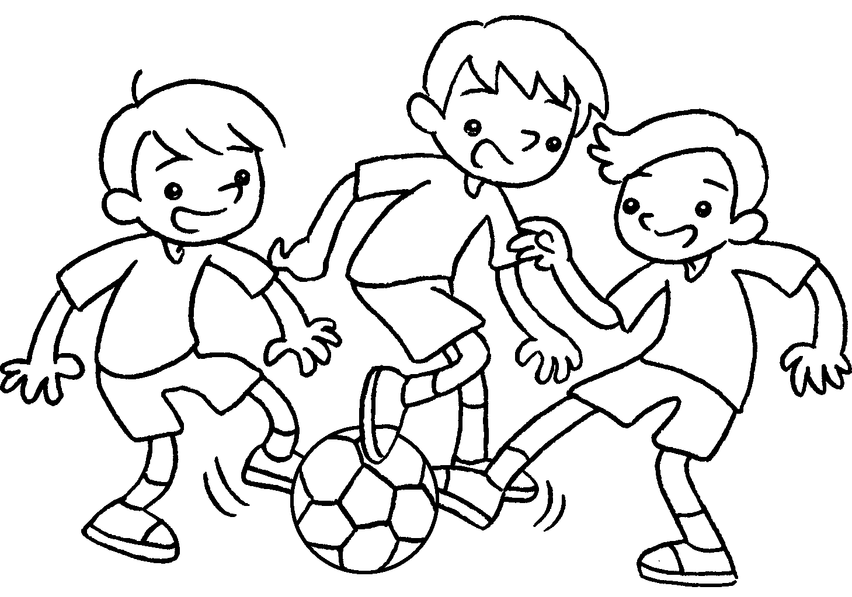
 | I am drinking . |  | We are _______________ .
3 | 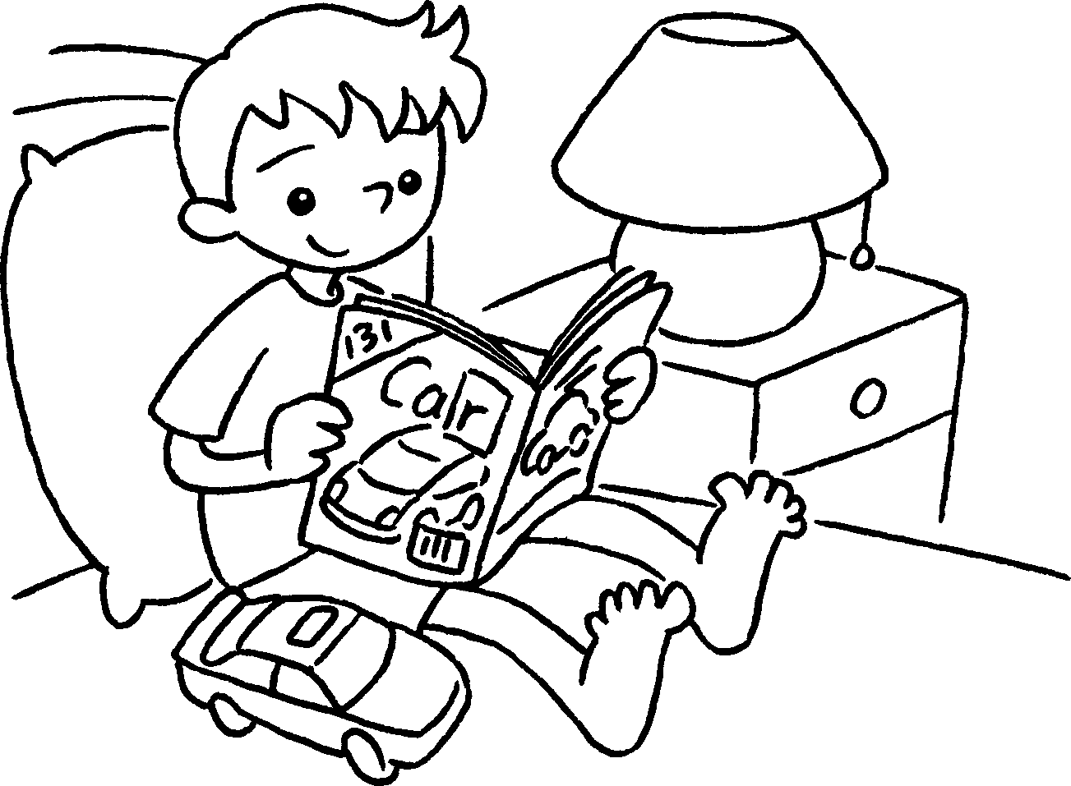  … | 4 | 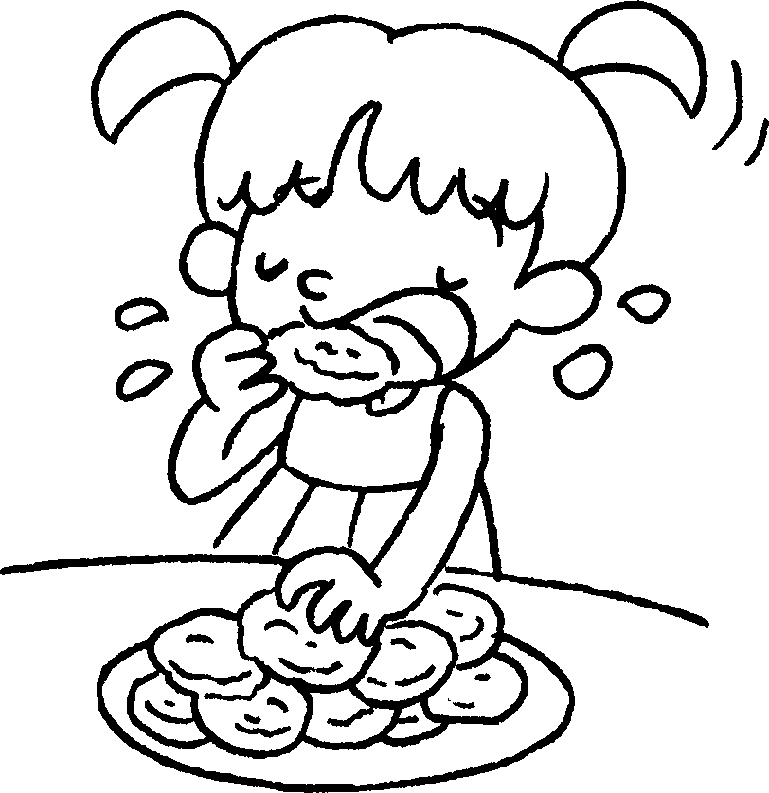  …
 | I am _______________ . |  | I am _______________ .
5 | 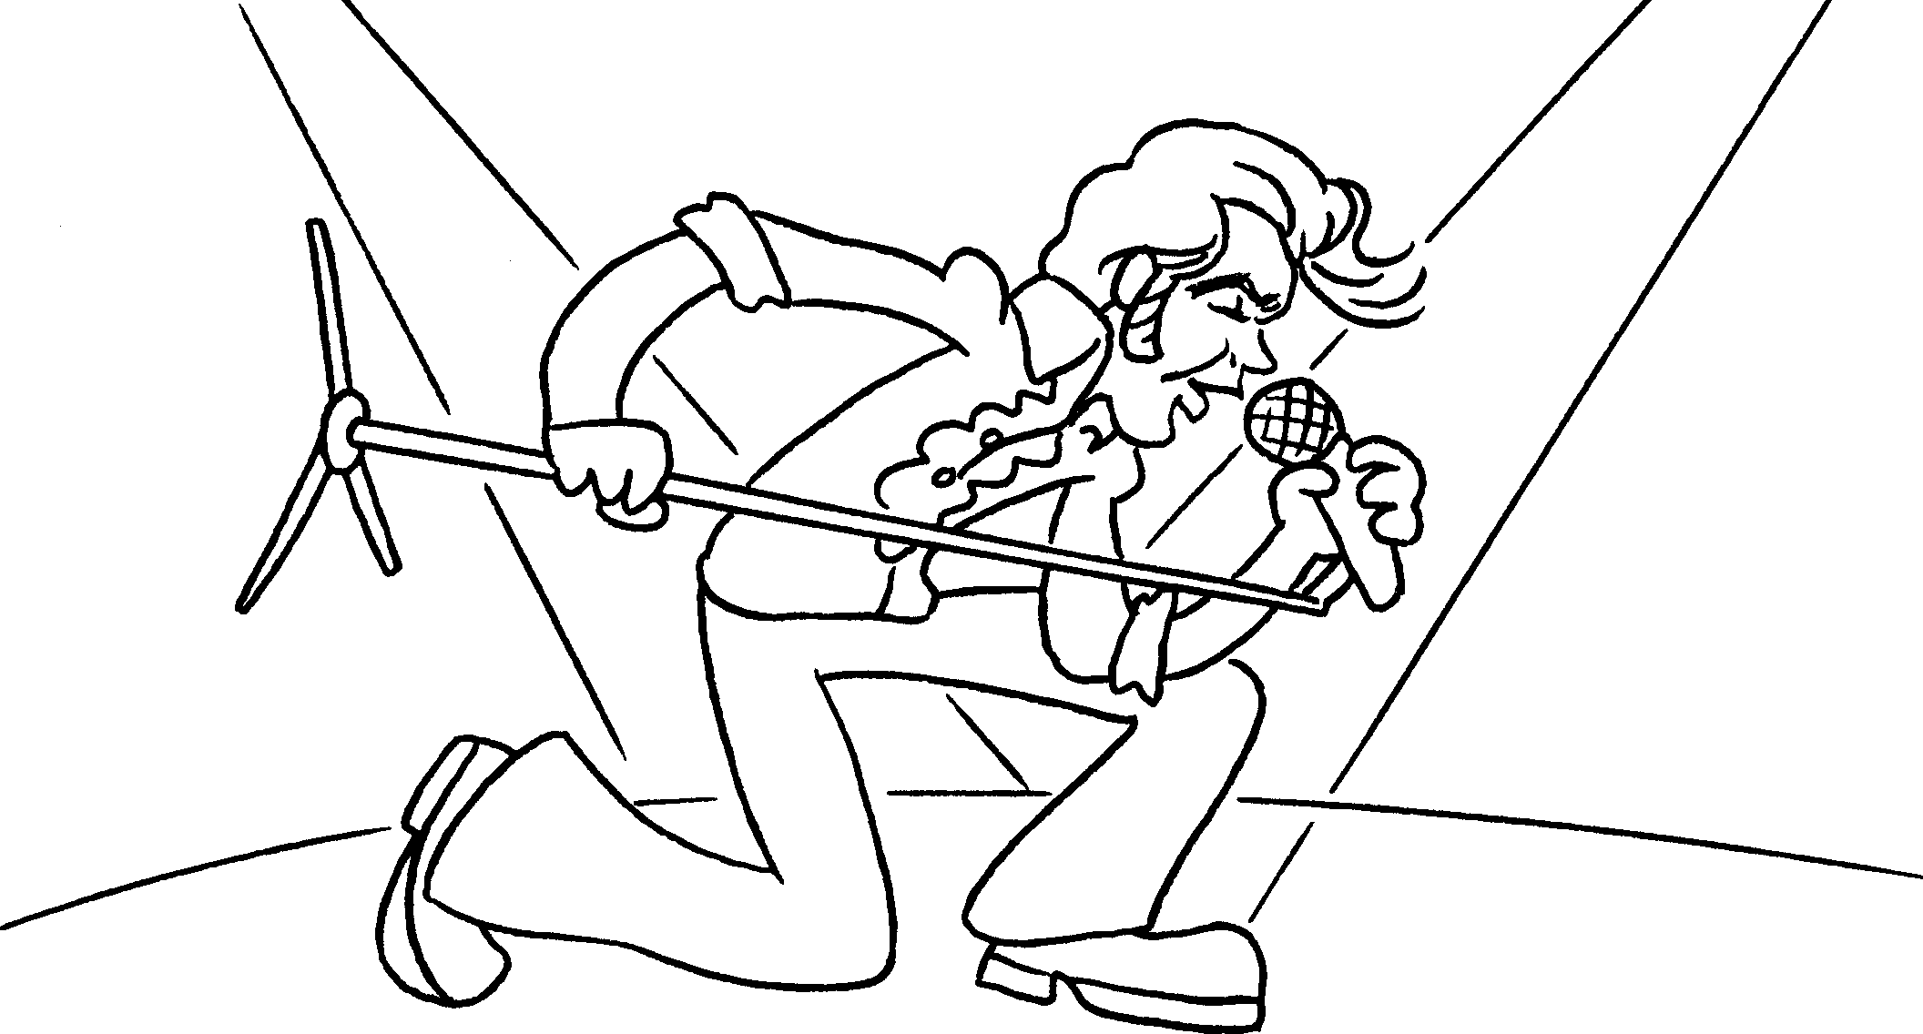  … | 6 | 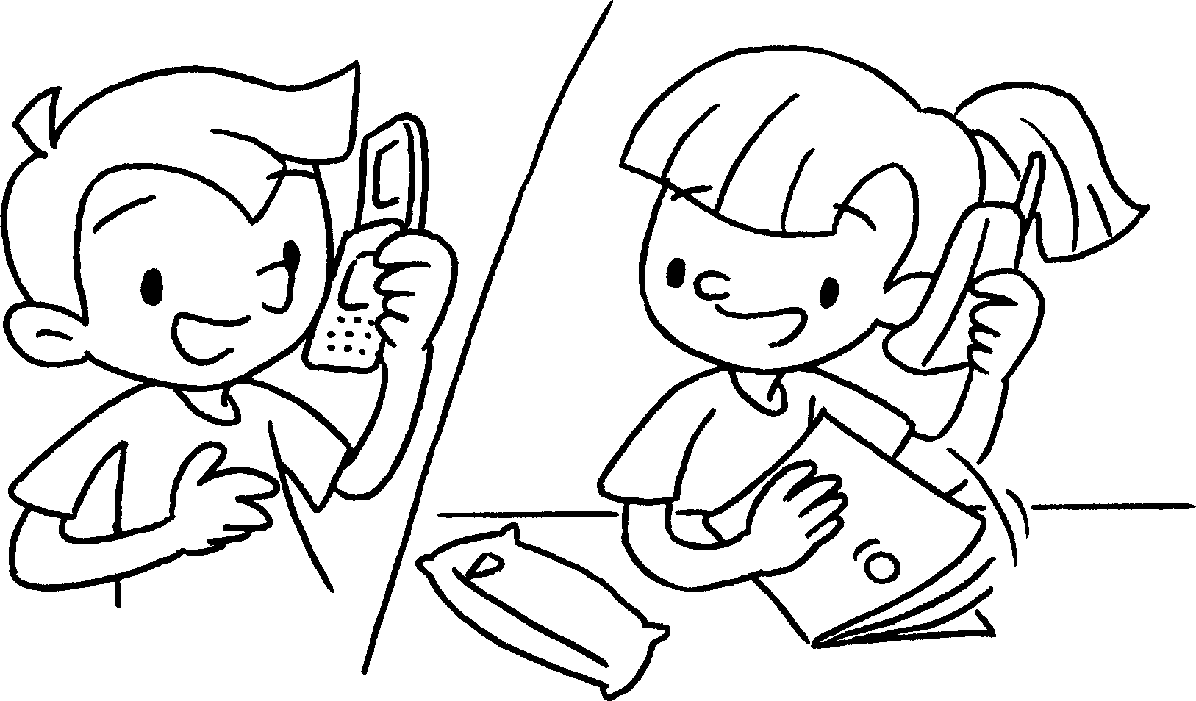  …
 | I am _______________ . |  | We are _______________ .


Book 1B Chapter 5 Graded Worksheets
Worksheet 2⬇⬇
2 playing
3 reading
4 eating
5 singing
6 talking

