What are they doing? Write.
1 | 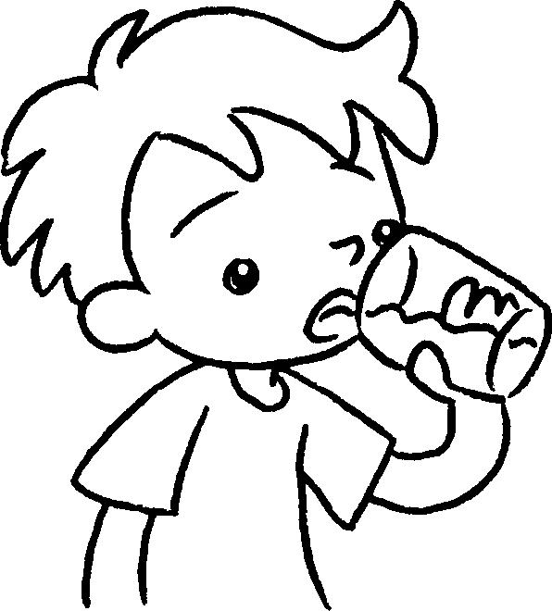  …  … | 2 | 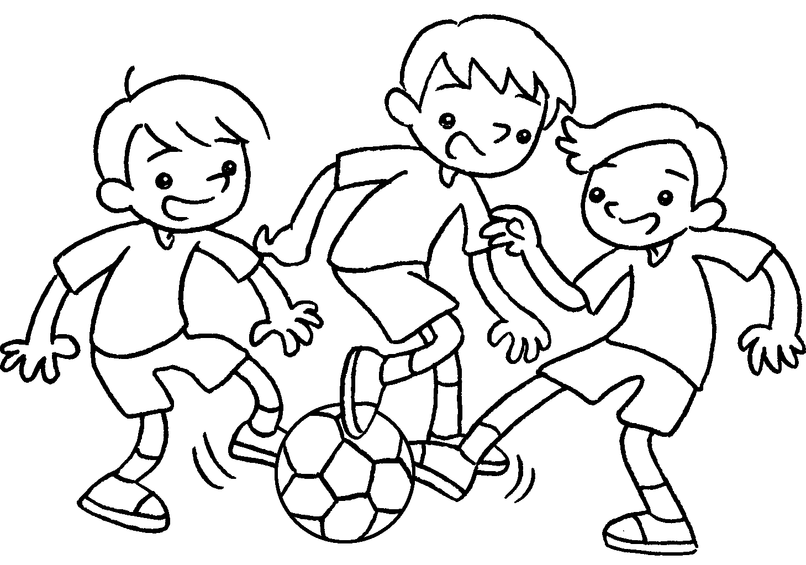
 | I am drinking . |  | We are _______________ .
3 | 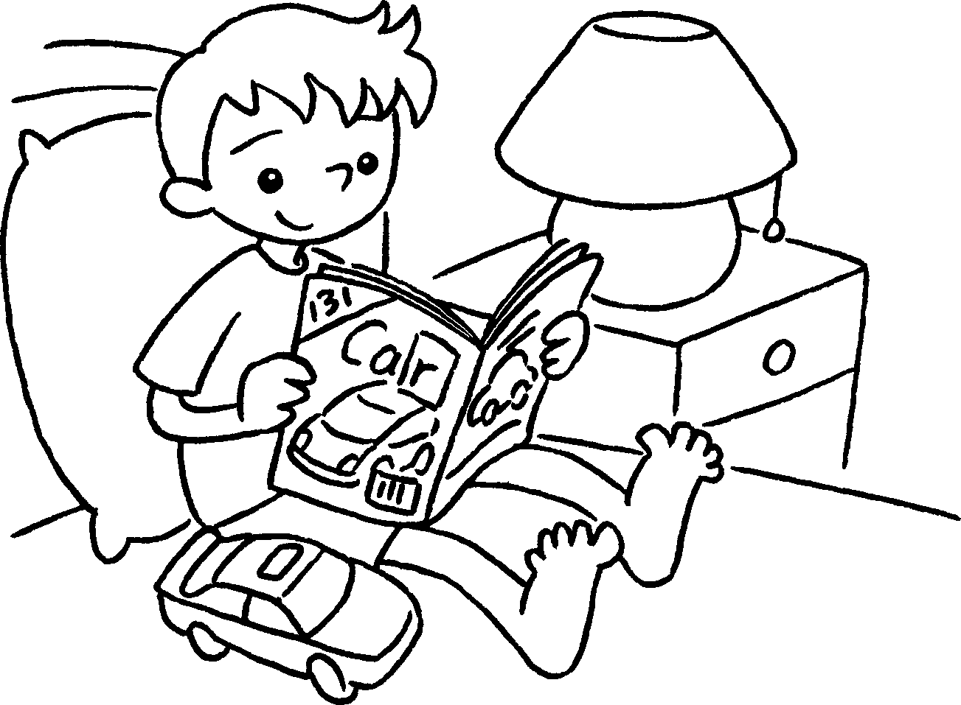  … | 4 | 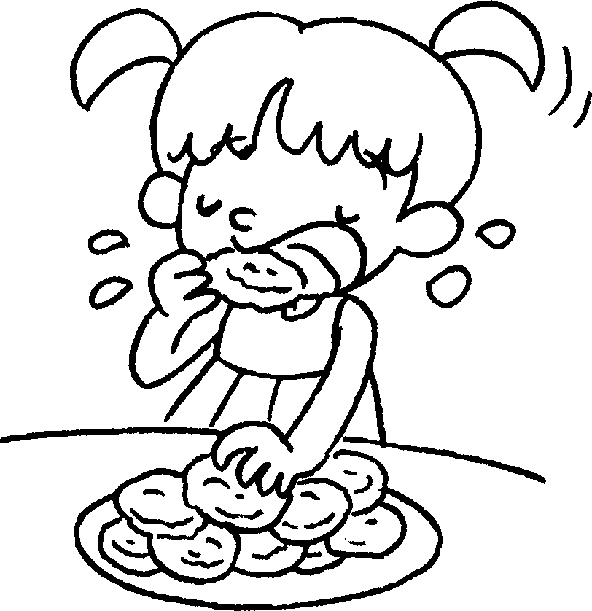  …
 | I am _______________ . |  | I ______ ______________ .
5 | 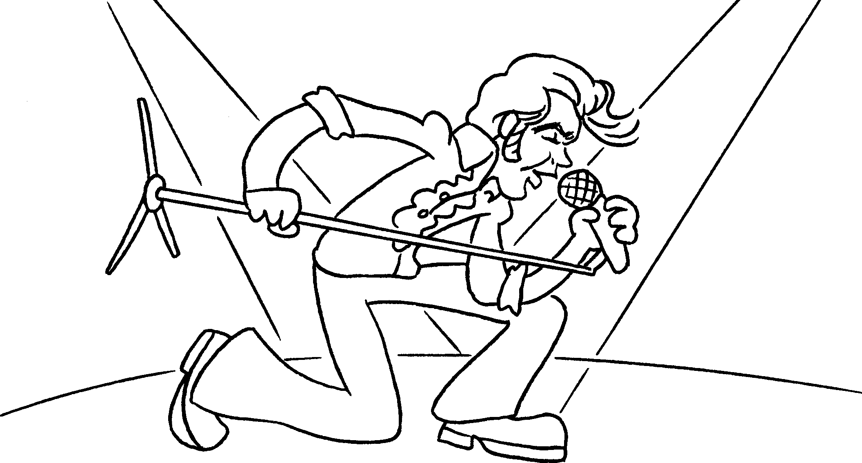  … | 6 | 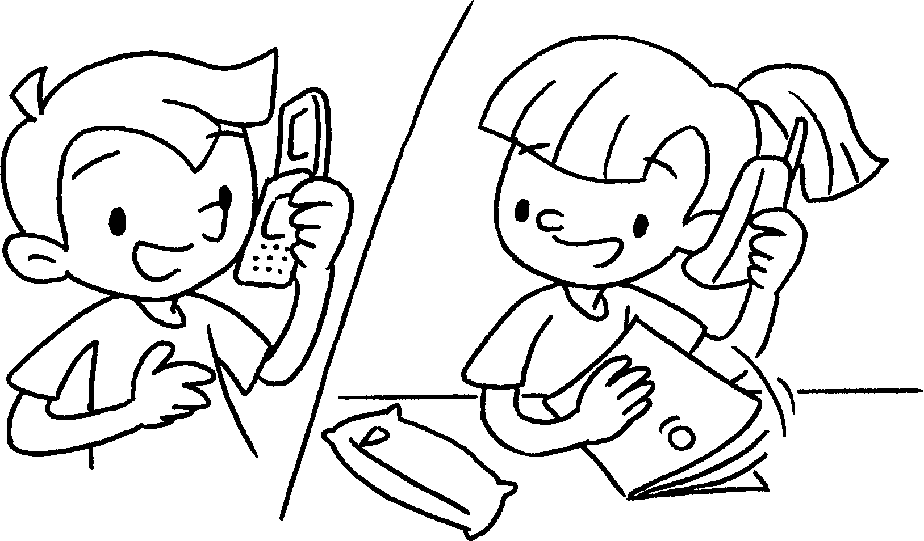  …
 | I ____________________ . |  | We ____________________ .


Book 1B Chapter 5 Graded Worksheets
Worksheet 2⬇⬇⬇
2 playing
3 reading
4 am eating
5 am singing
6 are talking

