Fill in the blanks. Use the present continuous tense.
am
are

1  A  B | 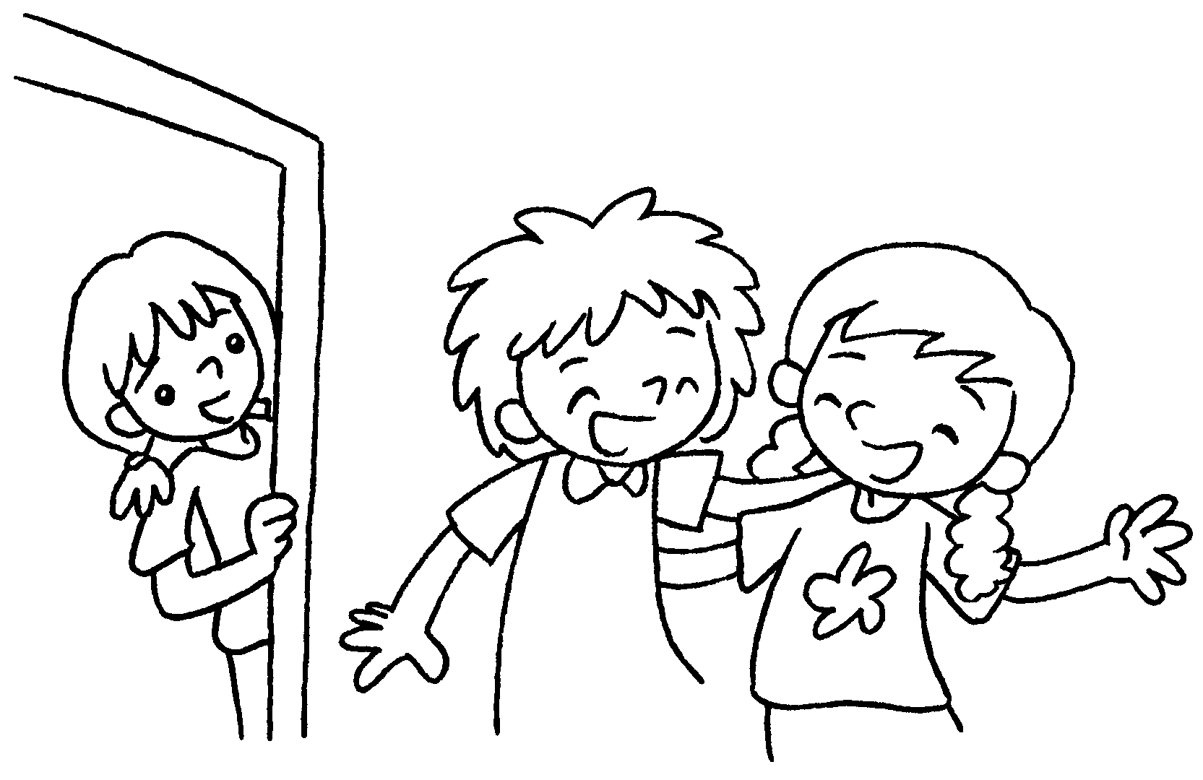 | A : What are you doing?  B : We ( laugh ).
2  A  B | 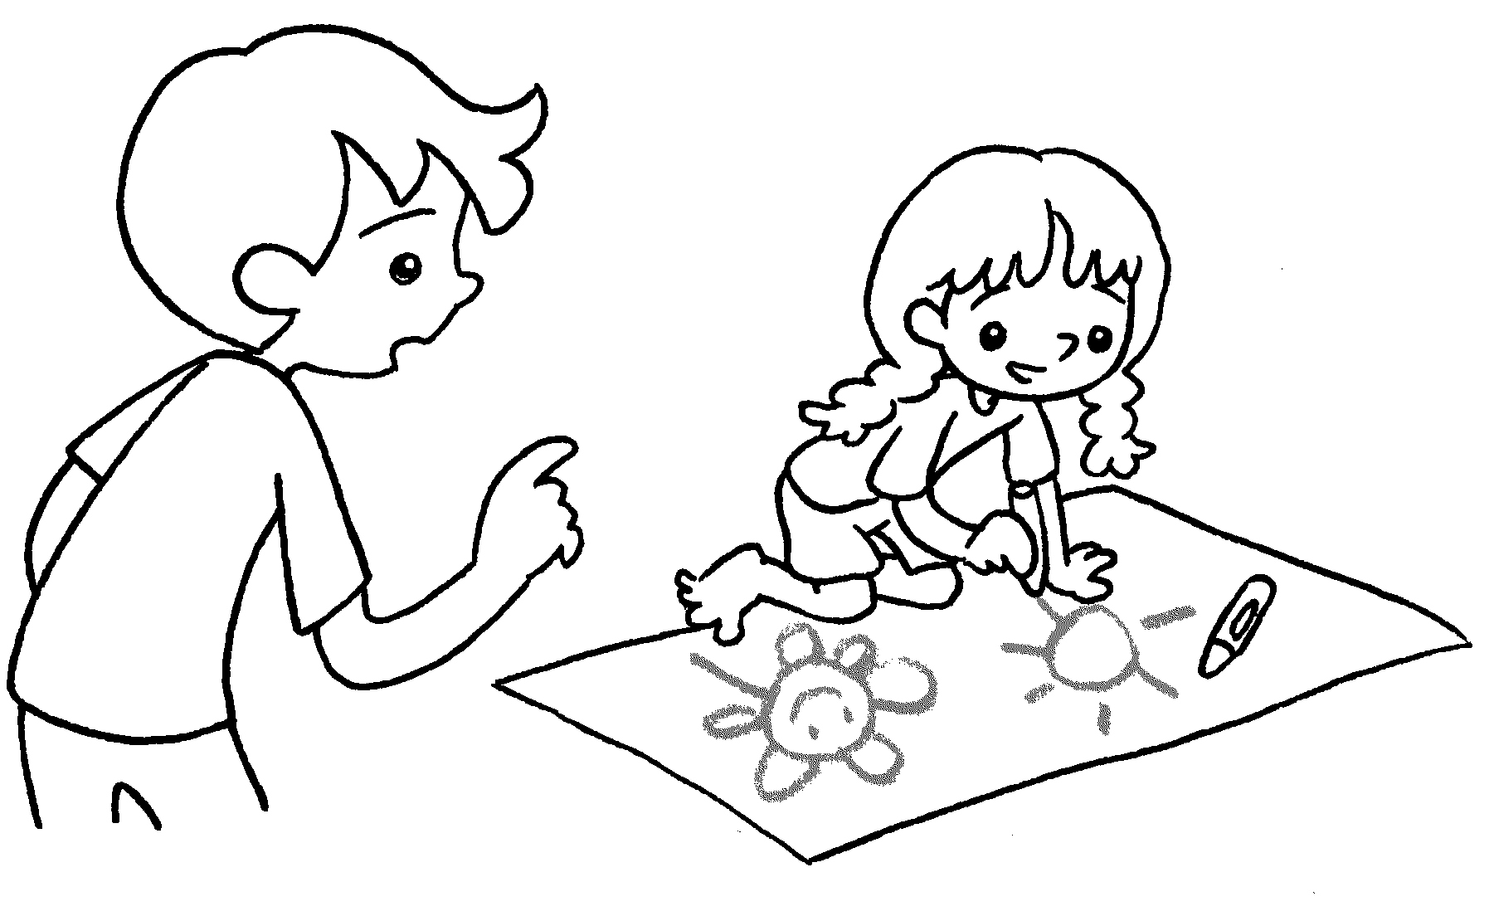 | A : What are you doing?  B : I ( draw ).
3  A  B | 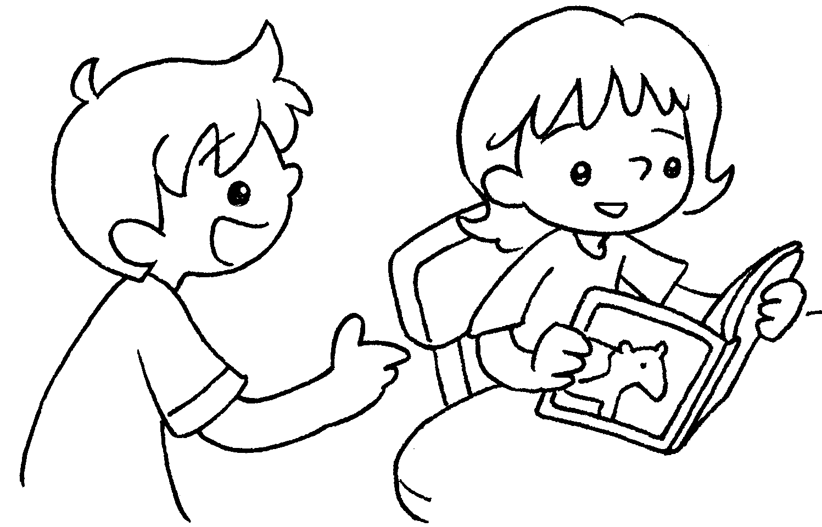 | A : What are you doing?  B : I ( read ).
4  A  B | 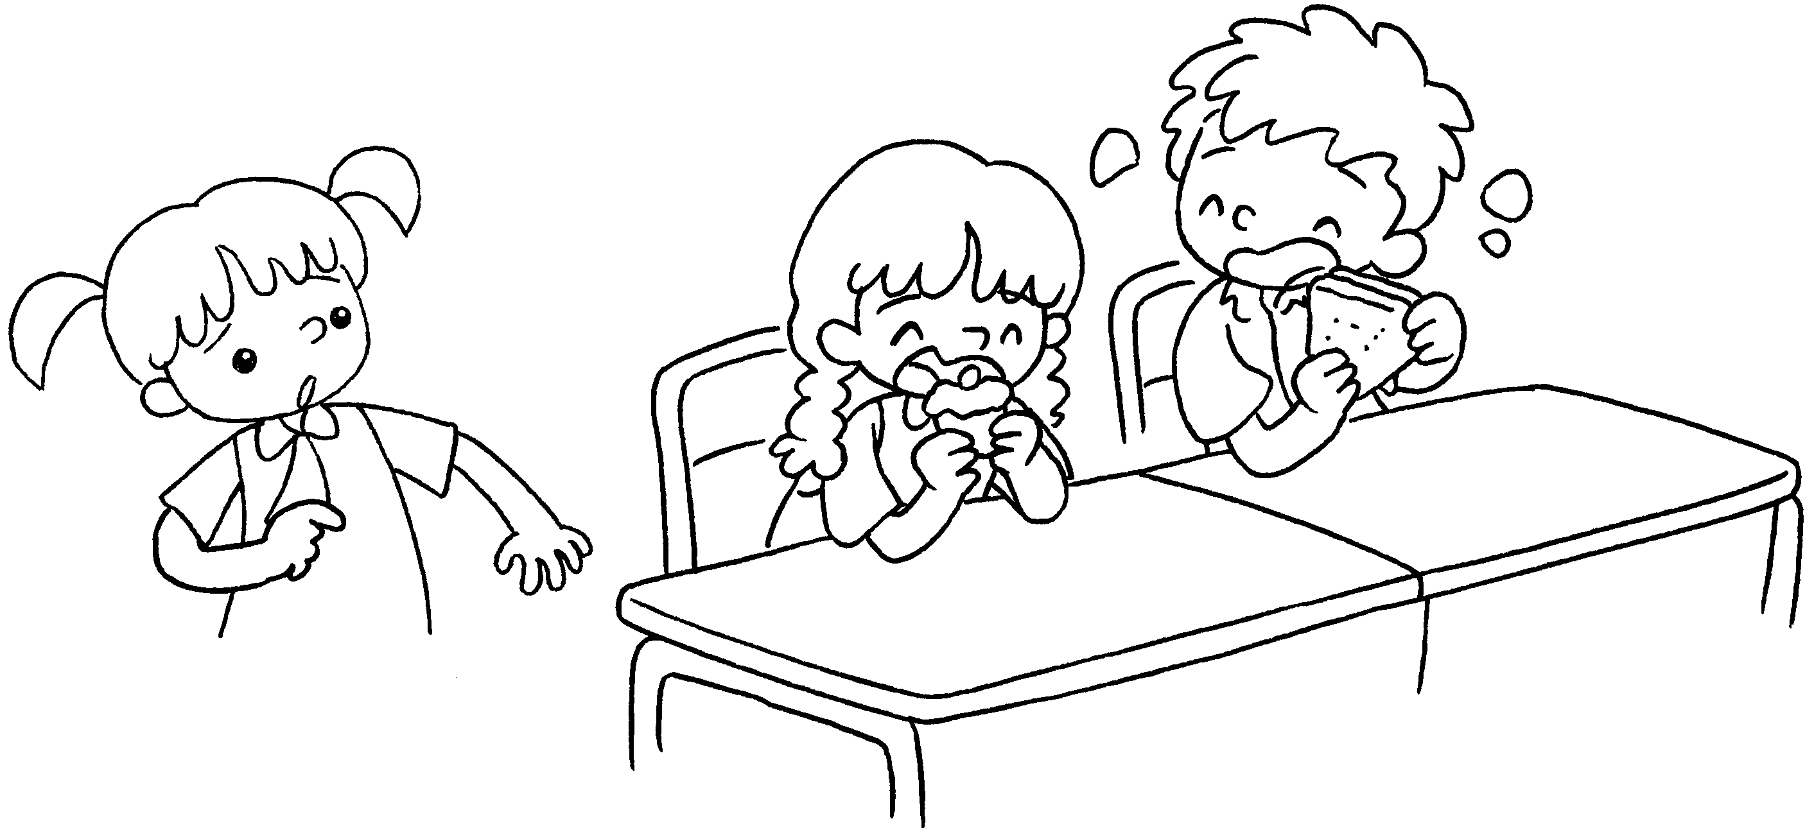 | A : What are you doing?  B : We ( eat ).
5  A  B | 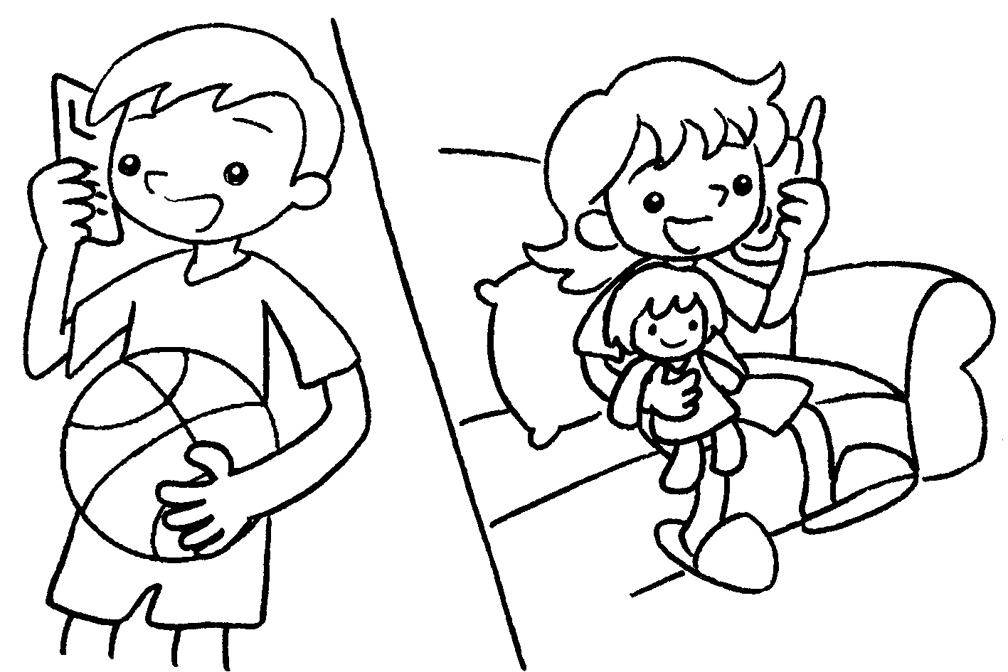 | A : What are you doing?  B : I ( play ).


Book 1B Chapter 5 Graded Worksheets
Worksheet 3⬇
- are laughing
- am drawing
- am reading
- are eating
- am playing

