Fill in the blanks. Use the present continuous tense.
am
are

eat laugh play draw read

1  A  B | 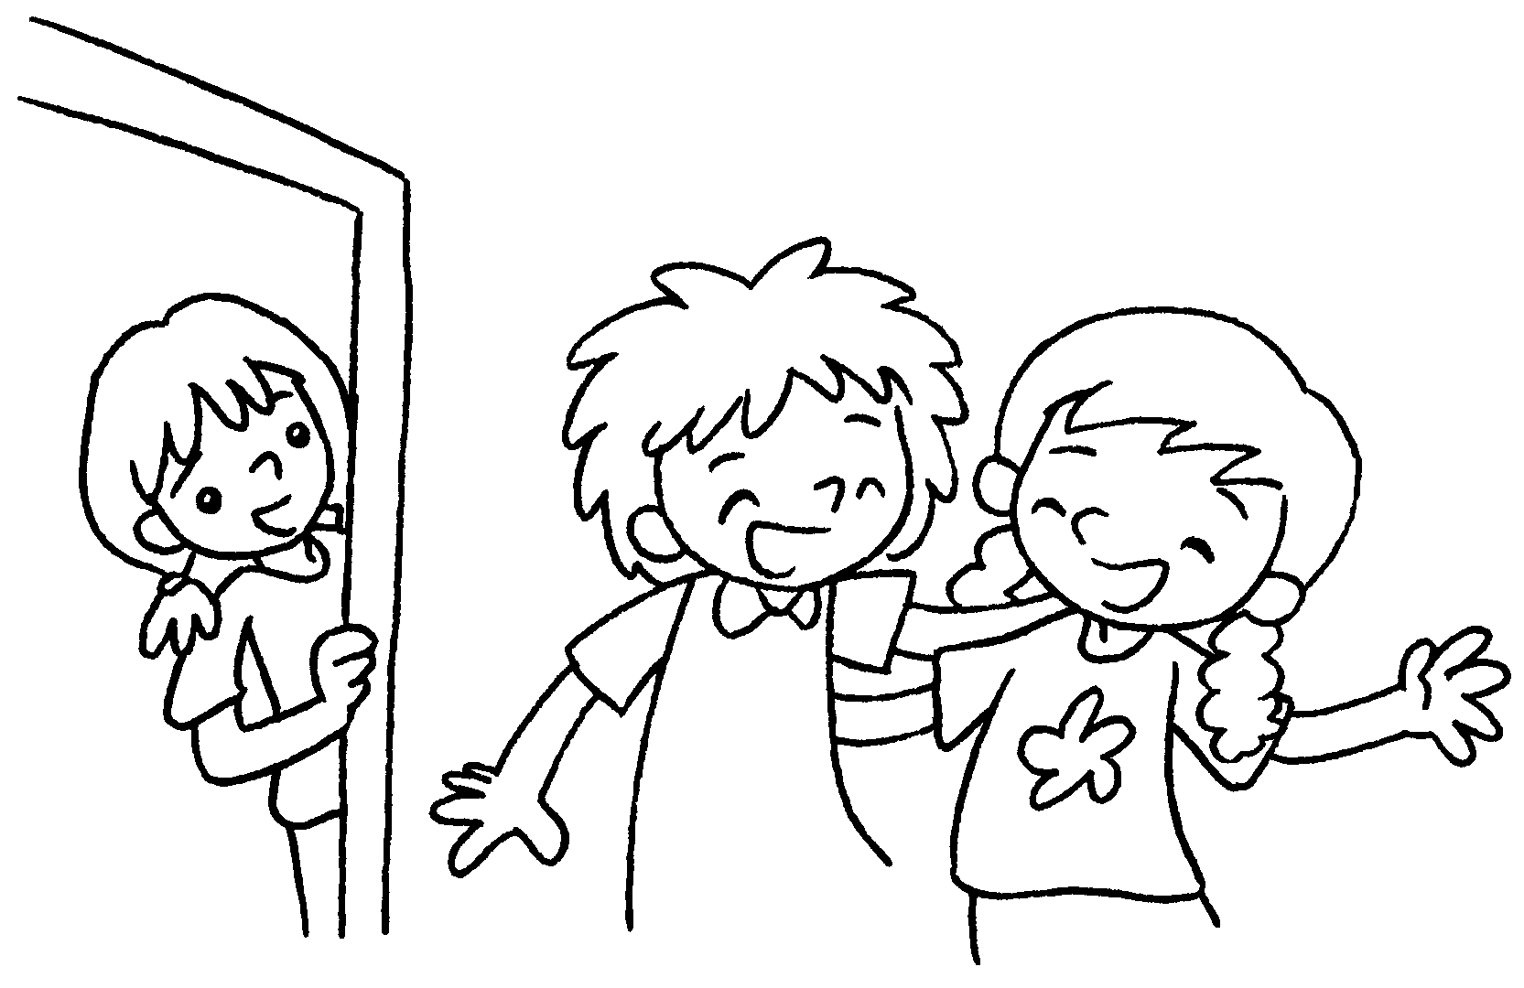 | A : What are you doing?  B : We .
2  A  B | 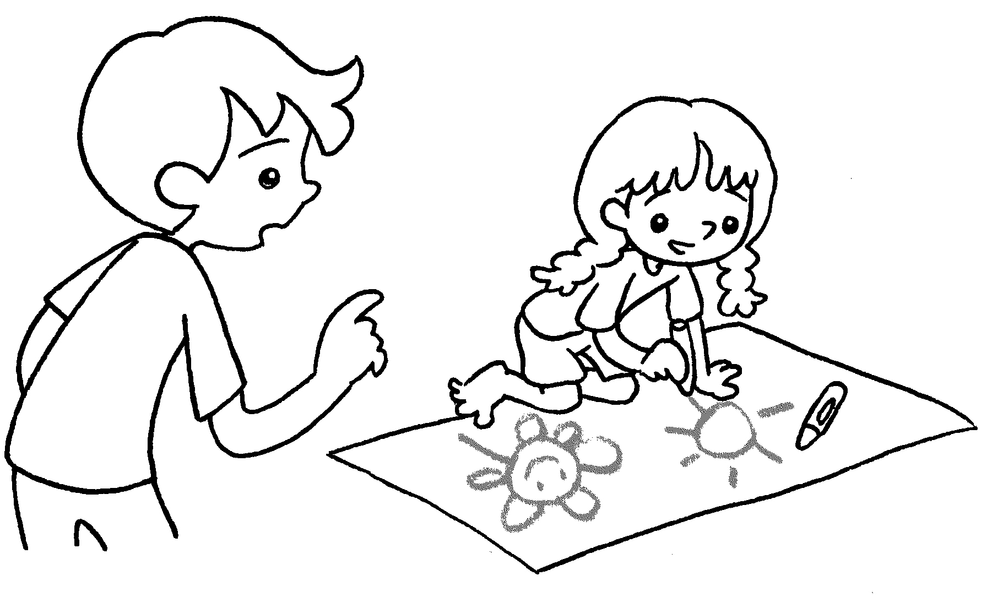 | A : What are you doing?  B : I .
3  A  B | 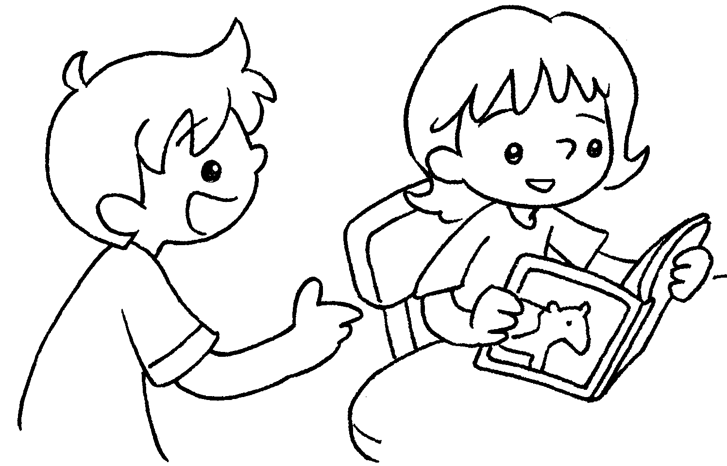 | A : What are you doing?  B : I .
4  A  B | 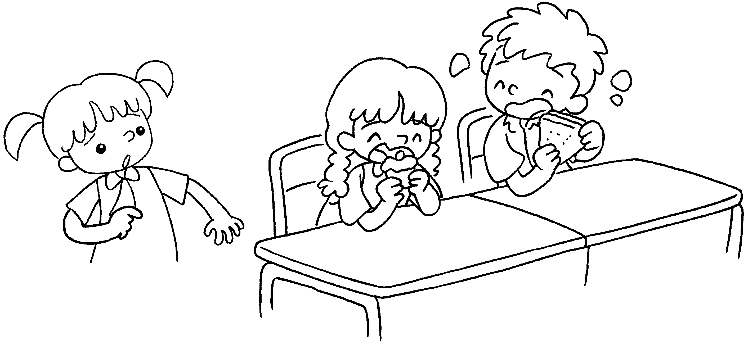 | A : What are you doing?  B : We .
5  A  B | 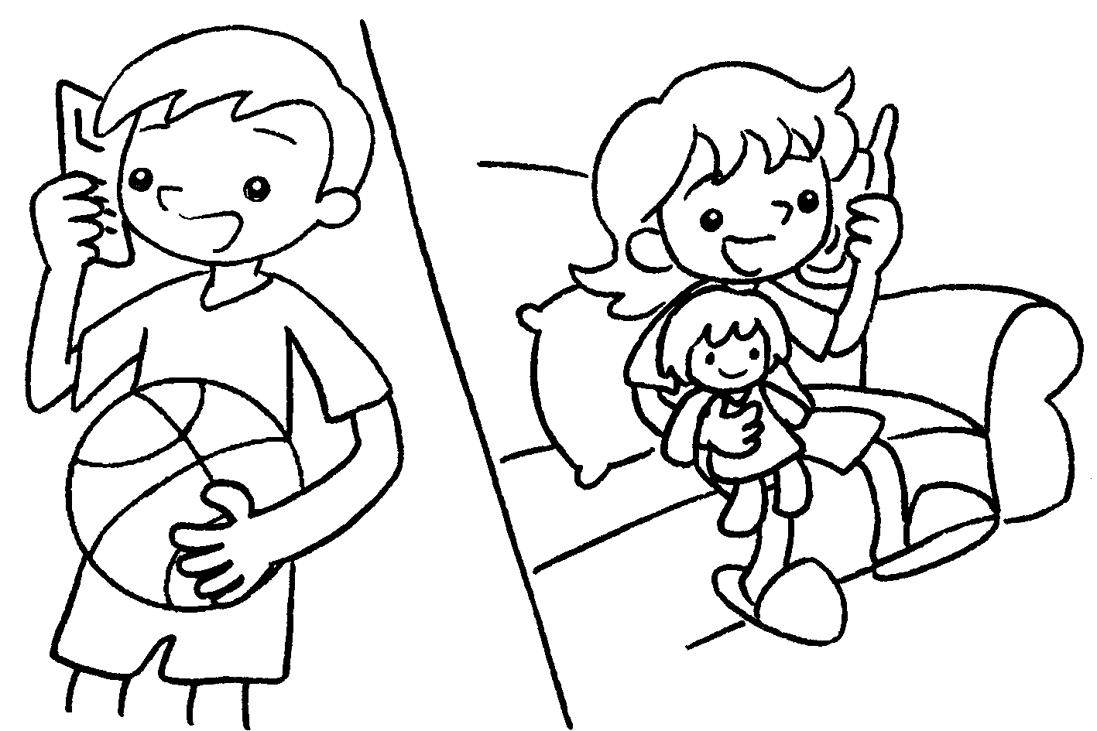 | A : _______ _____ ______ doing?  B : I .


Book 1B Chapter 5 Graded Worksheets
Worksheet 3⬇⬇
- are laughing
- am drawing
- am reading
- are eating
- What are you
am playing

