Choose and write.

dance | hike | ice-skate | make
ride | run | skip | swim

1  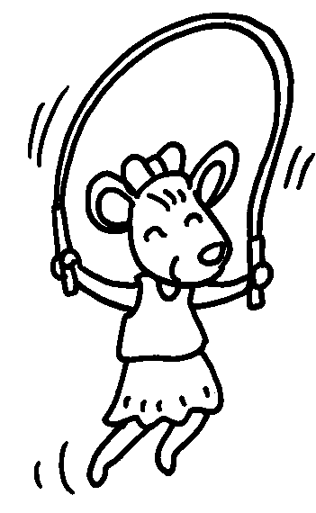 | 2  1  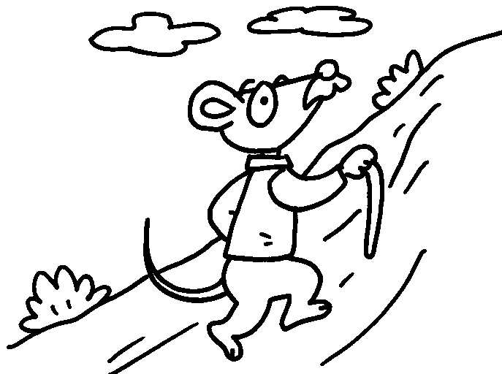 |  | 3  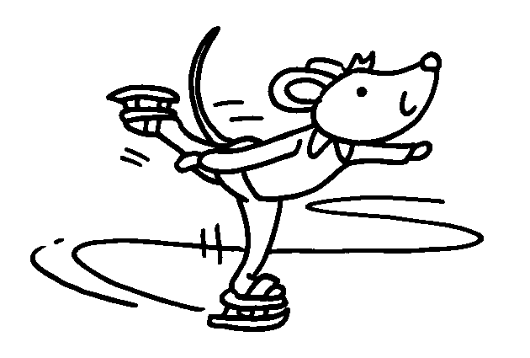
4  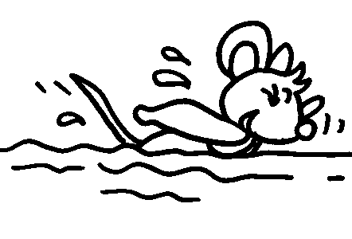 | 5  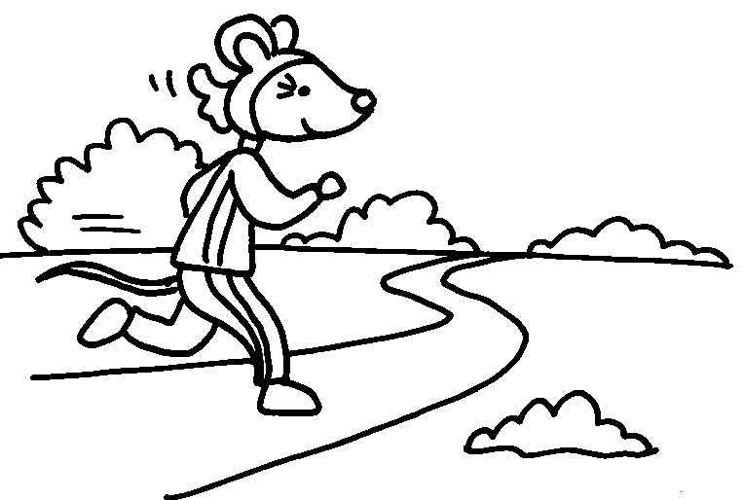 |  | 6  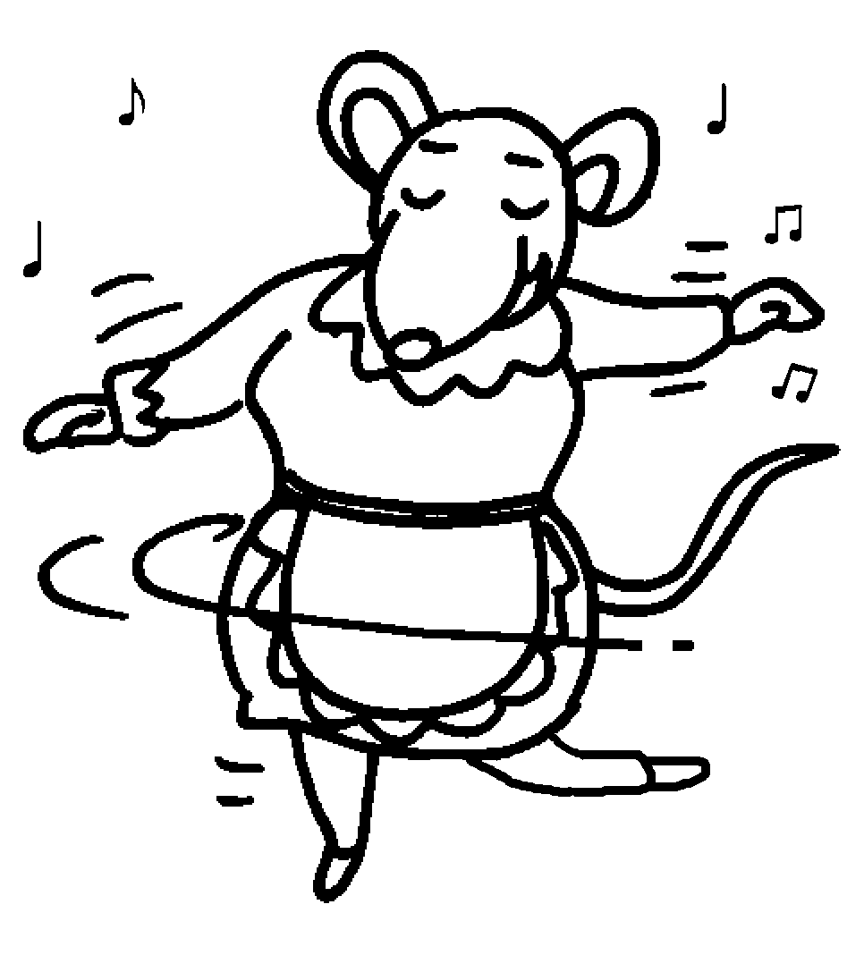
a bicycle  7  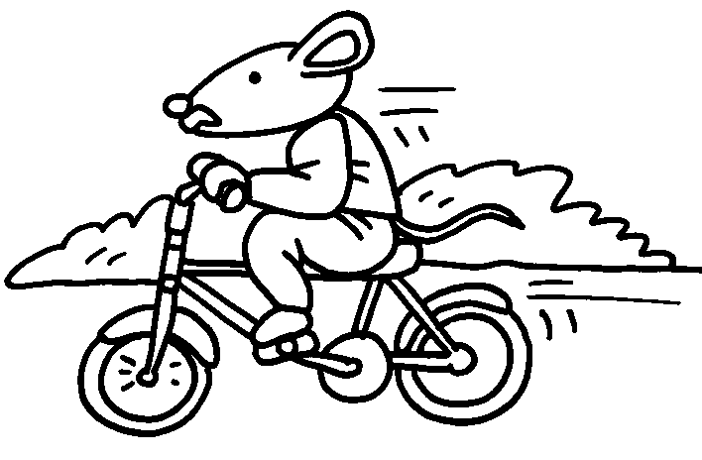 |  | a model  8  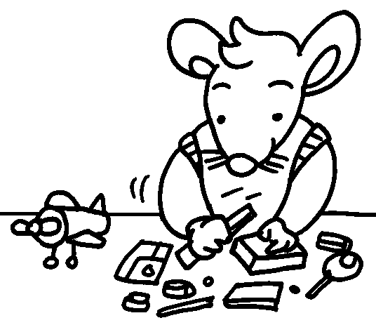


Book 1B Chapter 6 Graded Worksheets
Worksheet 1⬇
1 skip 2 hike 3 ice-skate
4 swim 5 run 6 dance
7 ride 8 make

