What actions can you see? Fill in the missing letters.

1  s __ __ __  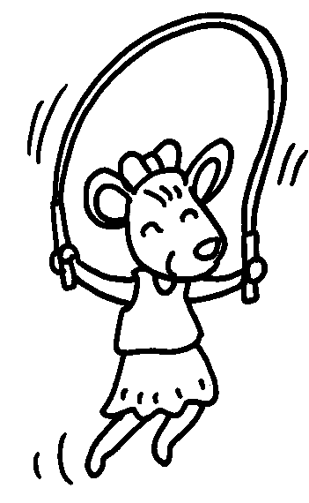 | 2  h __ __ __  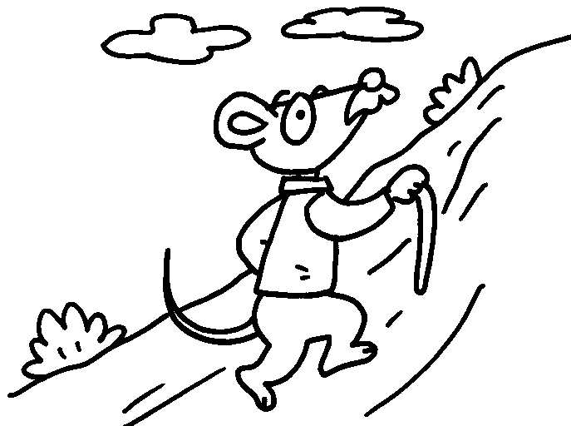 |  | 3  i __ __ - sk __ __ __ __  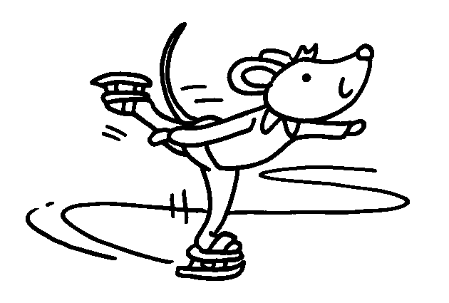
4  r __ __  s __ __ __  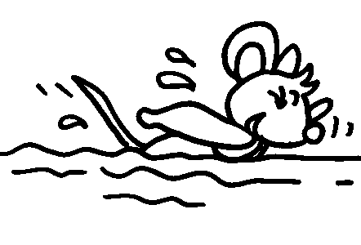 | 5  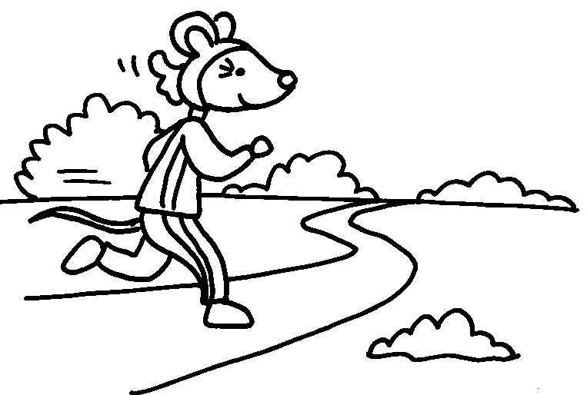 |  | d __ __ __ __  6  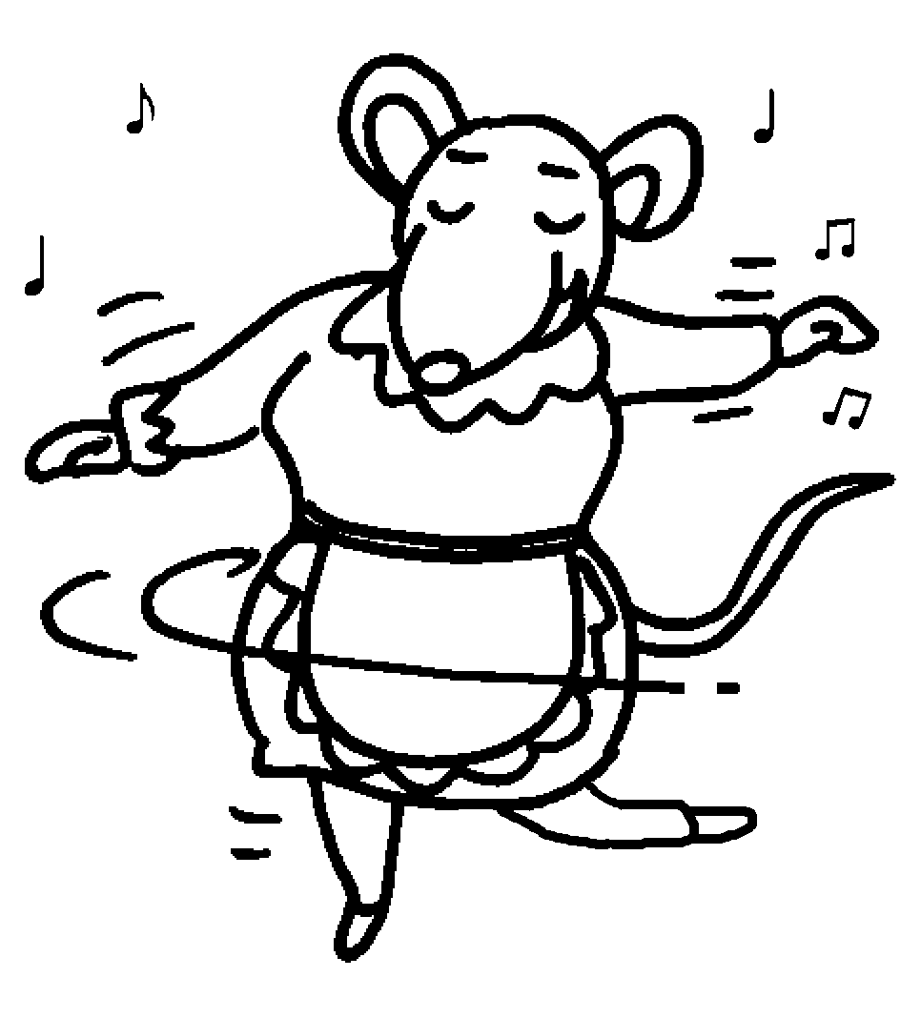
r __ __ __  a bicycle  7  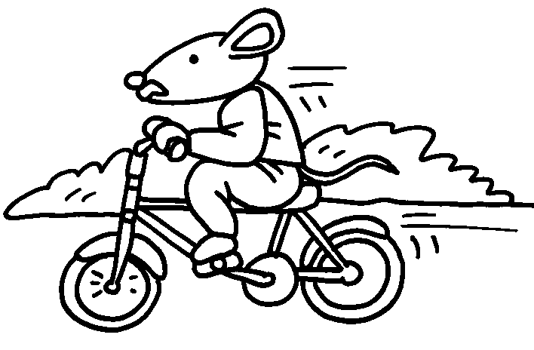 |  | m __ __ __  a model  8  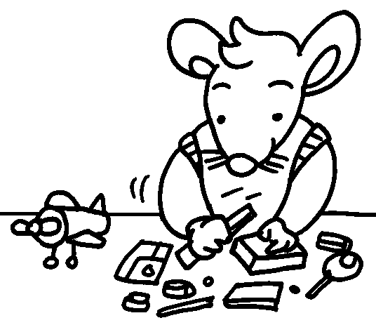


Book 1B Chapter 6 Graded Worksheets
Worksheet 1⬇⬇
1 s k i p 2 h i k e 3 i c e-s k a t e
4 s w i m 5 r u n 6 d a n c e
7 r i d e 8 m a k e

