What actions can you see? Write.

1  skip  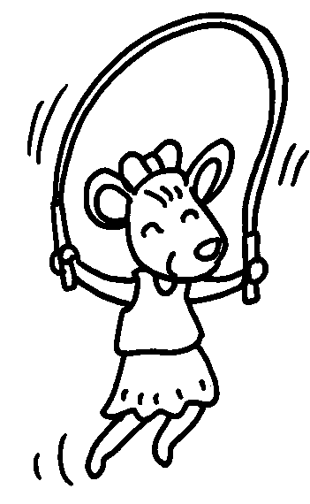 | 2  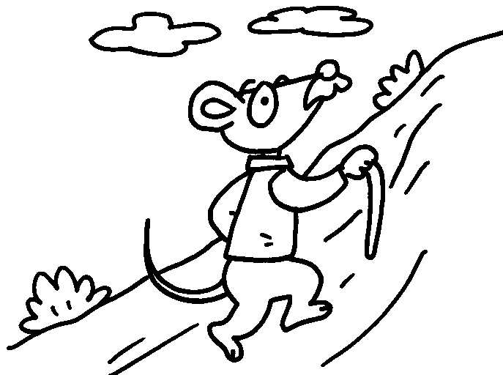 |  | 3  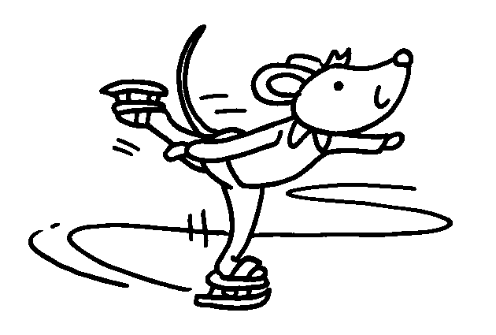
4  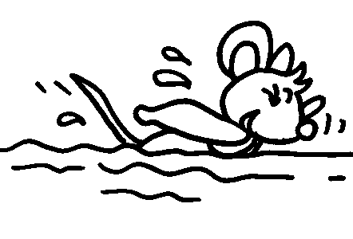 | 5  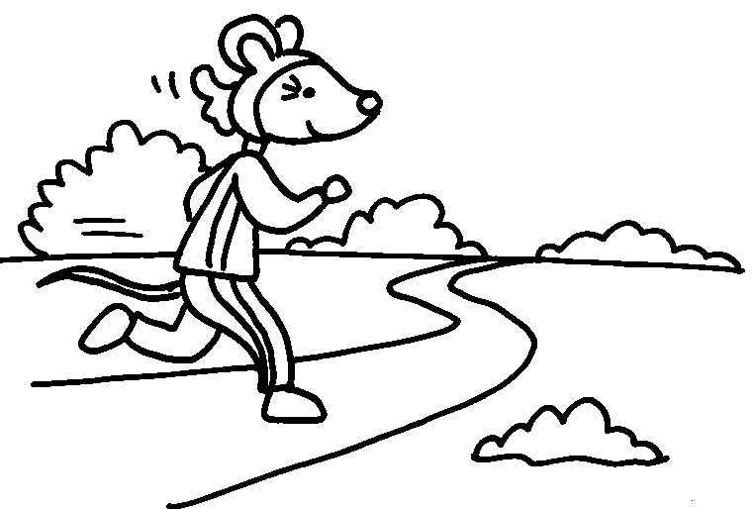 |  | 6  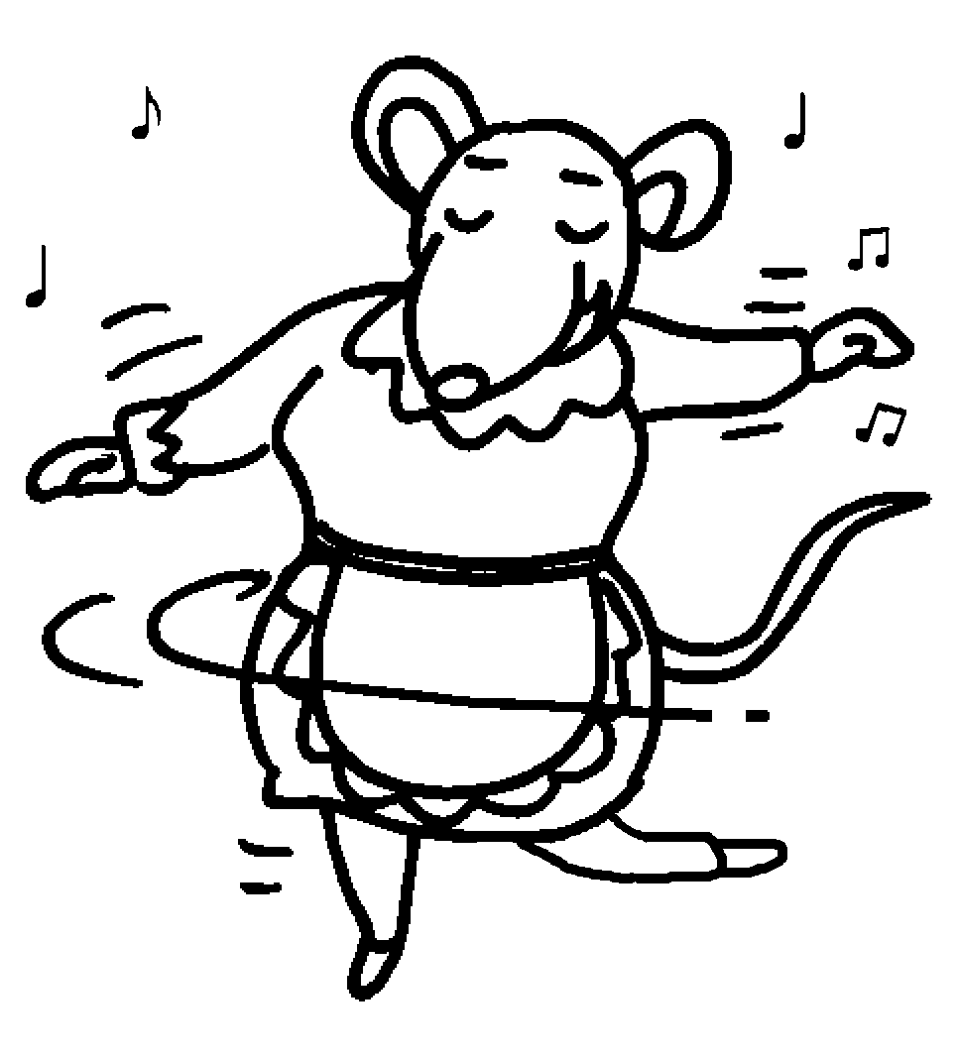
a bicycle  7  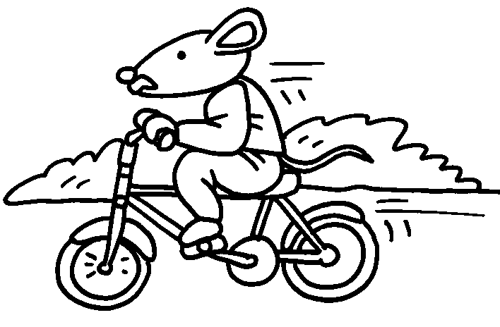 |  | a model  8  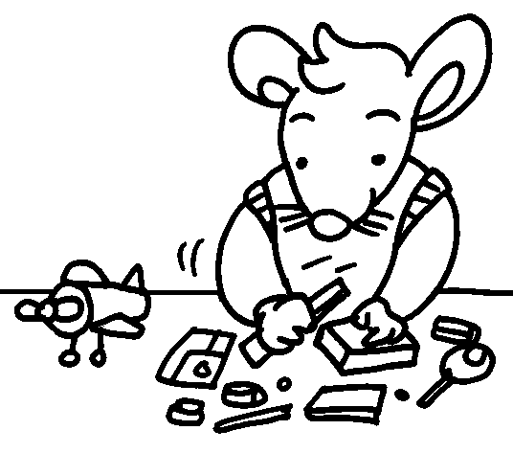


Book 1B Chapter 6 Graded Worksheets
Worksheet 1⬇⬇⬇
2 hike 3 ice-skate
4 swim 5 run 6 dance
7 ride 8 make

