Fill in the blanks. Use the present continuous tense.
is
are
1 | 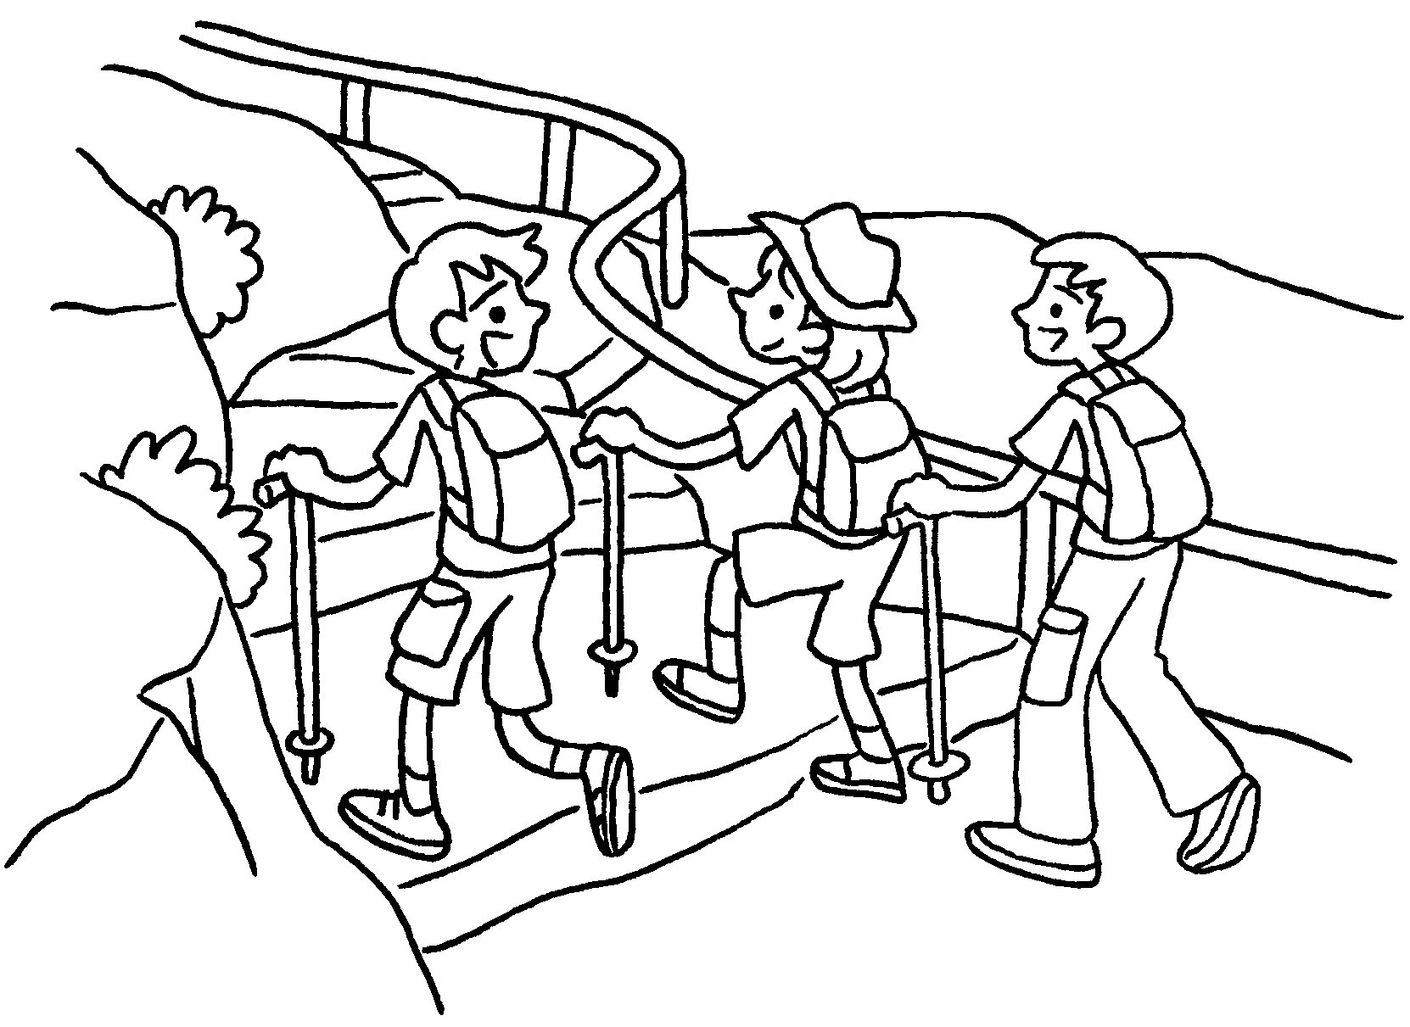 | Amy and her brothers  ( hike ).
2 | 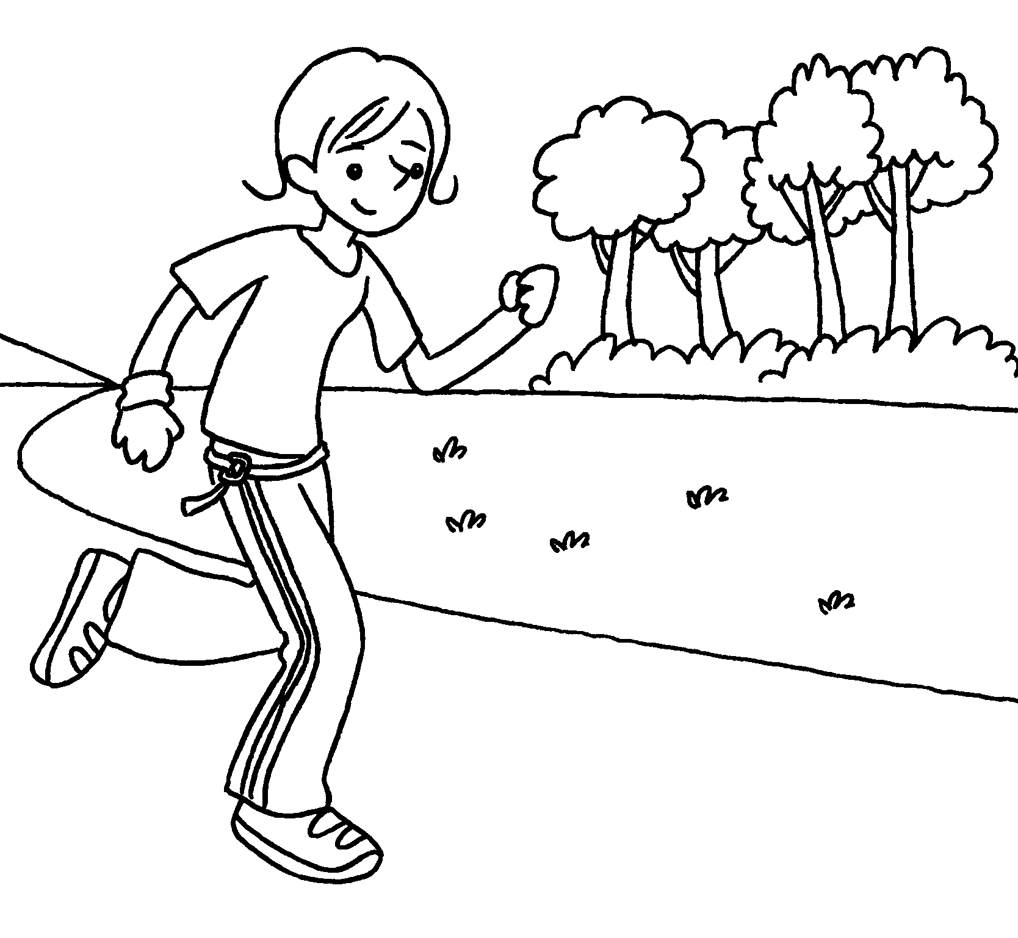 | Jenny ( run ).
3 | 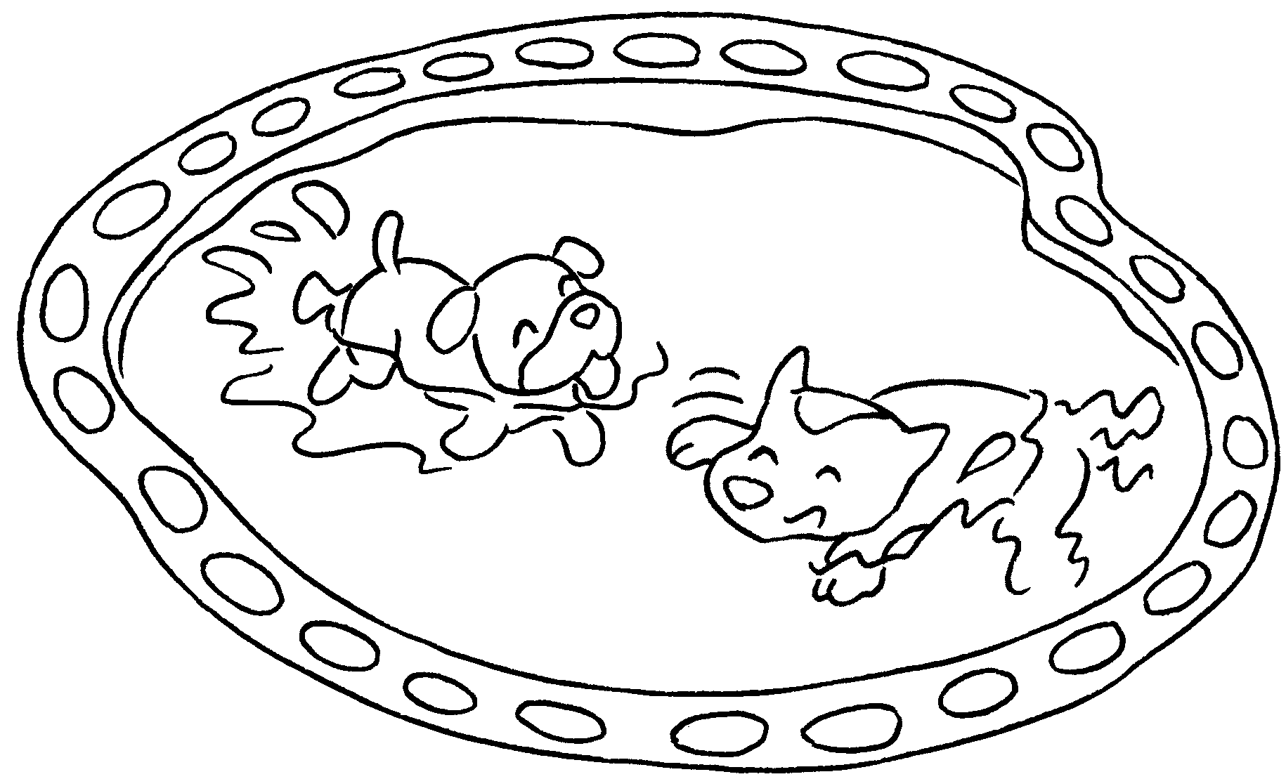 | The dogs ( swim ).
4 | 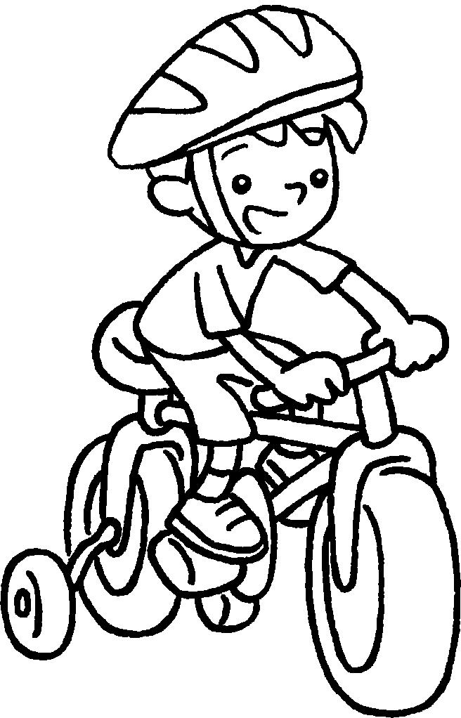 | Billy ( ride ) his bicycle.
5 | 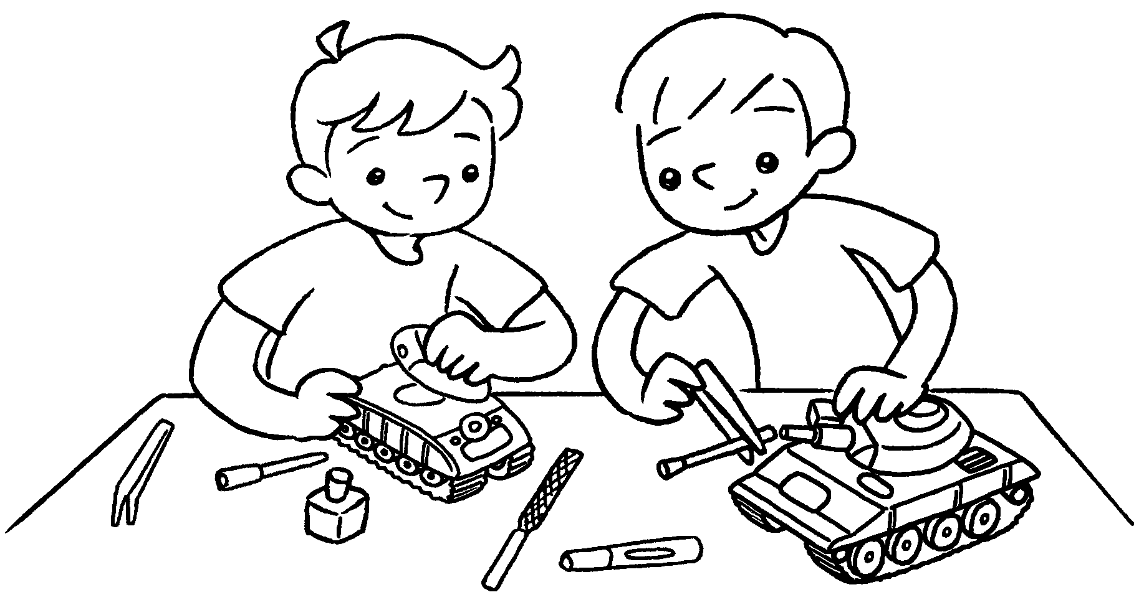 | Joe and David ( make ) models.



Book 1B Chapter 6 Graded Worksheets
Worksheet 2⬇
- are hiking
- is running
- are swimming
- is riding
- are making

