Fill in the blanks. Use the present continuous tense.
is are
run ride swim hike make
1 | 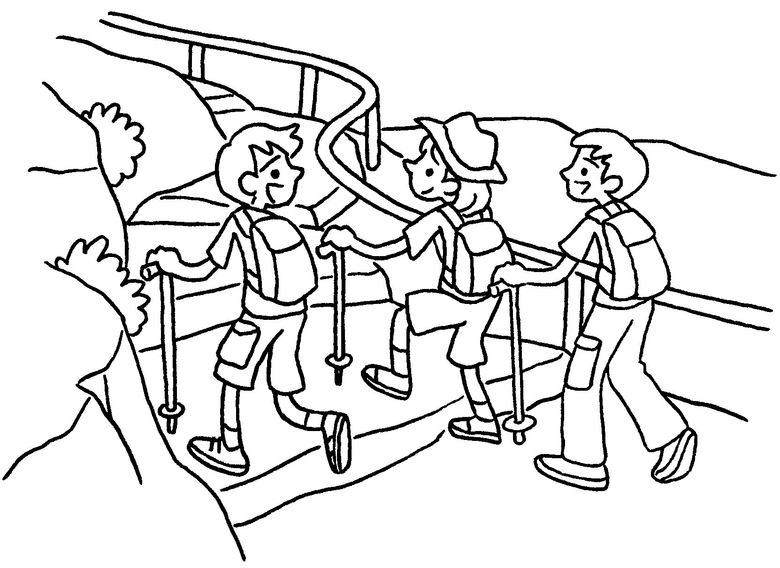 | Amy and her brothers are  .
2 | 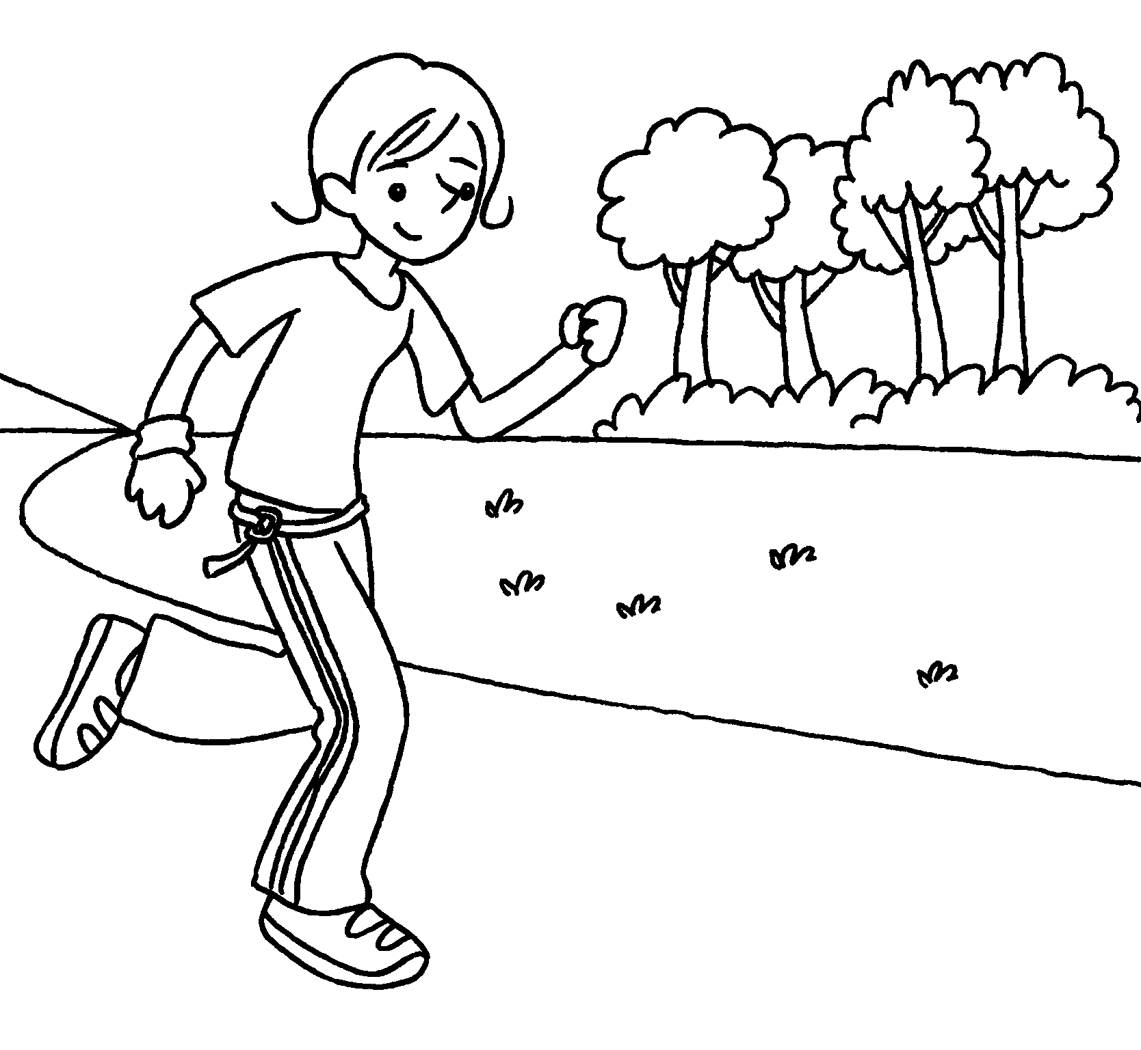 | Jenny .
3 | 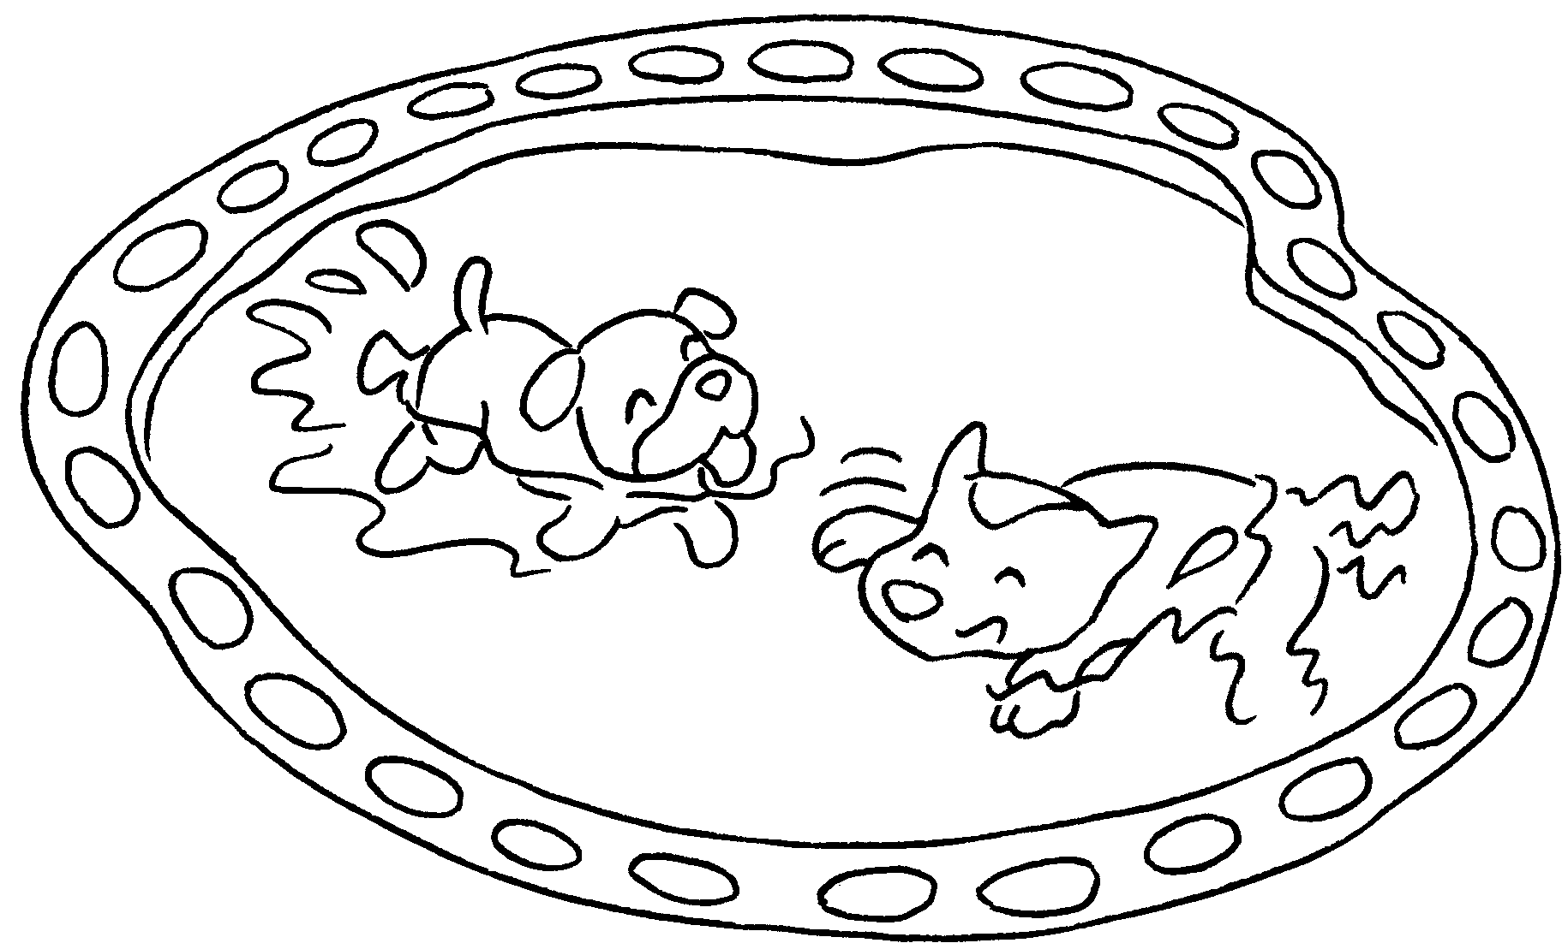 | The dogs .
4 | 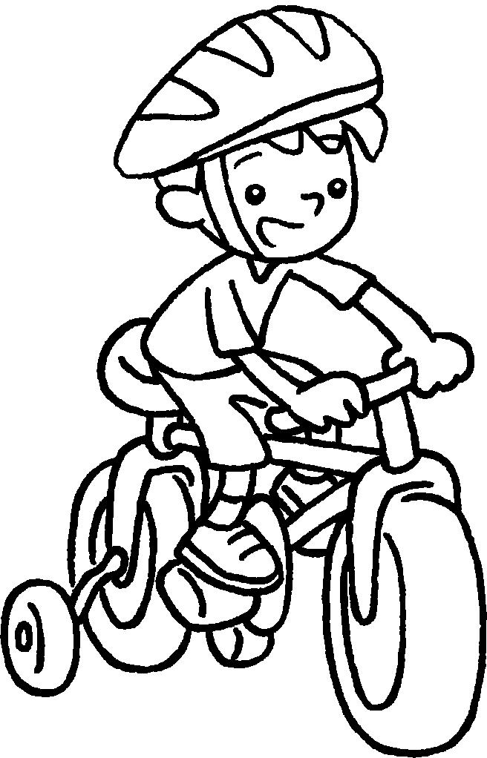 | Billy his bicycle.
5 | 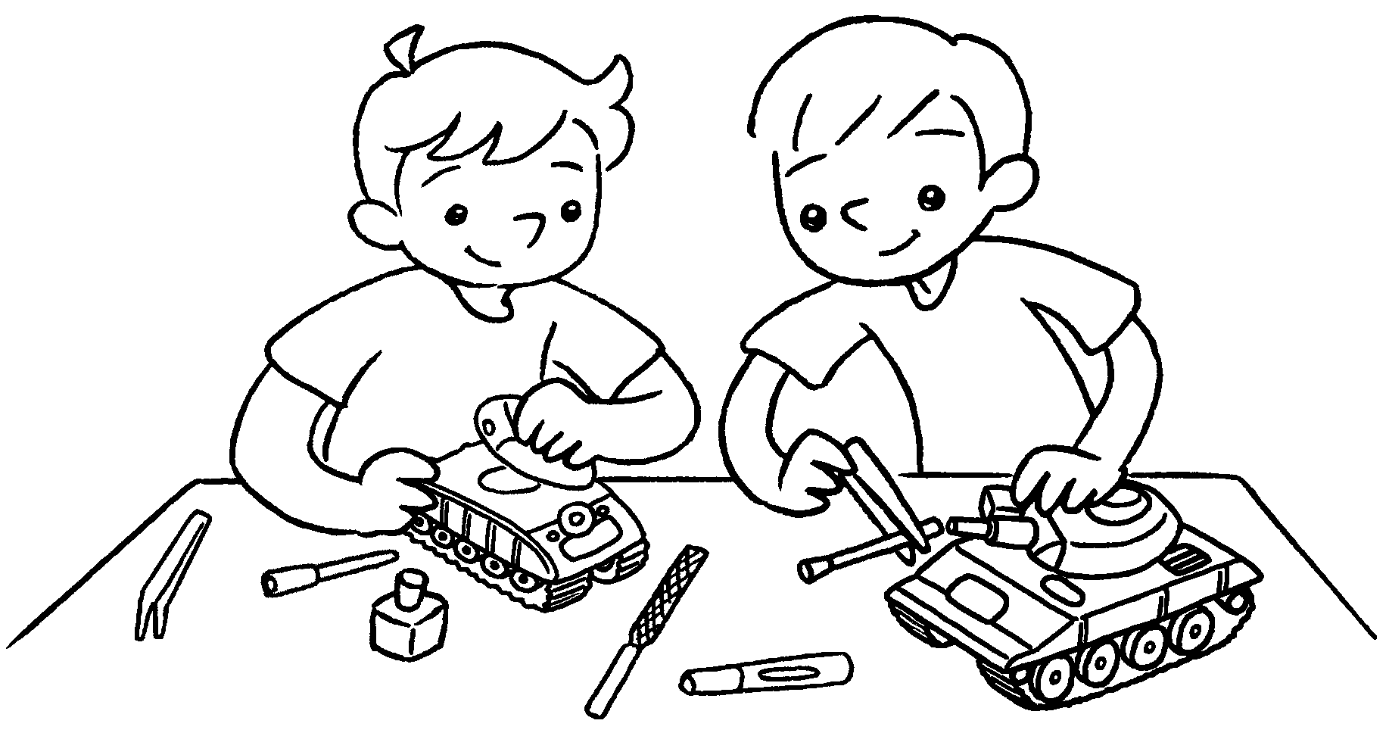 | Joe and David models.



Book 1B Chapter 6 Graded Worksheets
Worksheet 2⬇⬇
- hiking
- is running
- are swimming
- is riding
- are making

