What are they doing? Write.
1 | 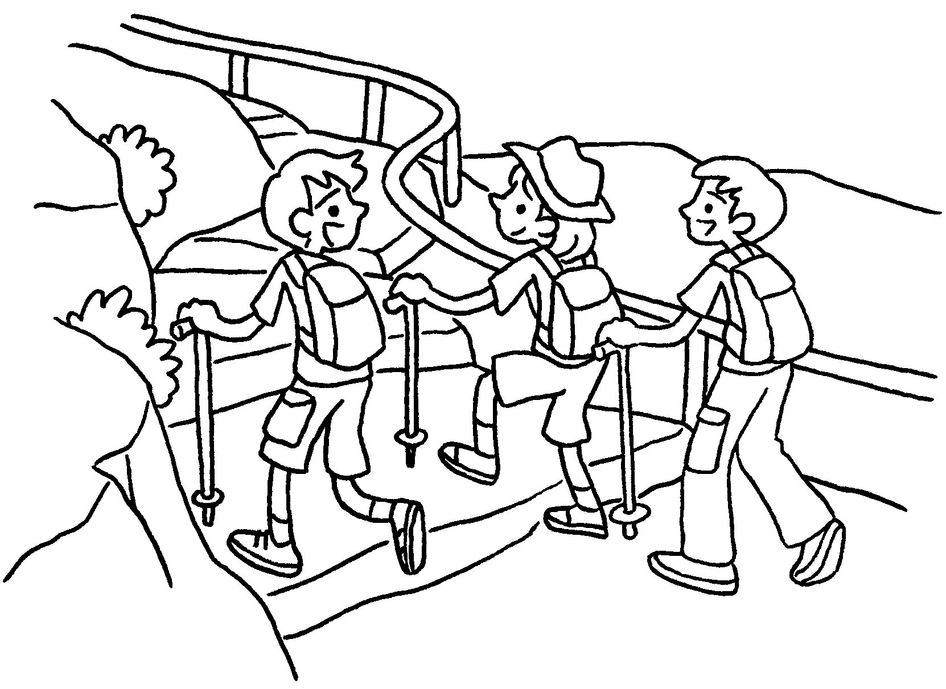 | Amy and her brothers  hiking.
2 | 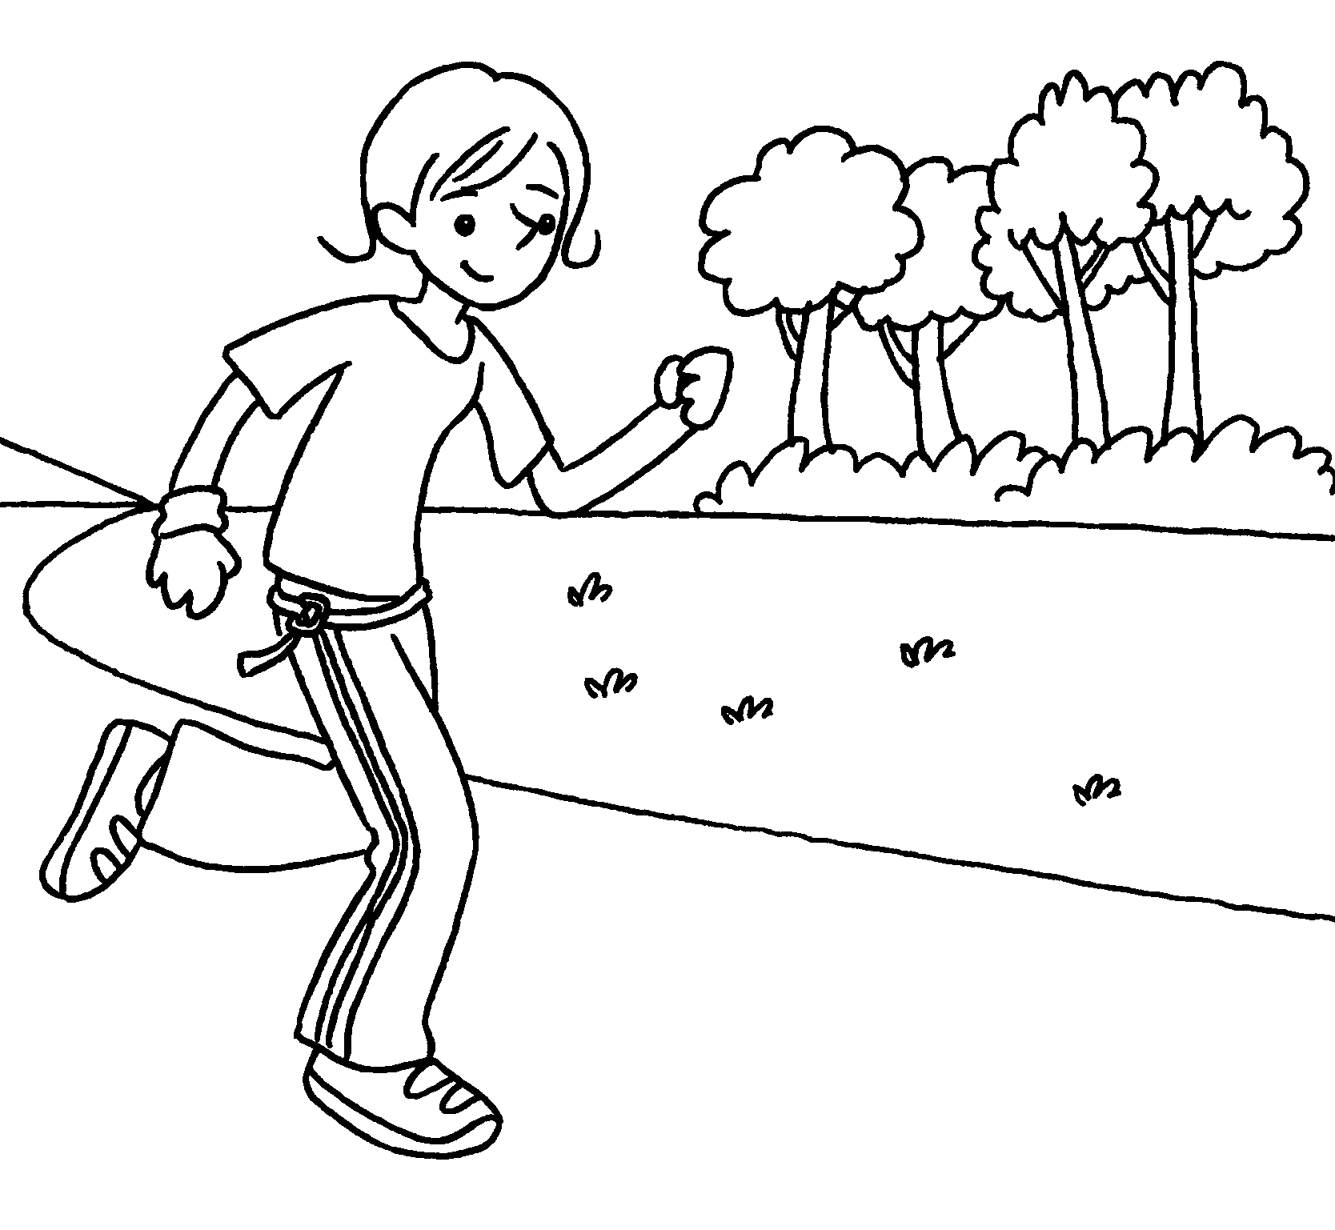 | Jenny is .
3 | 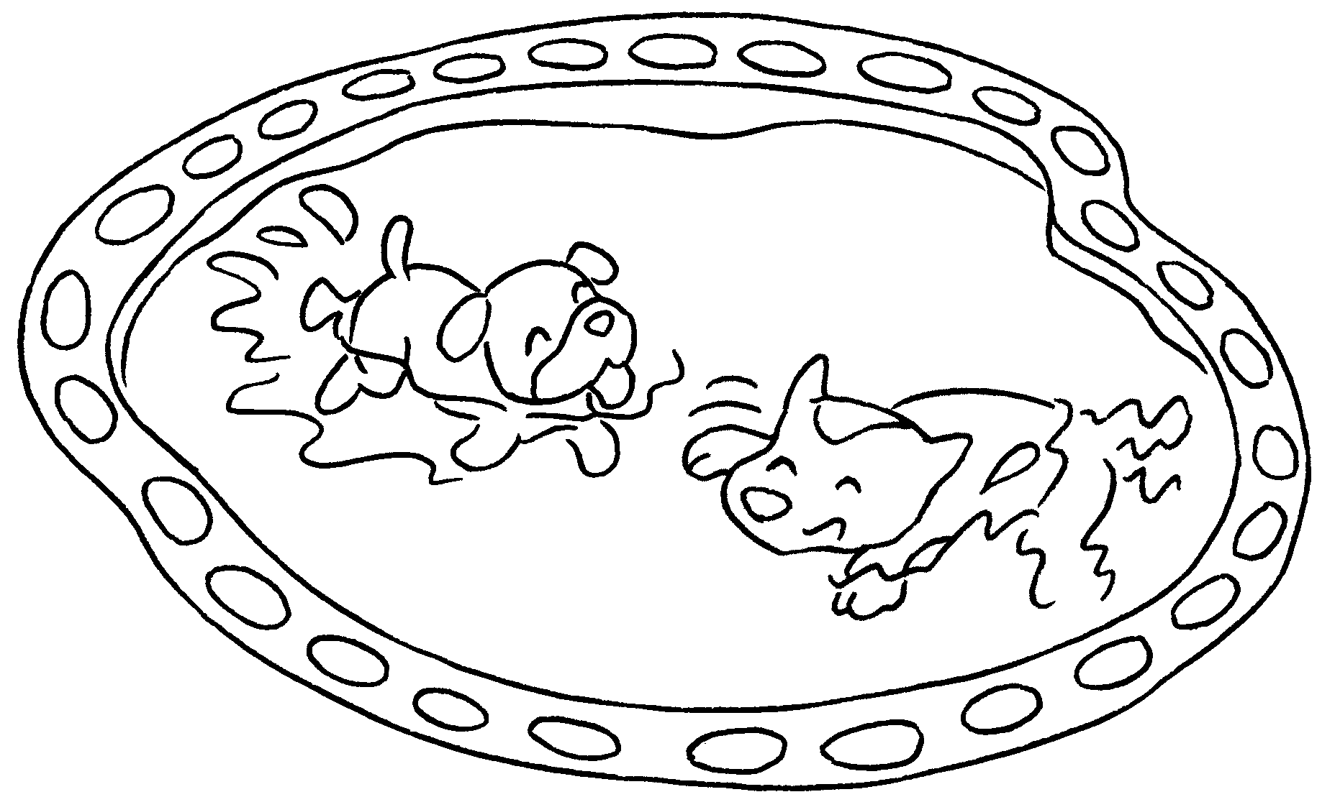 | The dogs .
4 | 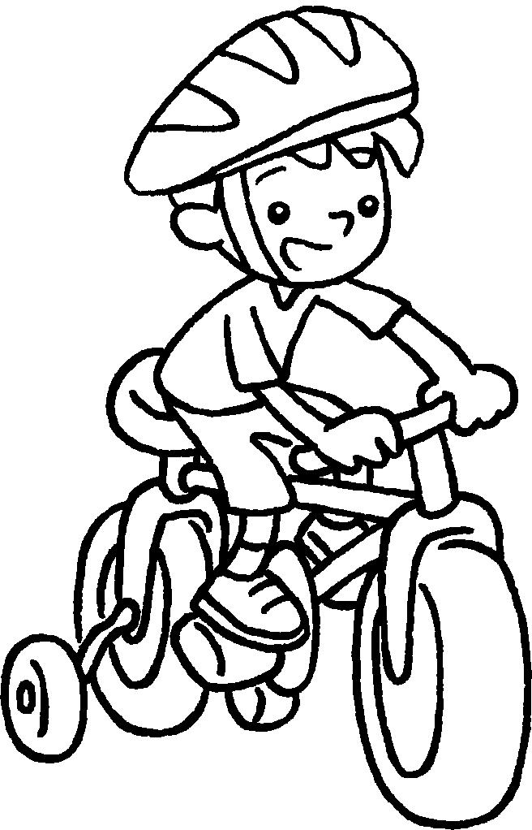 | Billy his bicycle.
5 | 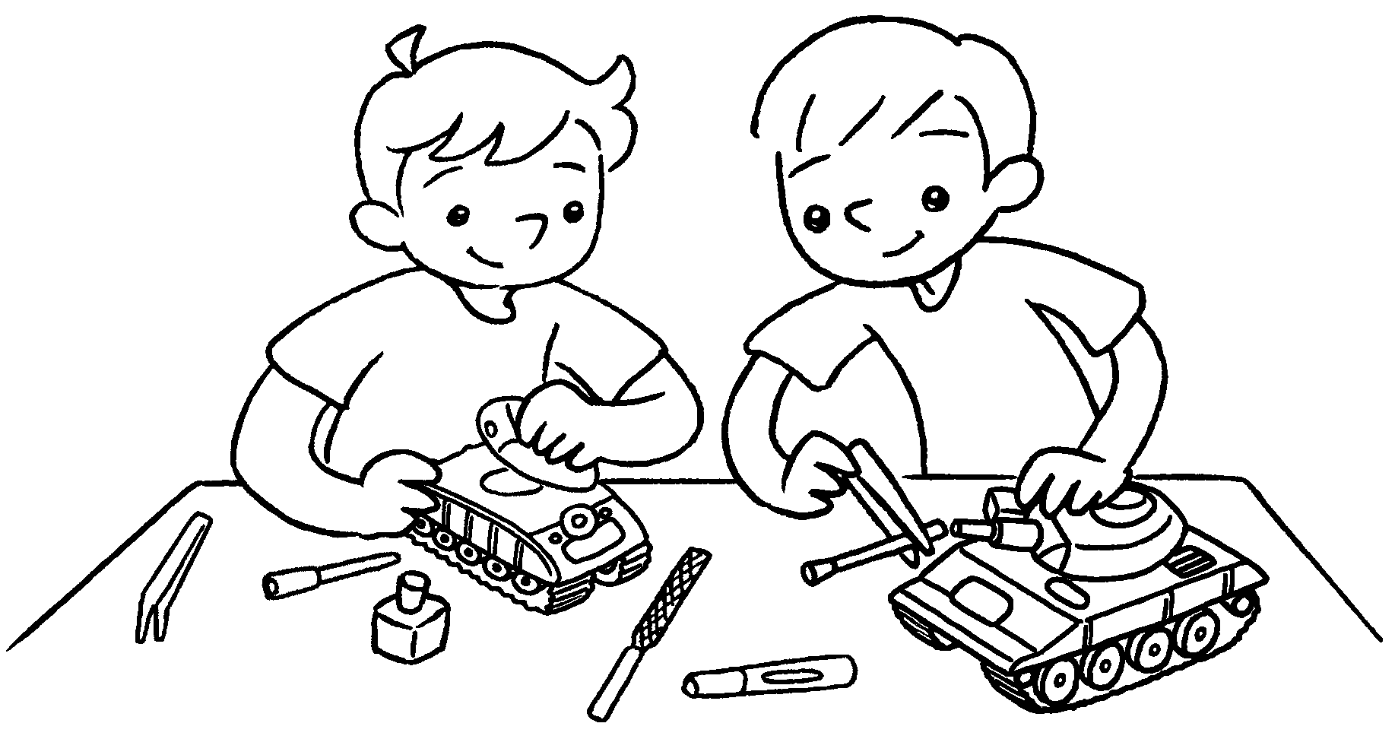 | Joe and David models.



Book 1B Chapter 6 Graded Worksheets
Worksheet 2⬇⬇⬇
- are
- running
- are swimming
- is riding
- are making

