Circle and write the correct answers.
1 | 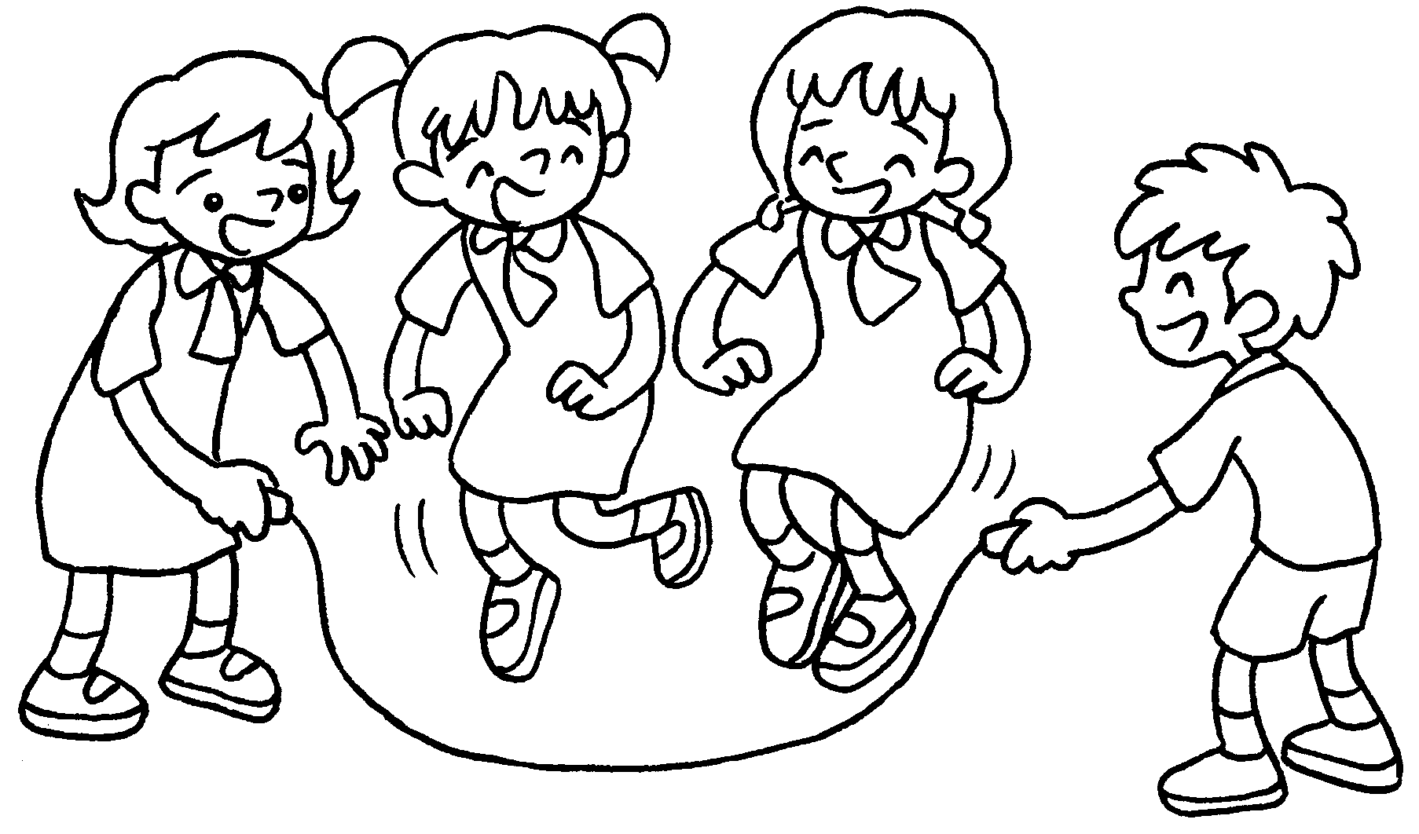 | Q : What ( is / are ) Kitty and  Kate doing?  A : They are skipping.
2 | 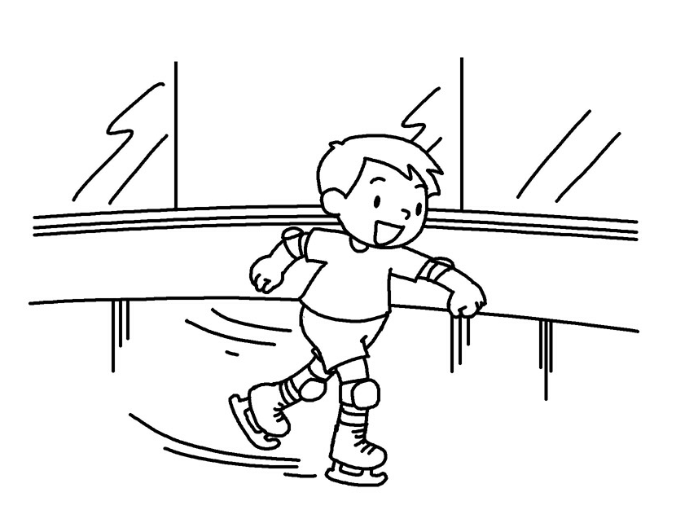 | Q : What ( are / is ) Billy doing?  A : He is __________________  ( ice-skate ).
3 | 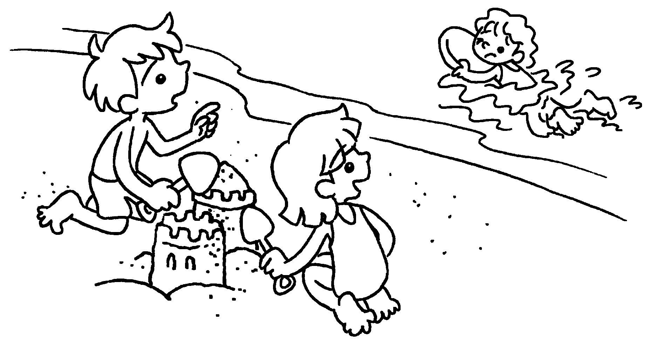 | A : What ( is / are ) Betty doing?  B : She is _____________ ( swim ).
4 | 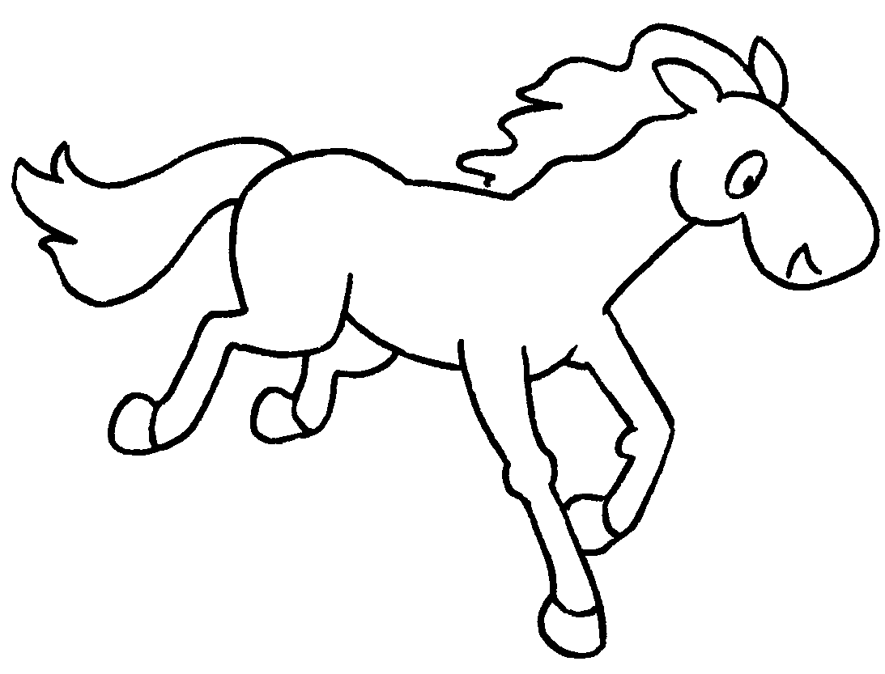  A  B | Q : What ( is / are ) the horse doing?  A : It is _________________ ( run ).
5 | 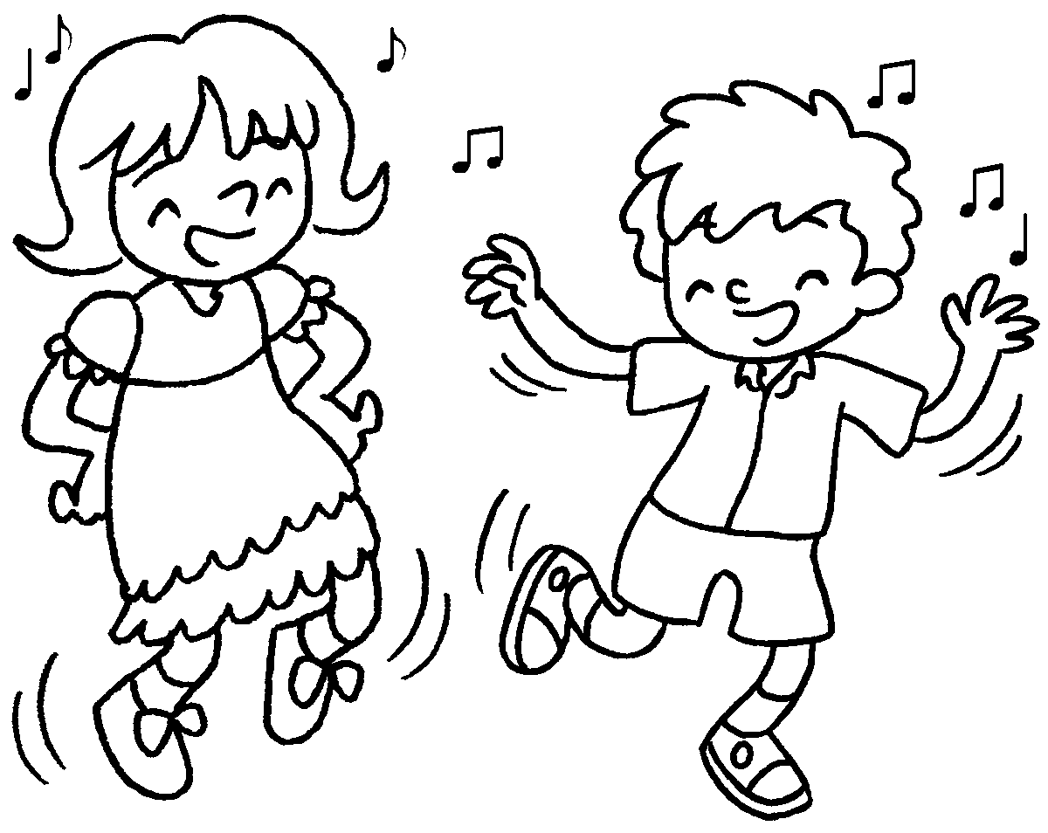 | Q : What ( are / is ) Paul and  Sue ( doing / do )?  A : They are _________________  ( dance ).



Book 1B Chapter 6 Graded Worksheets
Worksheet 3⬇
1 ( is / are )
2 ( are / is )
ice-skating
3 ( is / are )
swimming
4 ( is / are )
running
5 ( are / is ) ( doing / do )
dancing

