What are they doing? Finish the questions and answers.

is / are dance swim run ice-skate

1 | 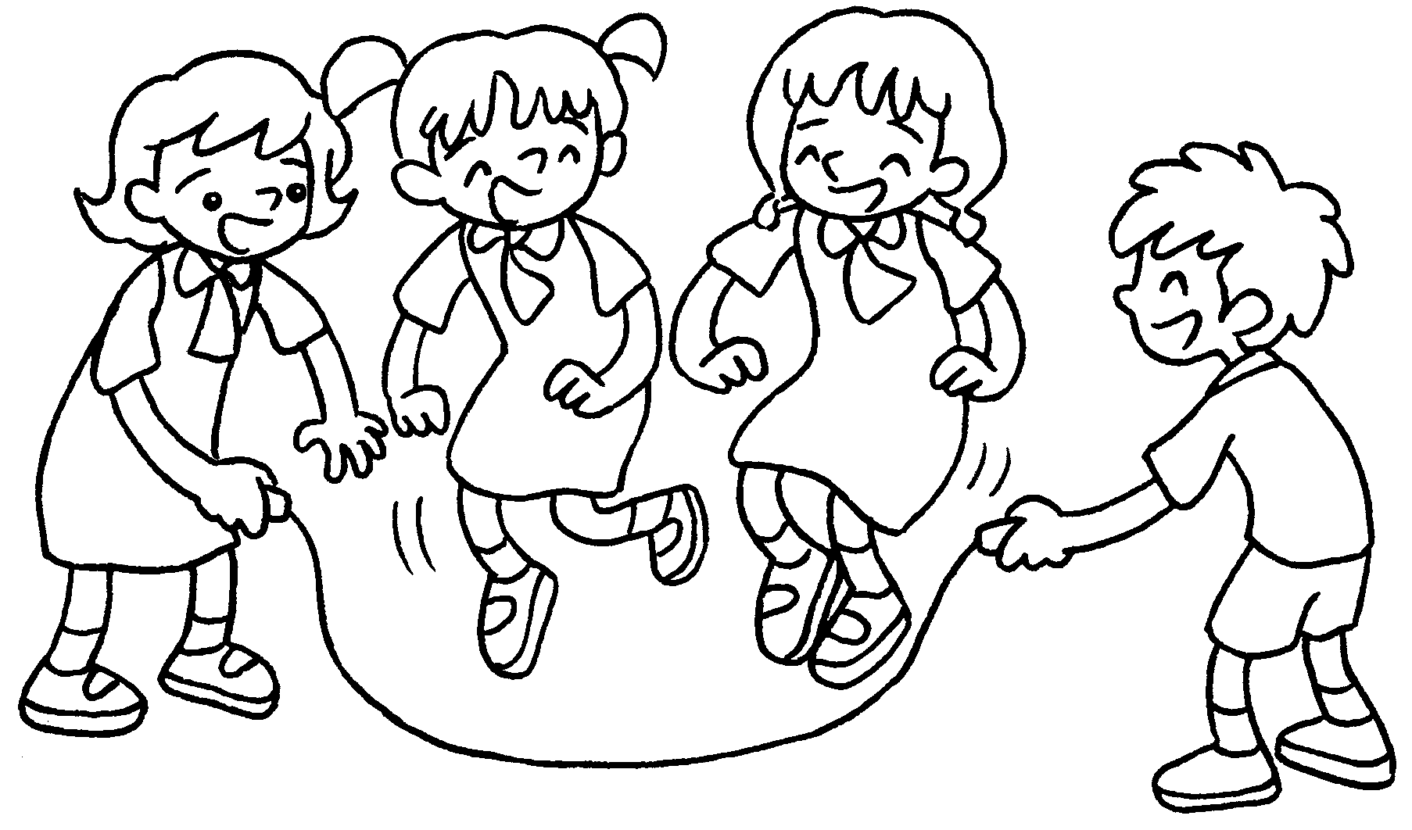 | Q : What _____ Kitty and  Kate doing?  A : They are skipping.
2 | 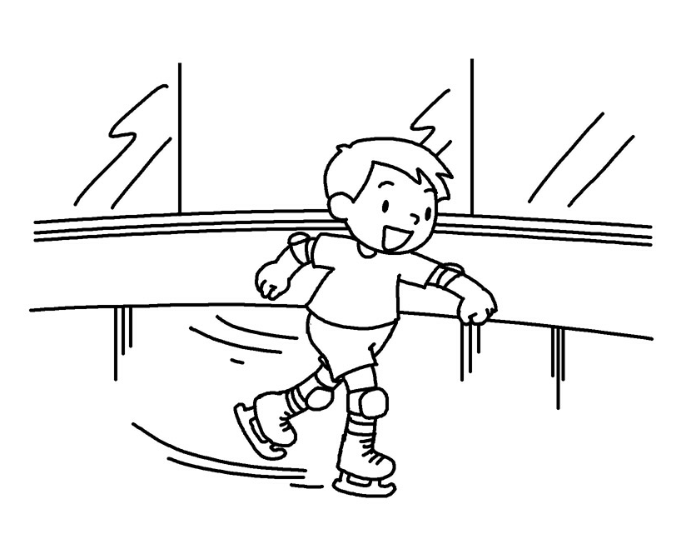 | Q : What ____ Billy doing?  A : He is _________________ .
3 | 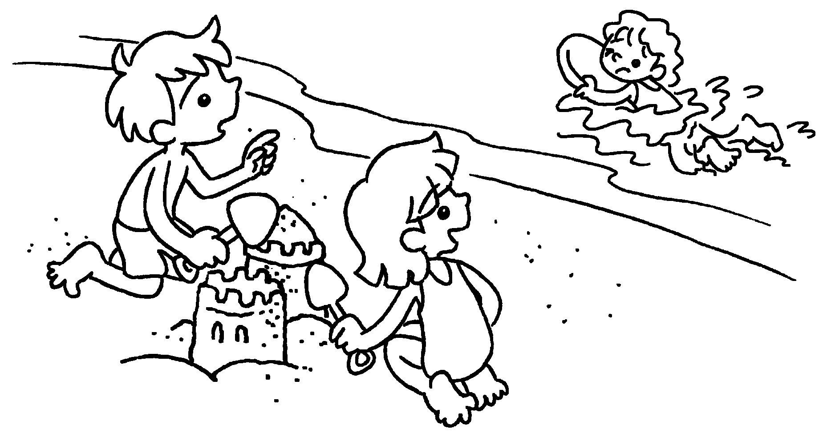 | A : What _____ Betty doing?  B : She _____________________ .
4 | 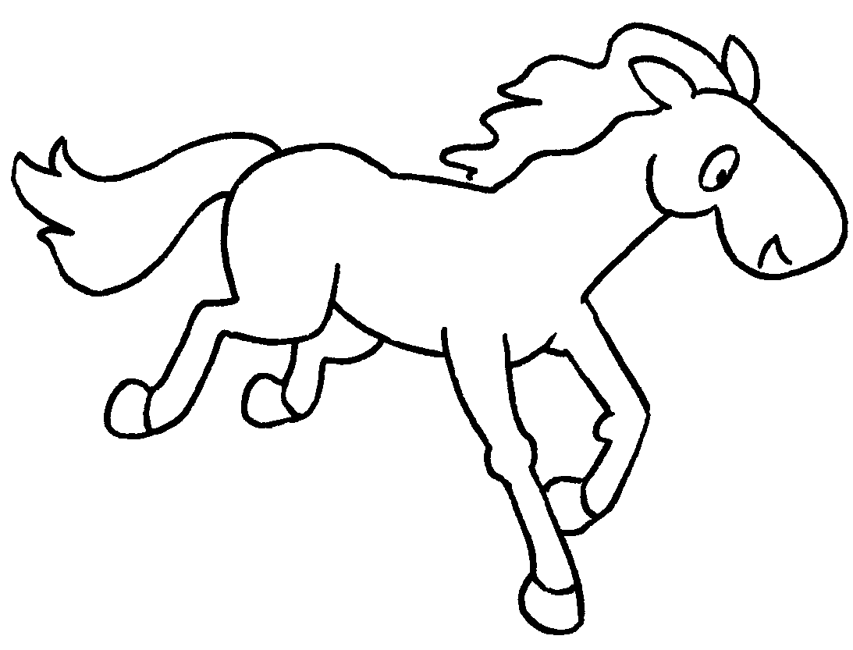  B  A  B | Q : What _____ the horse  ____________ ?  A : It _____ ________________ .
5 | 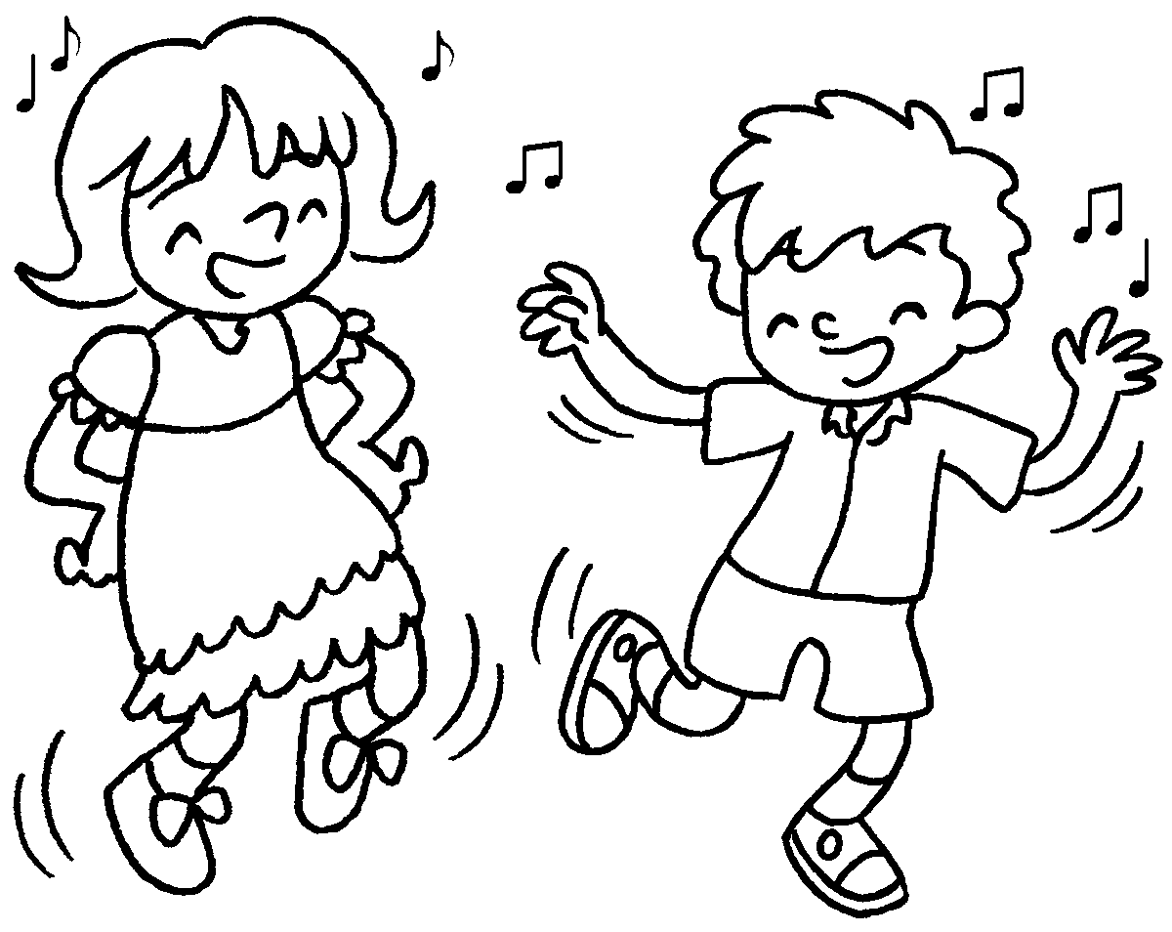 | Q : What ______ Paul and Sue  ____________ ?  A : They _____________________ .



Book 1B Chapter 6 Graded Worksheets
Worksheet 3⬇⬇
1 are
2 is
ice-skating
3 is
is swimming
4 is doing
is running
- are doing
are dancing

