What are they doing? Finish the questions and answers.

He / She / It / They is / are

1 | 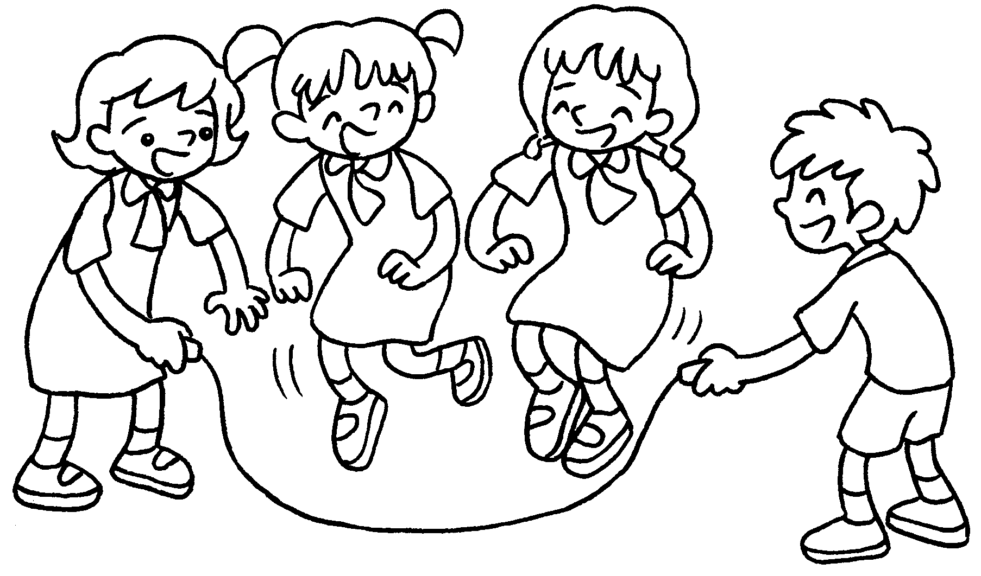 | Q : What _____ Kitty and  Kate doing?  A : They _____ skipping.
2 | 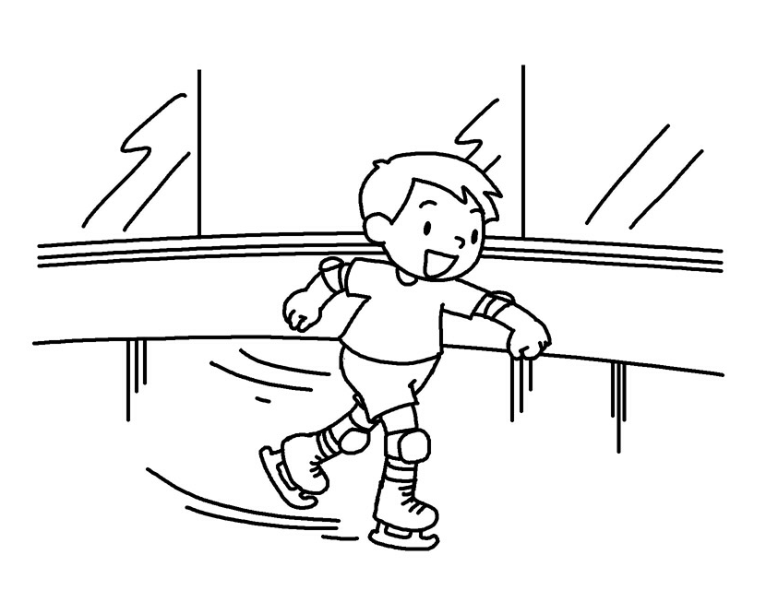 | Q : What ____ Billy doing?  A : ______ _____ ____________ .
3 | 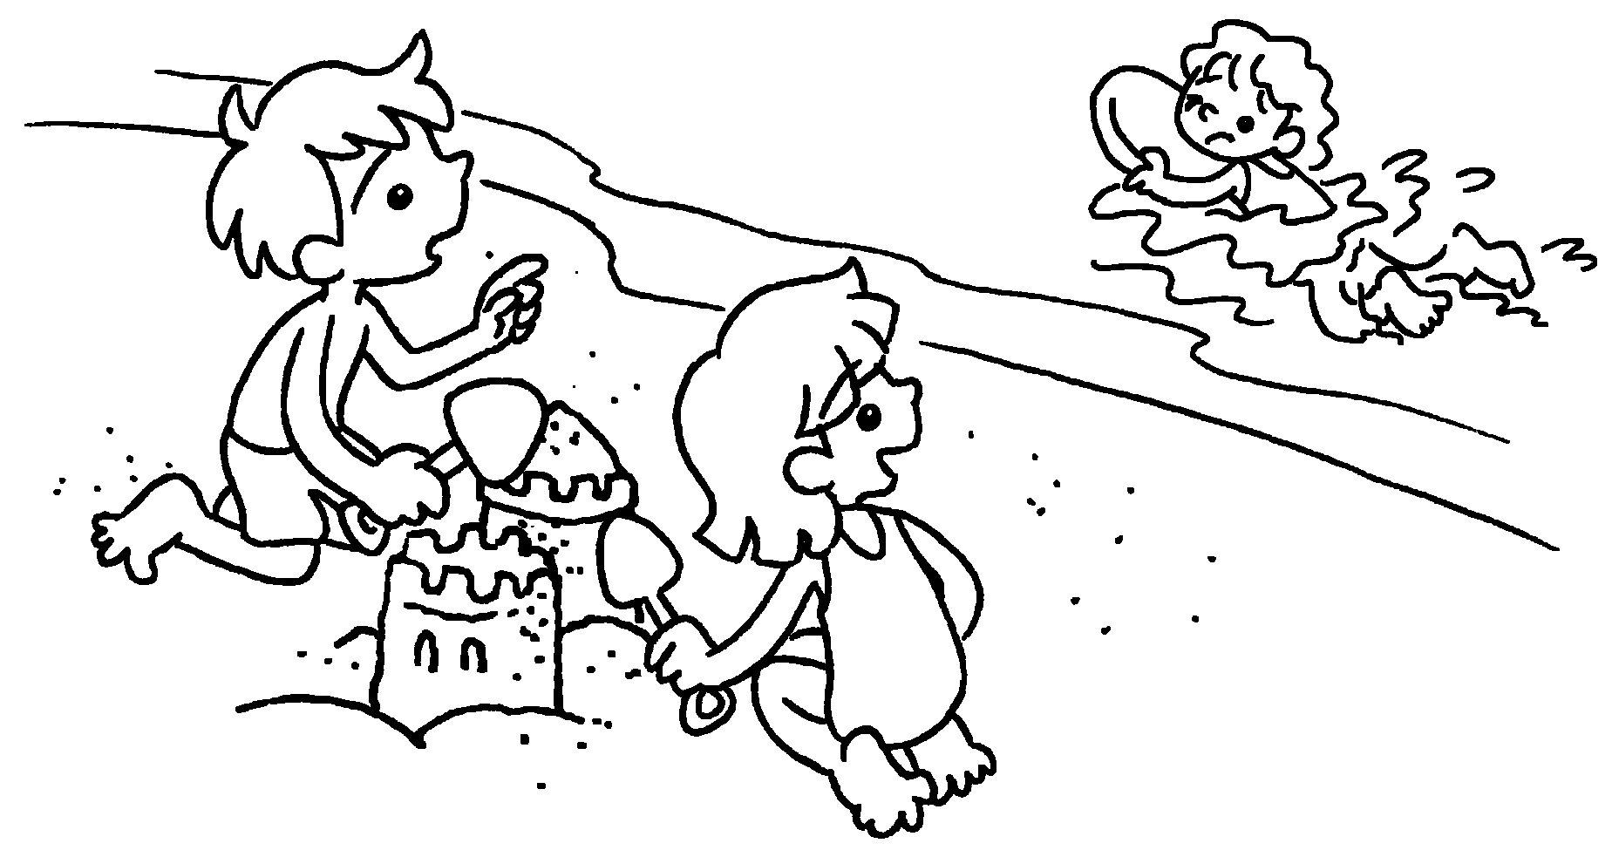 | A : What _____ Betty doing?  B : ____________________________
4 | 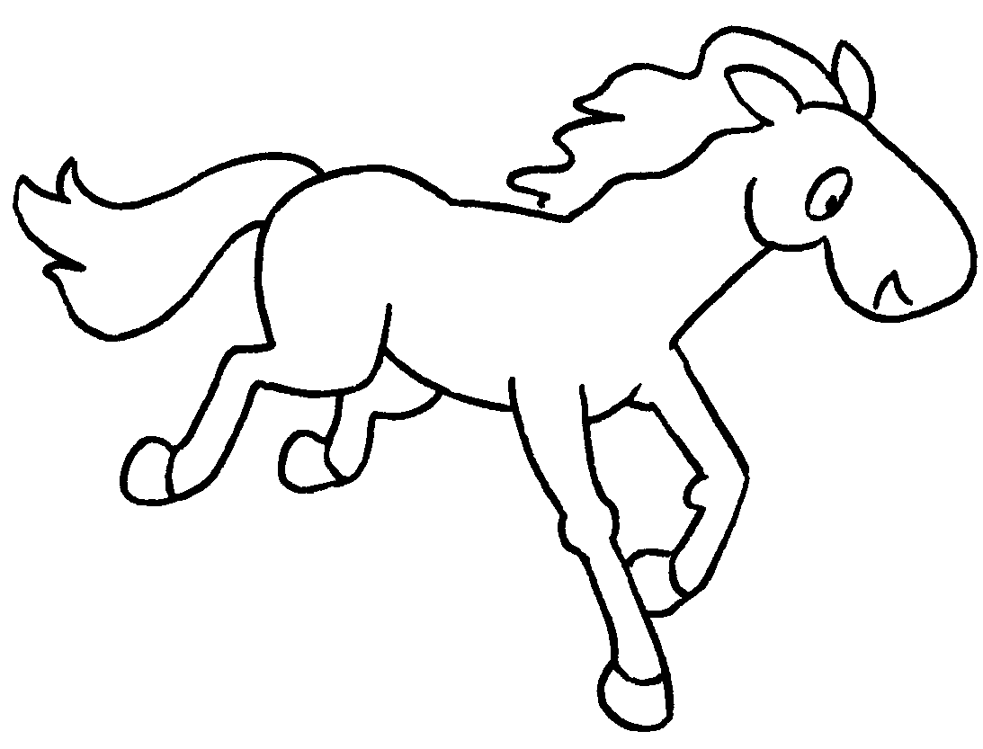  A  B | Q : What _____ the horse  ____________ ?  A : ____________________________
5 | 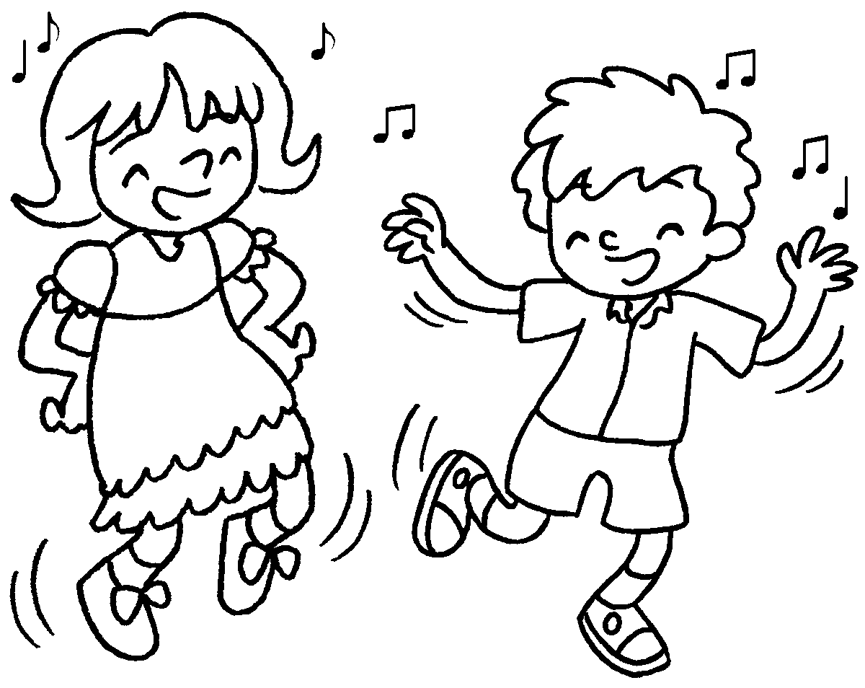 | Q : _____________ Paul and Sue  ____________ ?  A : ____________________________



Book 1B Chapter 6 Graded Worksheets
Worksheet 3⬇⬇⬇
- are
are
- is
He is ice-skating
- is
She is swimming.
4 is doing
It is running.
5 What are doing

They are dancing.

