A
B
A
B
Choose and write.

art room |  | classroom |  | computer room |  |  | garden
library | lift |  | music room |  | playground | toilets

1 | 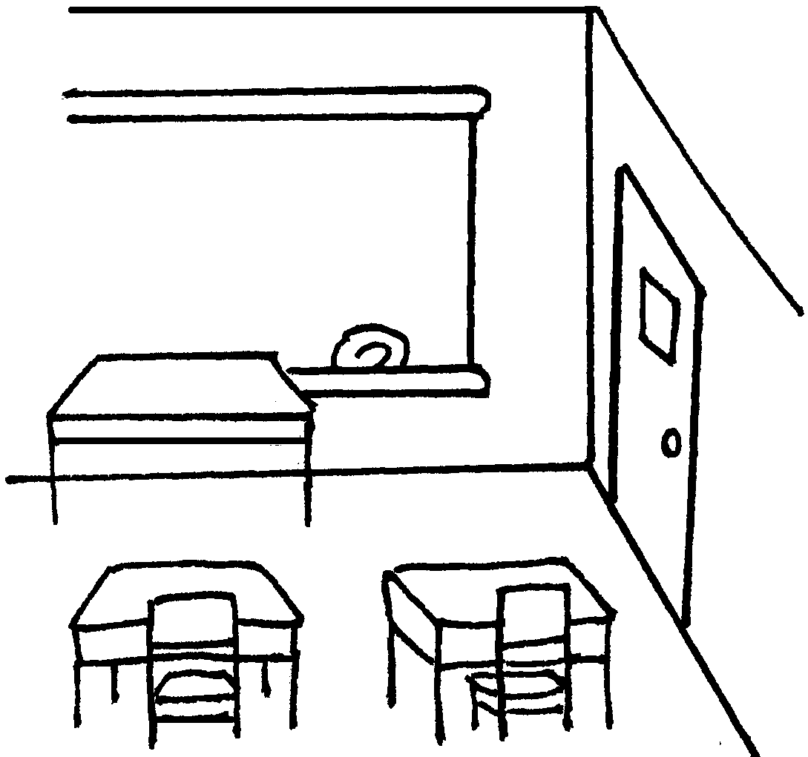 |  | 2 |  | 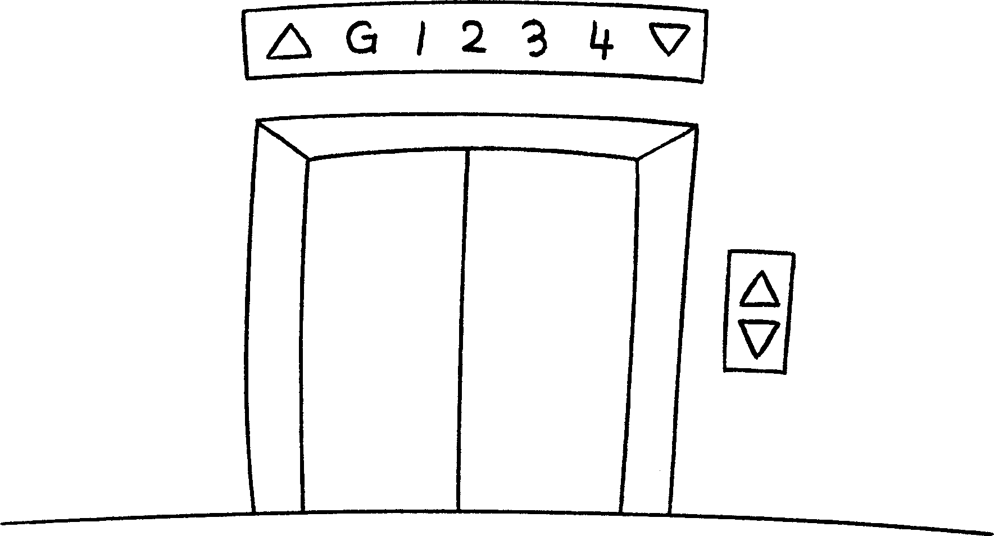 |  | 3 |  | 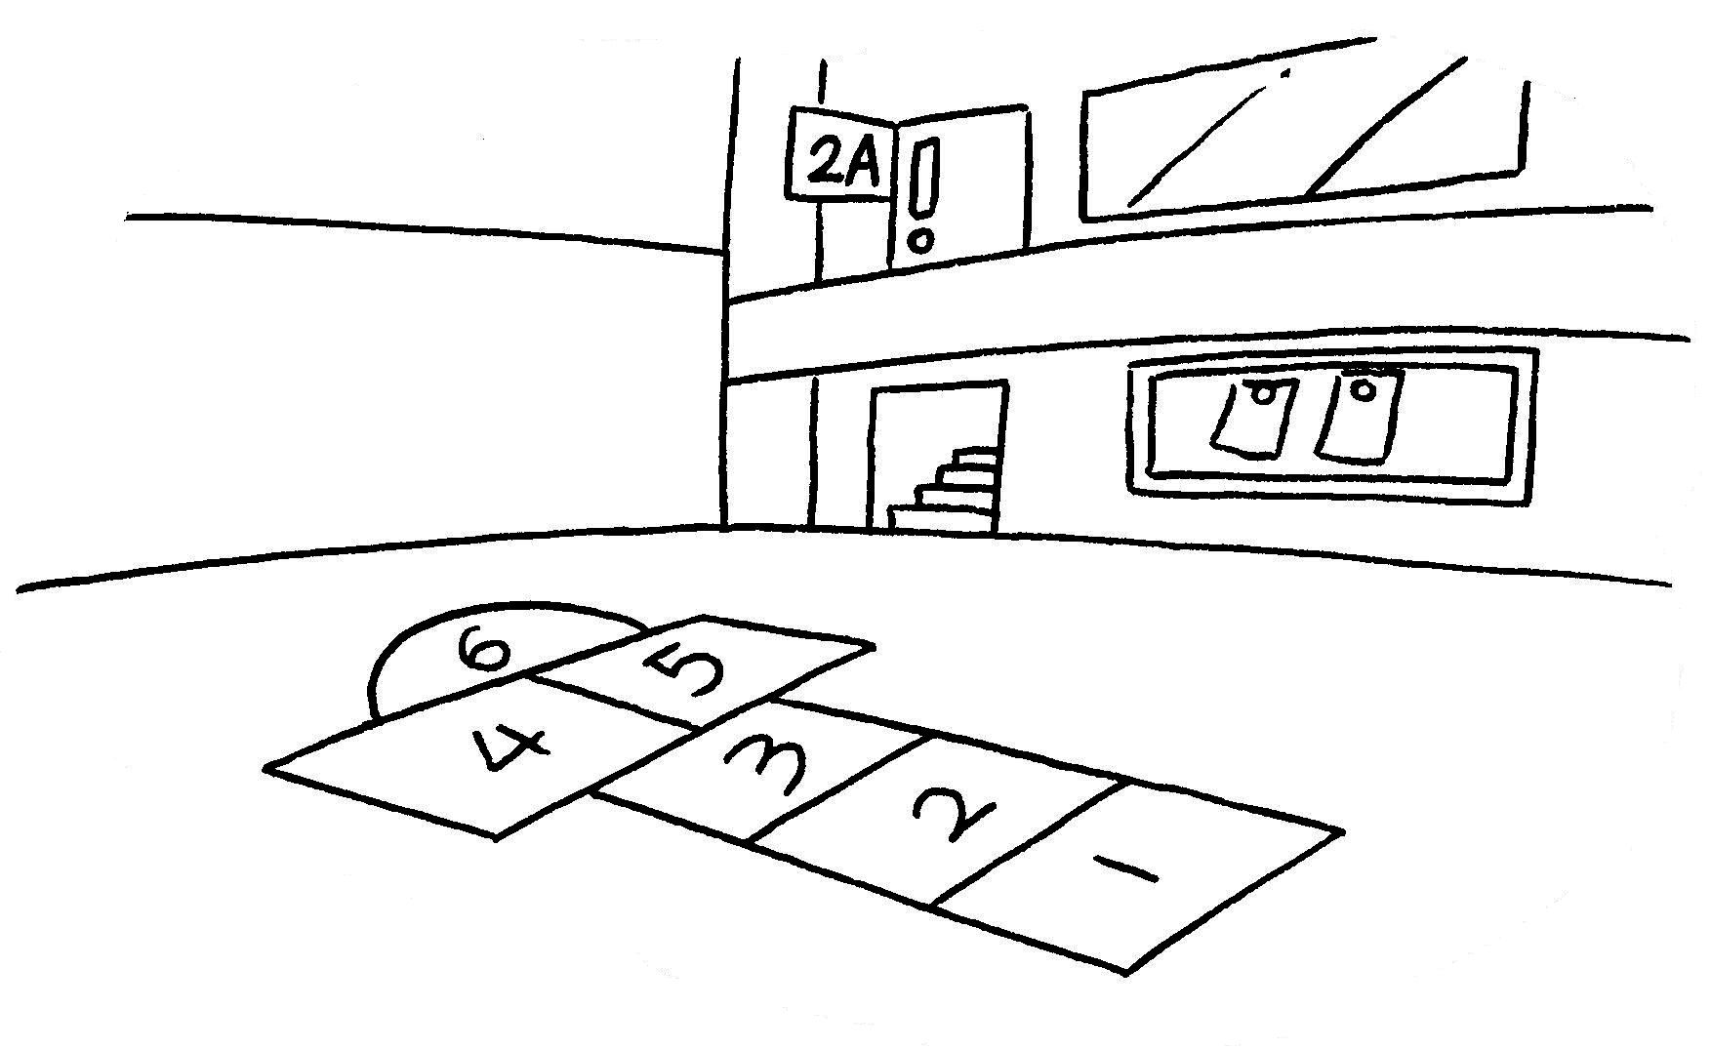
 | a |  |  |  | a |  |  |  | a
4 | 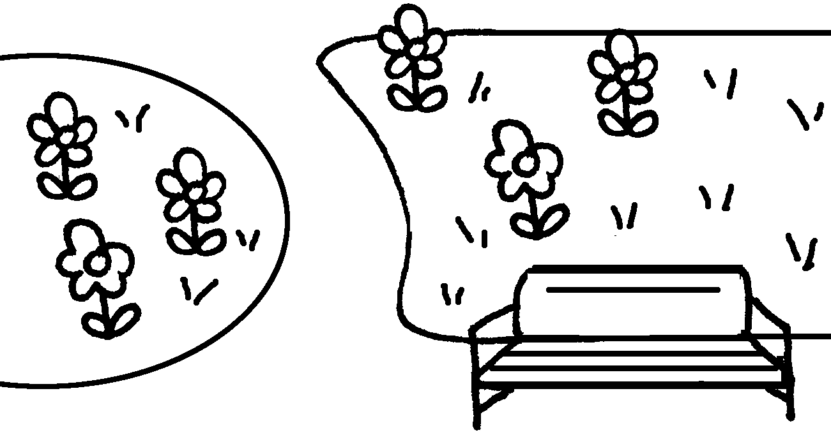 |  | 5 |  | 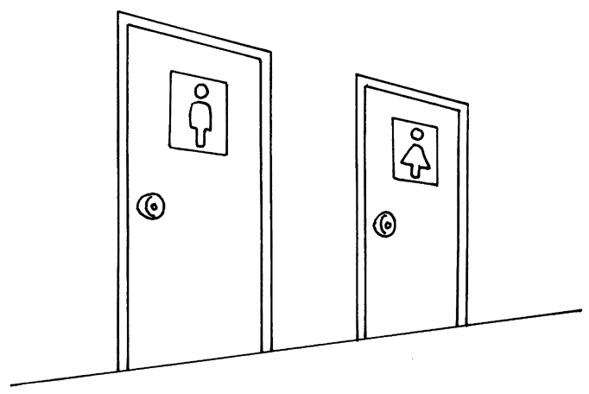 |  | 6 |  | 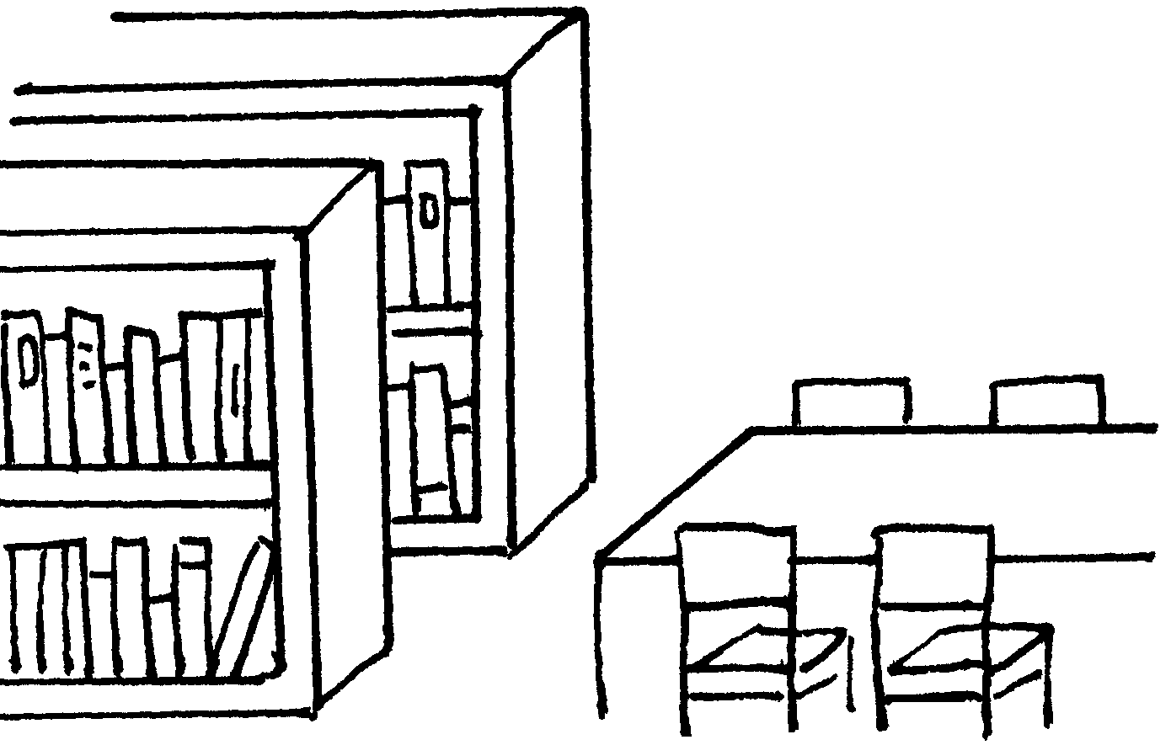
 |  | a |  |  |  |  |  |  |  | a
7 | 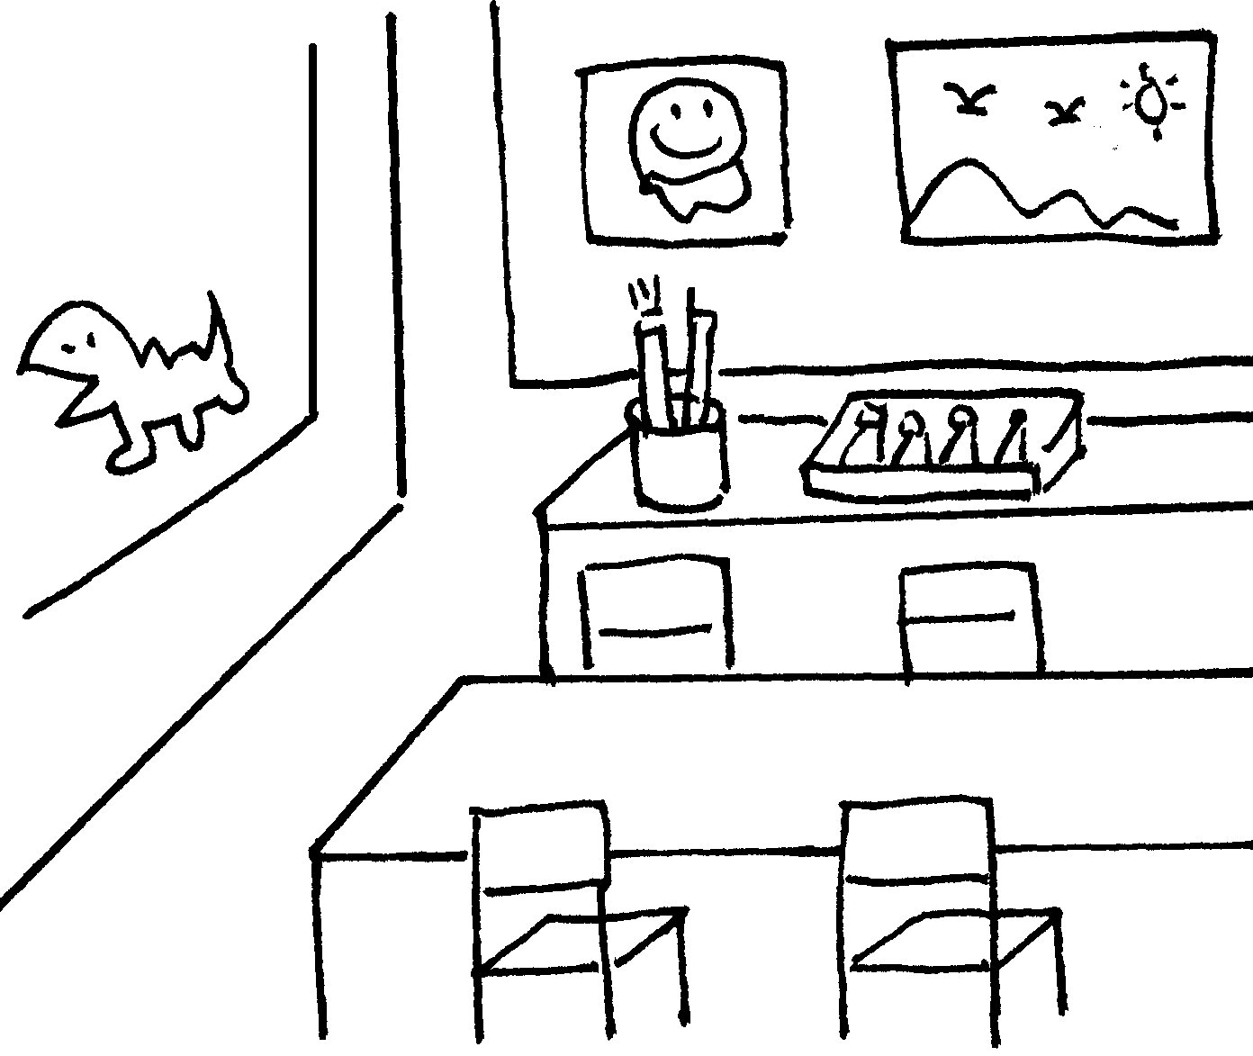 |  | 8 |  | 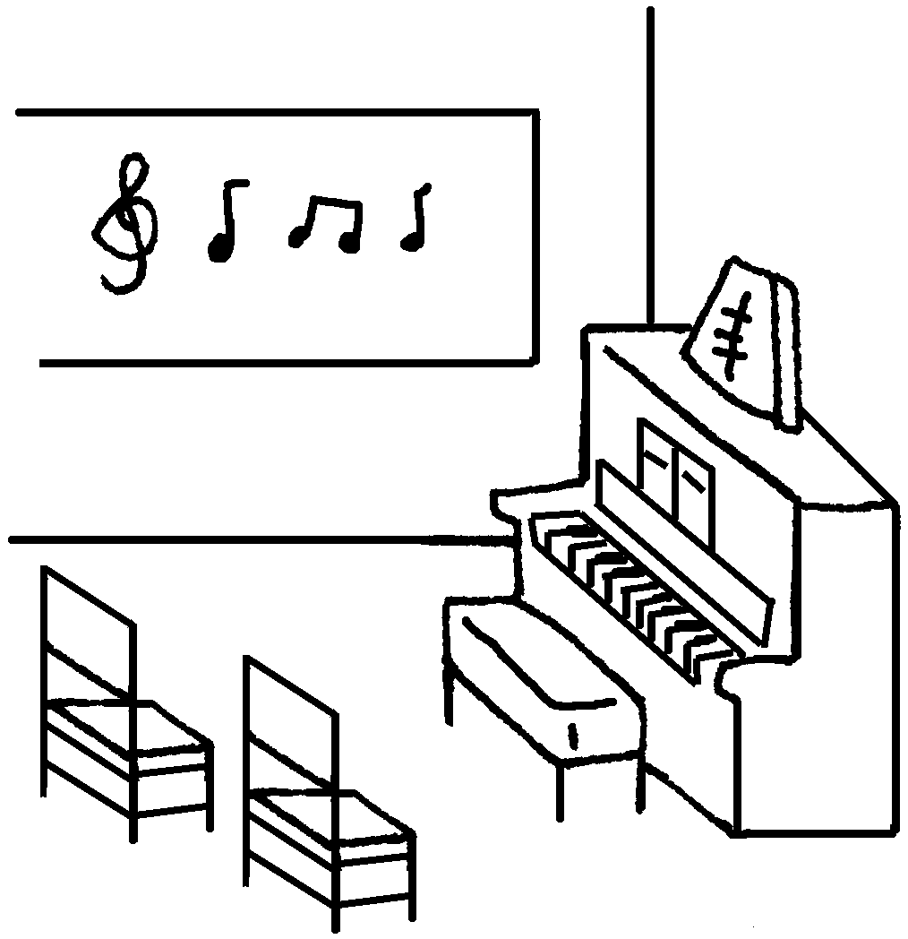 |  | 9 |  | 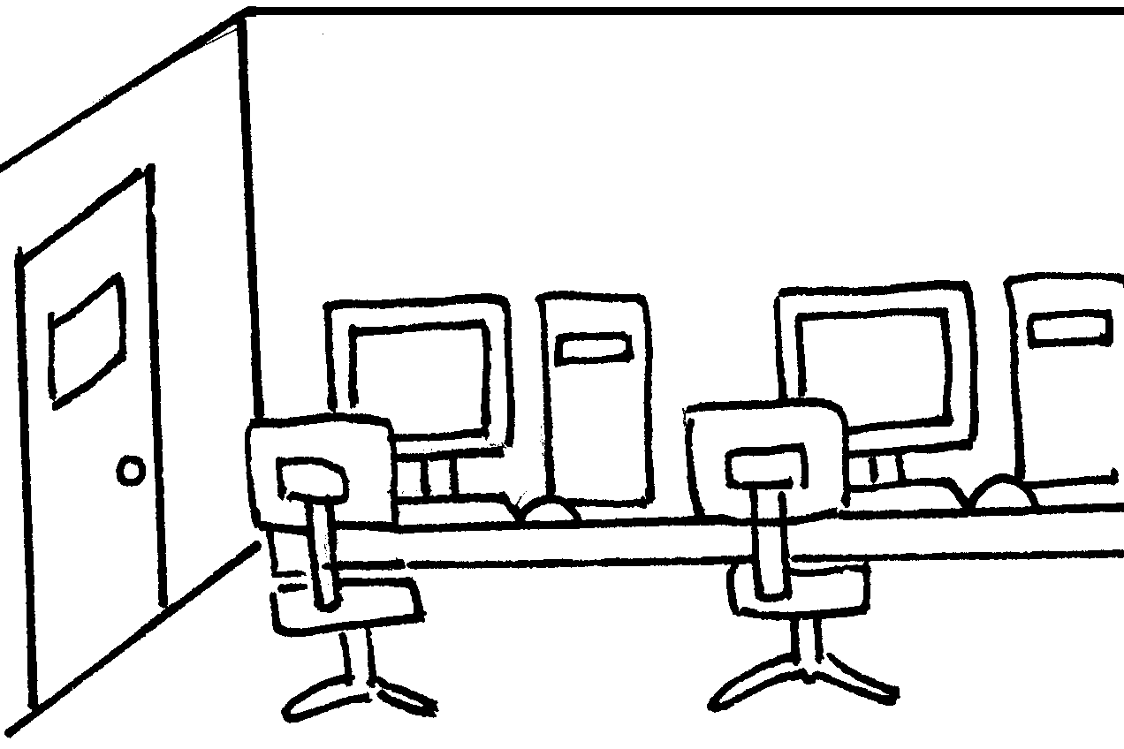
 | an |  |  |  | a |  |  |  | a


Book 2A Chapter 1 Graded Worksheets
Worksheet 1⬇
- classroom 2 lift 3 playground
4 garden 5 toilets 6 library
7 art room 8 music room 9 computer room

