A
B
A
B
A
B
A
B
What are they? Write.

1 | 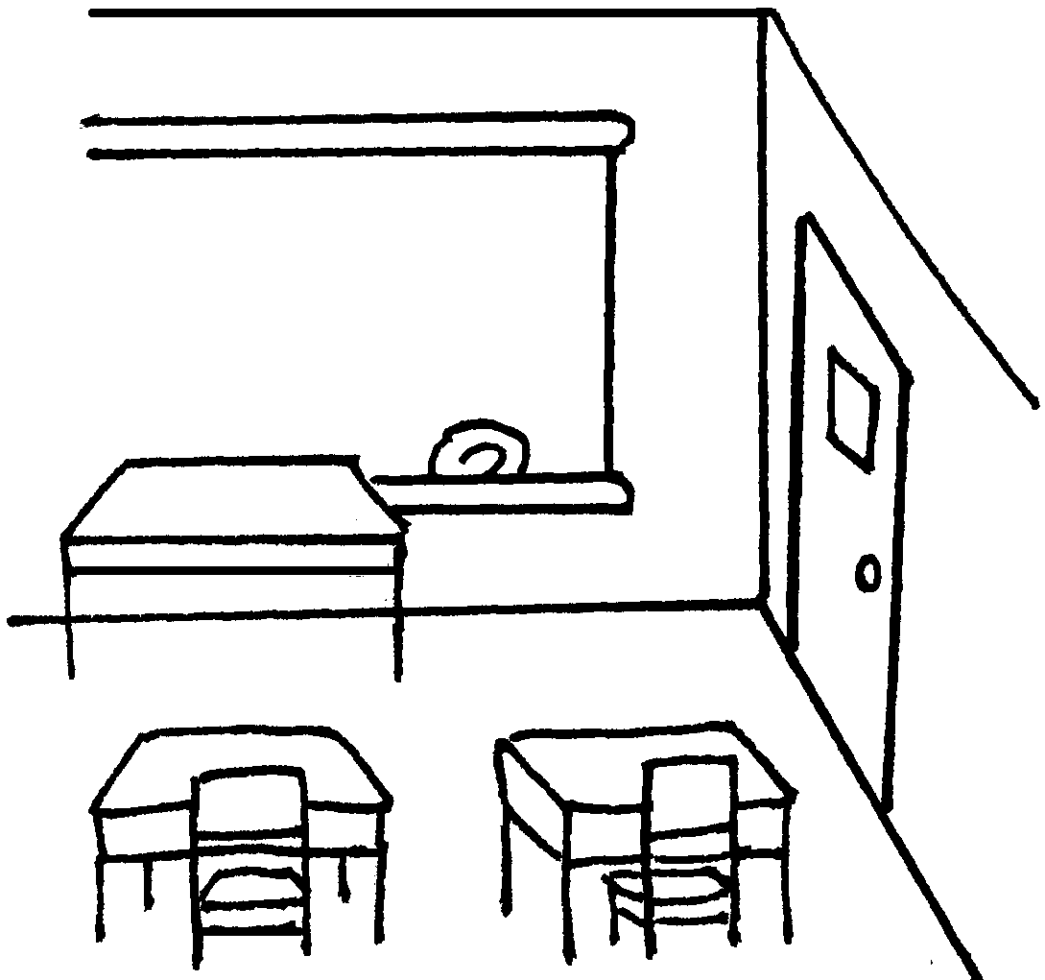 | 2 | 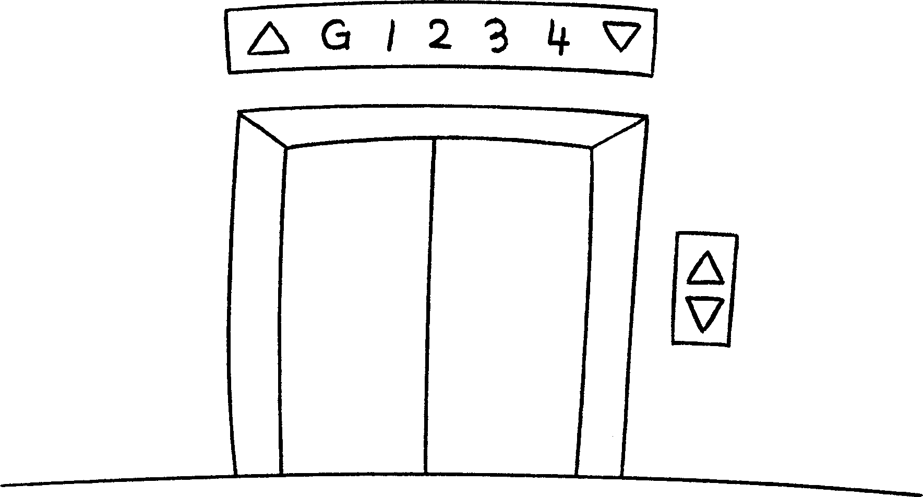 | 3 | 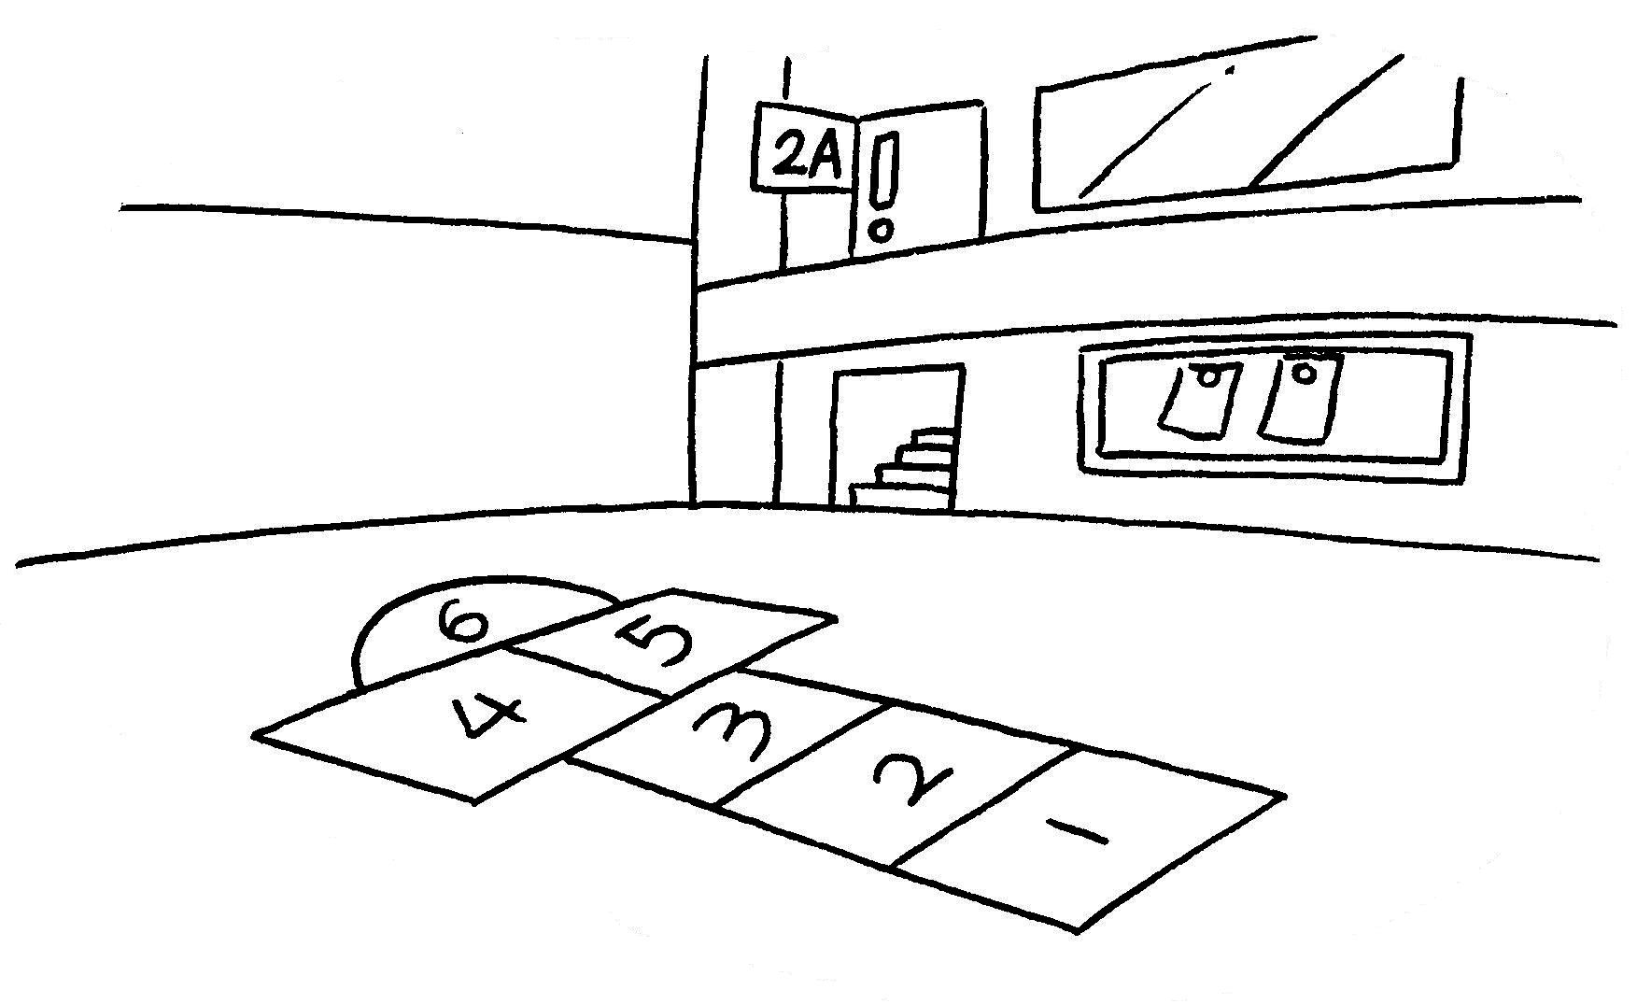
 | a |  | a |  | a

4 | 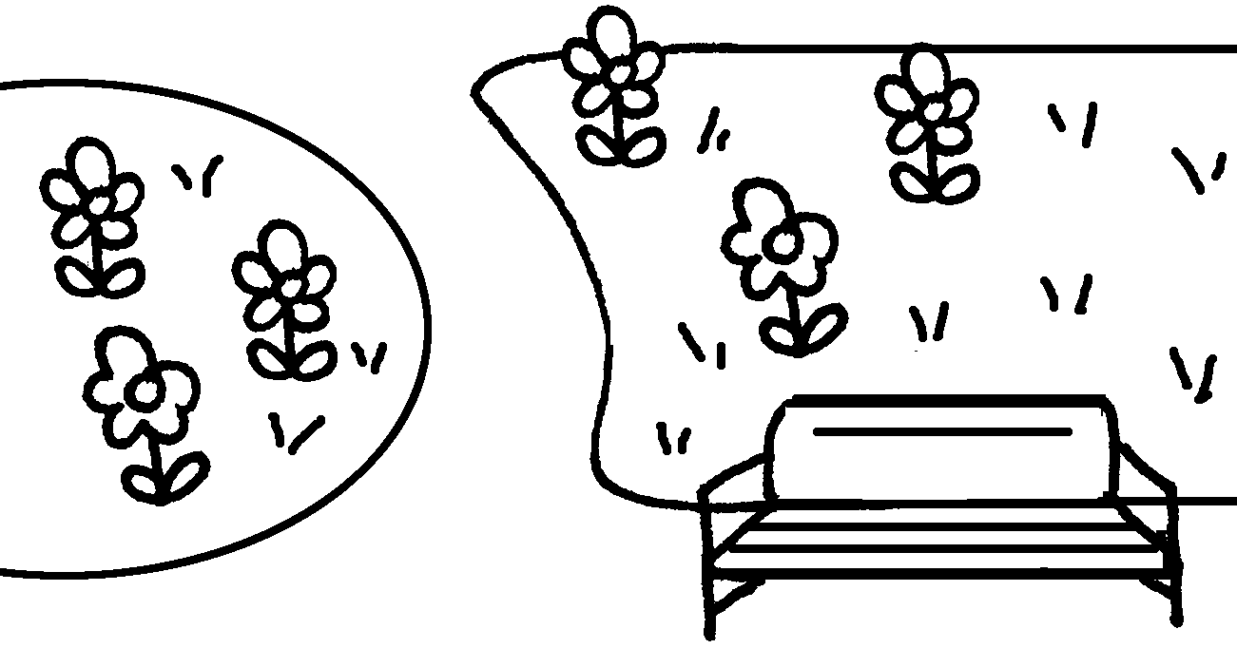 |  | 5 |  | 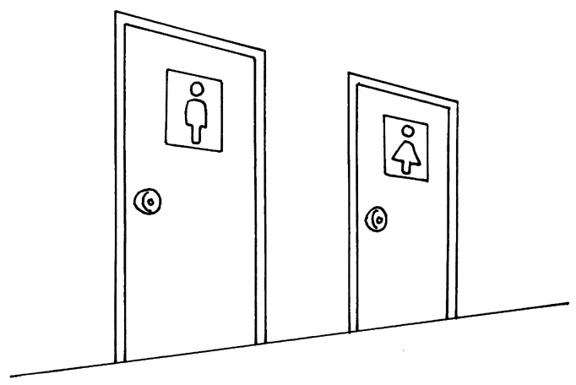 |  | 6 |  | 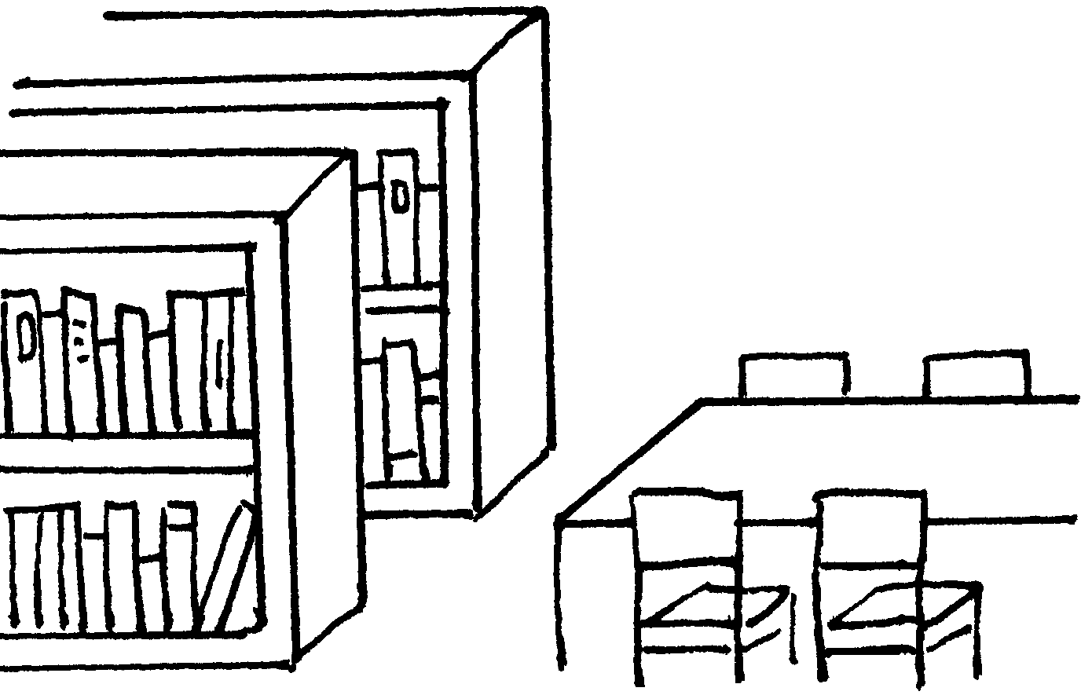
 |  | ___ |  |  |  |  |  |  |  | ___

7 | 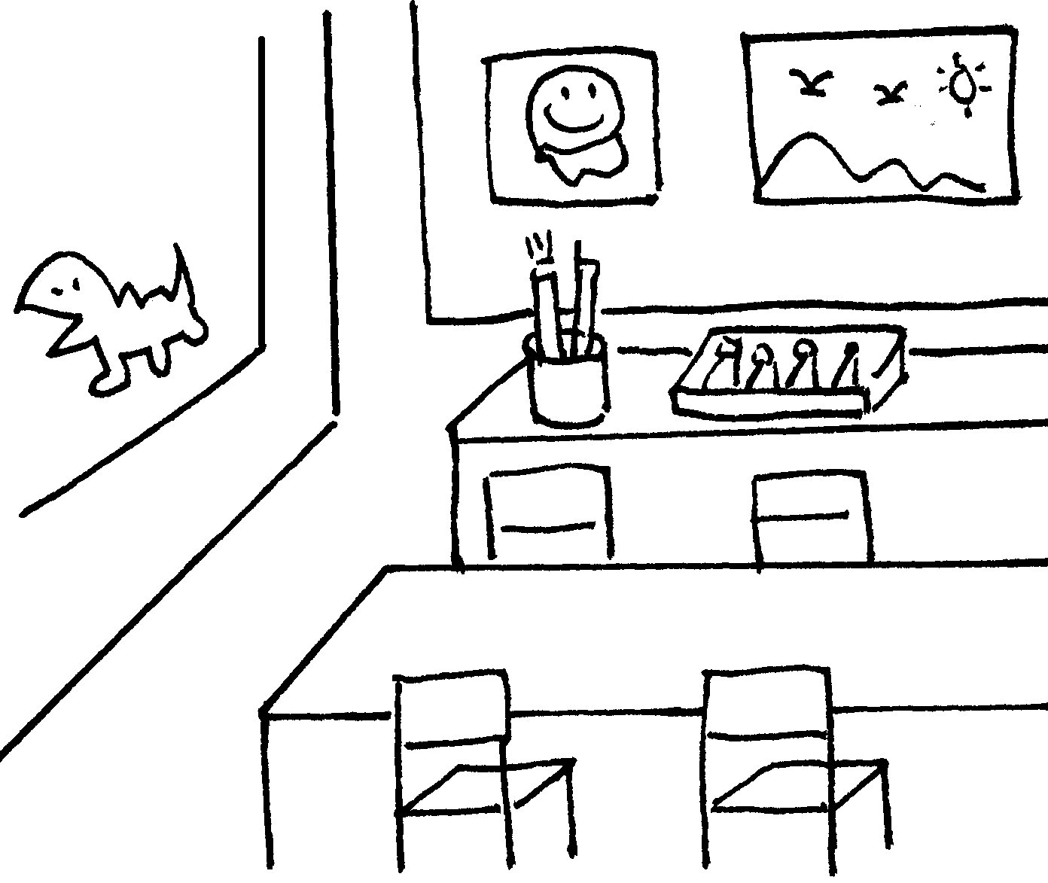 | 8 | 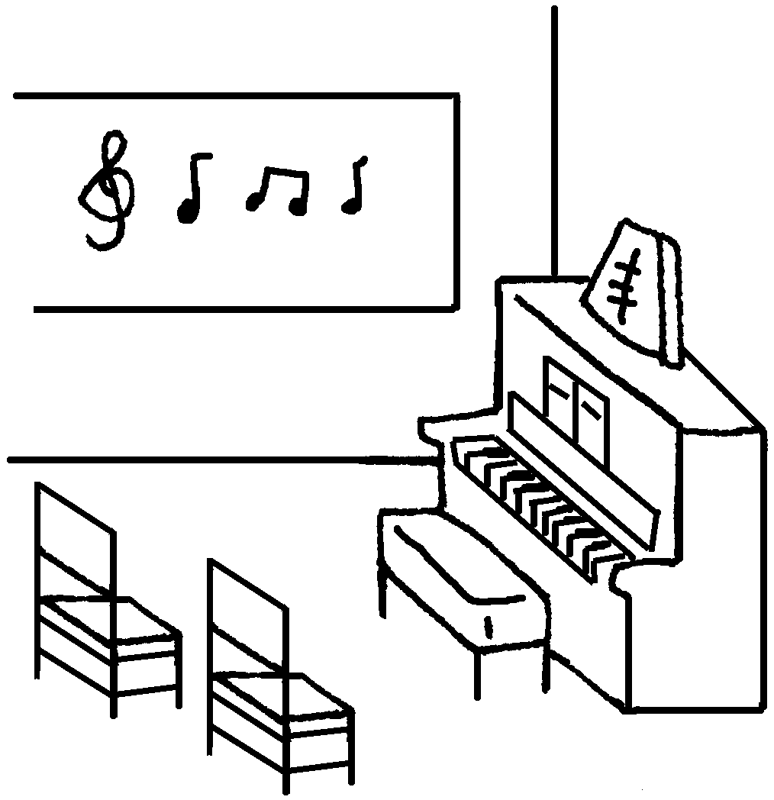 | 9 | 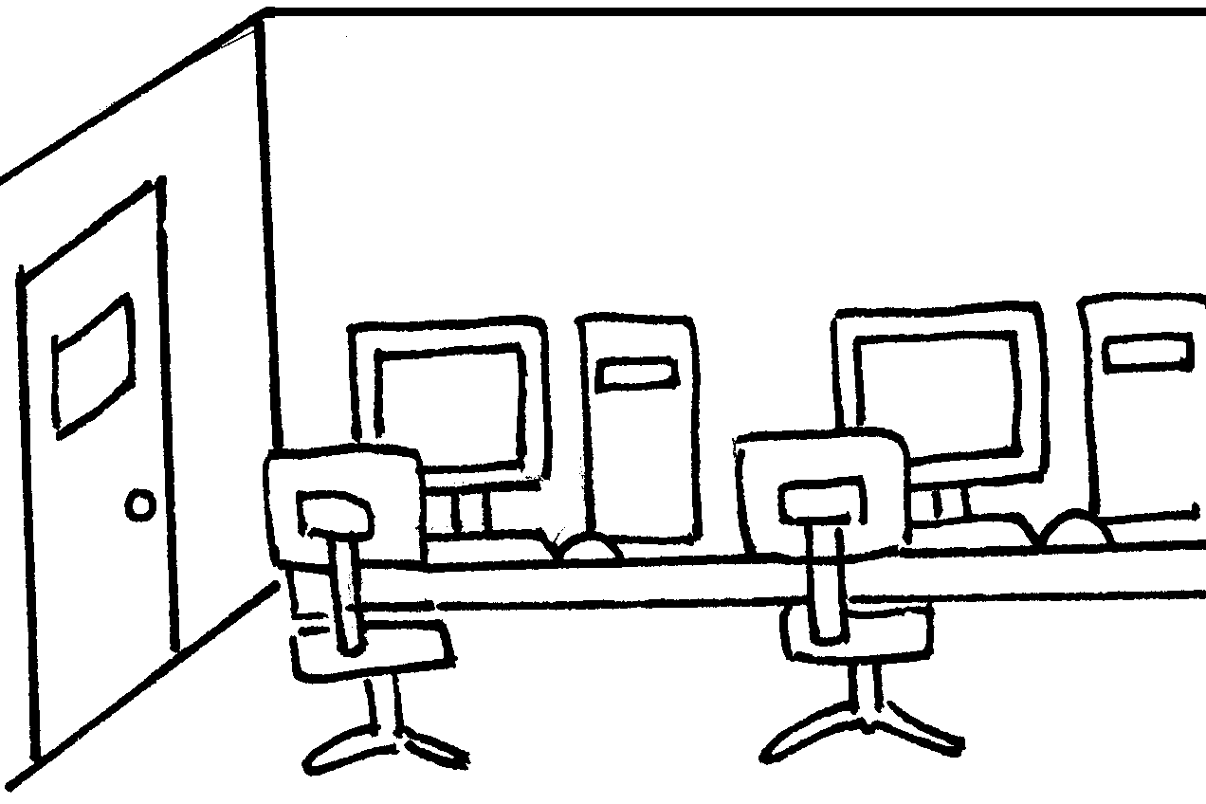
 | ___ |  | ___ |  | ___

Book 2A Chapter 1 Graded Worksheets

Worksheet 1⬇⬇⬇
- classroom 2 lift 3 playground
4 a garden 5 toilets 6 a library
7 an art room 8 a music room 9 a computer room

