Choose and write.

ground | first | second | third | fourth | fifth | sixth

1 | 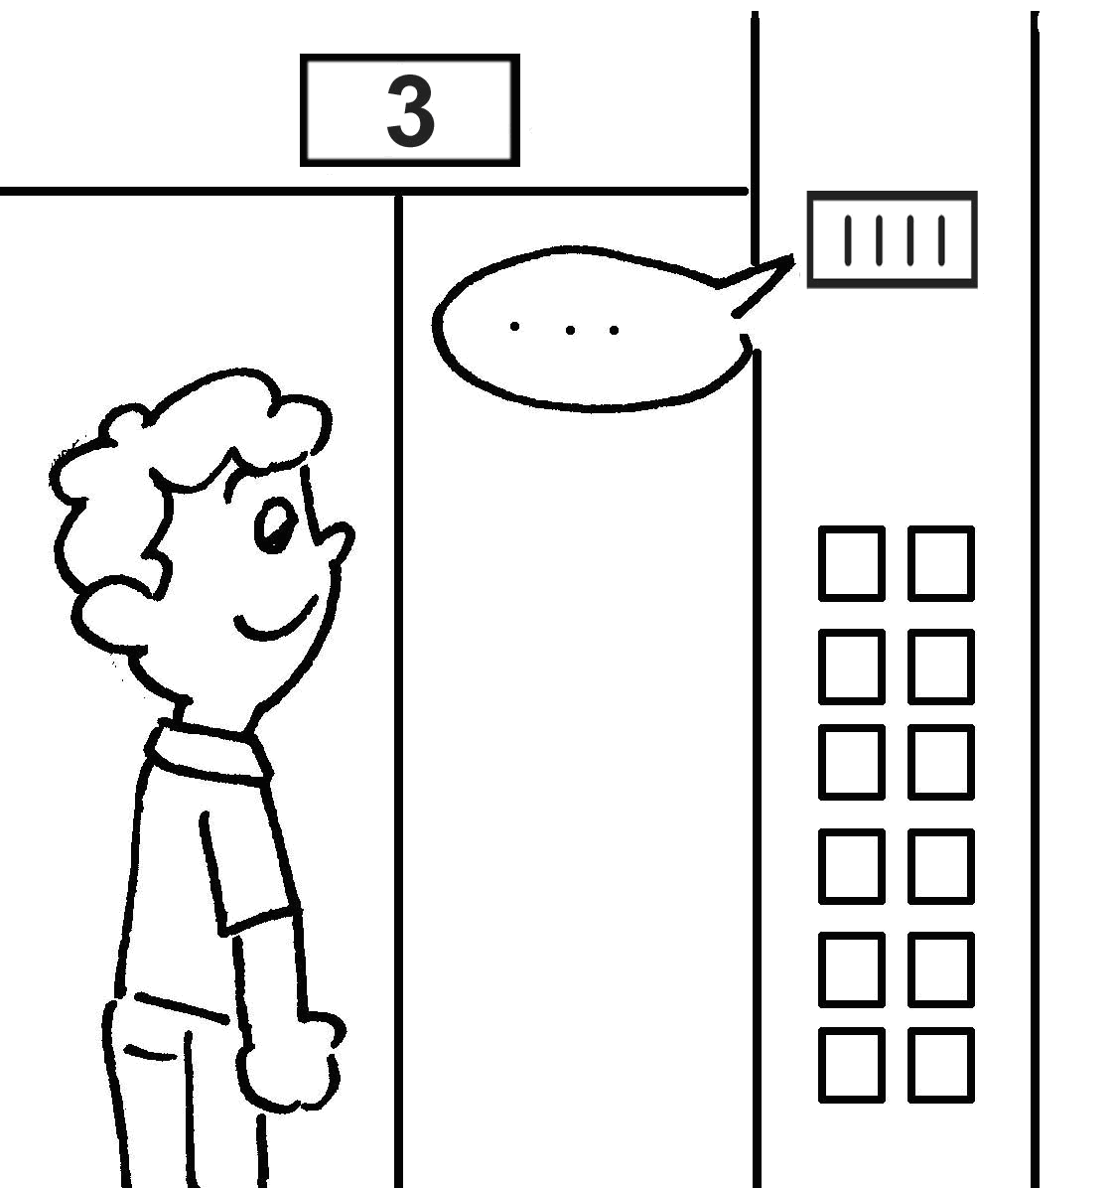 |  |  | 2 | 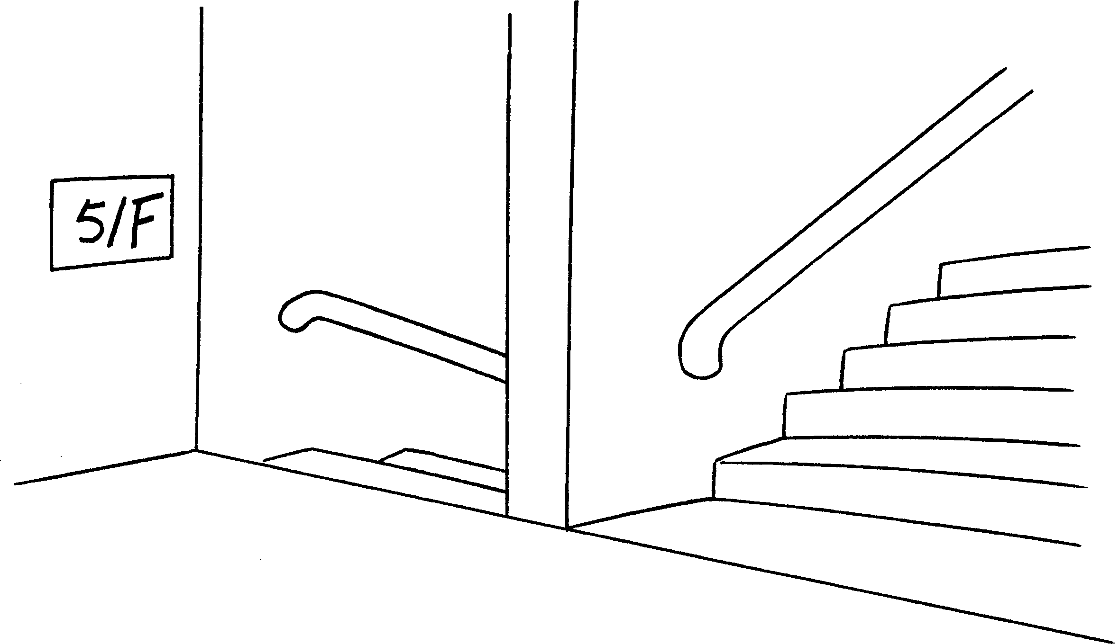
 | floor |  |  |  | floor
3 | 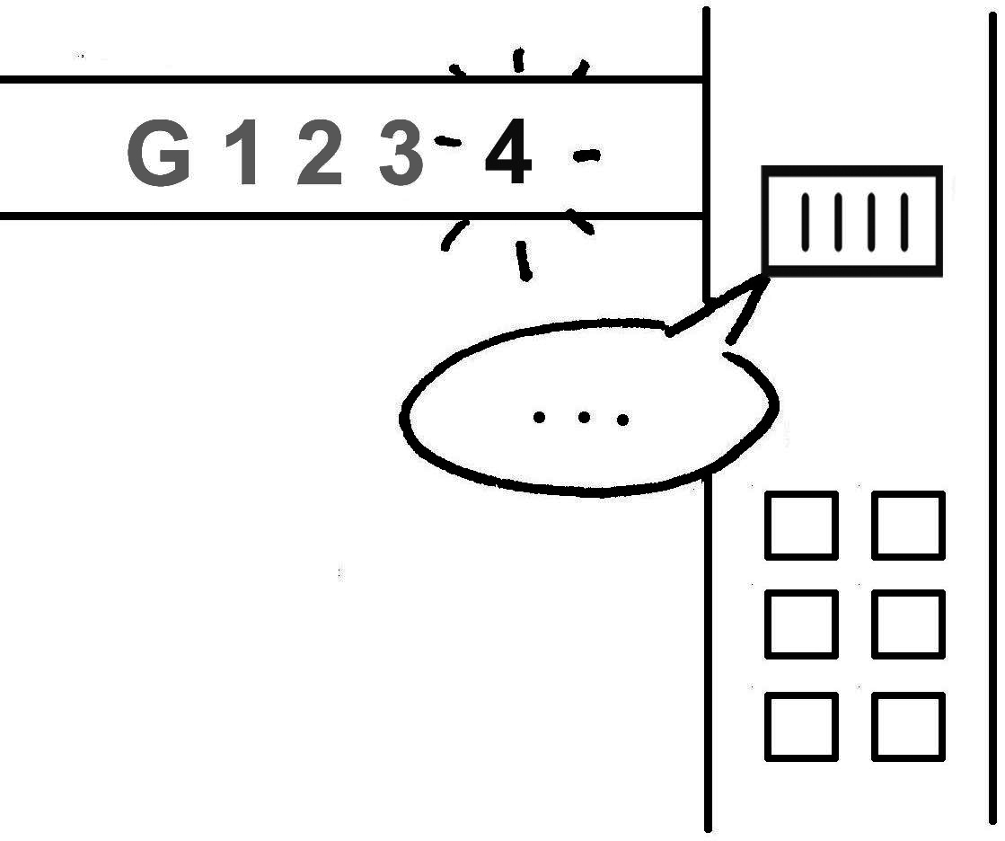 |  |  | 4 | 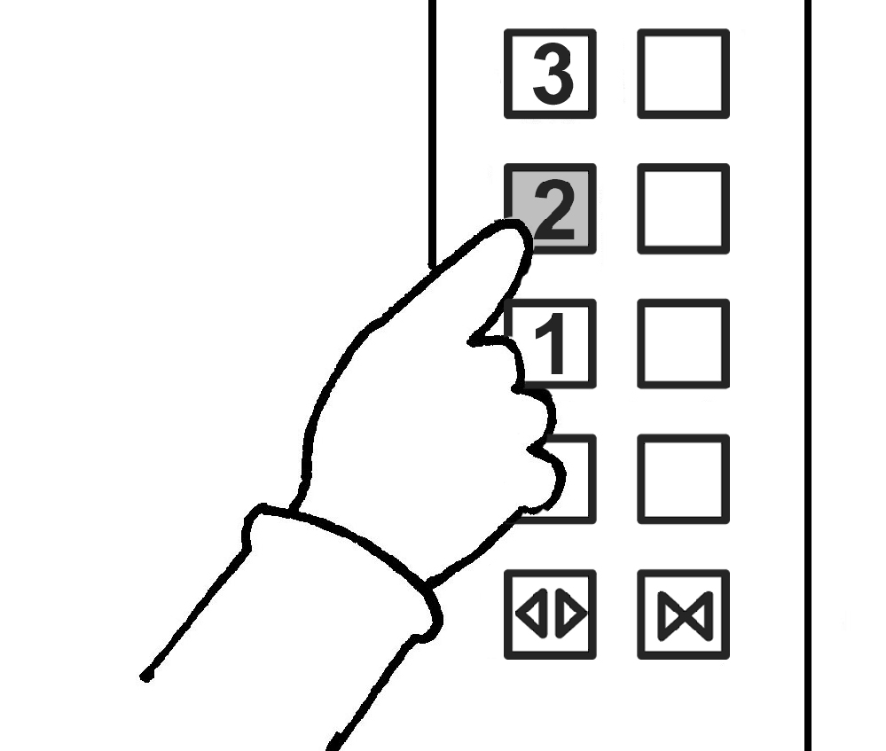
 | floor |  |  |  | floor
5 |  |  |  | 6 | 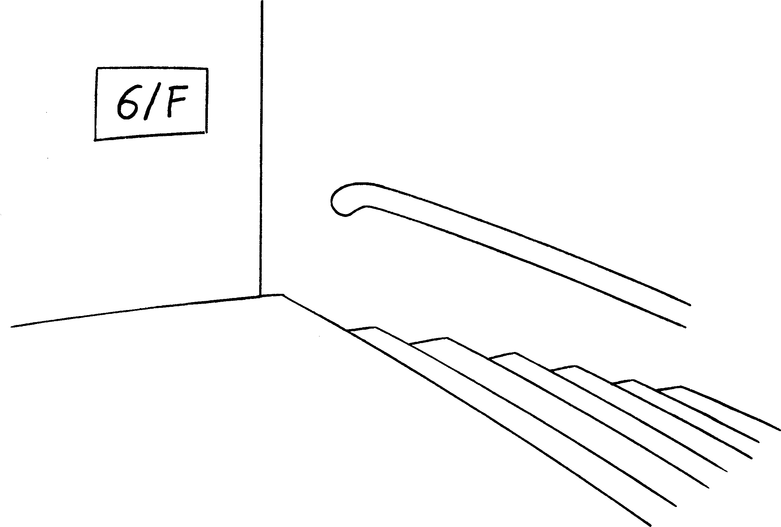
 | floor |  |  |  | floor
 |  | 7 | 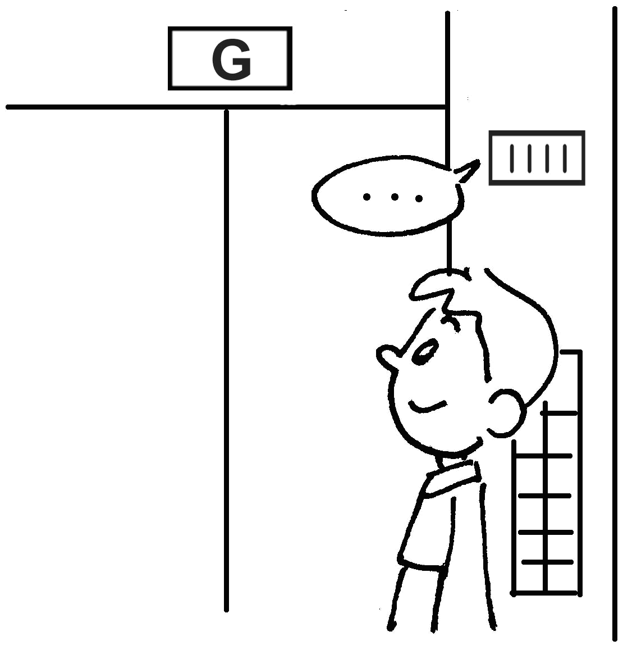
 |  |  | floor



Book 2A Chapter 1 Graded Worksheets
Worksheet 2⬇
1 third 2 fifth
3 fourth 4 second
5 first 6 sixth
7 ground

