Fill in the missing letters.

1 | 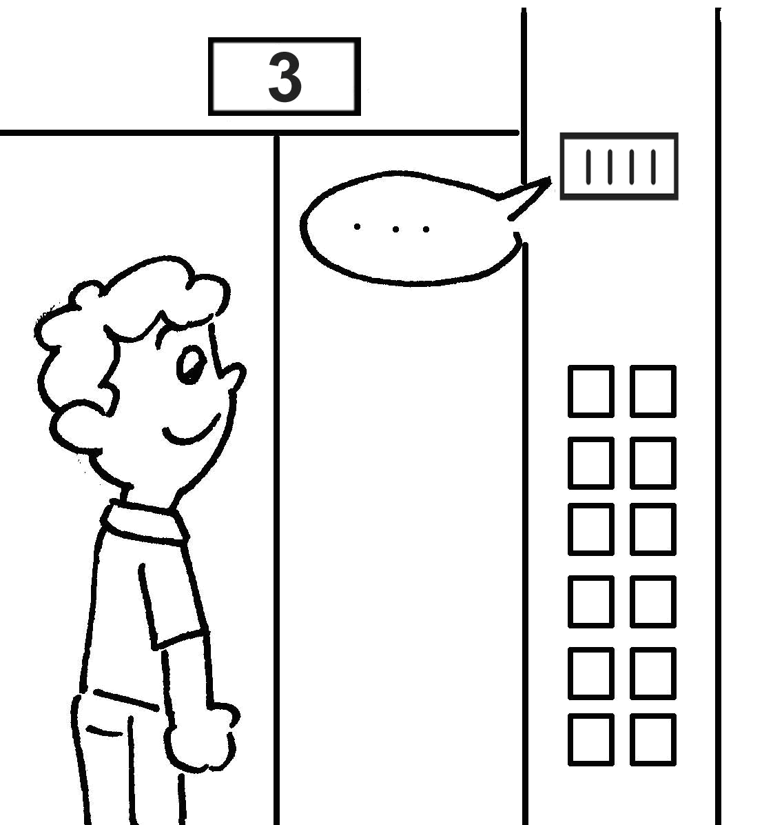 |  |  | 2 | 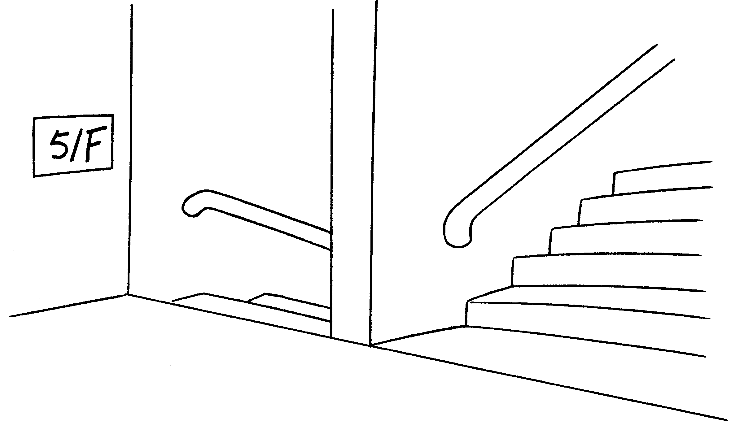
 | t __ __ __ __ floor |  |  |  | f __ __ __ __ floor
3 | 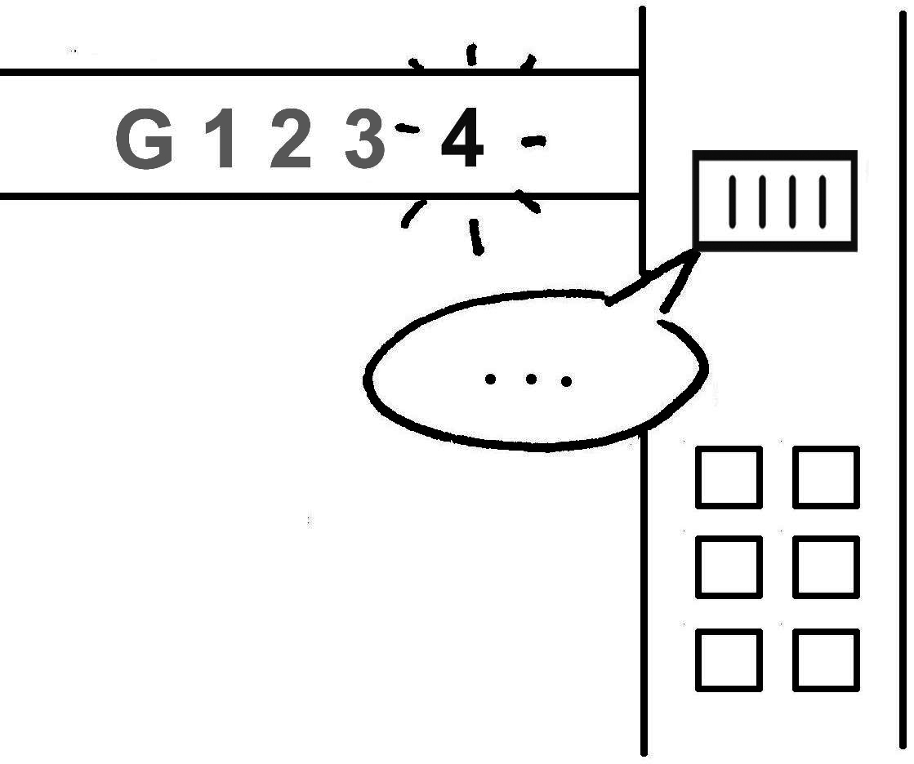 |  |  | 4 | 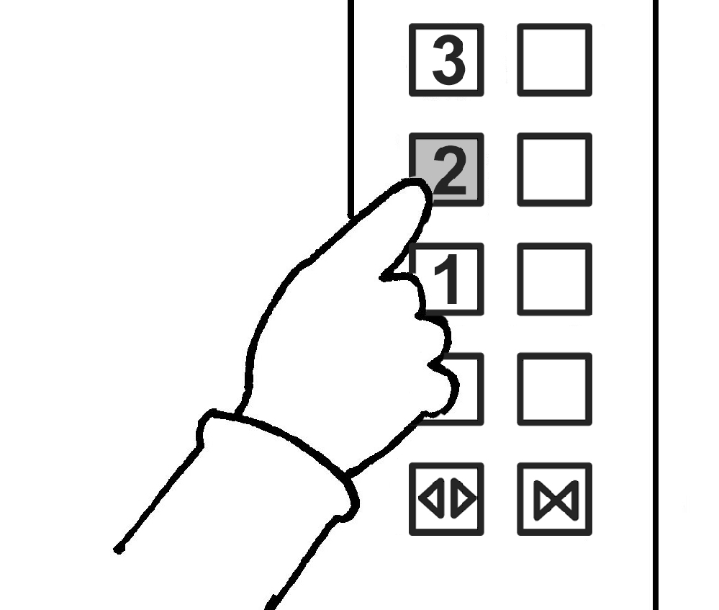
 | f __ __ __ __ __ floor |  |  |  | s __ __ __ __ __ floor
5 | 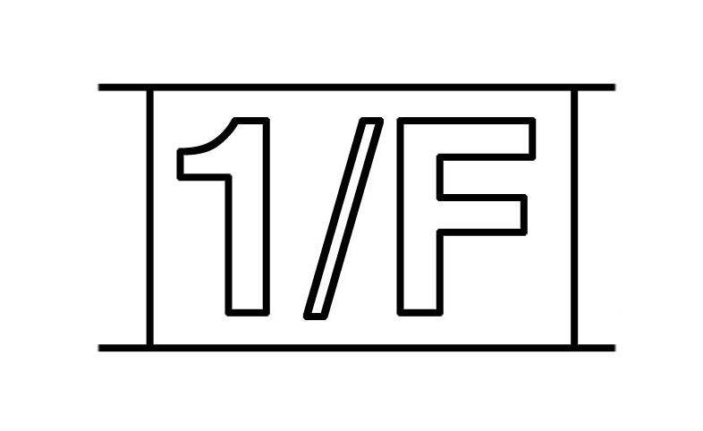 |  |  | 6 | 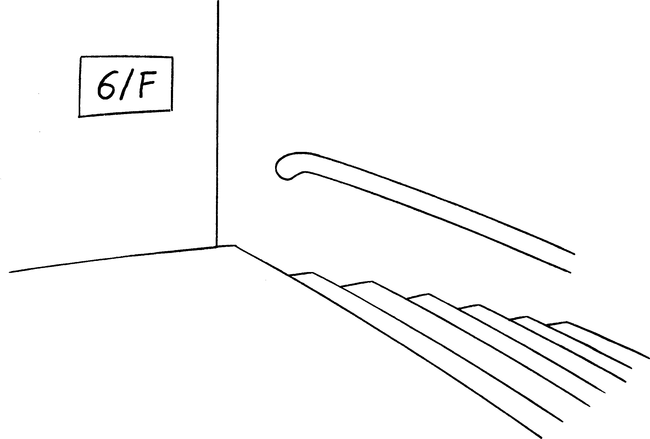
 | f __ __ __ __ floor |  |  |  | s __ __ __ __ floor
 |  | 7 | 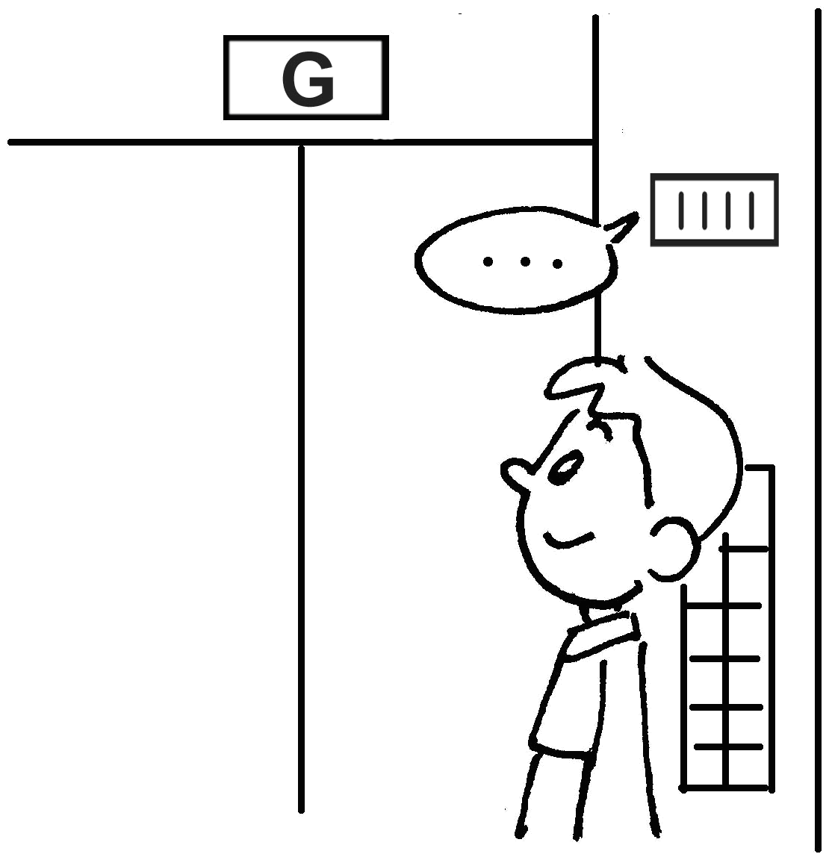
 |  |  | g __ __ __ __ __ floor



Book 2A Chapter 1 Graded Worksheets
Worksheet 2⬇⬇
1 t h i r d 2 f i f t h
3 f o u r t h 4 s e c o n d
5 f i r s t 6 s i x t h
7 g r o u n d

