Choose and write.

is
isn’t
A
B
1 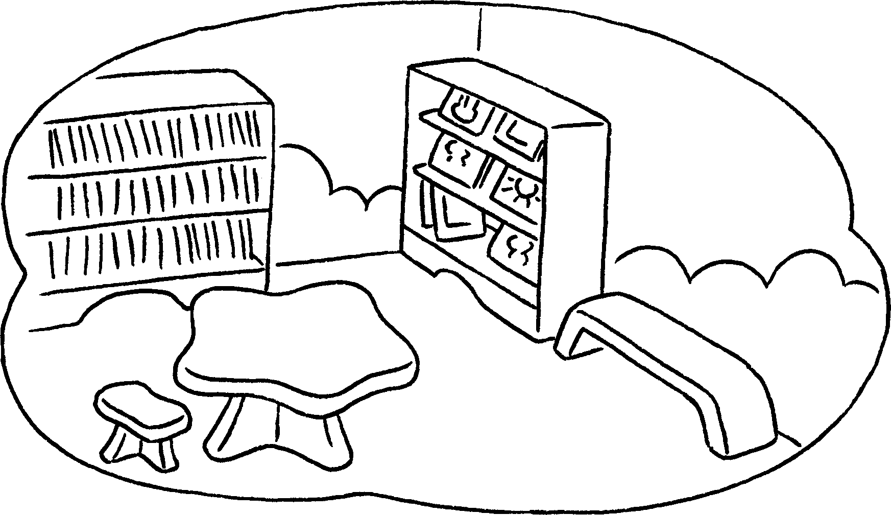 | ✓ | A : Is there a library?  B : Yes, there ________ .
2  | ✓ | A : Is there an art room?  B : ________ , there ________ .
3 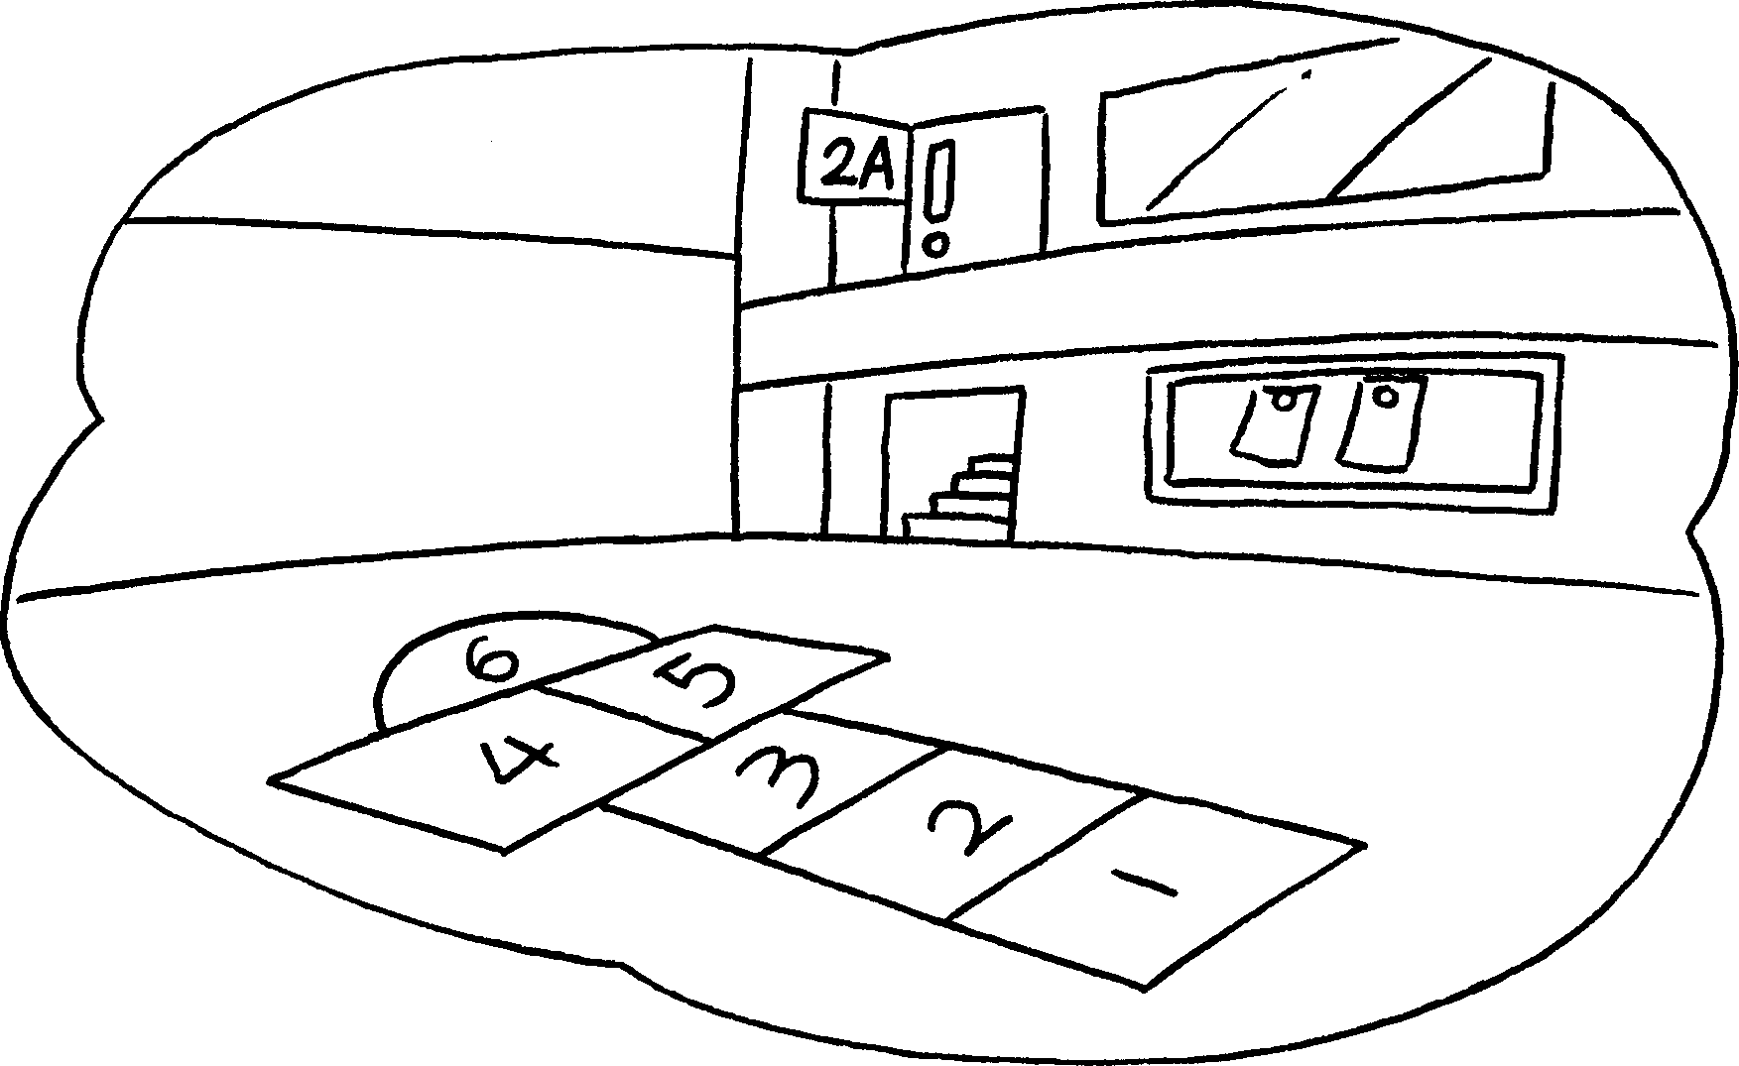 | ✗ | A : Is there a playground?  B : ________ , there ________ .
4 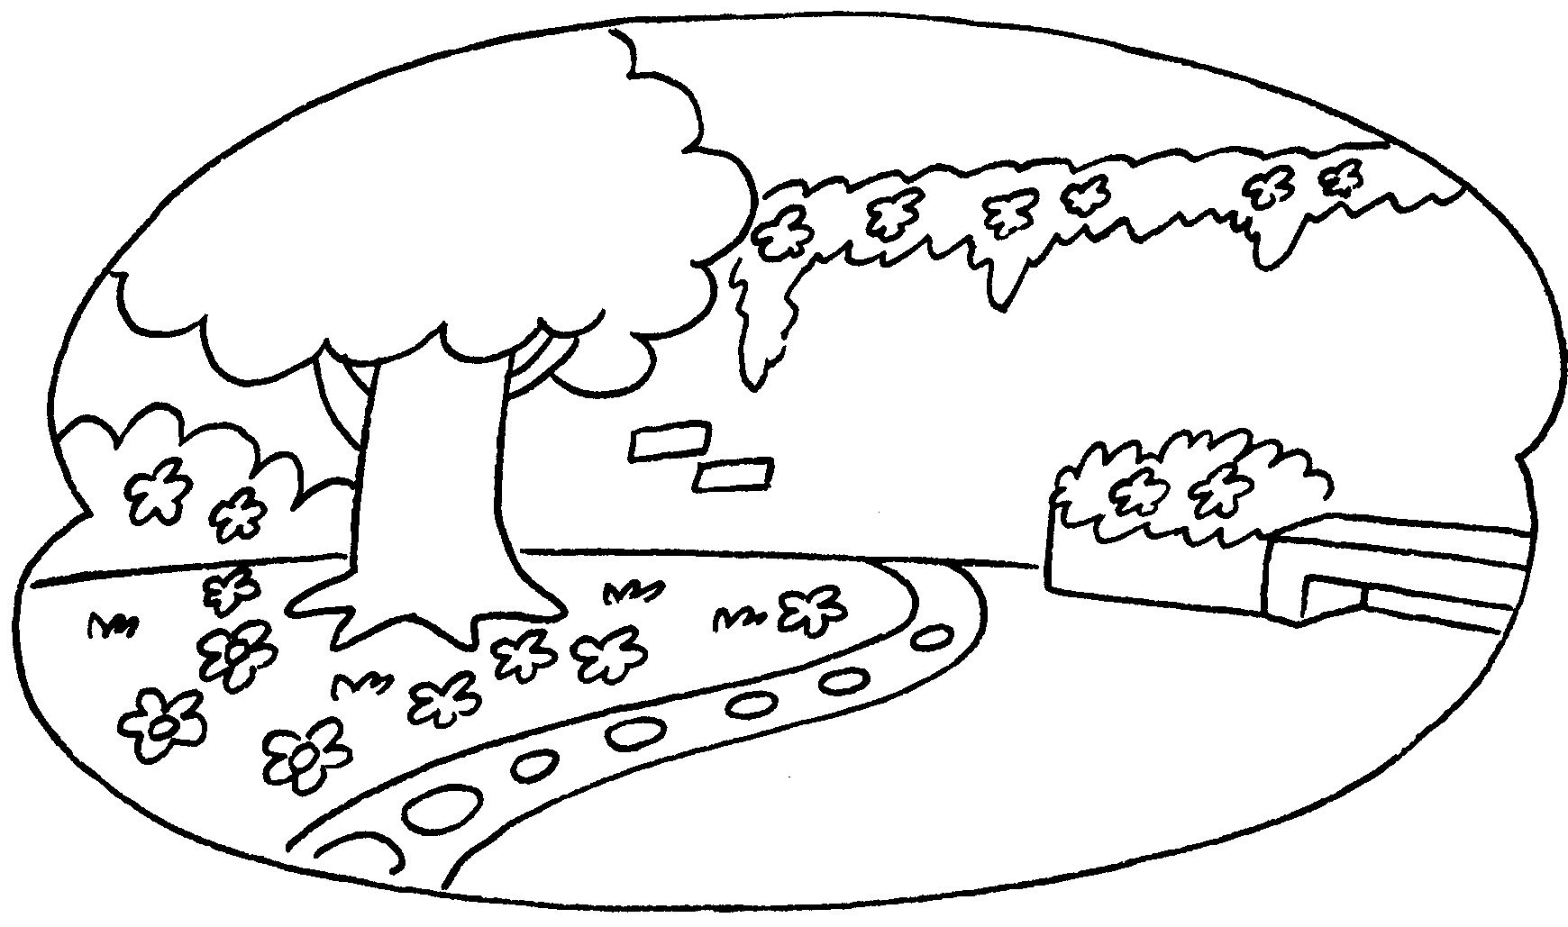 | ✓ | A : Is there a garden?  B : _____________________________
5 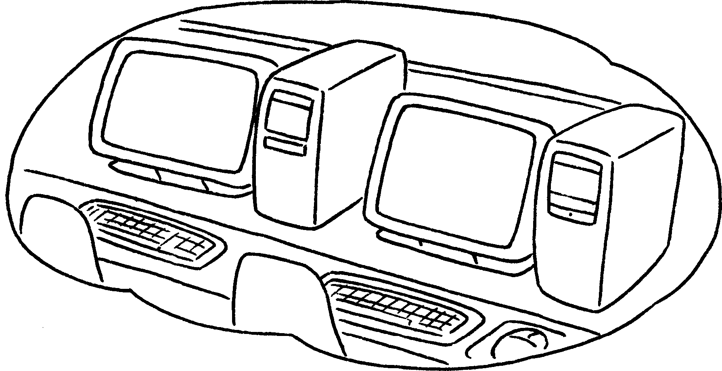 | ✗ | A : Is there a computer room?  B : _____________________________



Book 2A Chapter 1 Graded Worksheets
Worksheet 3⬇⬇
- is
- Yes is
- No isn’t
- Yes, there is.
- No, there isn’t.

