Finish the questions and answers.
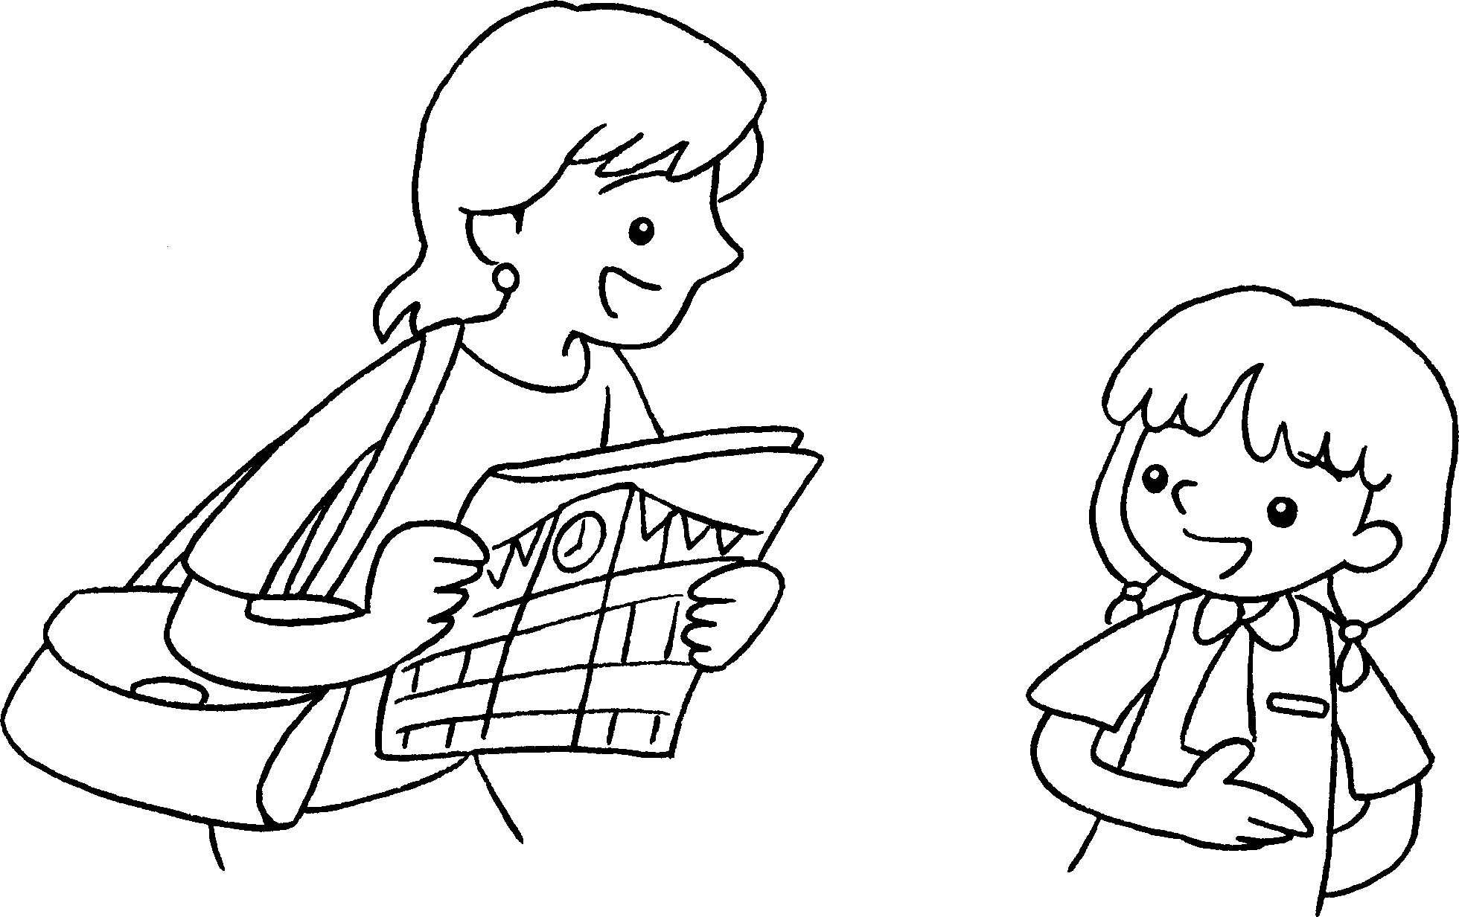
A
B
1 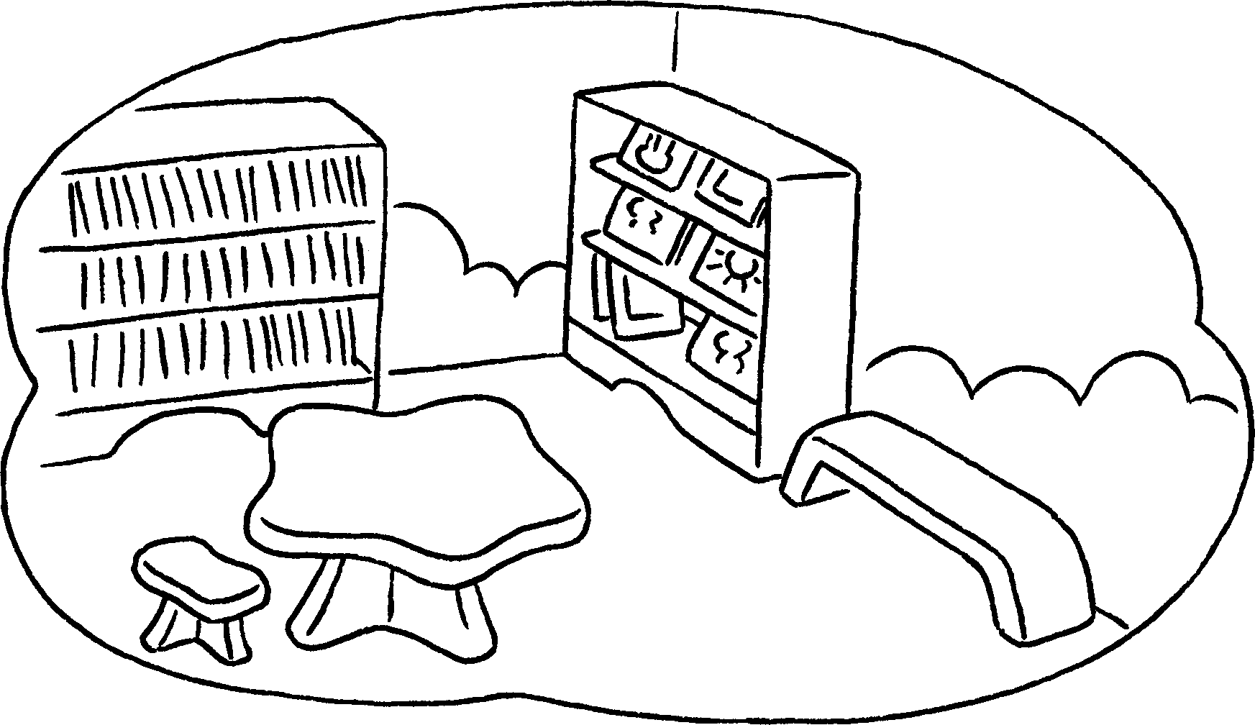 | ✓ | A : Is there a library?  B : Yes, there __________ .
2 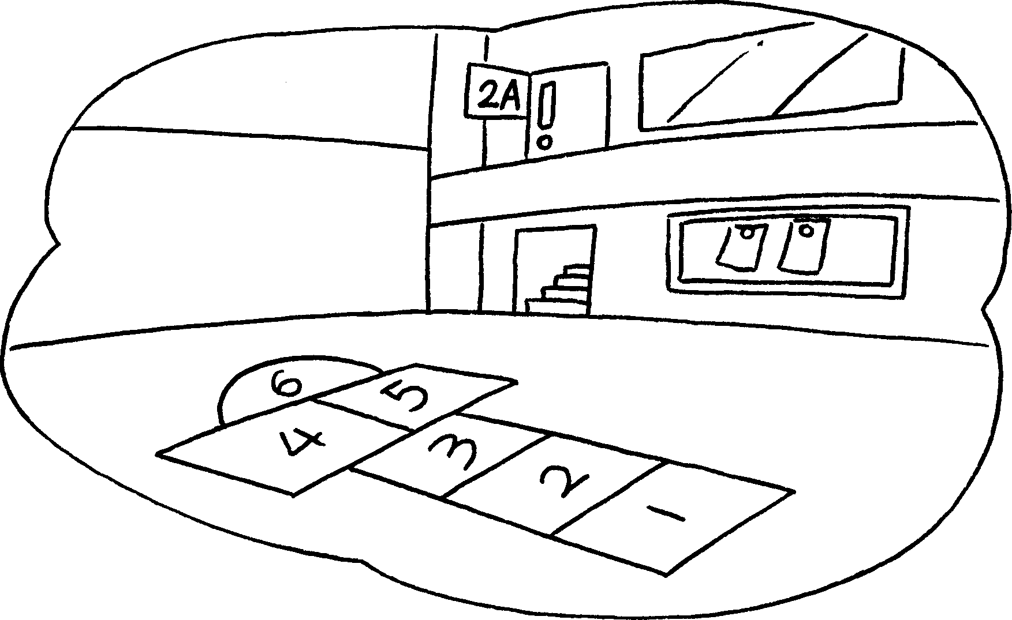 | ✗ | A : Is there a playground?  B : No, __________ isn’t.
3 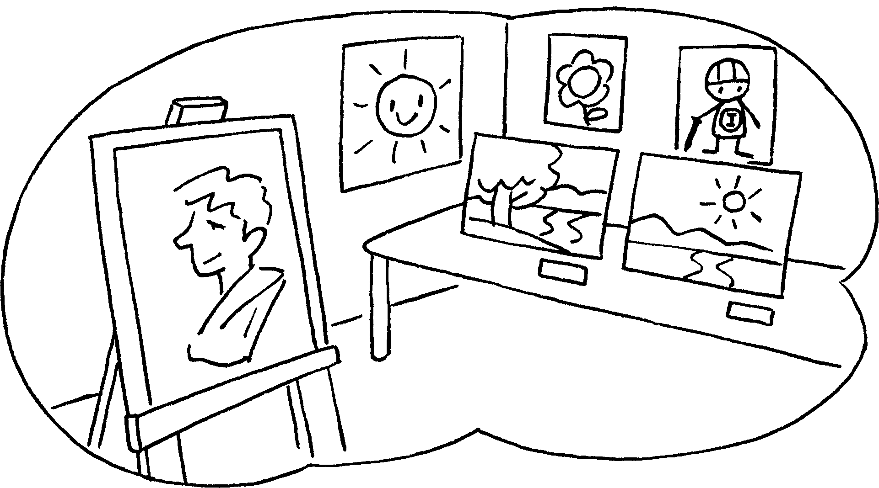 | ✓ | A : Is there an _________________ ?  B : _____________________________
4 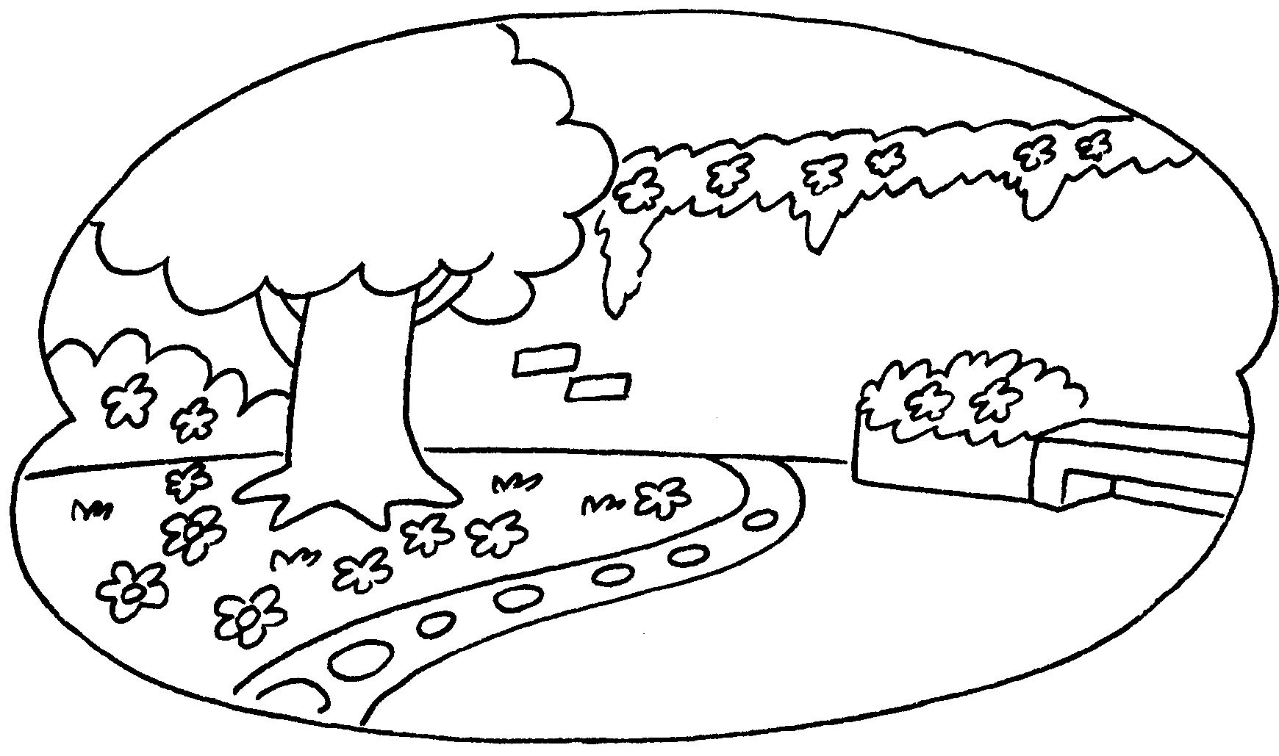 | ✓ | A : Is there ____________________ ?  B : _____________________________
5 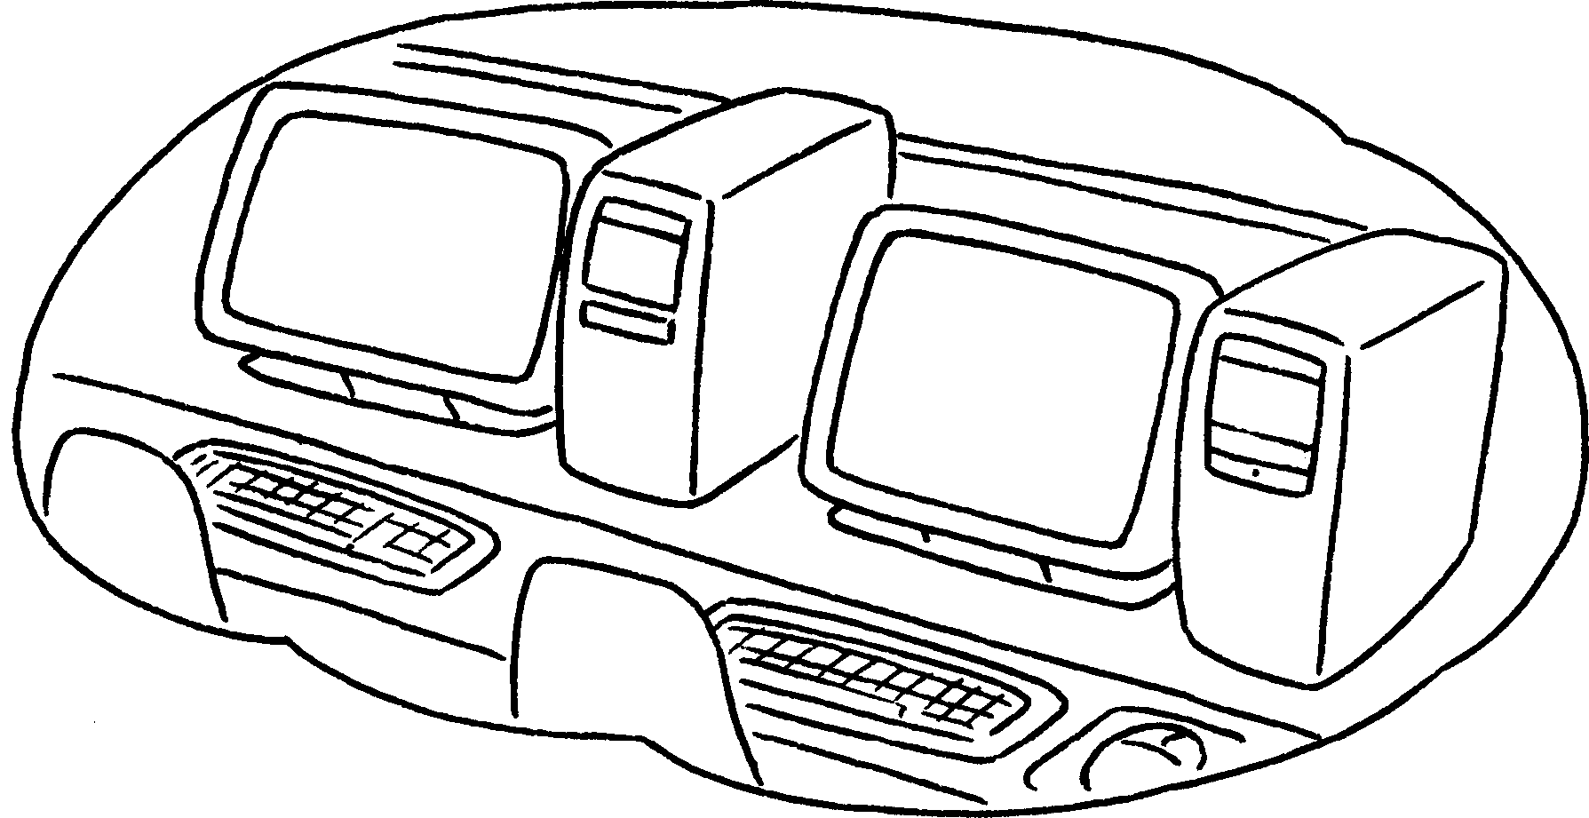 | ✗ | A : _____________________________  B : _____________________________



Book 2A Chapter 1 Graded Worksheets
Worksheet 3⬇⬇⬇
- is
- there
- art room
Yes, there is.
- a garden
Yes, there is.
- Is there a computer room?
No, there isn’t.

