Choose and write.
climbkeepkeeplinelitterpicksitspitwait

1 | 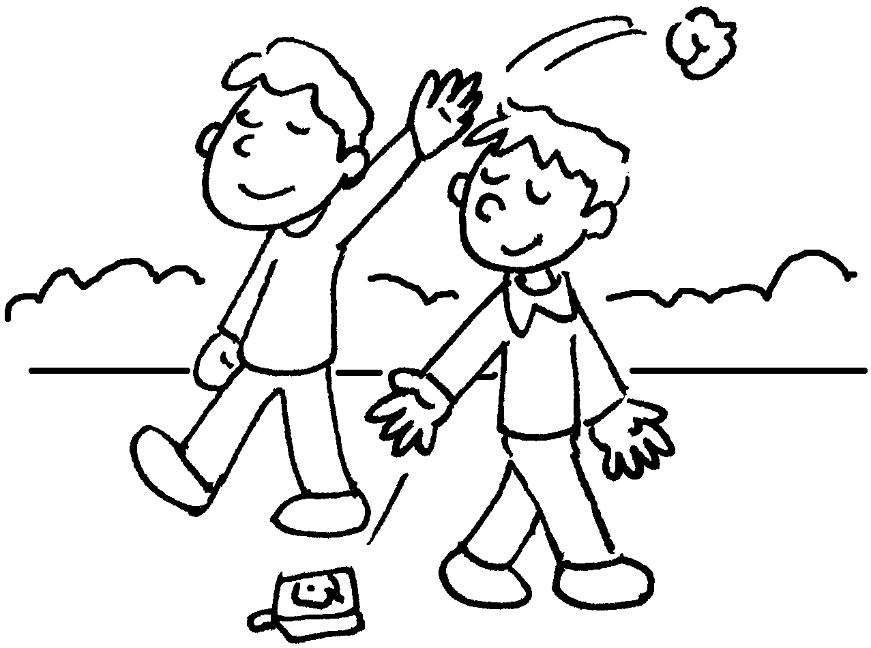 | 2 | 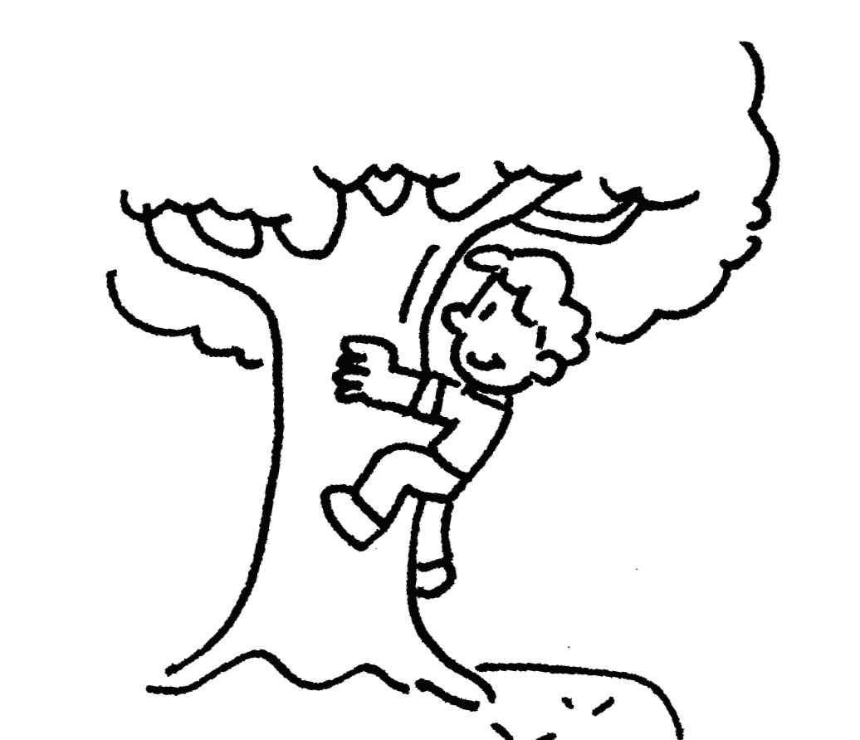 | 3 | 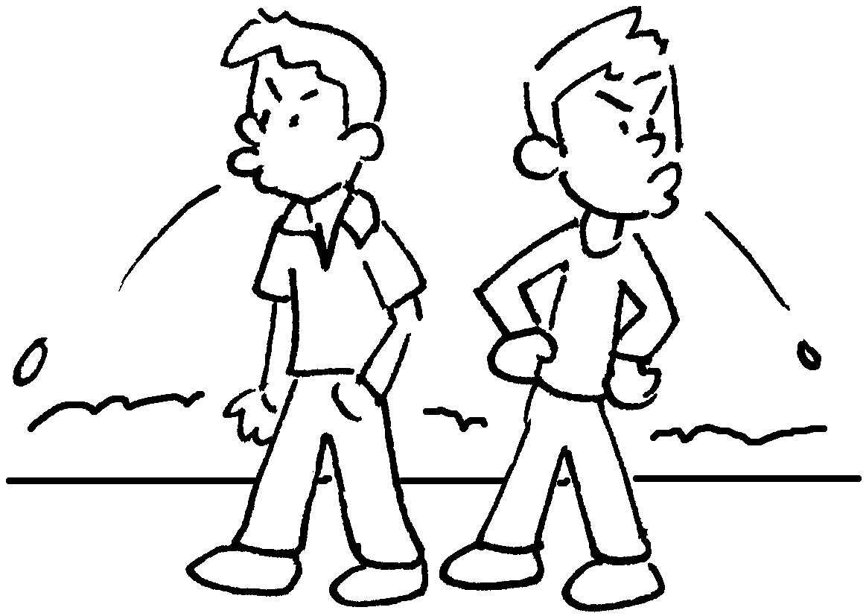
4 | 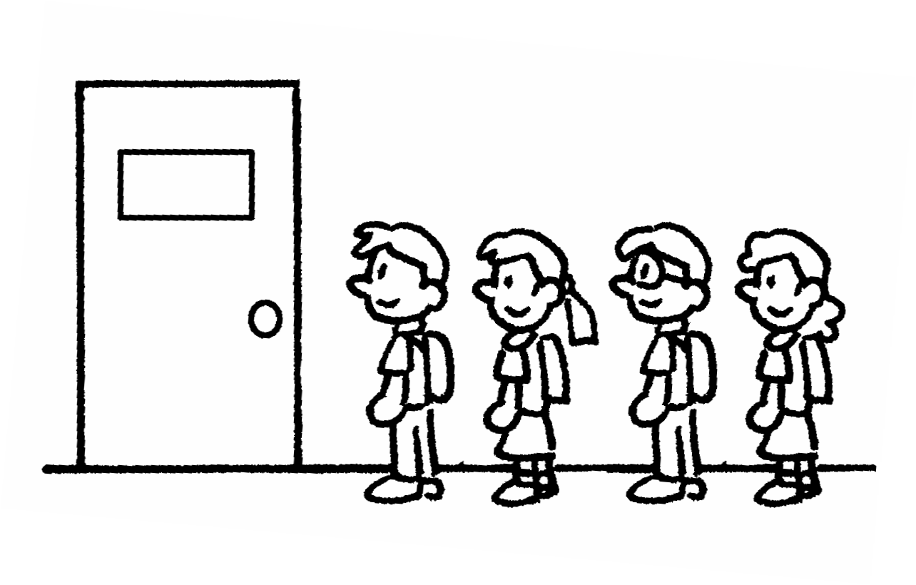 | 5 | 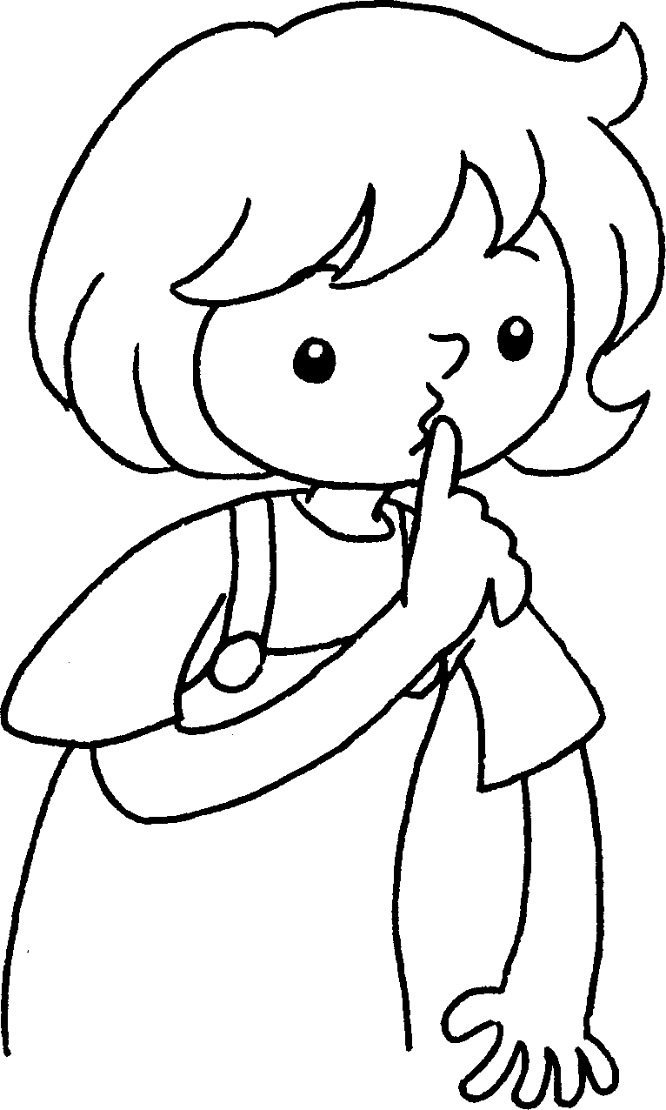 | 6 | 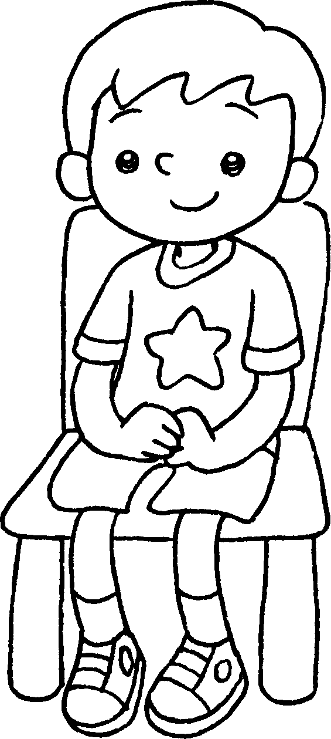
 | up |  | quiet |  | still
7 | 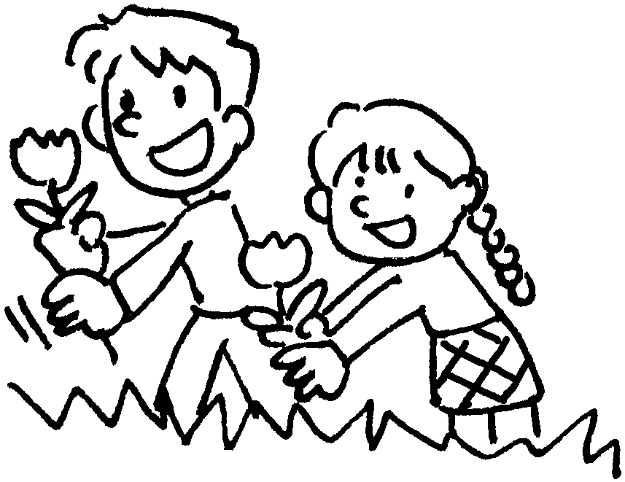 | 8 | 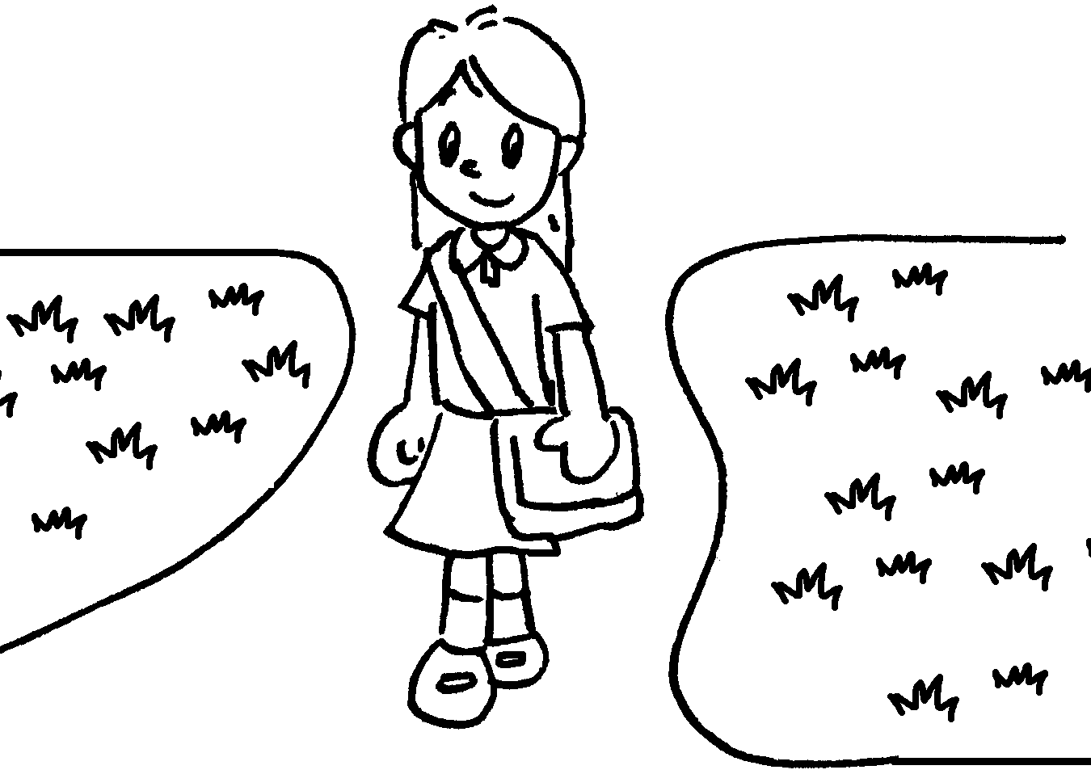 | 9 | 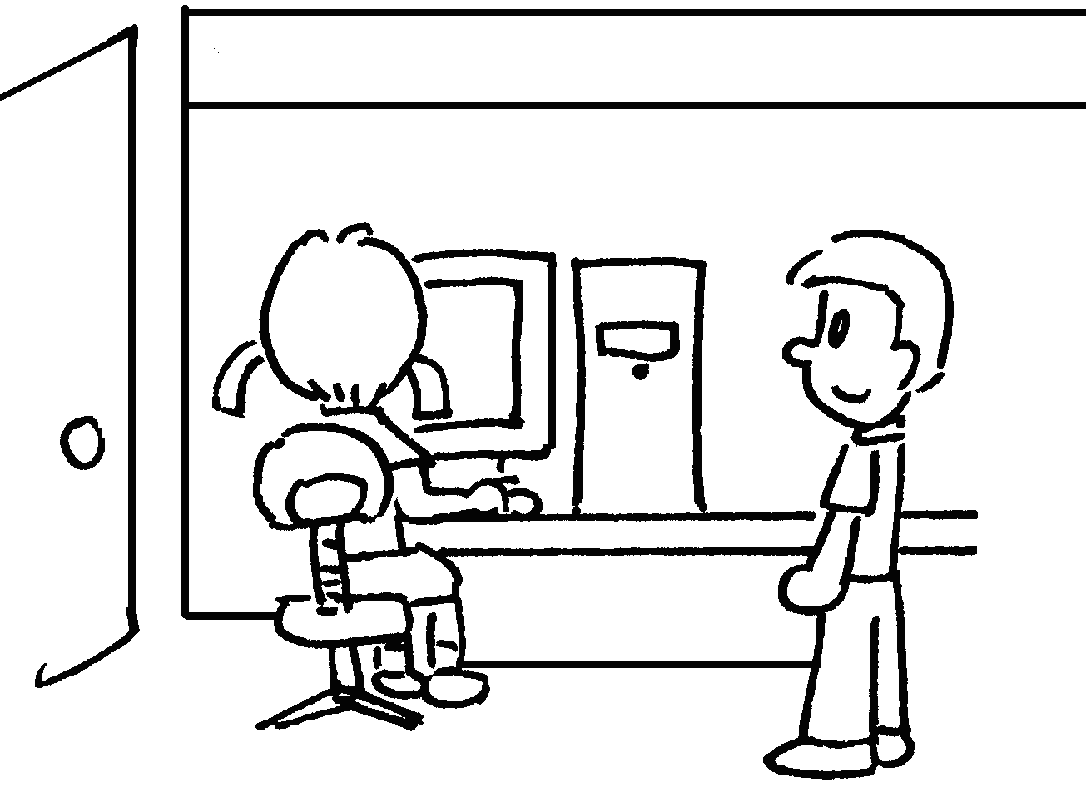
 | the flowers |  | off the grass |  | for your turn


Book 2A Chapter 2 Graded Worksheets
Worksheet 1⬇
- litter 2 climb 3 spit
4 line 5 keep 6 sit
7 pick 8 keep 9 wait

