Look at the pictures and fill in the missing letters.

1 | 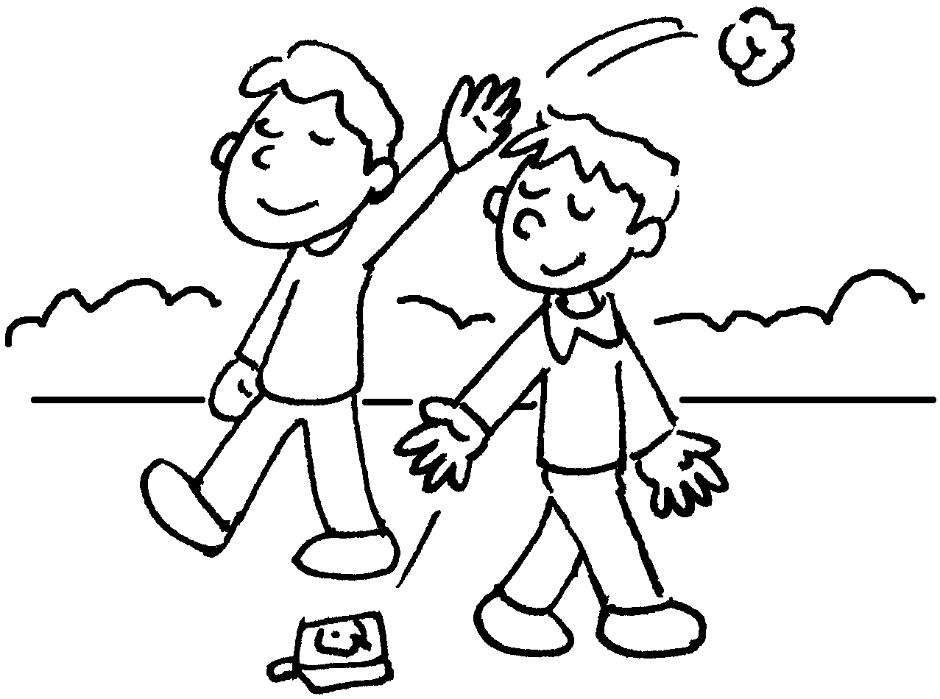 | 2 | 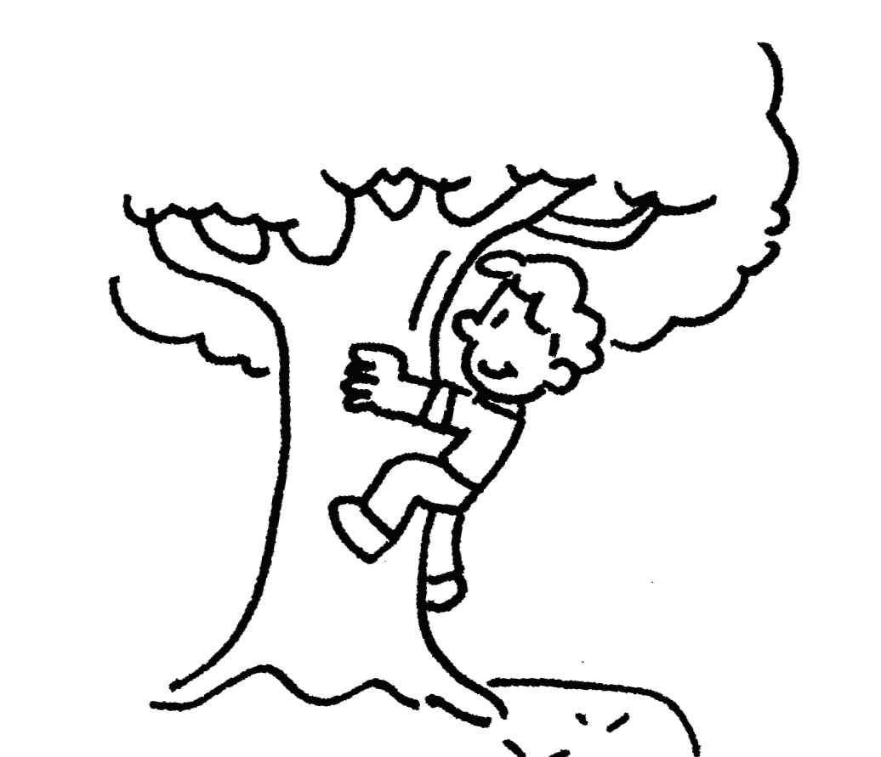 | 3 | 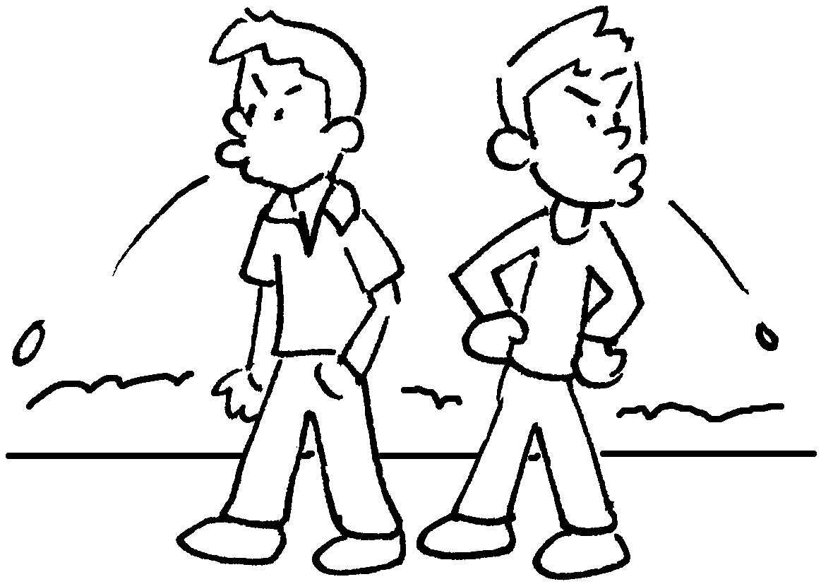
 | l __ __ __ __ __ |  | c __ __ __ __ |  | s __ __ __

4 | 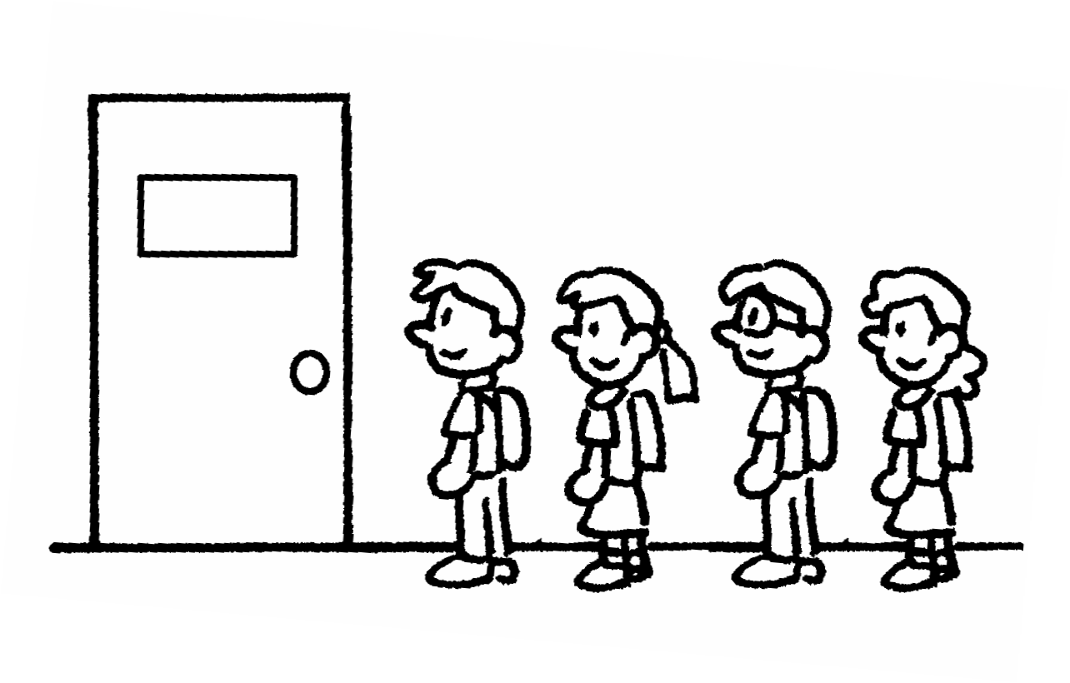 | 5 | 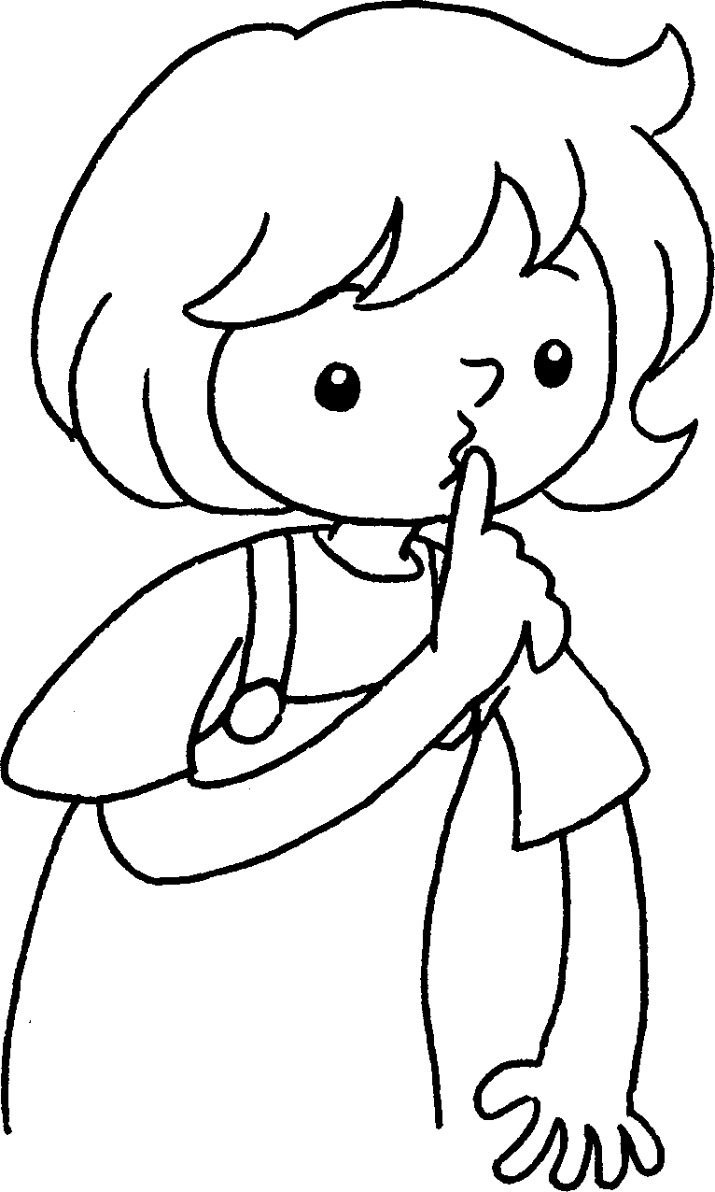 | 6 | 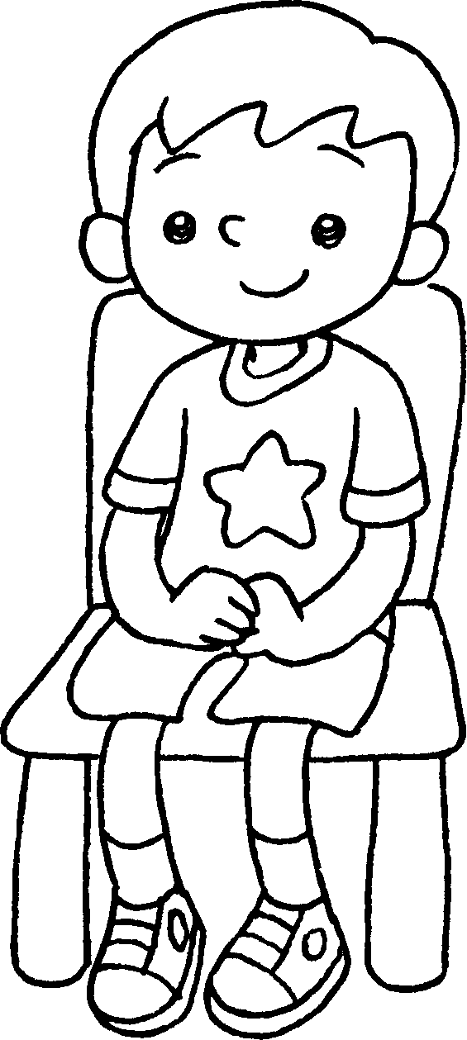
 | l __ __ __ up |  | k __ __ __ quiet |  | s __ __ still

7 | 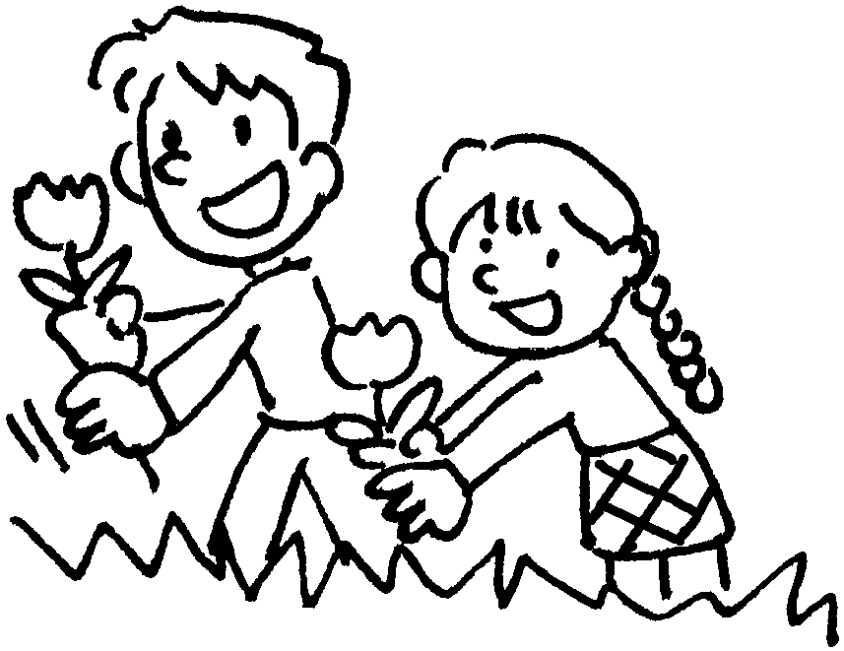 | 8 | 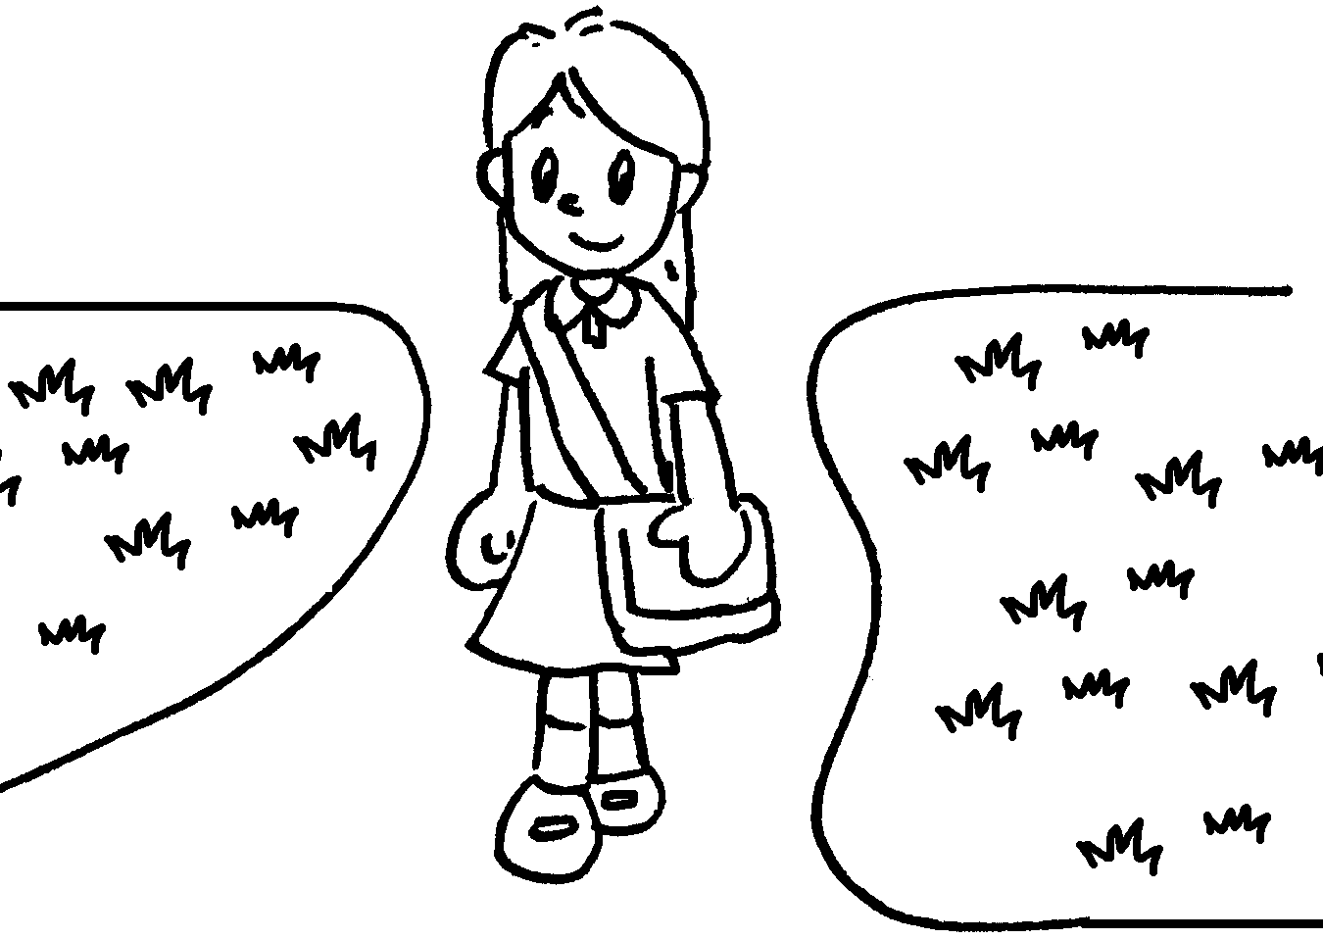 | 9 | 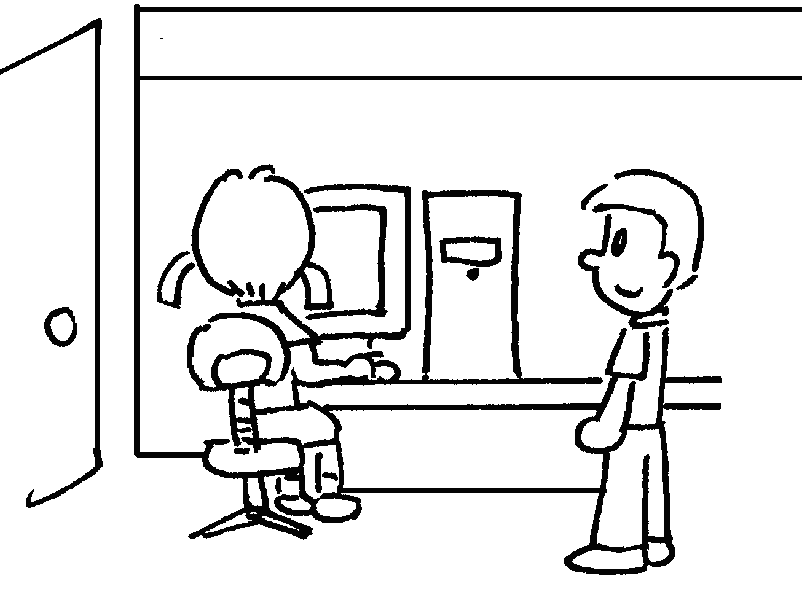
 | p __ __ __  the flowers |  | k __ __ __  off the grass |  | w __ __ __  for your turn


Book 2A Chapter 2 Graded Worksheets
Worksheet 1⬇⬇
1 I i t t e r 2 c l i m b 3 s p i t
4 l i n e 5 k e e p 6 s i t
7 p i c k 8 k e e p 9 w a i t

