Look at the pictures and write.

1 | 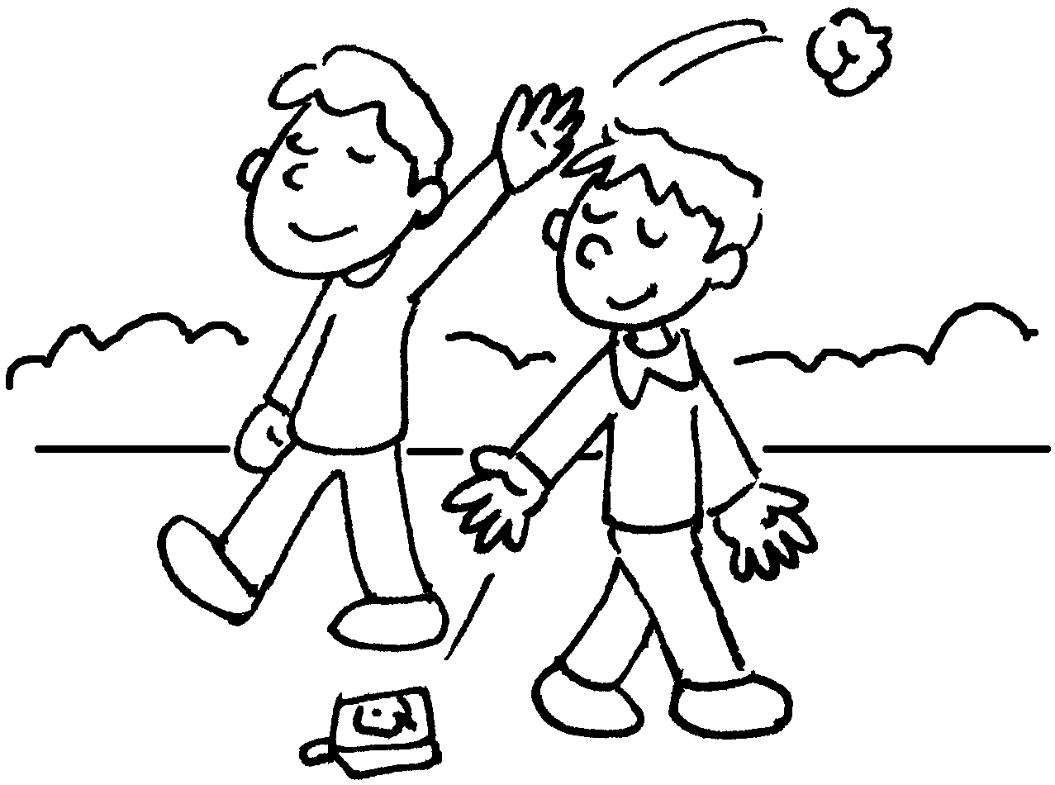 | 2 | 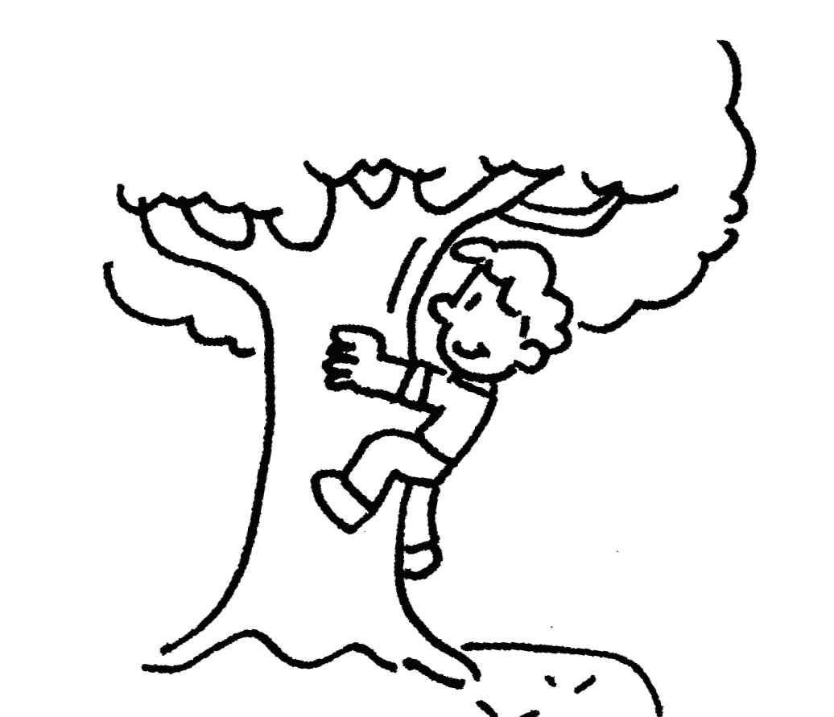 | 3 | 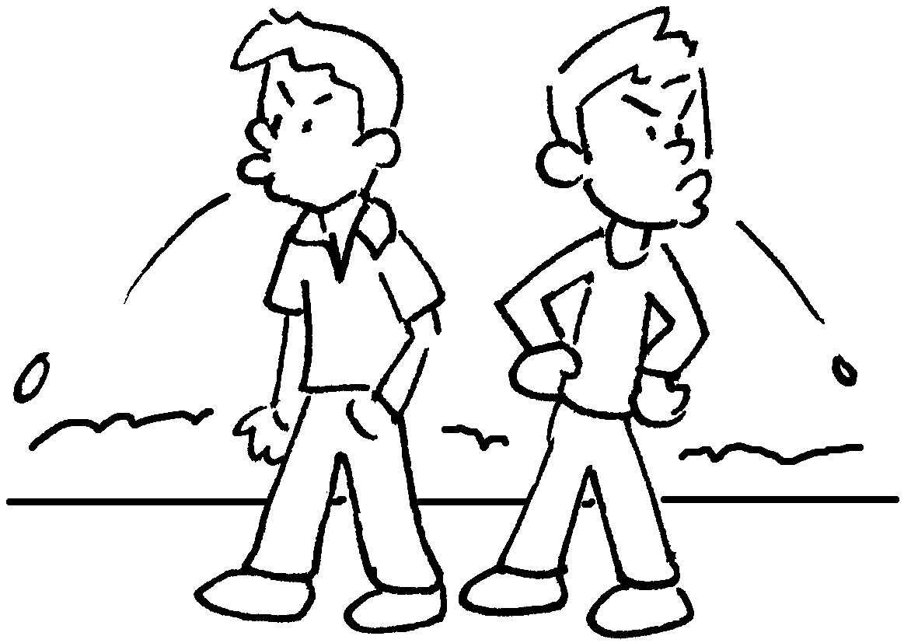
 | litter |  | c |  | s
4 | 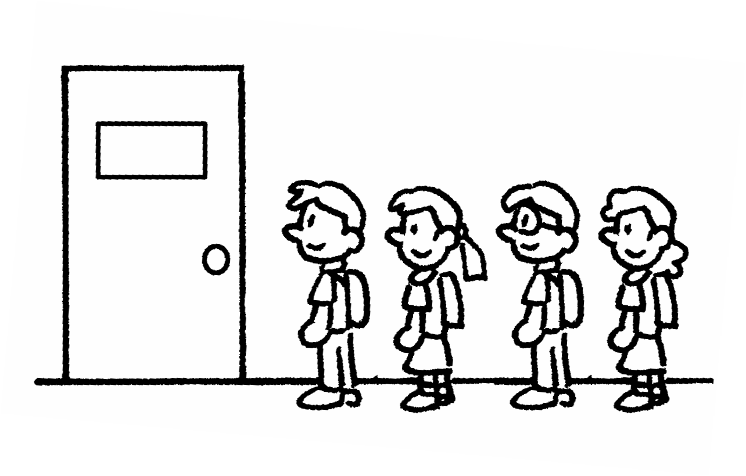 | 5 | 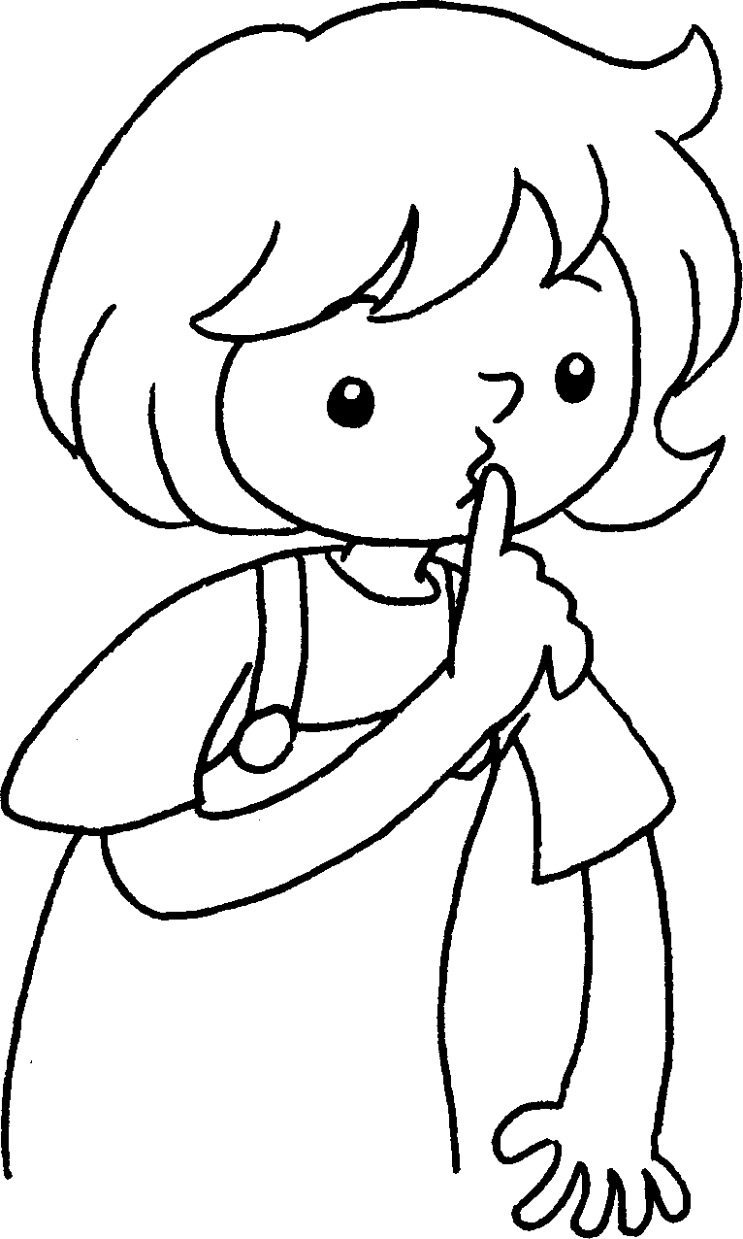 | 6 | 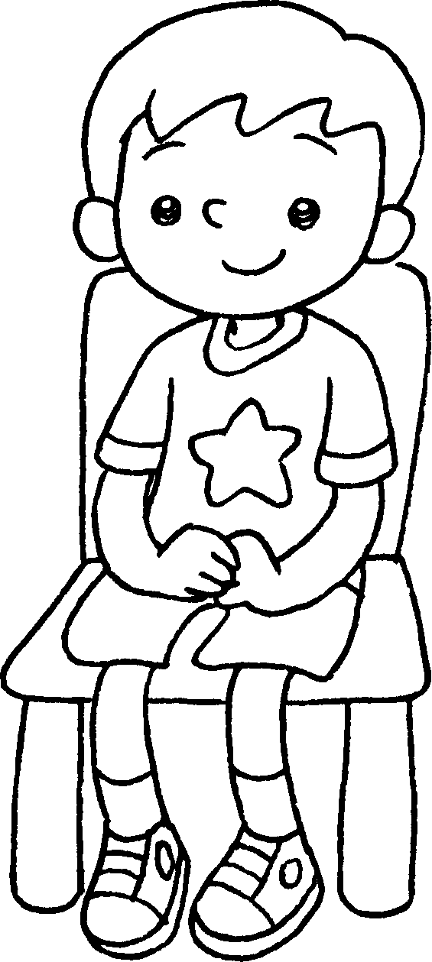
 | l u |  | k  q |  | s s
7 | 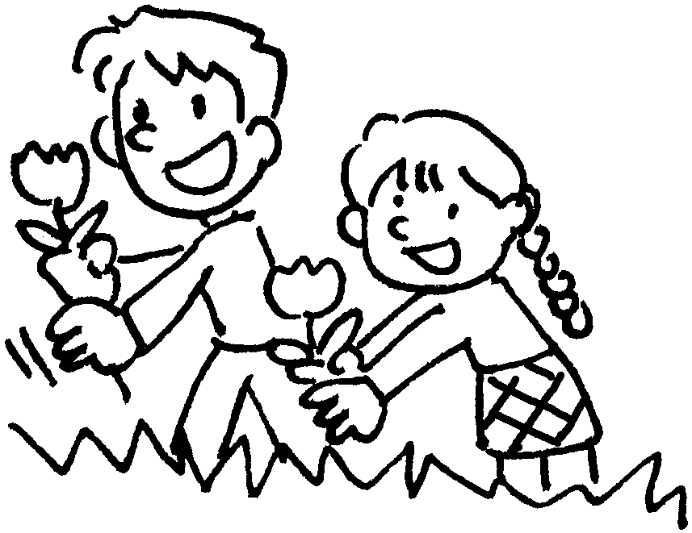 | 8 | 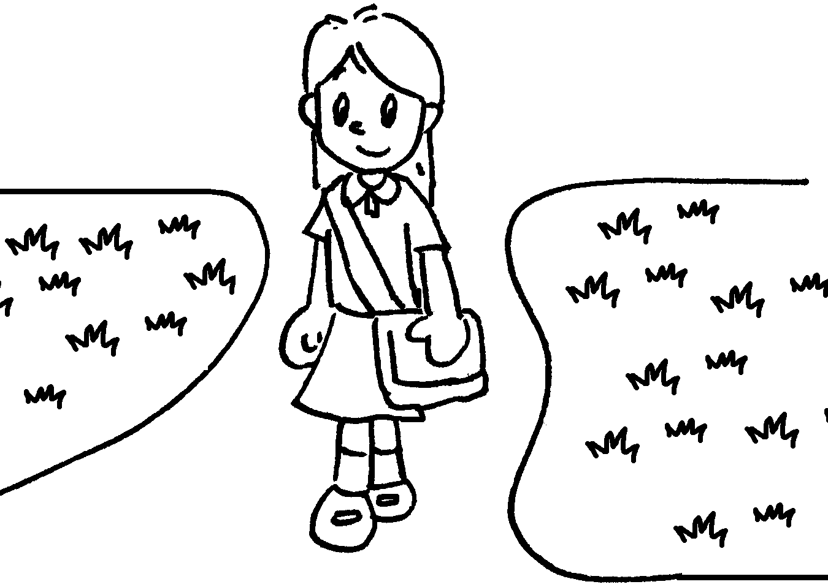 | 9 | 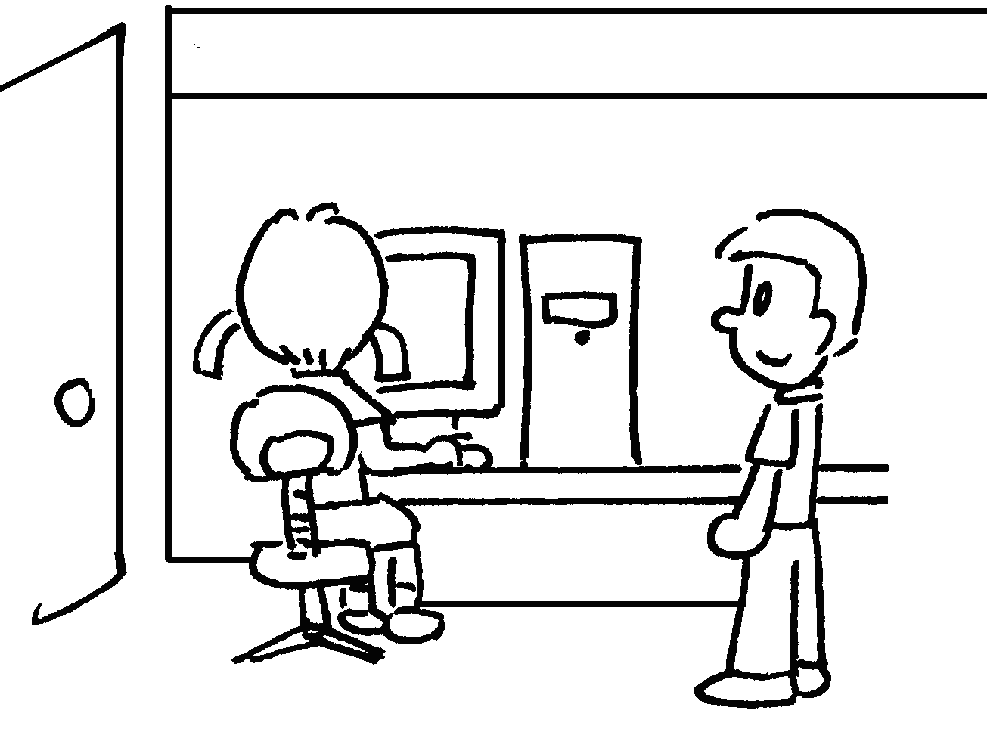
 | p the  f |  | k o  the g |  | w for  your t


Book 2A Chapter 2 Graded Worksheets
Worksheet 1⬇⬇⬇
2 climb 3 spit
4 line up 5 keep quiet 6 sit still
7 pick the flowers 8 keep off the grass 9 wait for your turn

