Choose and write.
Sit still.Line up.Keep quiet.Wait for your turn.Keep off the grass.

Rules
1 | 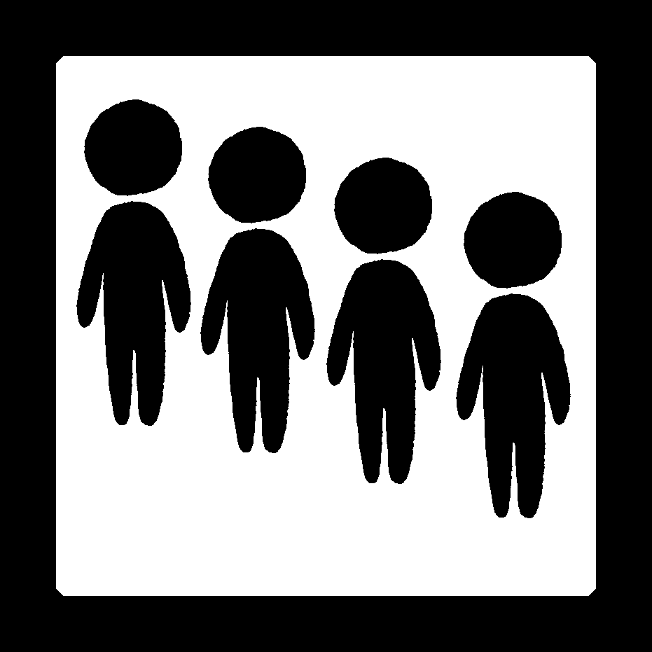 | ____________________________________
2 | 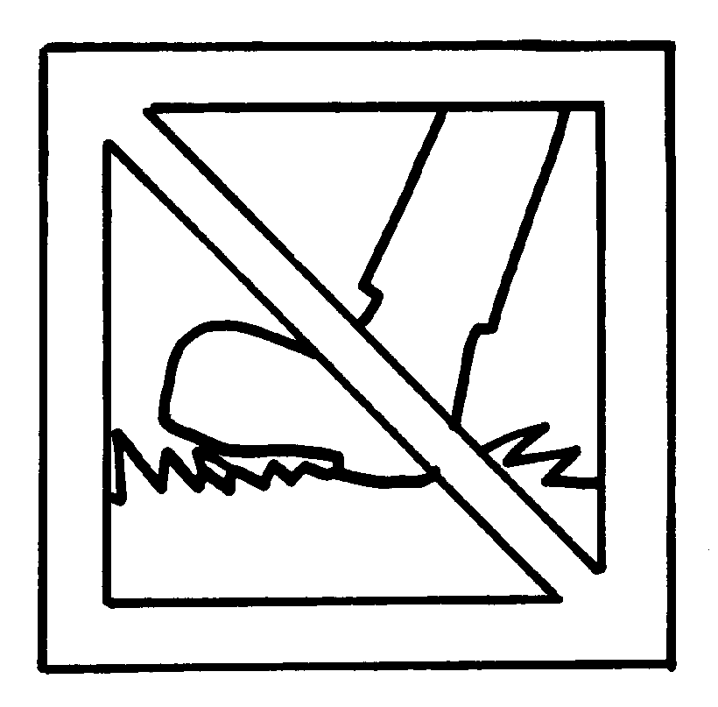 | ____________________________________
3 |  | ____________________________________
4 | 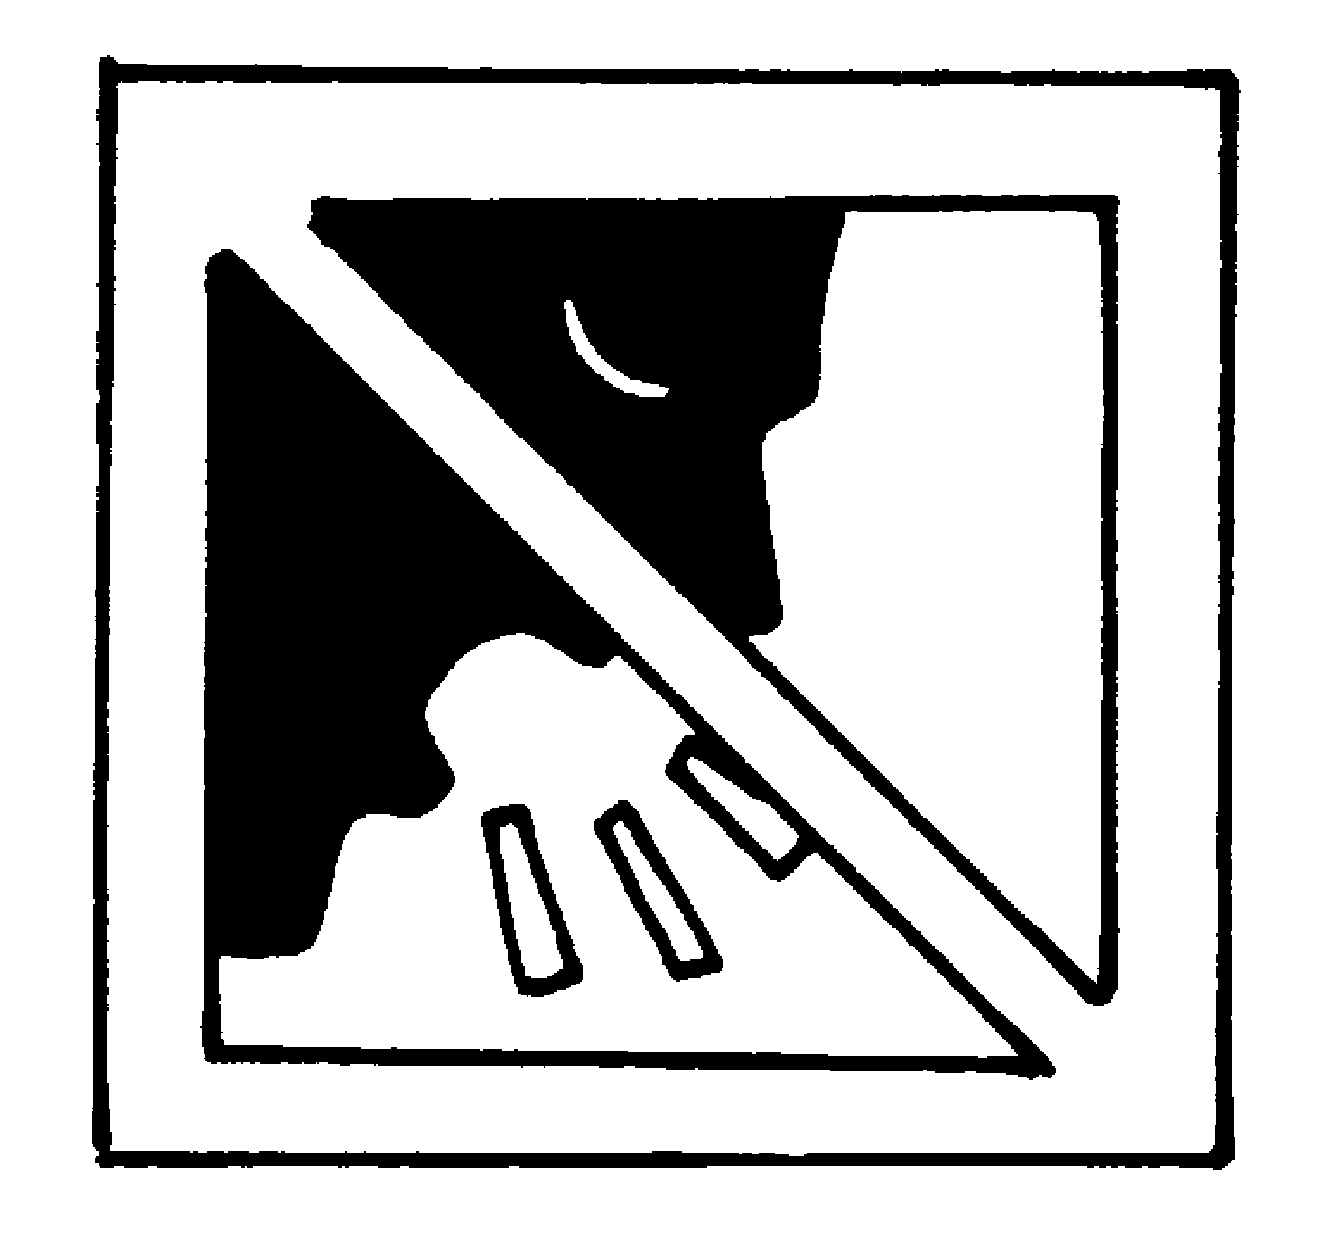 | ____________________________________
5 | 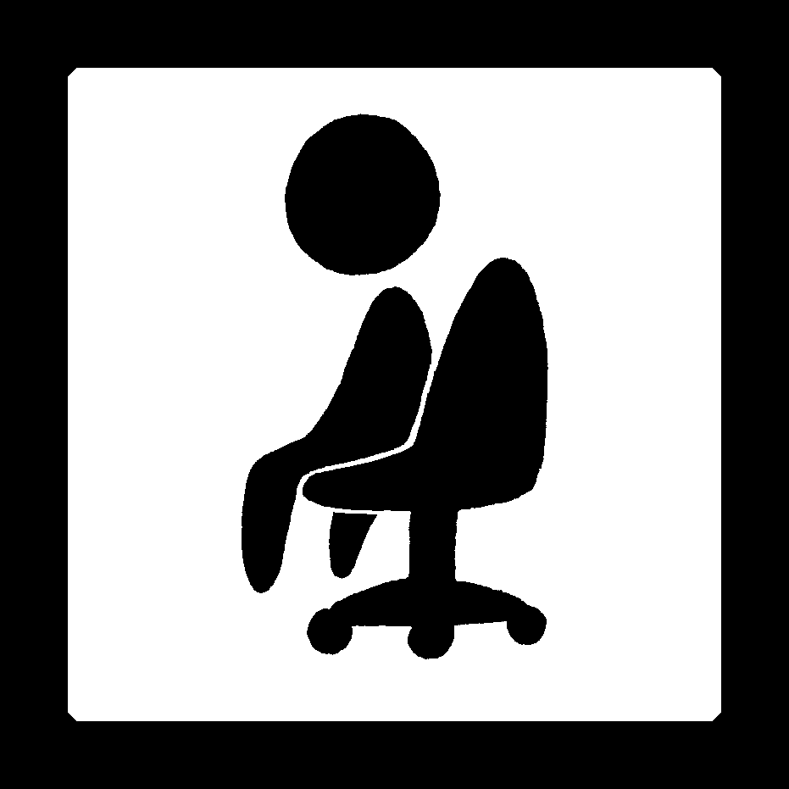 | ____________________________________



Book 2A Chapter 2 Graded Worksheets
Worksheet 2⬇
- Line up.
- Keep off the grass.
- Wait for your turn.
- Keep quiet.
- Sit still.

