Choose and write.
wait for keep
sit keep off
up the grass still
quiet your turn

Rules
1 | 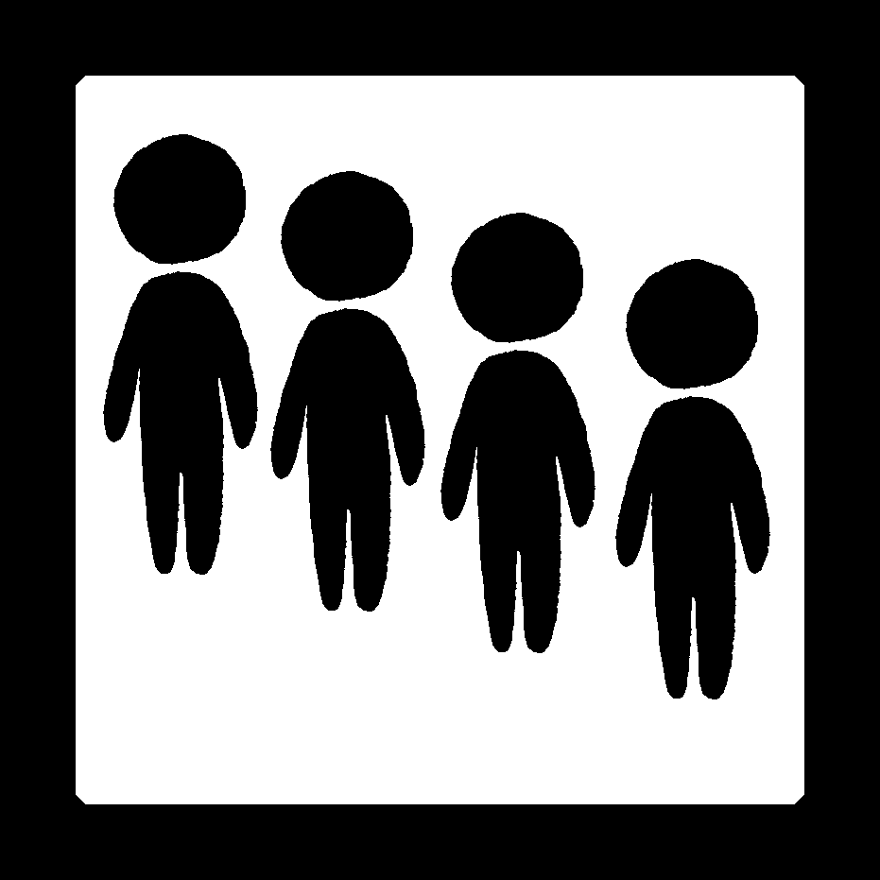 | Line __________ .
2 | 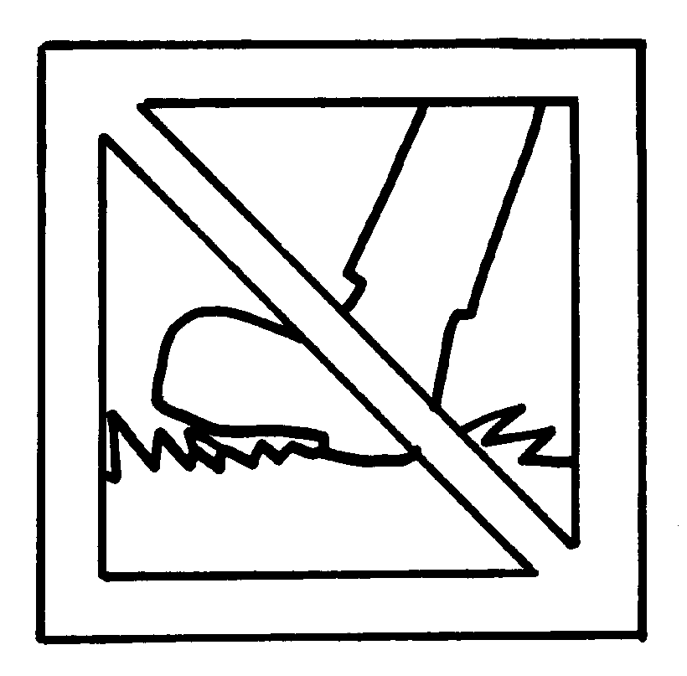 | ______________________________________
3 | 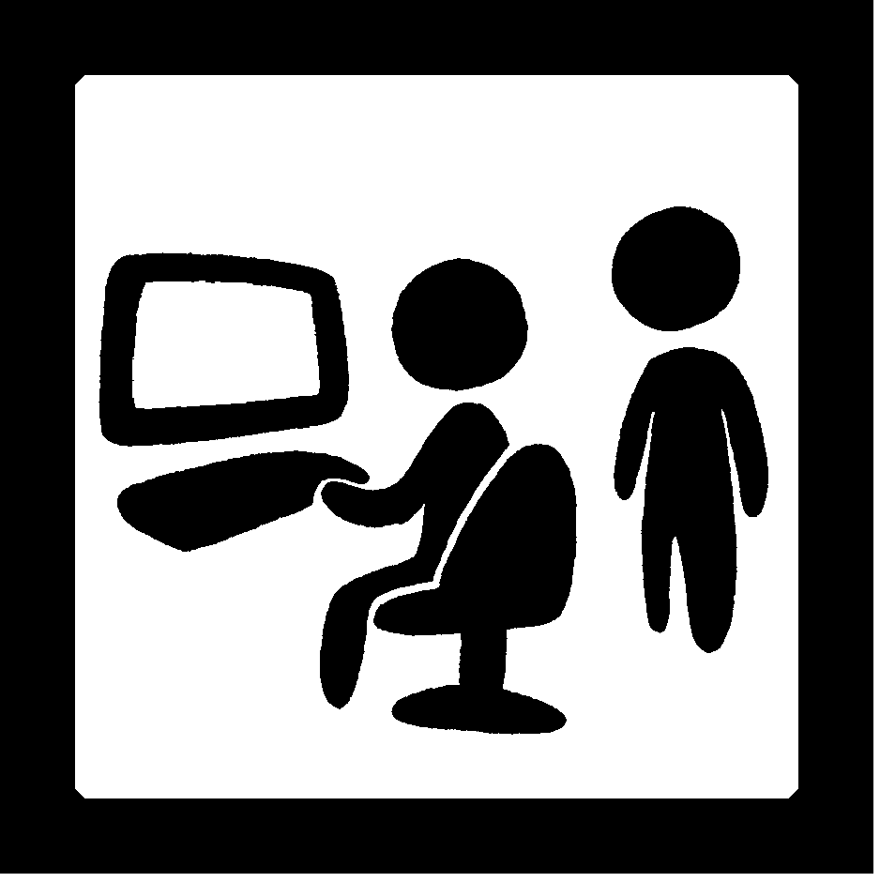 | ______________________________________
4 | 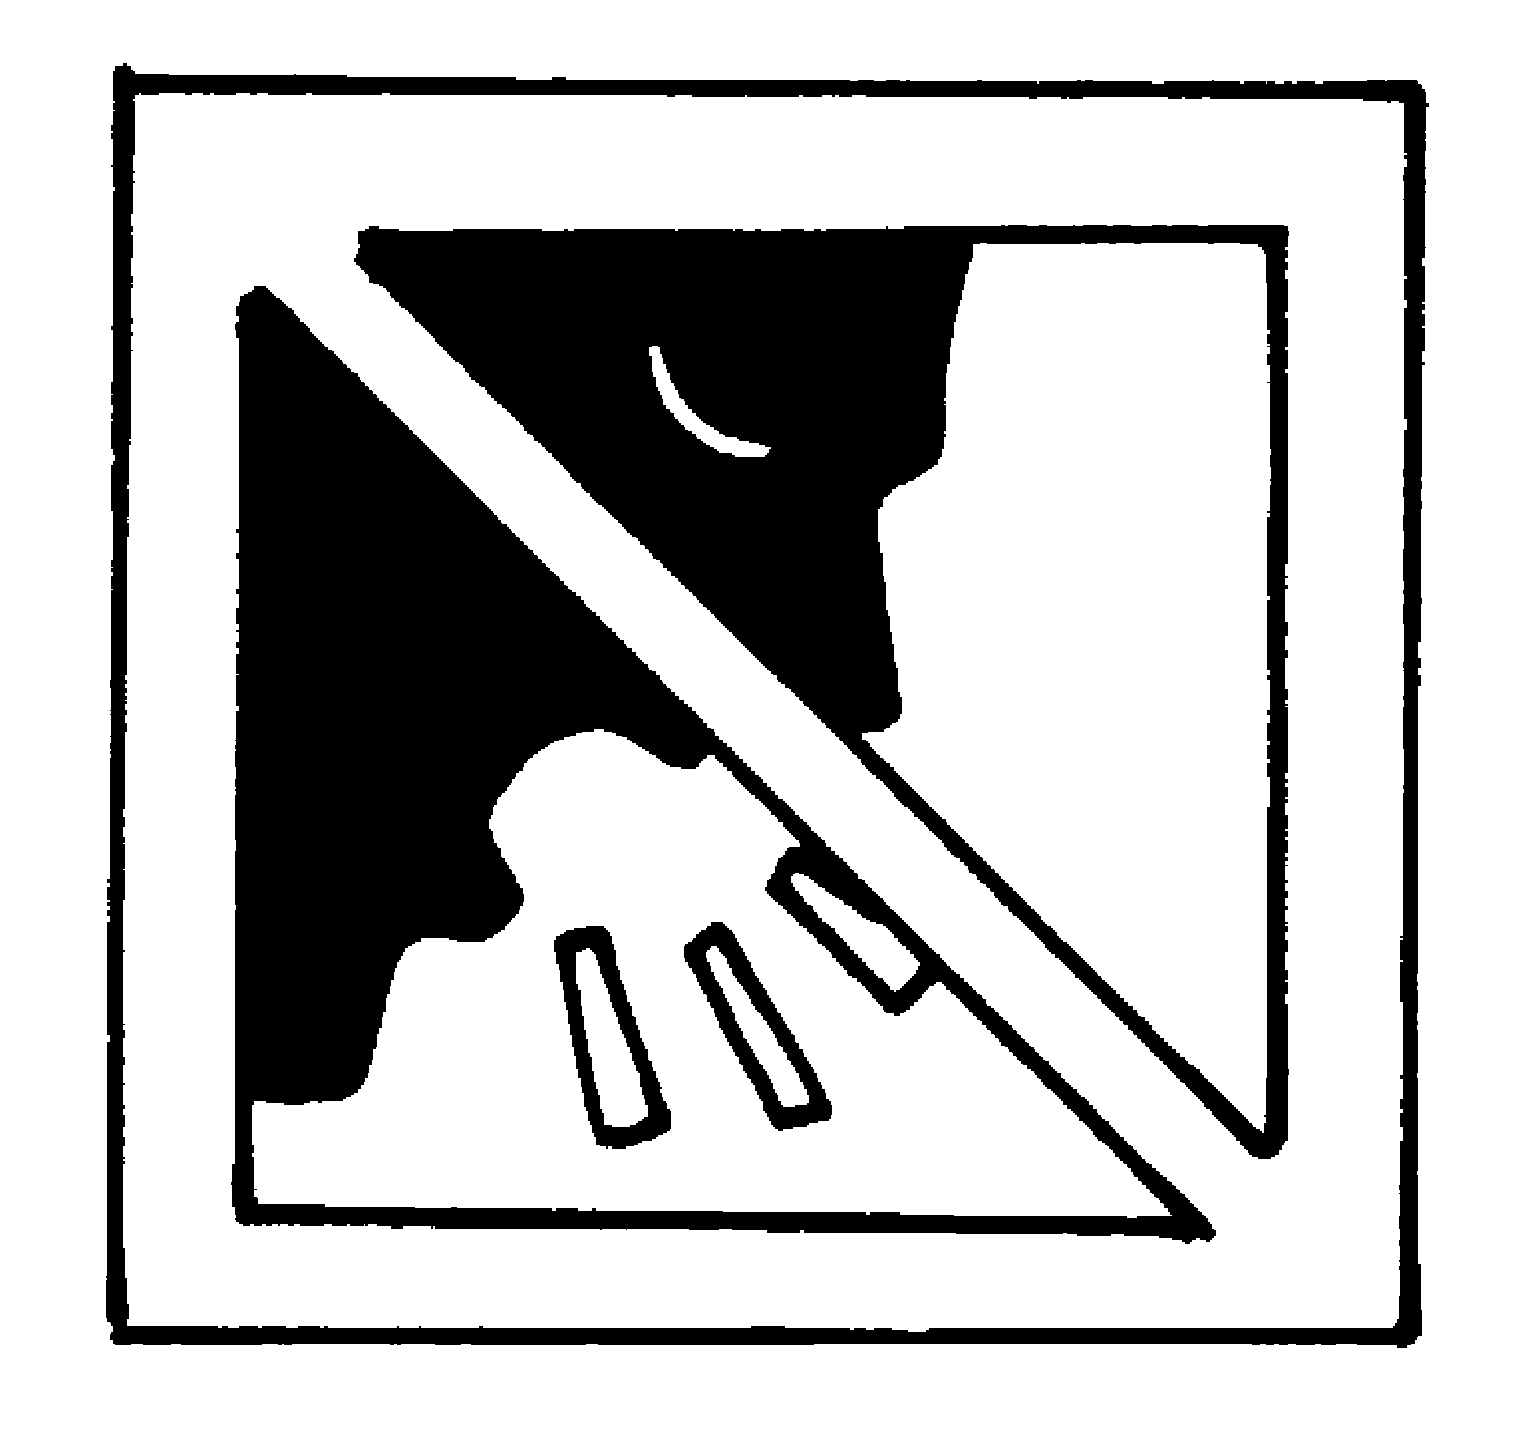 | ______________________________________
5 | 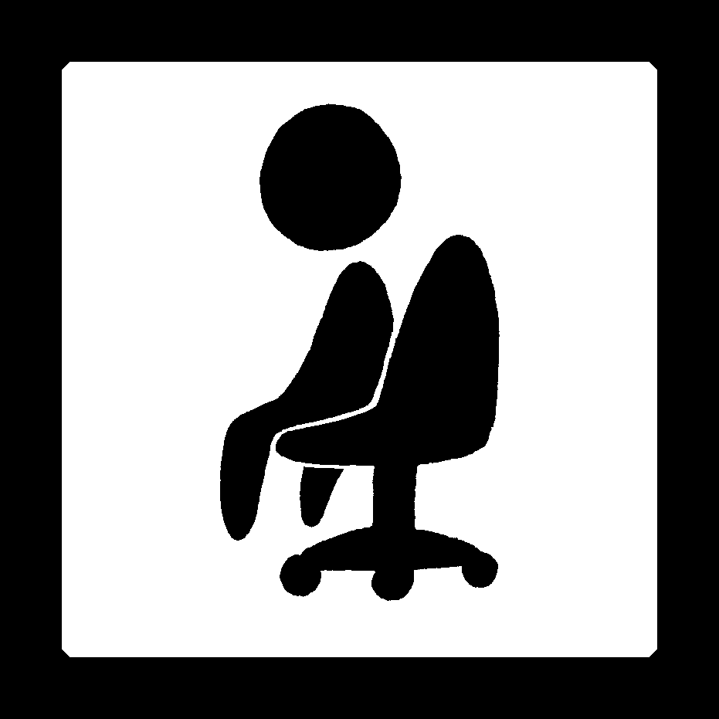 | ______________________________________



Book 2A Chapter 2 Graded Worksheets
Worksheet 2⬇⬇
- up
- Keep off the grass.
- Wait for your turn.
- Keep quiet.
- Sit still.

