Look at the signs and write the rules.

Rules
1 | 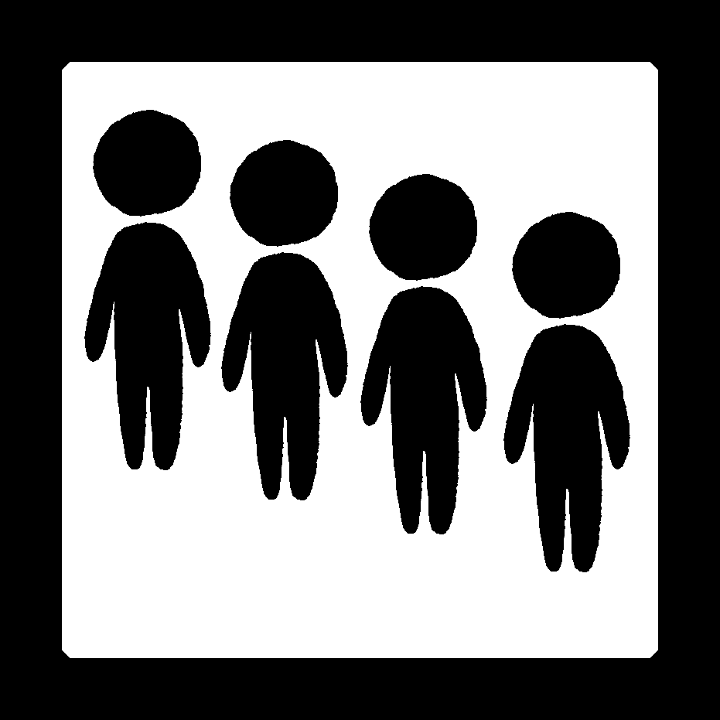 | Line ______ .
2 | 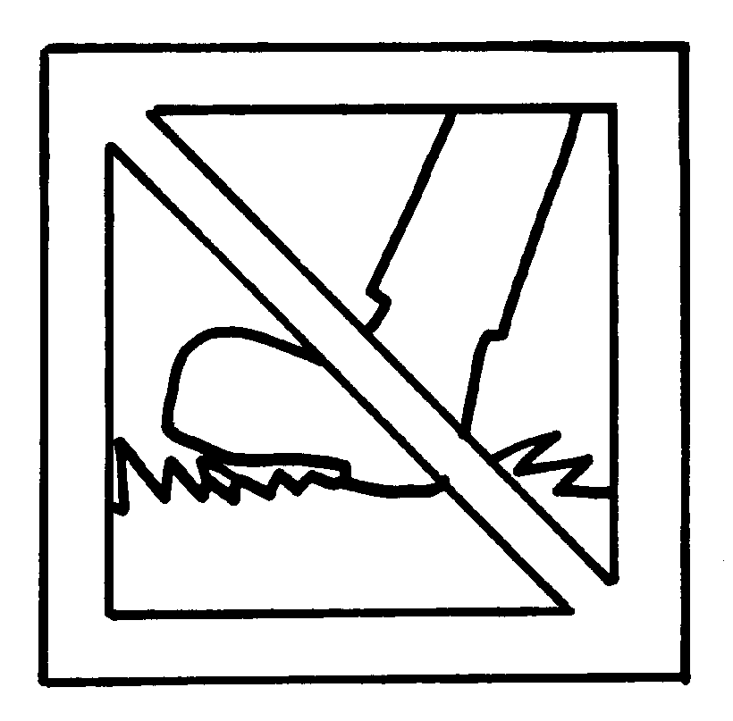 | ___________ _______ the grass.
3 | 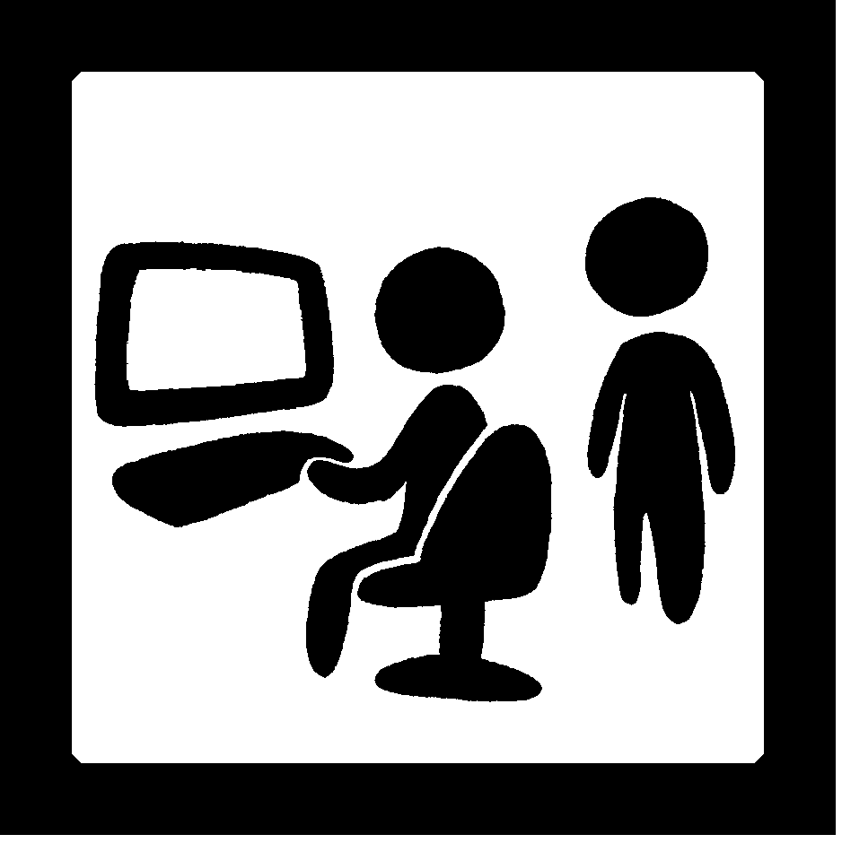 | ___________ _______ your ____________ .
4 | 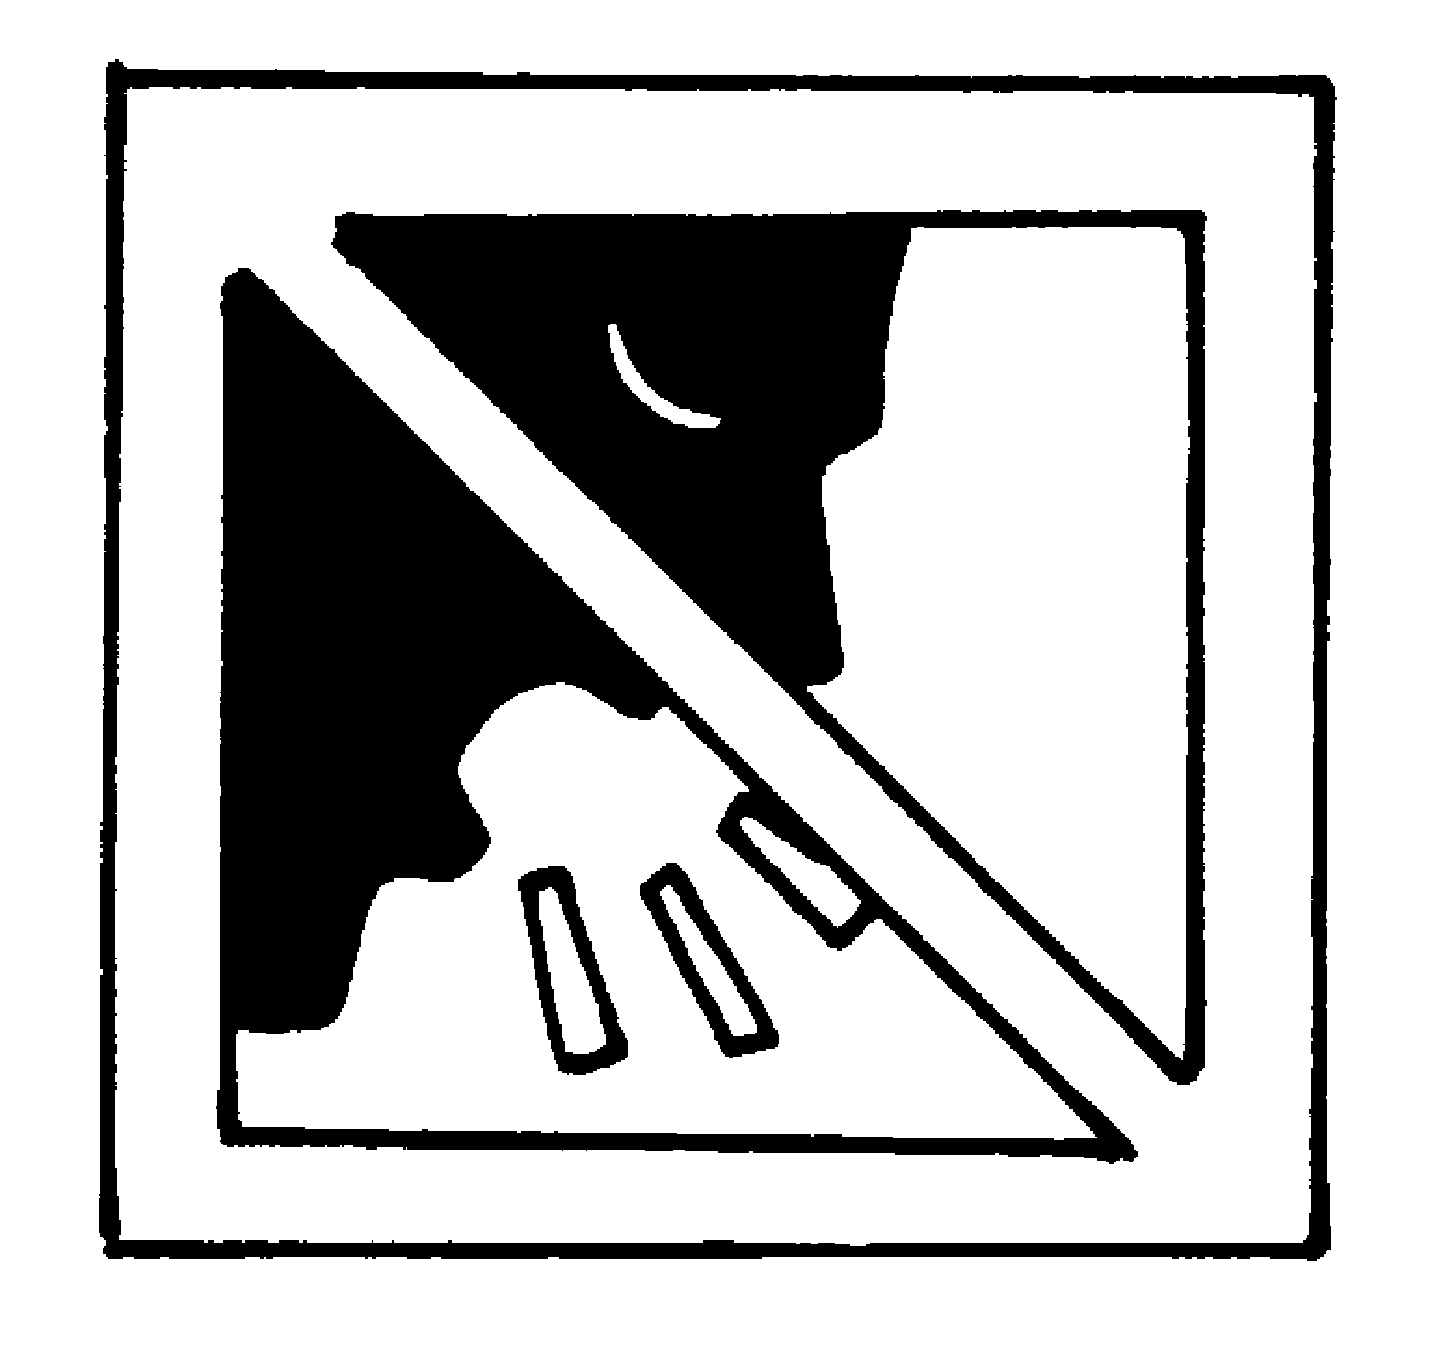 | ______________________________________
5 | 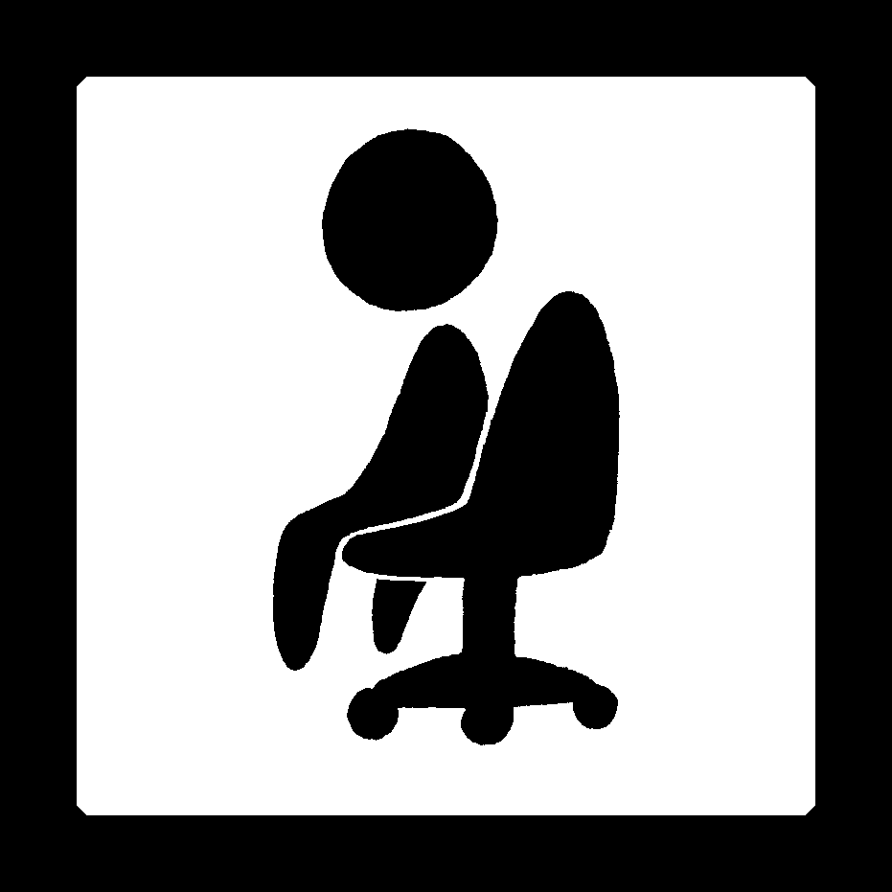 | ______________________________________



Book 2A Chapter 2 Graded Worksheets
Worksheet 2⬇⬇⬇
- up
- Keep off
- Wait for turn
- Keep quiet.
- Sit still.
(Accept any reasonable answers.)

