Circle the correct answers.

1 | 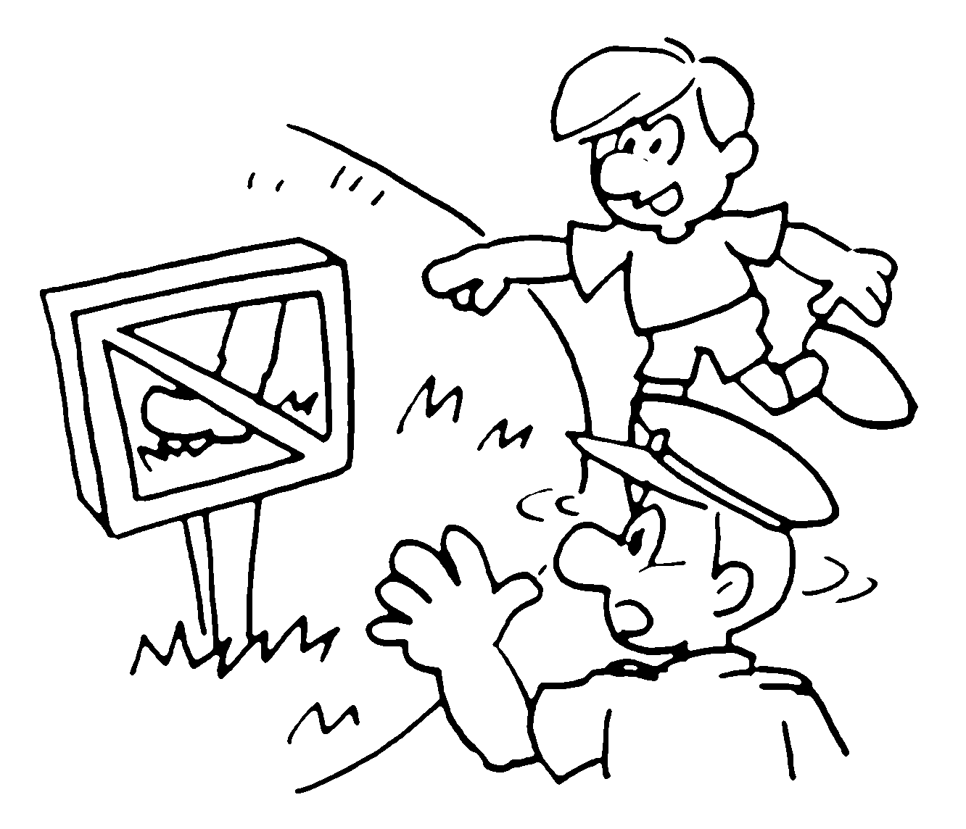 | You ( must / mustn’t ) keep off the grass.
2 | 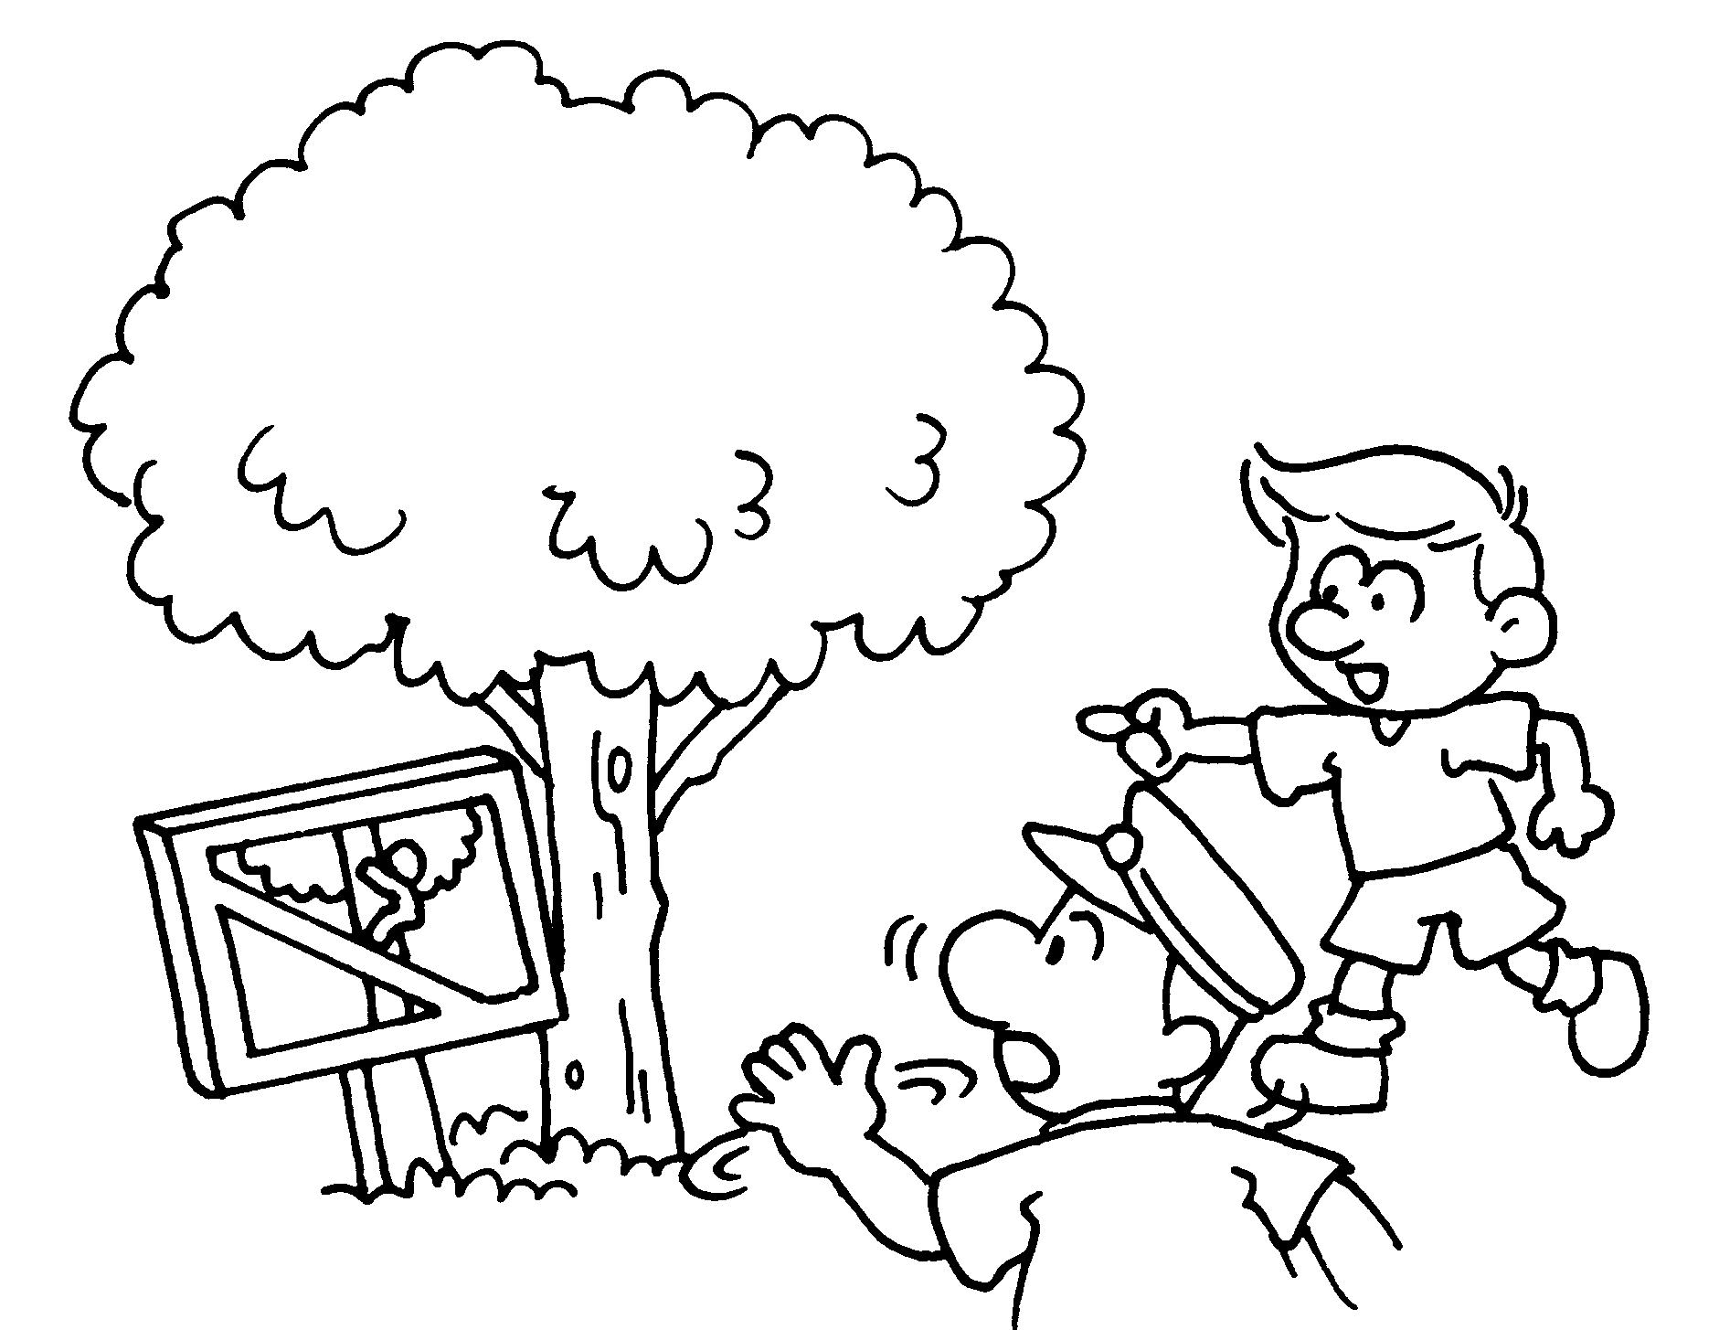 | You ( must / mustn’t ) climb the tree.
3 | 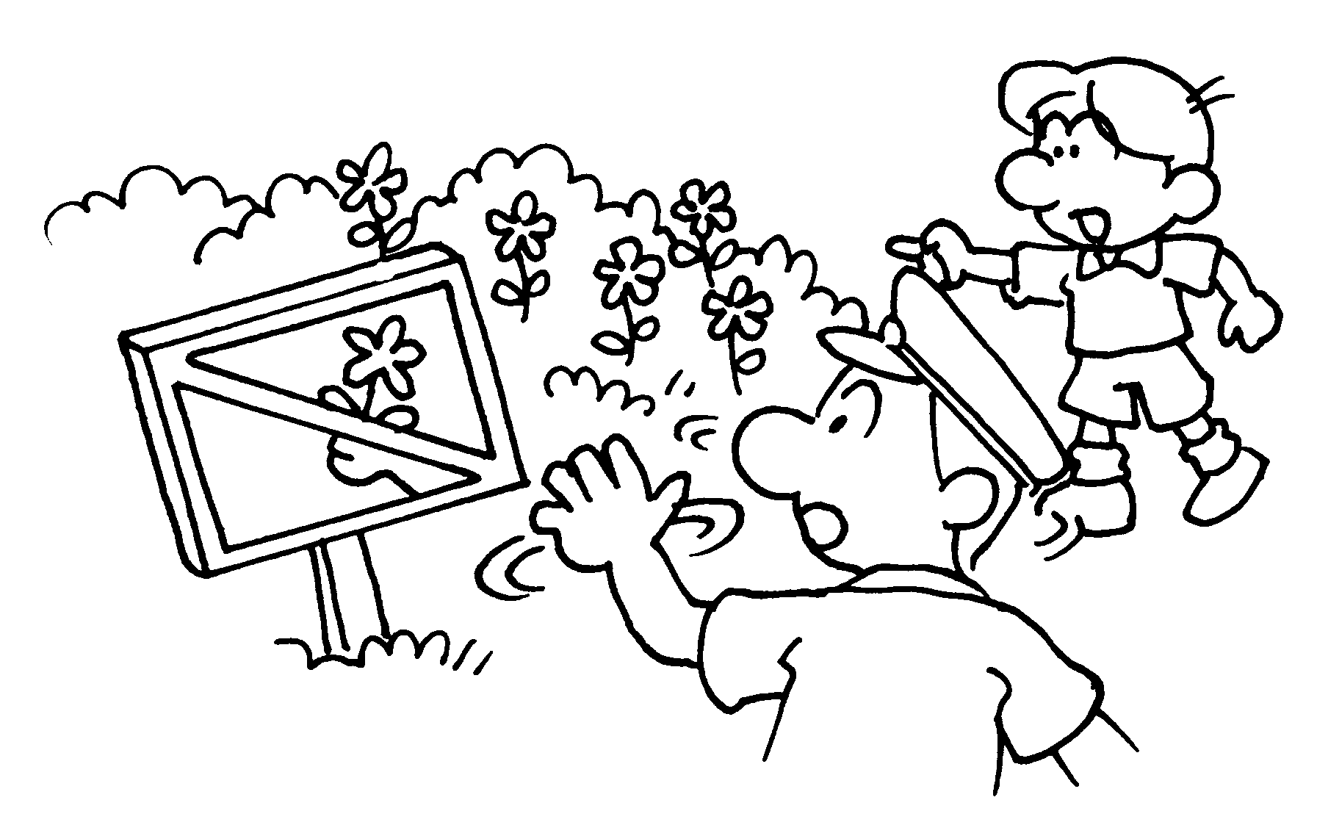 | You ( must / mustn’t ) pick the flowers.
4 | 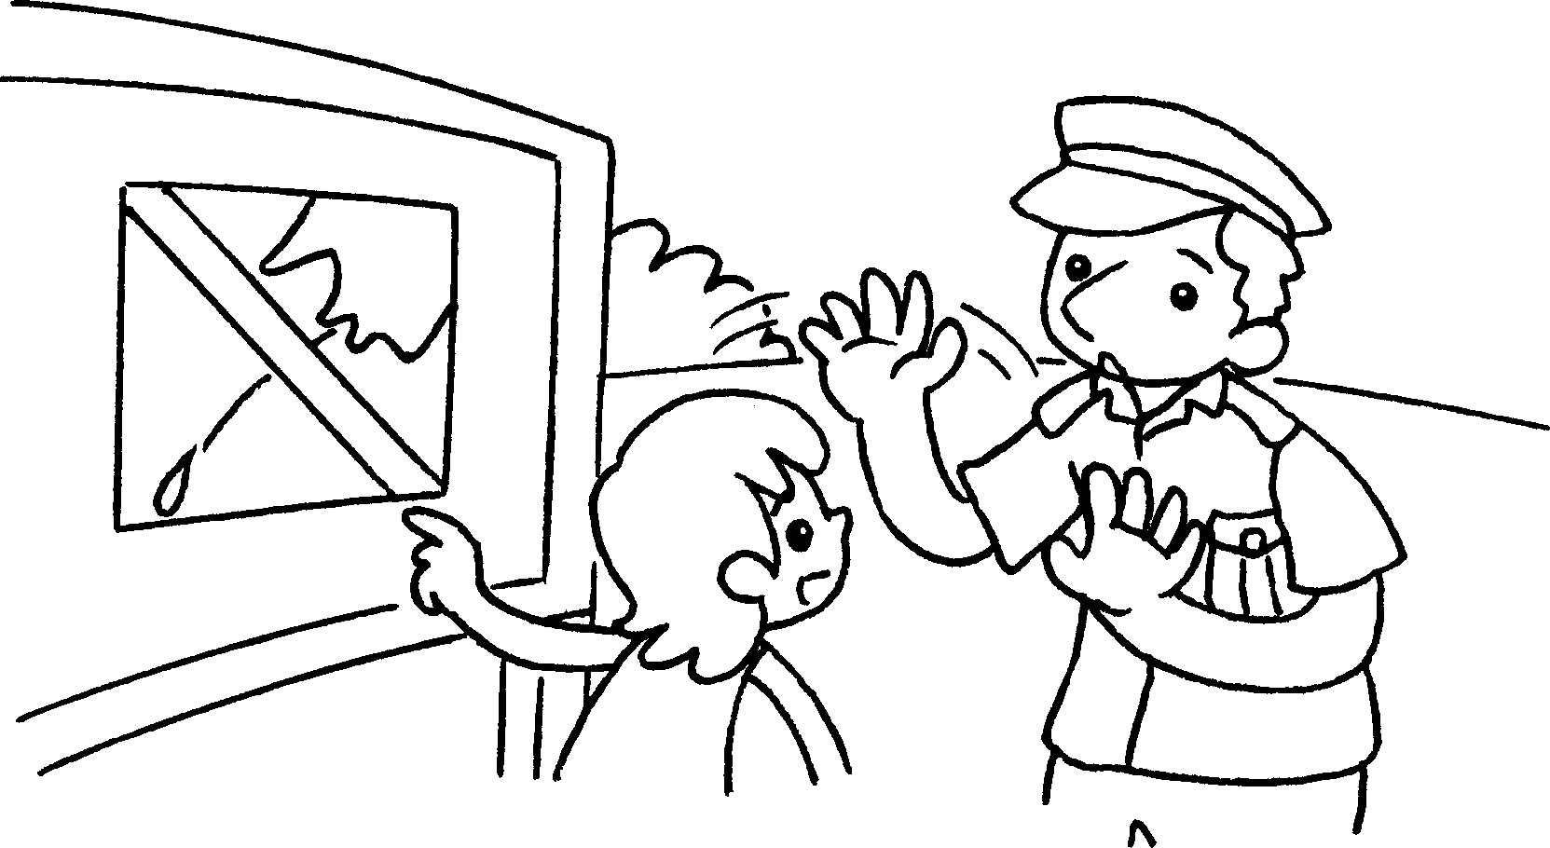 | You ( must / mustn’t ) spit.
5 | 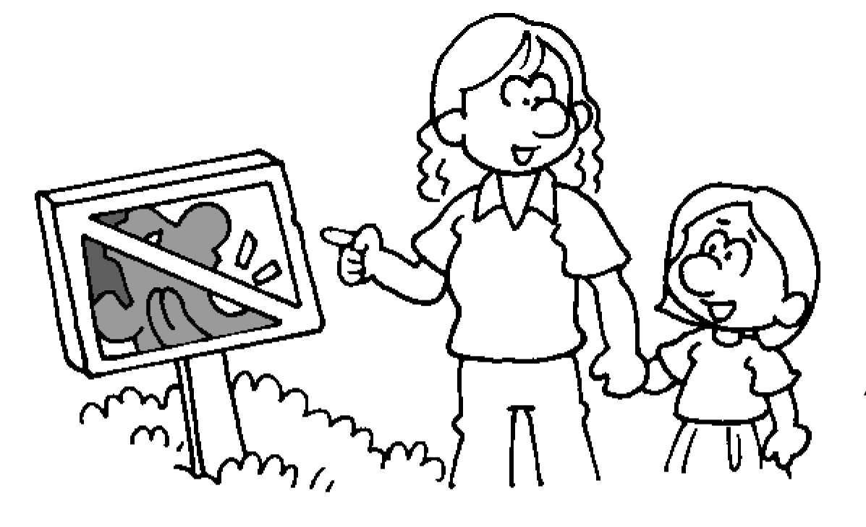 | You ( must / mustn’t ) keep quiet.
6 | 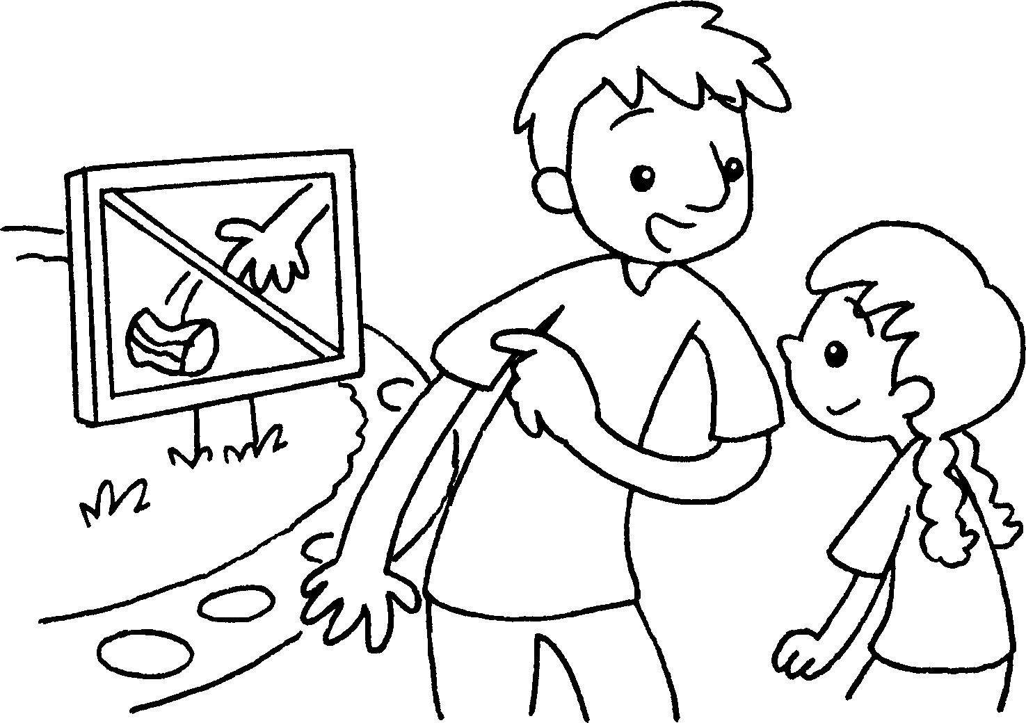 | You ( must / mustn’t ) litter.


Book 2A Chapter 2 Graded Worksheets
Worksheet 3⬇
- ( must / mustn’t )
- ( must / mustn’t )
- ( must / mustn’t )
- ( must / mustn’t )
- ( must / mustn’t )
- ( must / mustn’t )

