Choose and write.

must / mustn’t | pick keep climb
must / mustn’t | spit litter keep off

1 | 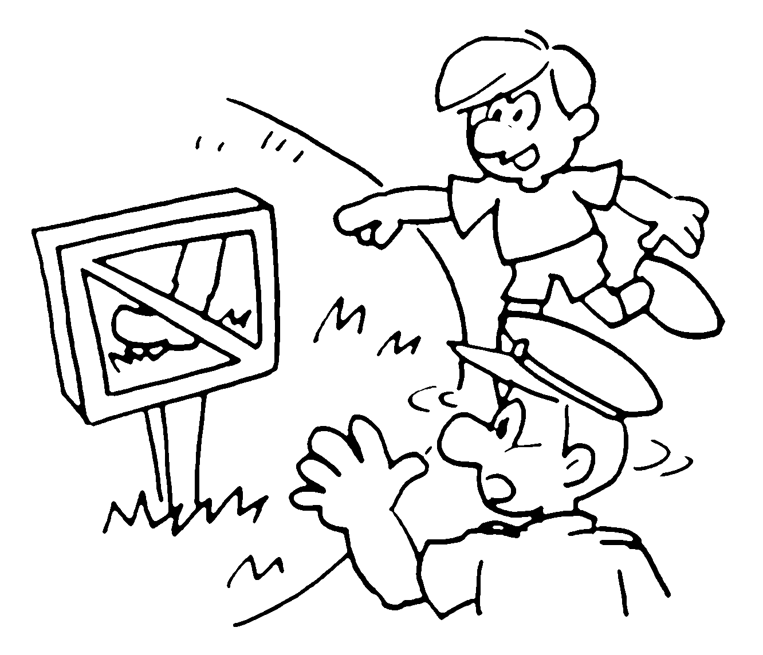 | You must _________________ the grass.
2 | 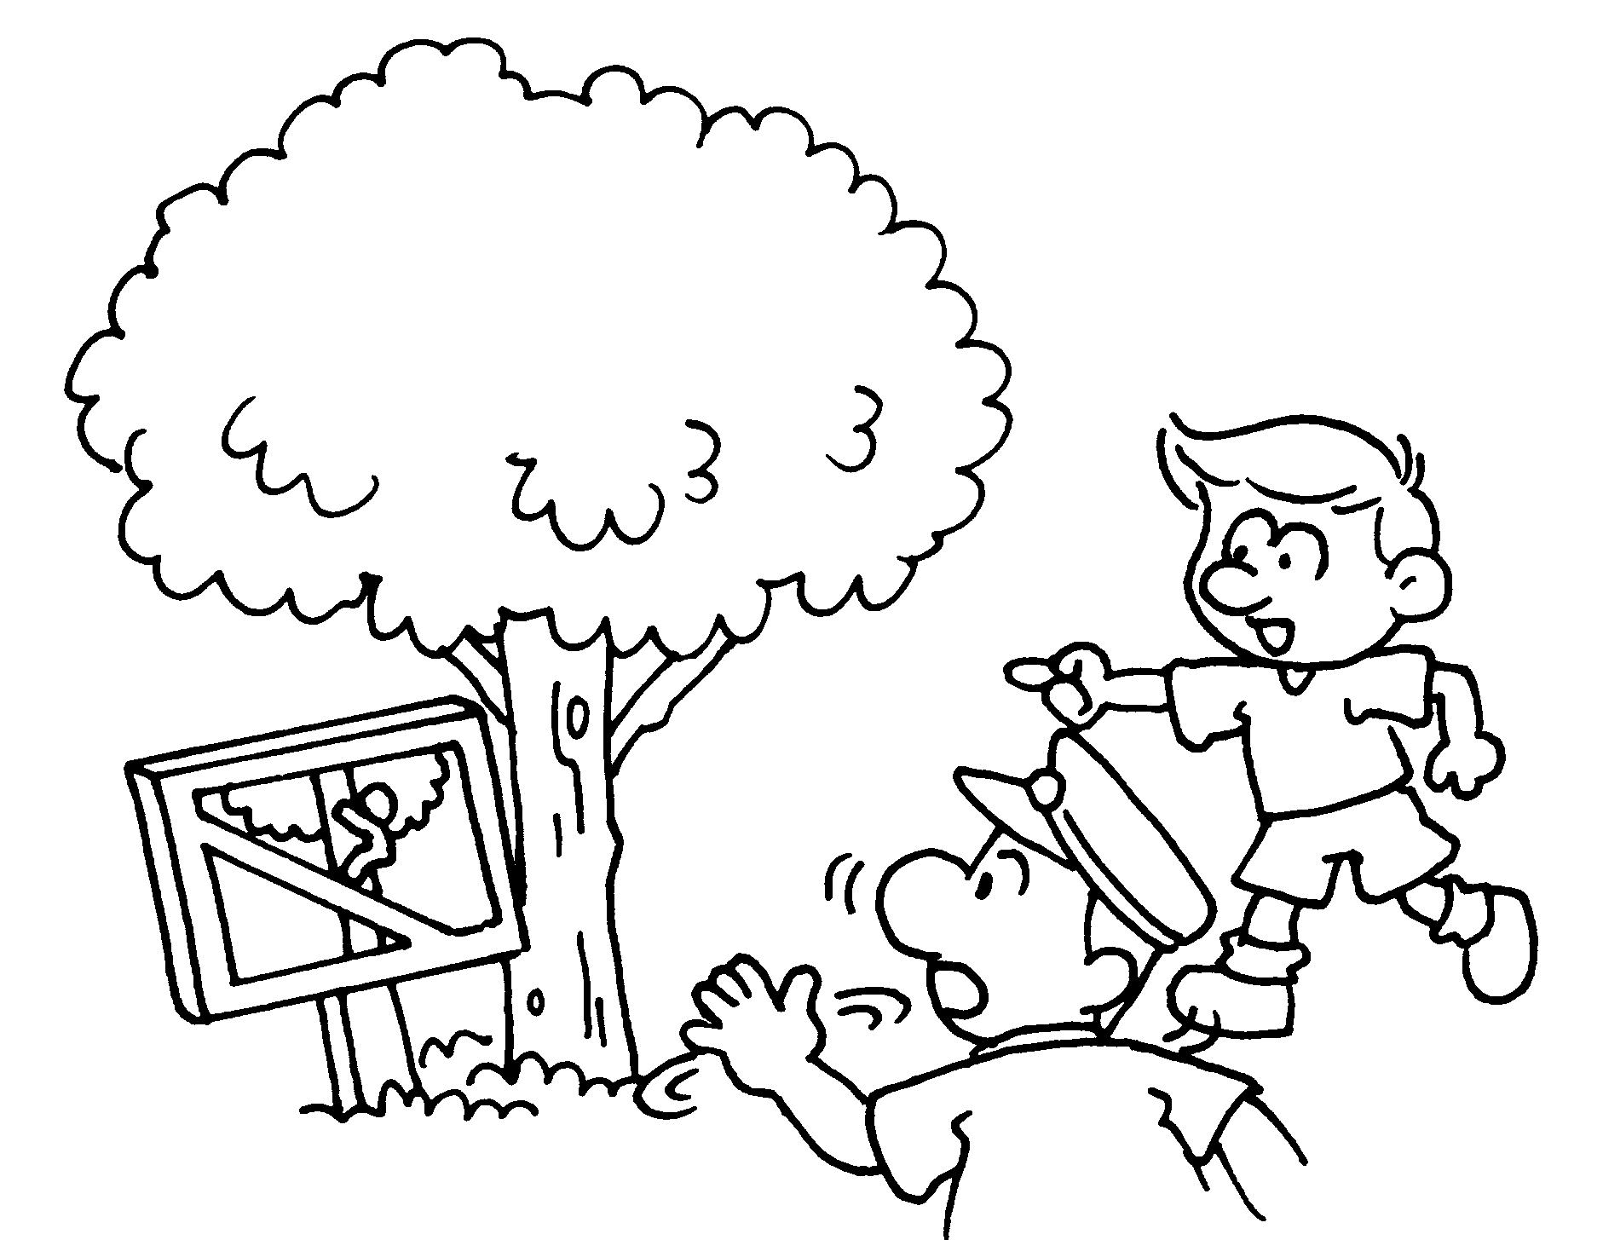 | You __________________________ the tree.
3 | 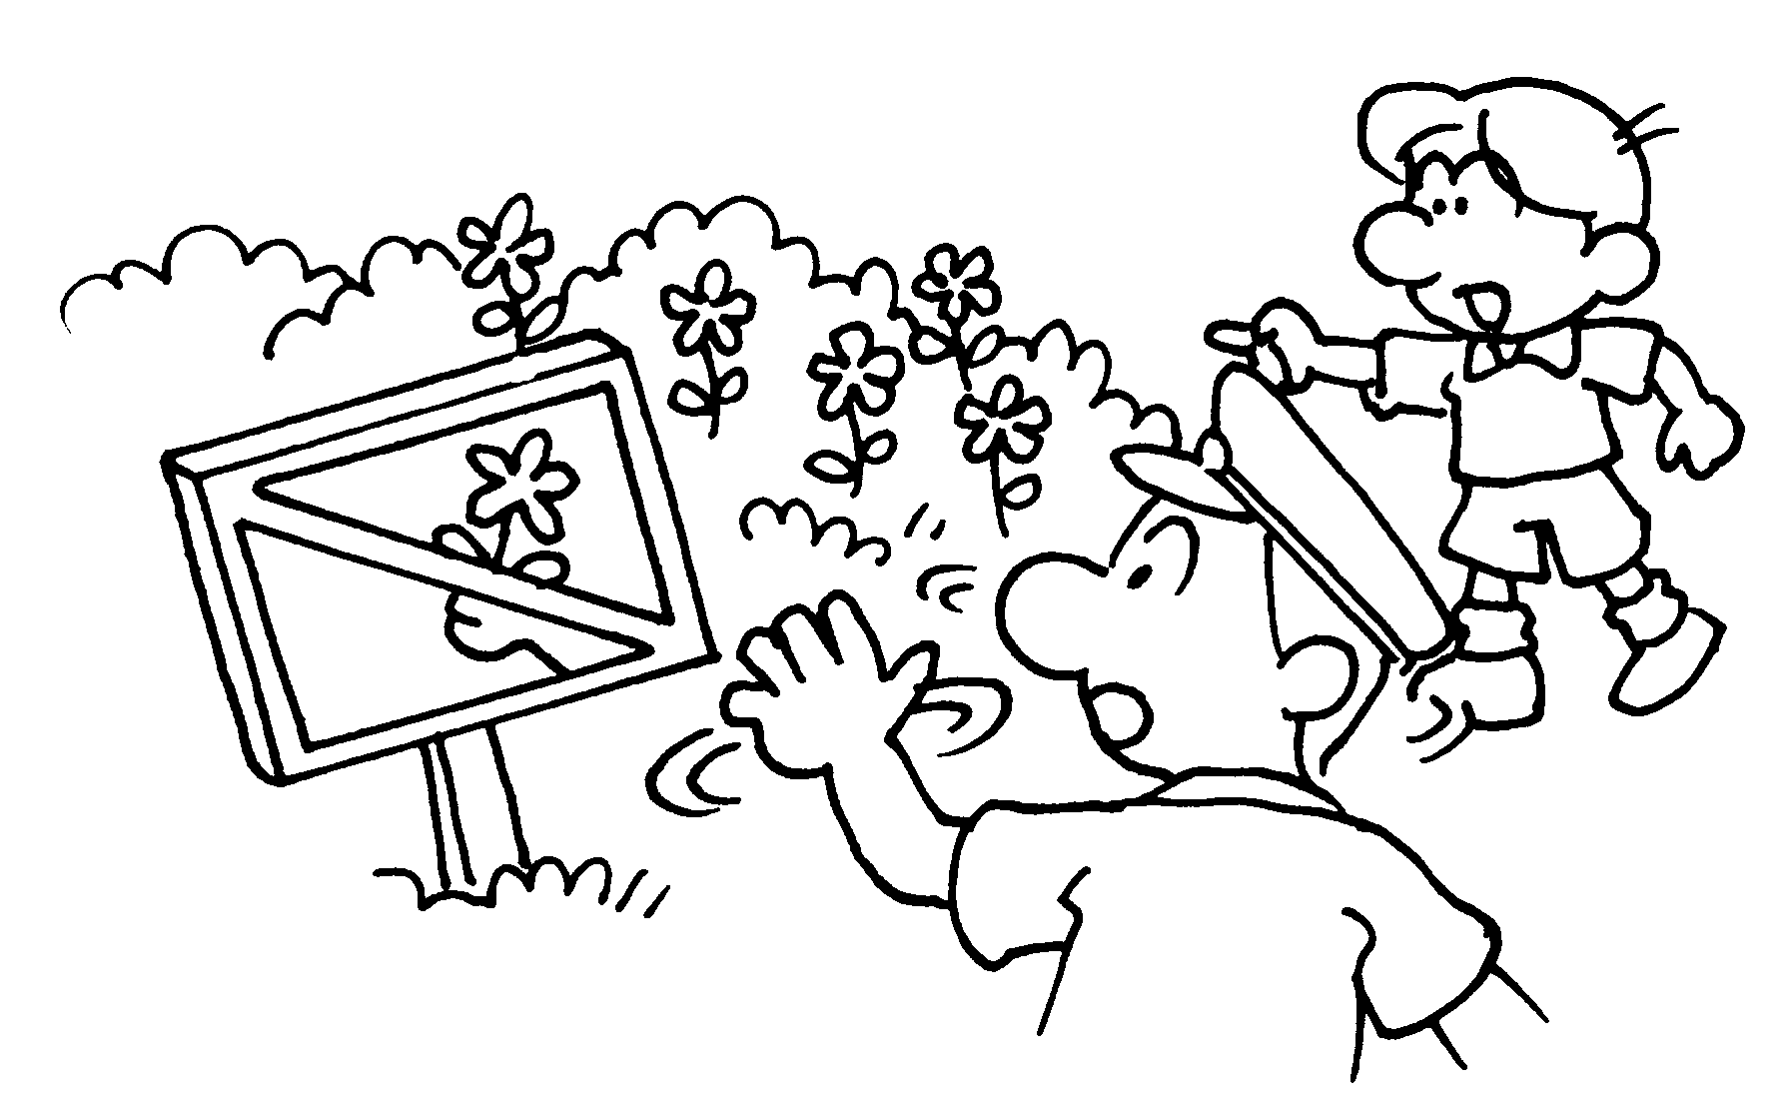 | You __________________________  the flowers.
4 | 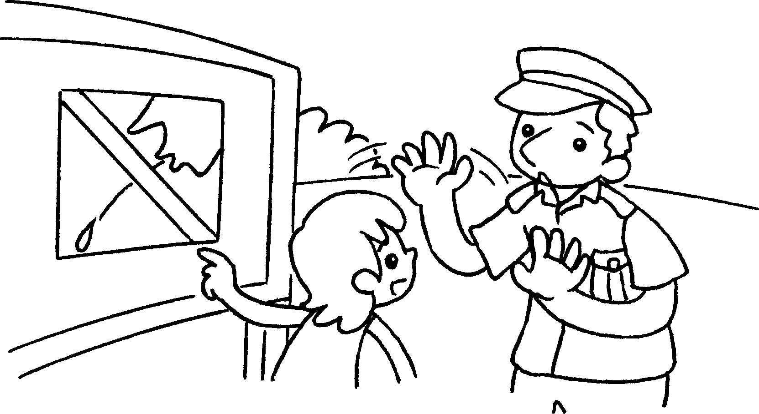 | You _________________________ .
5 | 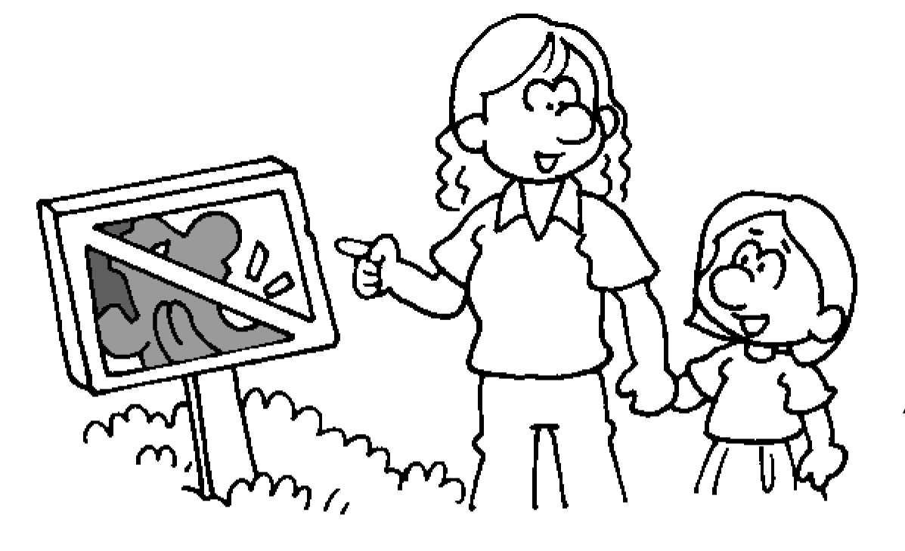 | You __________________________  quiet.
6 | 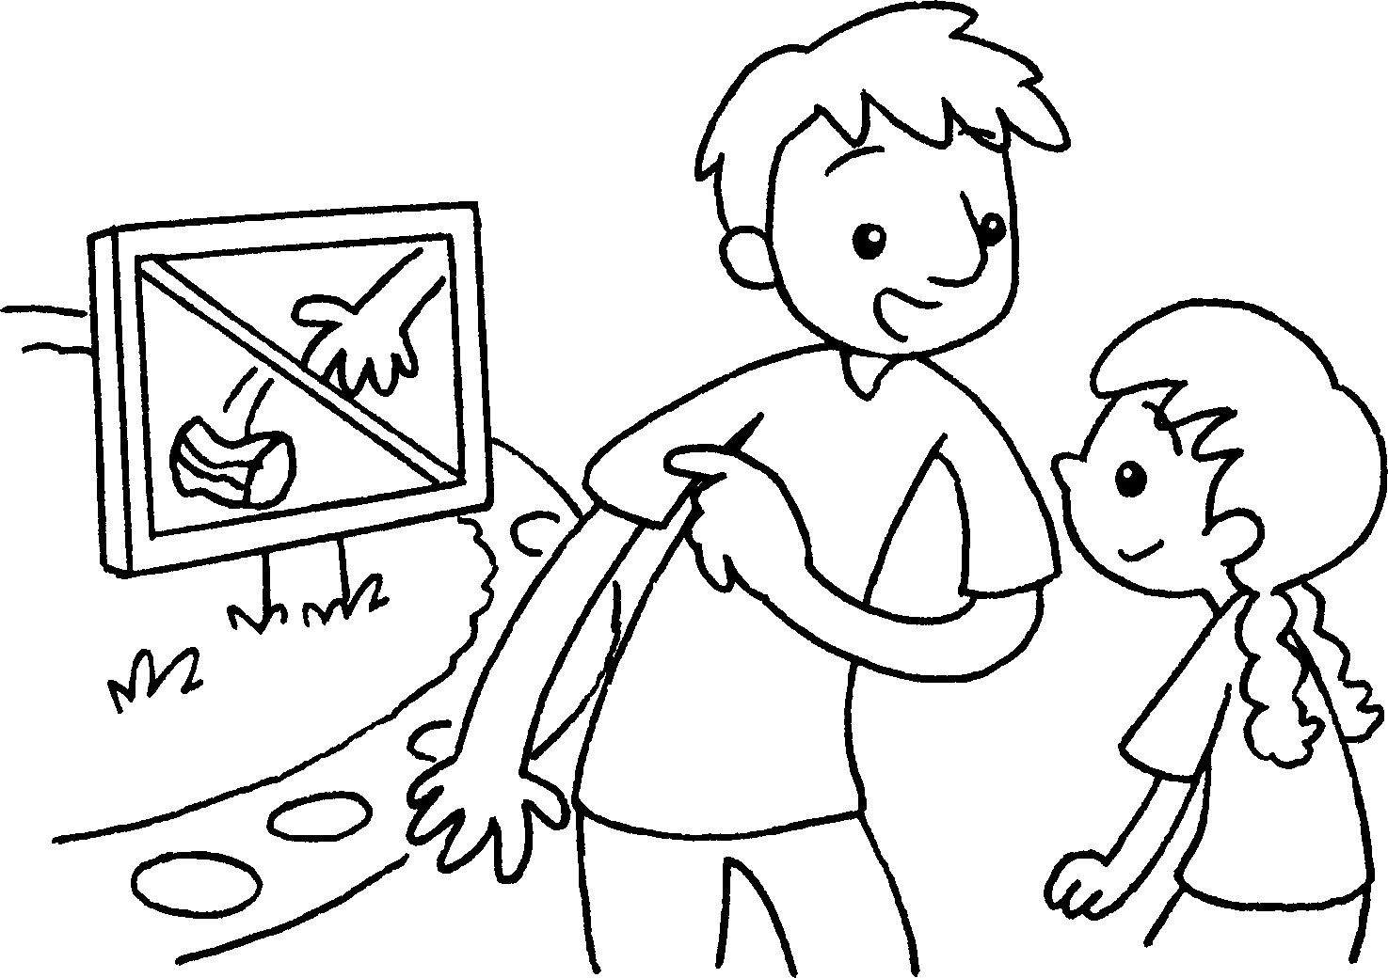 | You _________________________ .


Book 2A Chapter 2 Graded Worksheets
Worksheet 3⬇⬇
- keep off
- mustn’t climb
- mustn’t pick
- mustn’t spit
- must keep
- mustn’t litter

