What must or mustn’t the people do? Write.

1 | 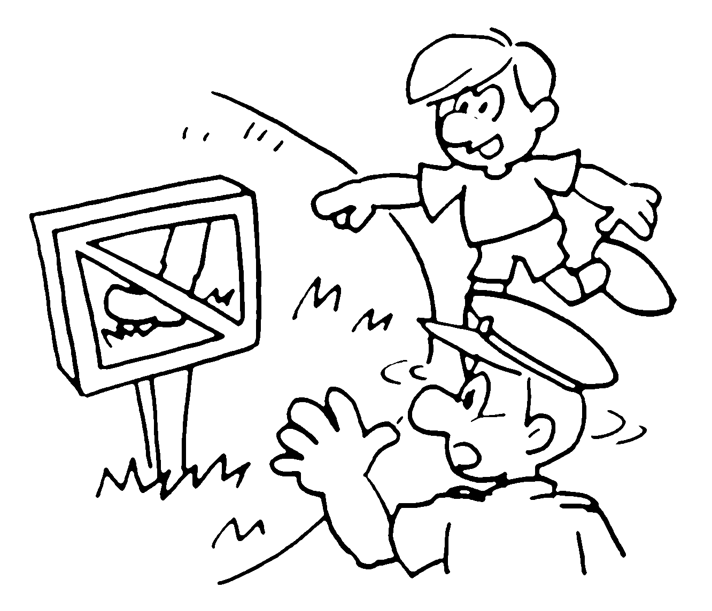 | You must _________ ______ the grass.
2 | 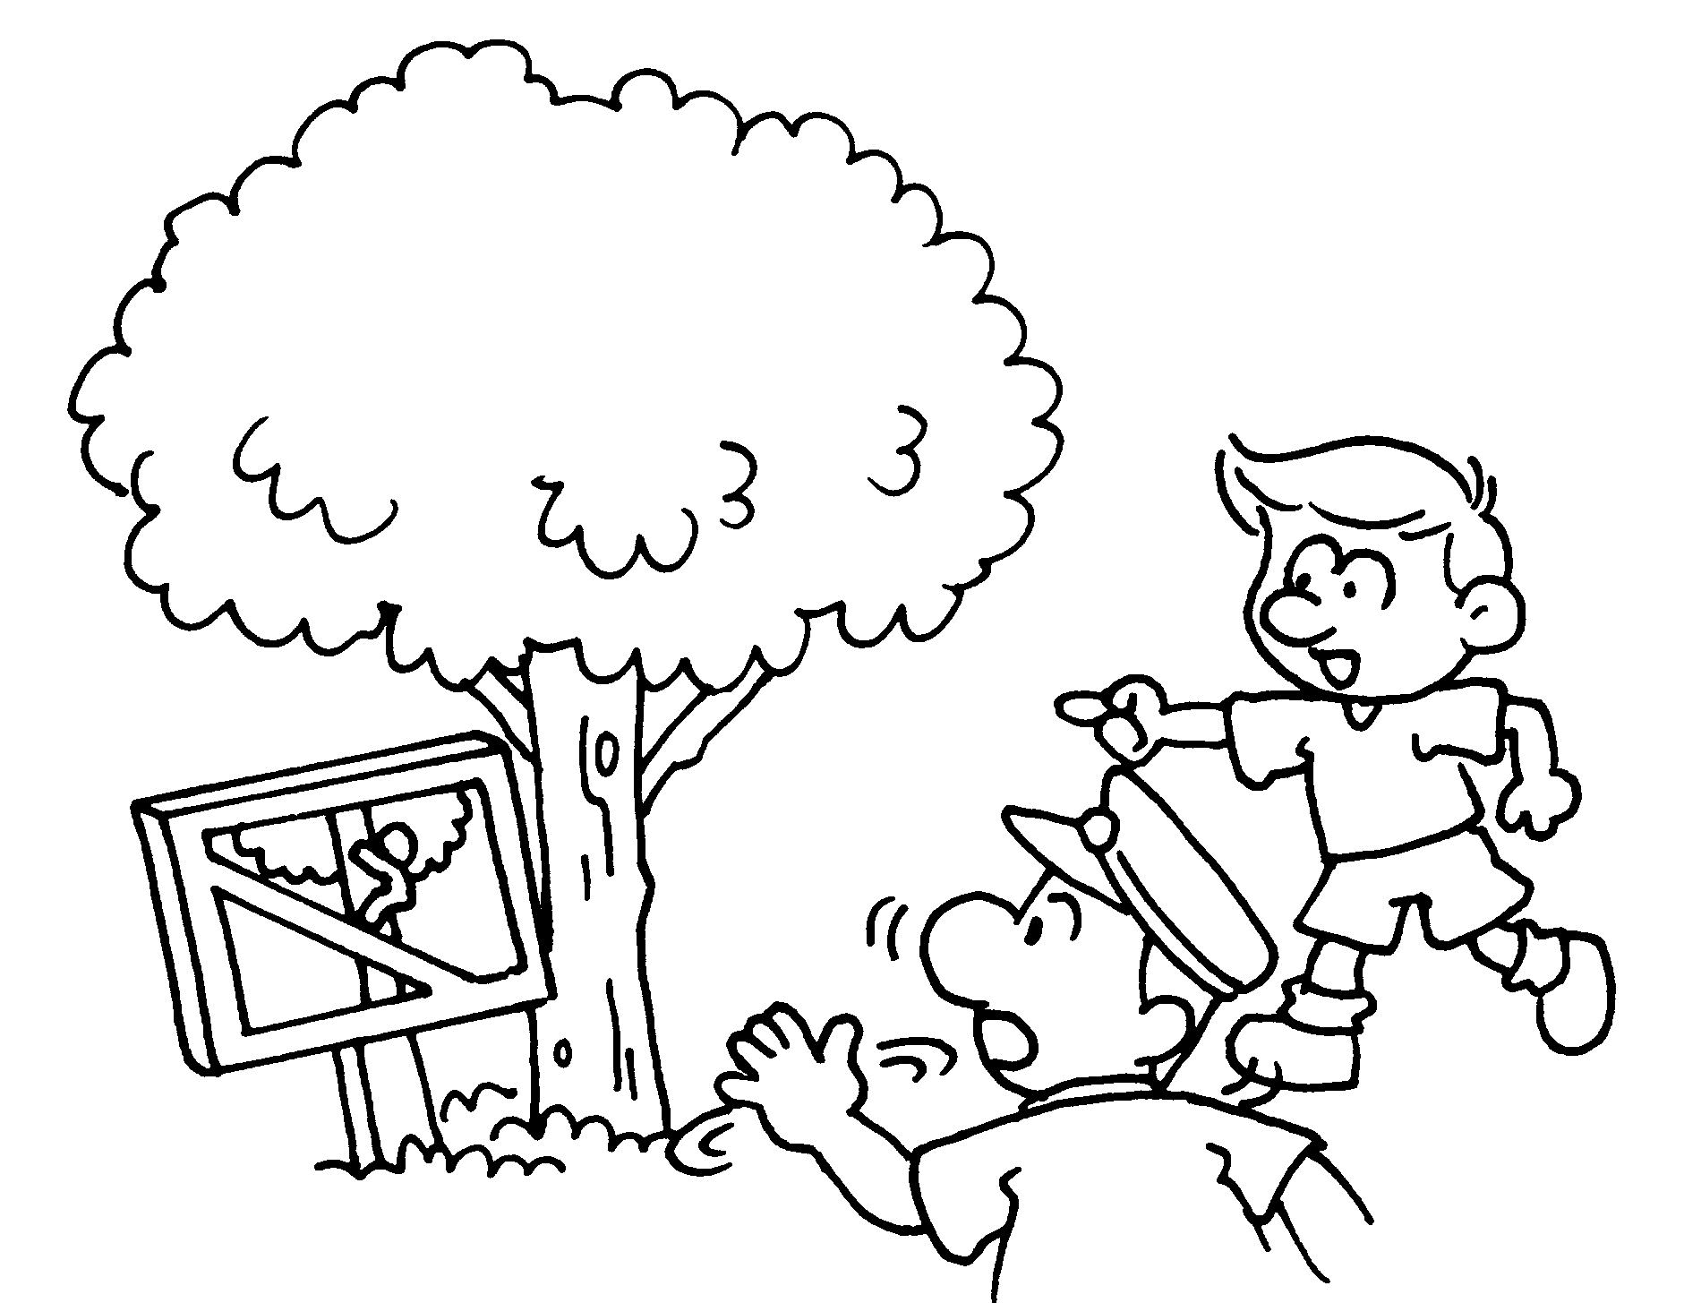 | You ___________ _____________ the tree.
3 | 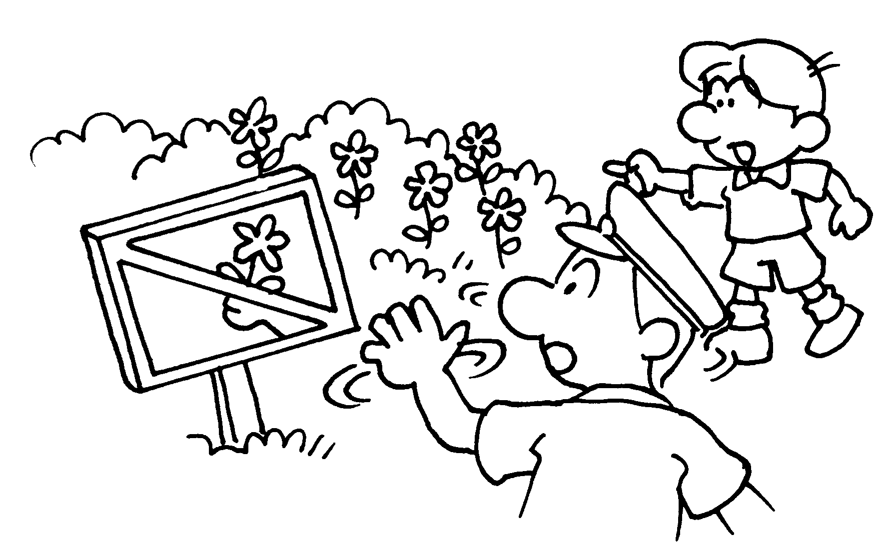 | You __________________________  the flowers.
4 | 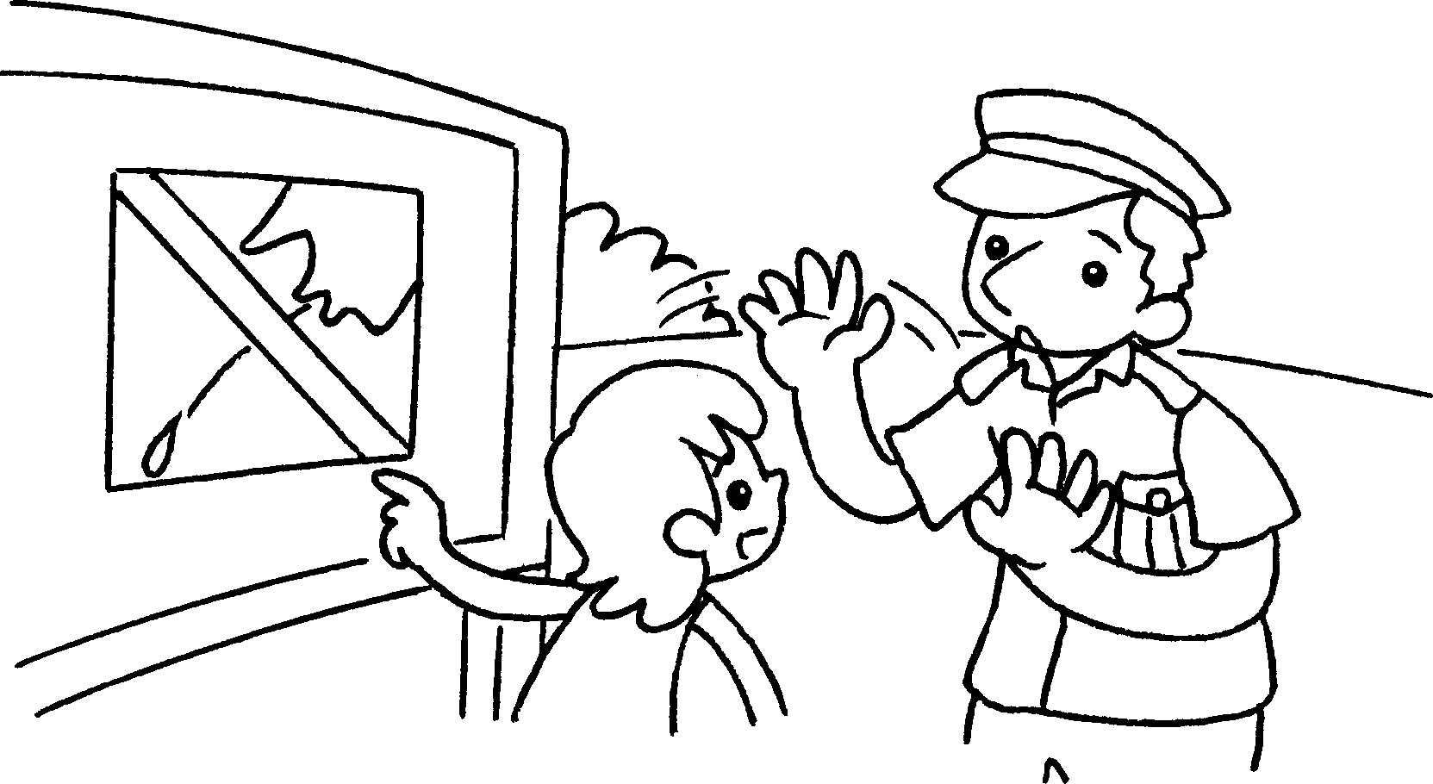 | You _________________________ .
5 | 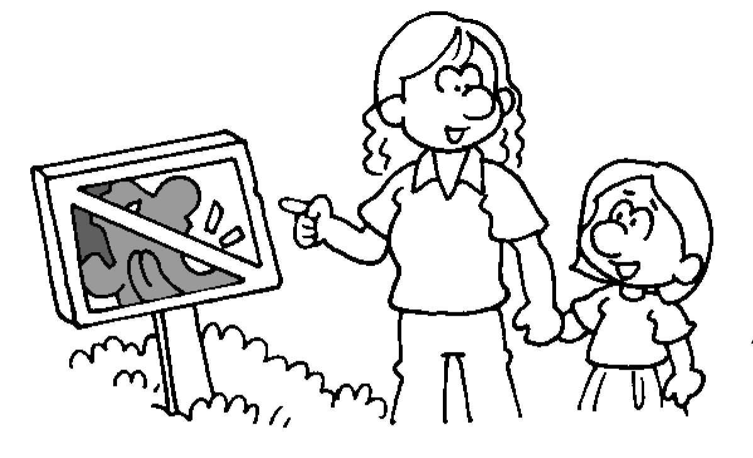 | ______________________________
6 | 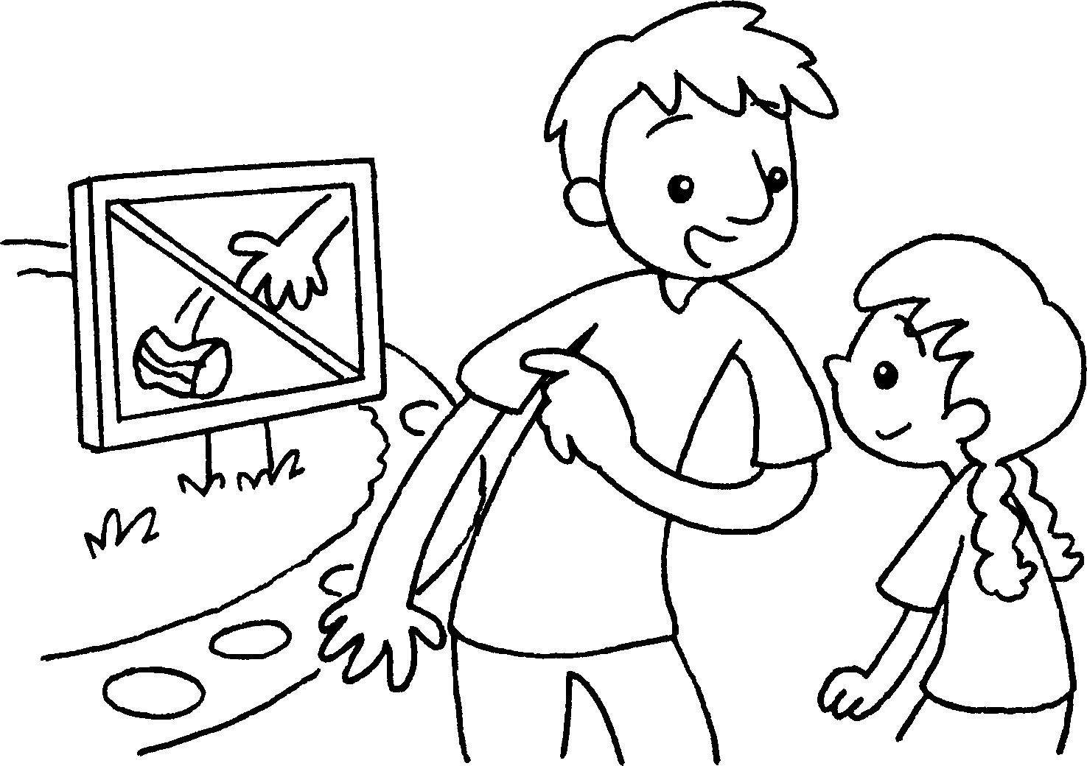 | ______________________________


Book 2A Chapter 2 Graded Worksheets
Worksheet 3⬇⬇⬇
- keep off
- mustn’t climb
- mustn’t pick
- mustn’t spit
- You must keep quiet.
- You mustn’t litter.
(Accept any reasonable answers.)

