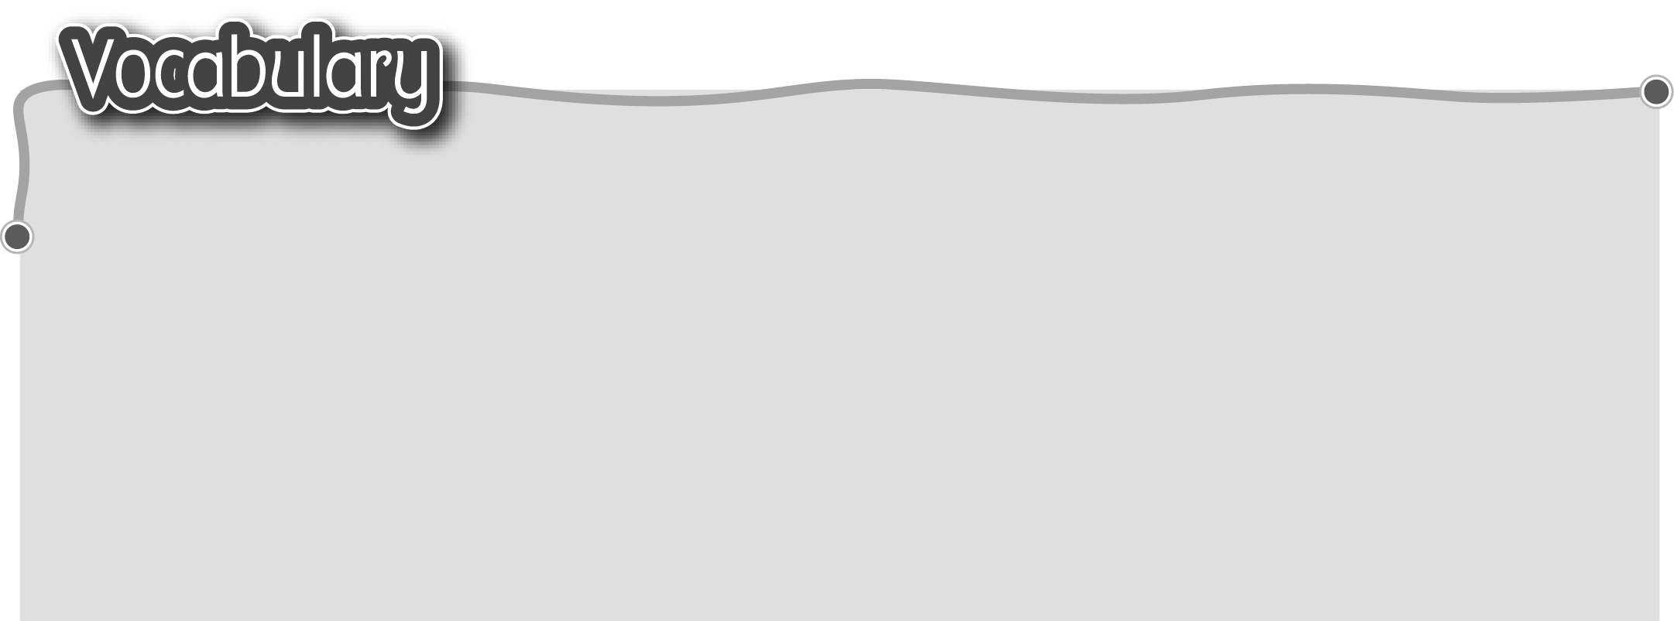
1 keep quiet 保持安靜 5 wait for your turn 輪候
The words marked with * have different meanings in other
contexts. You can look up those meanings in a dictionary.
2 sit still 端正地坐着 6 climb 攀爬
3 line up 排隊 7 spit 吐痰
4 keep off the grass 8 litter* 亂拋垃圾（動詞）
勿踏草地 9 pick the flowers 採摘花朵

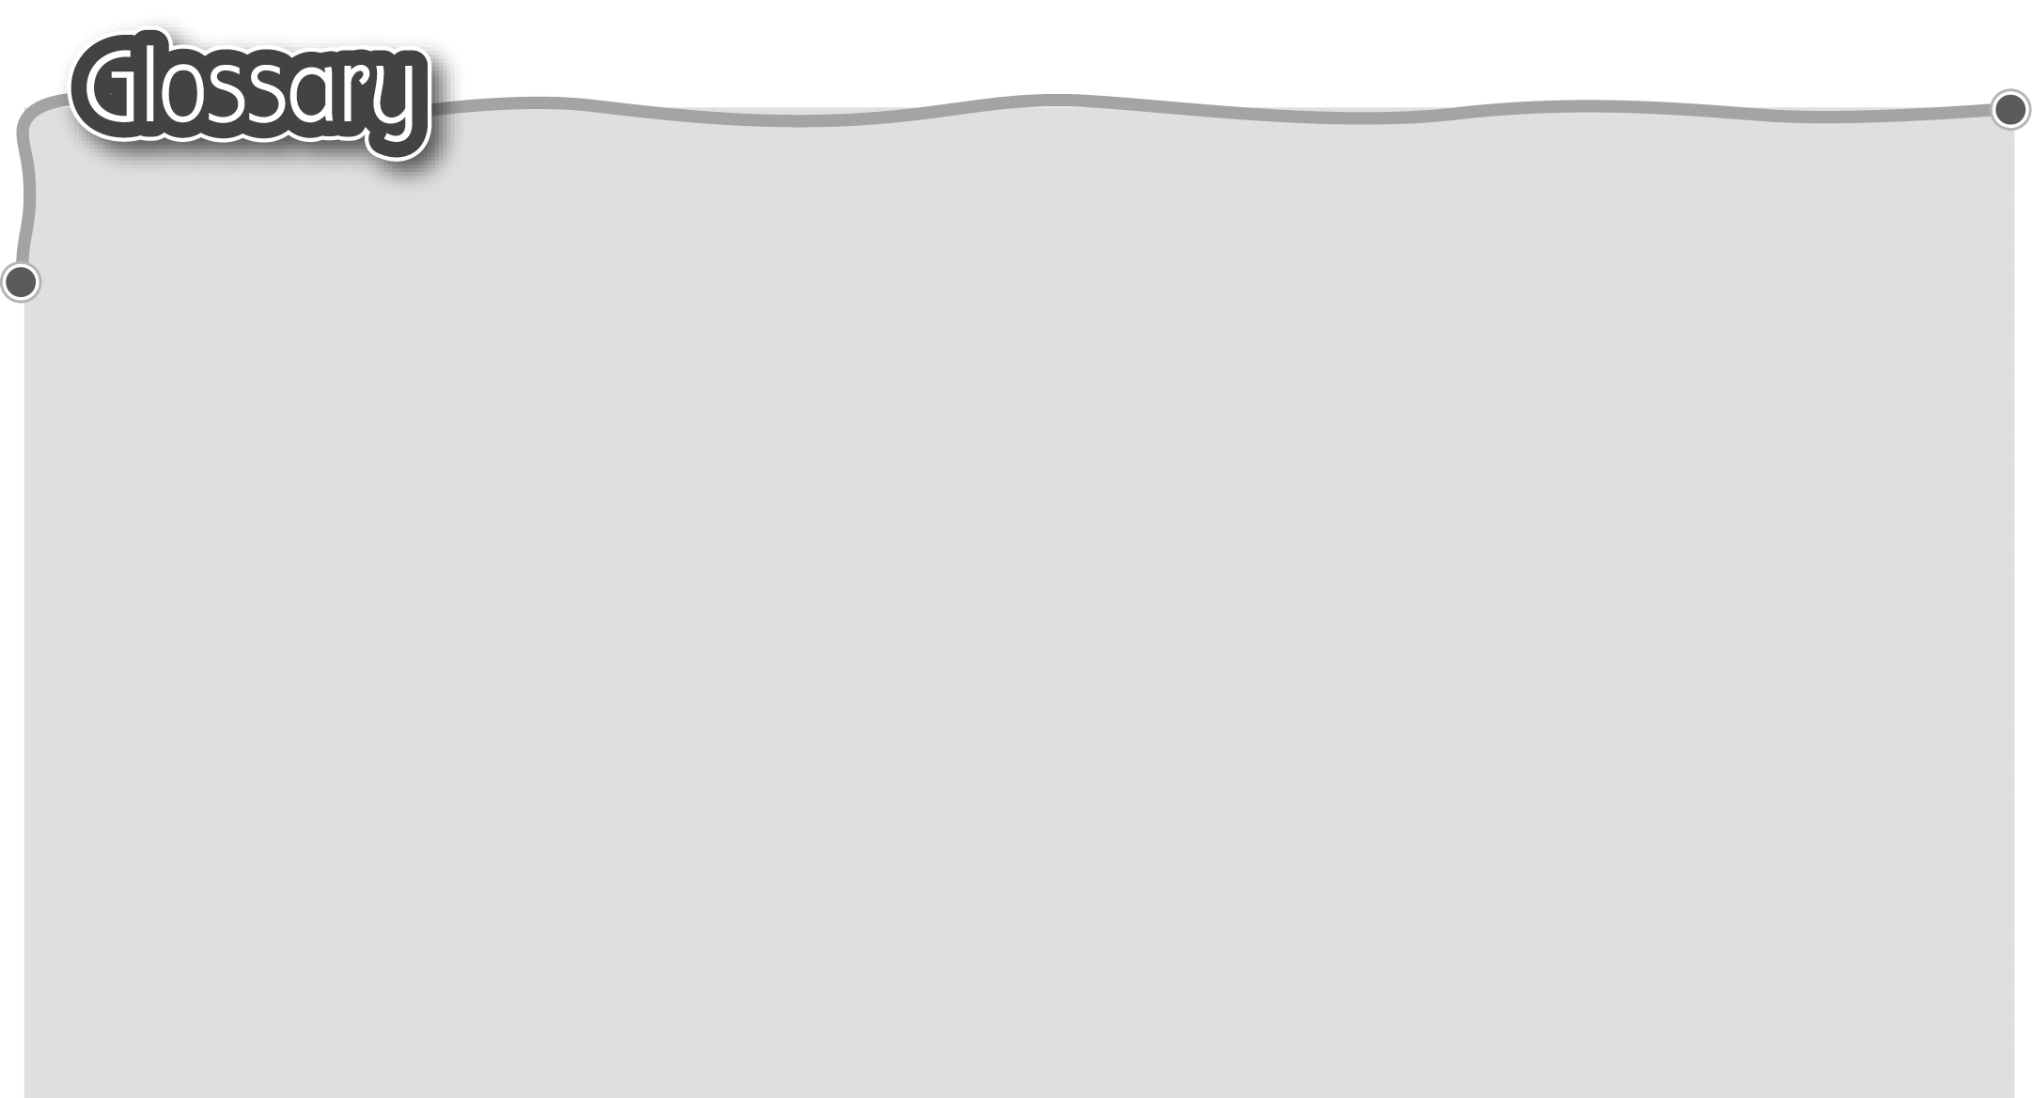
1 pupil (p.10) 學生 8 together (p.10) 一起
2 good* (p.10) 好 9 hit* (p.10) 打（動詞）
3 must (p.10) 必須 10 learn (p.10) 學習
4 corridor (p.10) 走廊 11 lots of (p.10) 很多
5 mustn’t (must not) (p.10) 12 thing* (p.10) 東西
不准/不可以 13 rule* (p.10) 規則（名詞）
6 tree (p.10) 樹 14 hall (p.13) 禮堂
7 run* (p.10) 跑（動詞）


