Task — Making a poster of rules for a place at school

1 Choose one of the places below by putting a tick () in the . Then circle the naughty children in the picture.
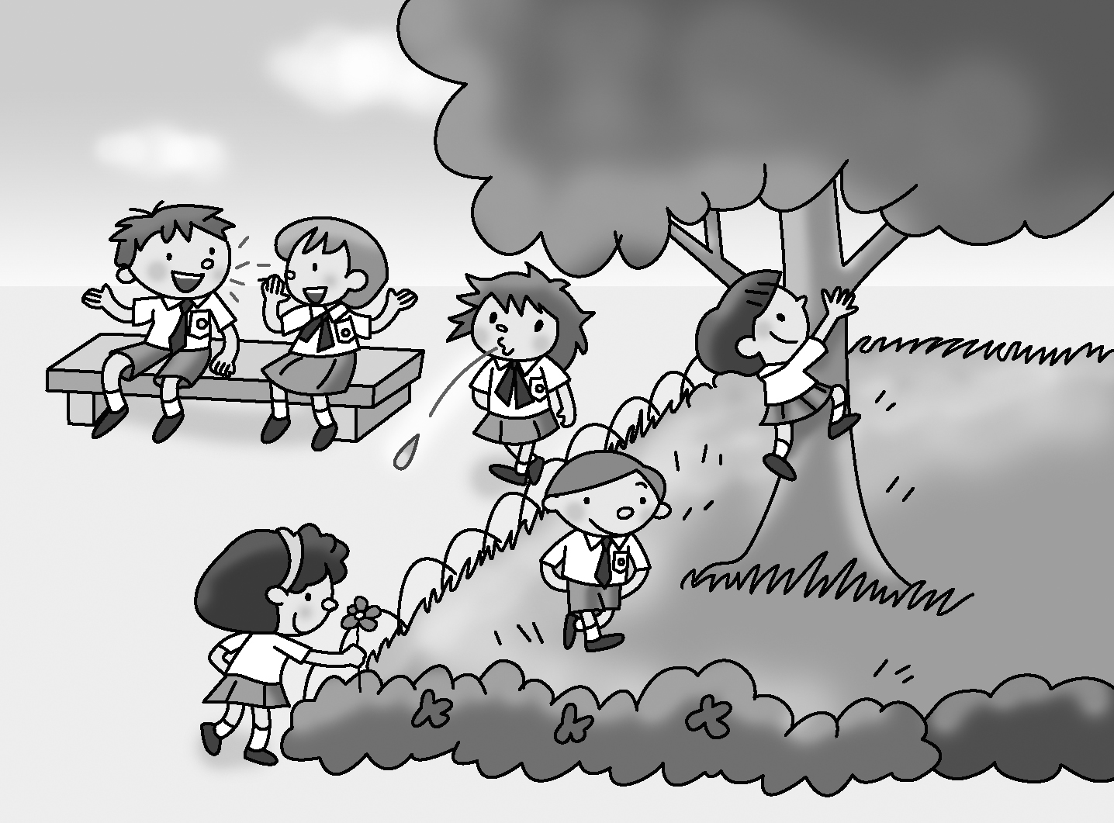

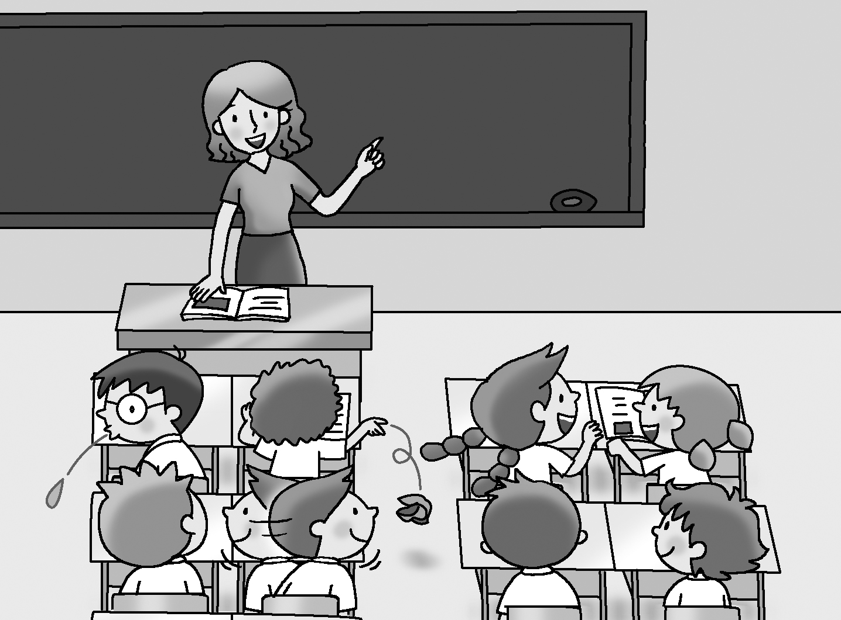

2 Write the name of the place in the blank. Think of some rules for that place and make notes. Use the hints provided.

line up pick the flowers spit litter
sit still keep off the grass keep quiet climb the tree

In the ___________________________
1.
2.
3.

3 Make a poster of rules for your place. Write the name of the place. Write
the rules using your notes. Then draw a picture.

__________________ Rules

1. You must ________________________________________________.

2. You mustn’t ______________________________________________.

3. ________________________________________________________.

4. ________________________________________________________.

5. ________________________________________________________.

6. ________________________________________________________.

Checklist for Ch 2 Task

Check your writing and tick (✓ ).

Checking for myself | ☺ ☺ | ☺ | ☹
- I can understand the topic.
- I can write school rules correctly.
- I can start each sentence with a capital letter (e.g. You mustn’t spit.).
- I can end each sentence with a full-stop (.).
- I can spell all the words (check spellings using the textbook).
- I can use must and mustn’t correctly.

Now ask your partner to check your writing and tick (✓ ).

Checking by ( _________________ ) | ☺ ☺ | ☺ | ☹
- Do I understand my partner’s writing?
- Does my partner start each sentence with a capital letter?
- Does my partner end each sentence with a full-stop (.)?
- Does my partner spell all the words correctly?
- Does my partner use must and mustn’t correctly?

Remember to make changes to your writing before you hand it in.

