Task — Making a poster of rules for a place at school

1 Choose one of the places below by putting a tick () in the . Then circle the naughty children in the picture.
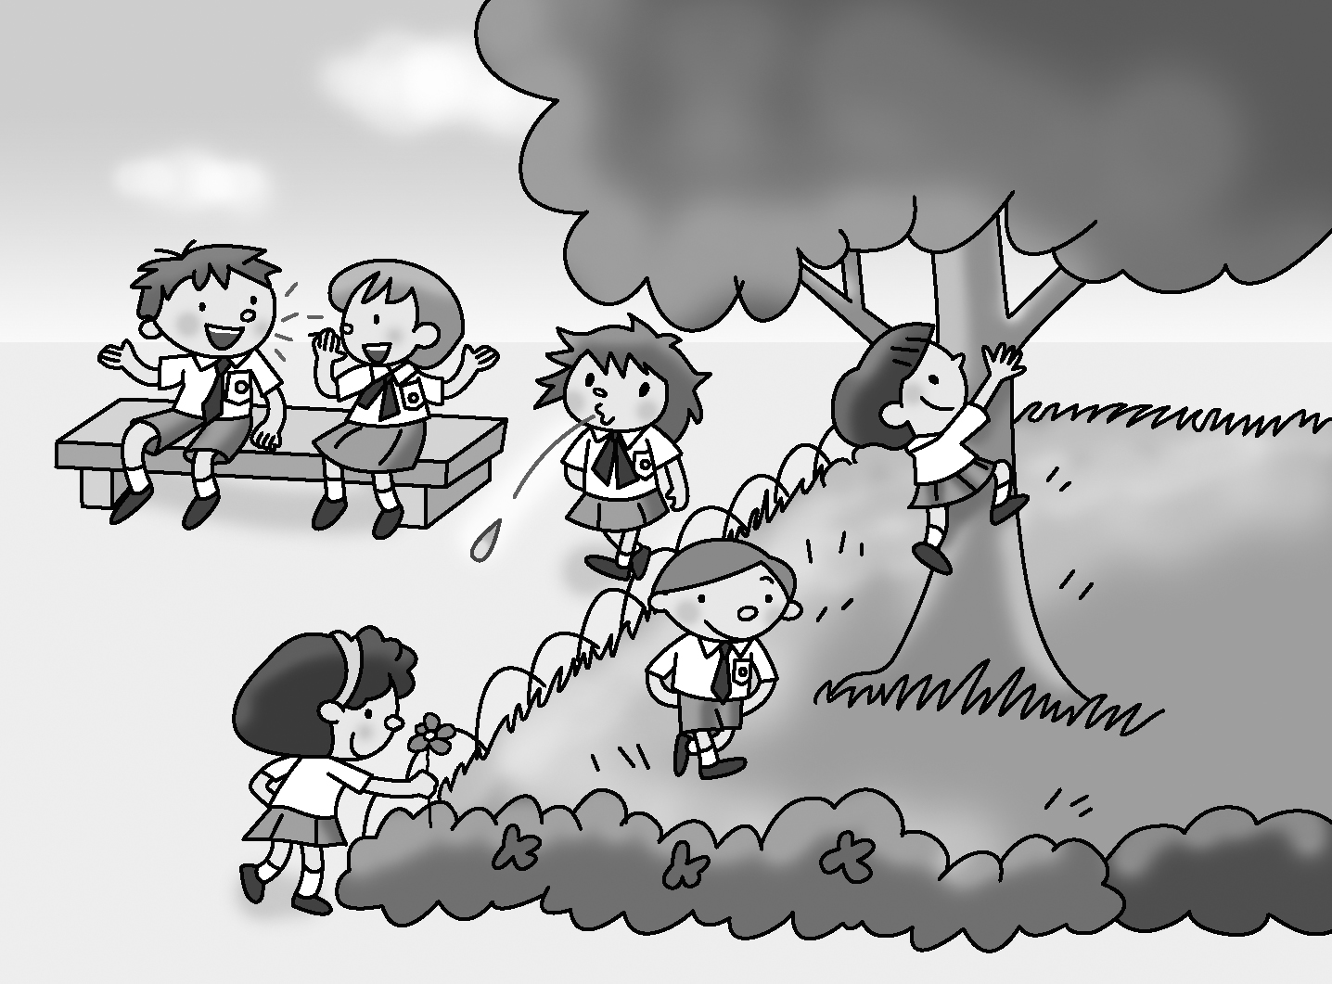

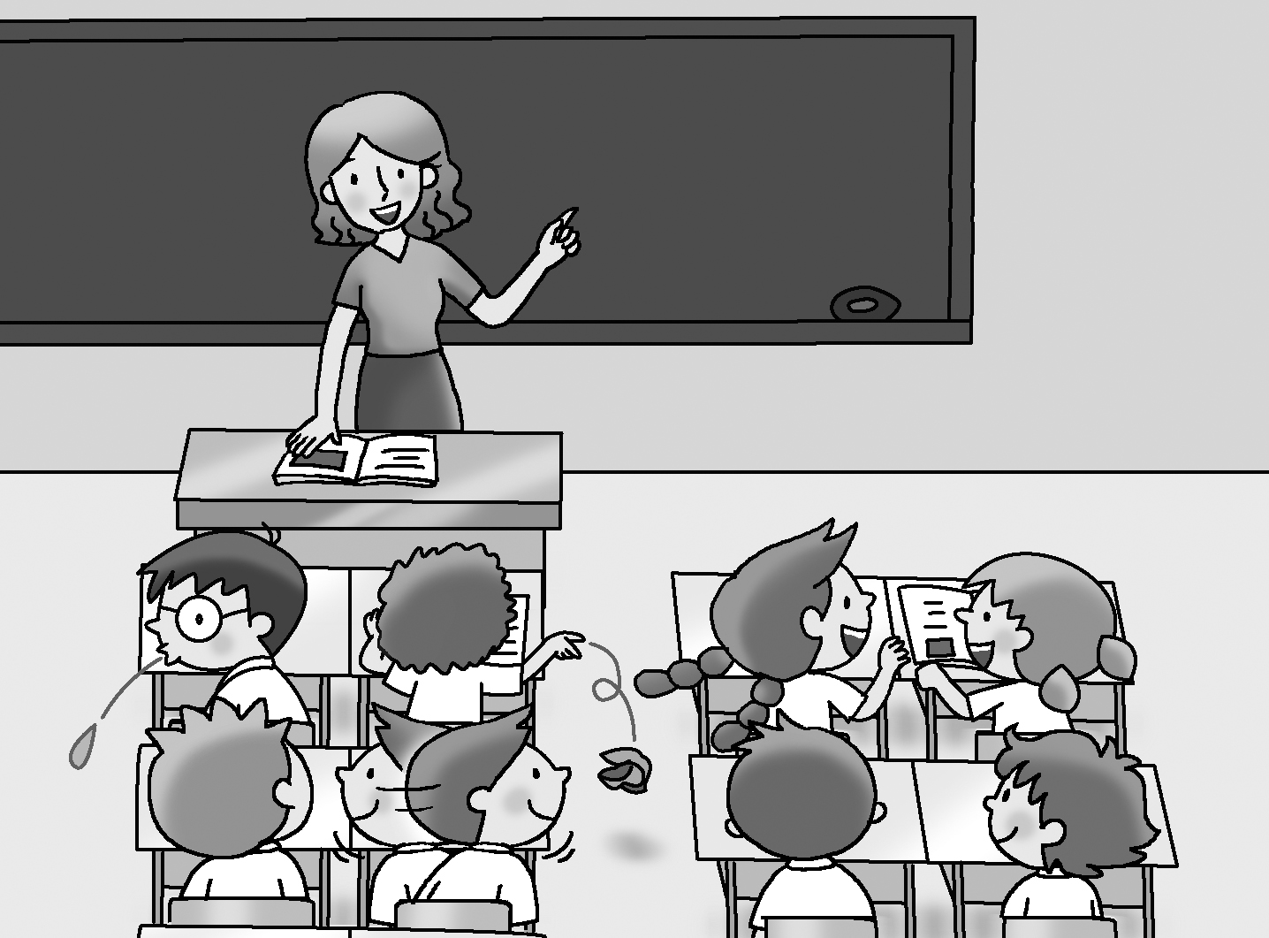

2 Write the name of the place in the blank. Think of some rules for that place and make notes.

In the ___________________________
1.
2.
3.

3 Make a poster of rules for your place. Write the name of the place. Write
the rules using your notes. Then draw a picture.

__________________ Rules

1. ________________________________________________________.

2. ________________________________________________________.

3. ________________________________________________________.

4. ________________________________________________________.

5. ________________________________________________________.

6. ________________________________________________________.

Checklist for Ch 2 Task

Check your writing and tick (✓ ).

Checking for myself | ☺ ☺ | ☺ | ☹
- I can understand the topic.
- I can write school rules correctly.
- I can start each sentence with a capital letter (e.g. You mustn’t spit.).
- I can end each sentence with a full-stop (.).
- I can spell all the words (check spellings using the textbook).
- I can use must and mustn’t correctly.

Now ask your partner to check your writing and tick (✓ ).

Checking by ( _________________ ) | ☺ ☺ | ☺ | ☹
- Do I understand my partner’s writing?
- Does my partner start each sentence with a capital letter?
- Does my partner end each sentence with a full-stop (.)?
- Does my partner spell all the words correctly?
- Does my partner use must and mustn’t correctly?

Remember to make changes to your writing before you hand it in.

