Choose and write.
bored | hungry | thirsty | tired

1 | 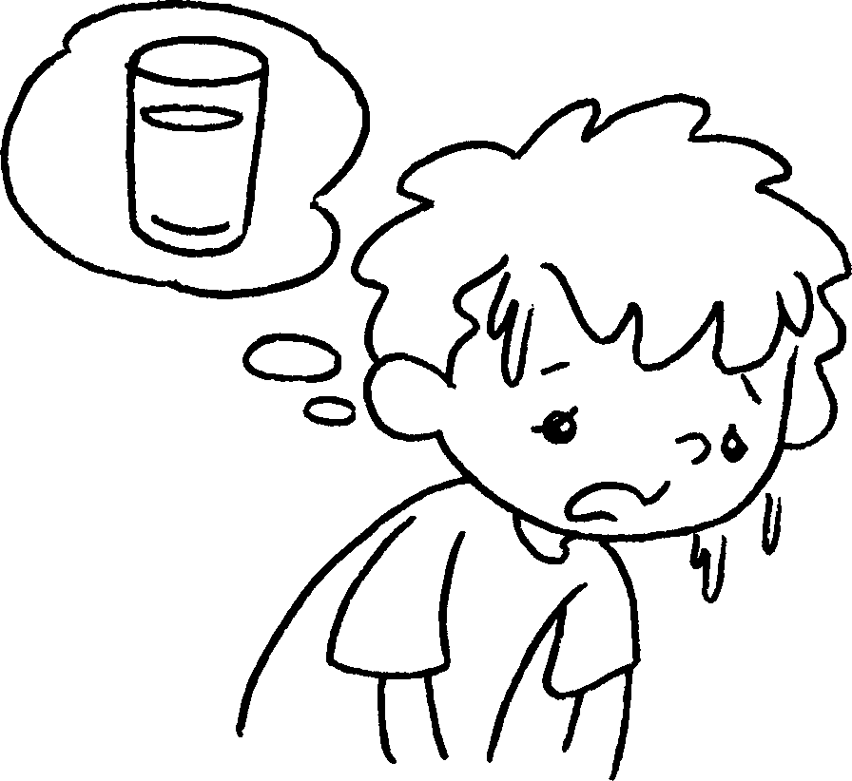 | 2 | 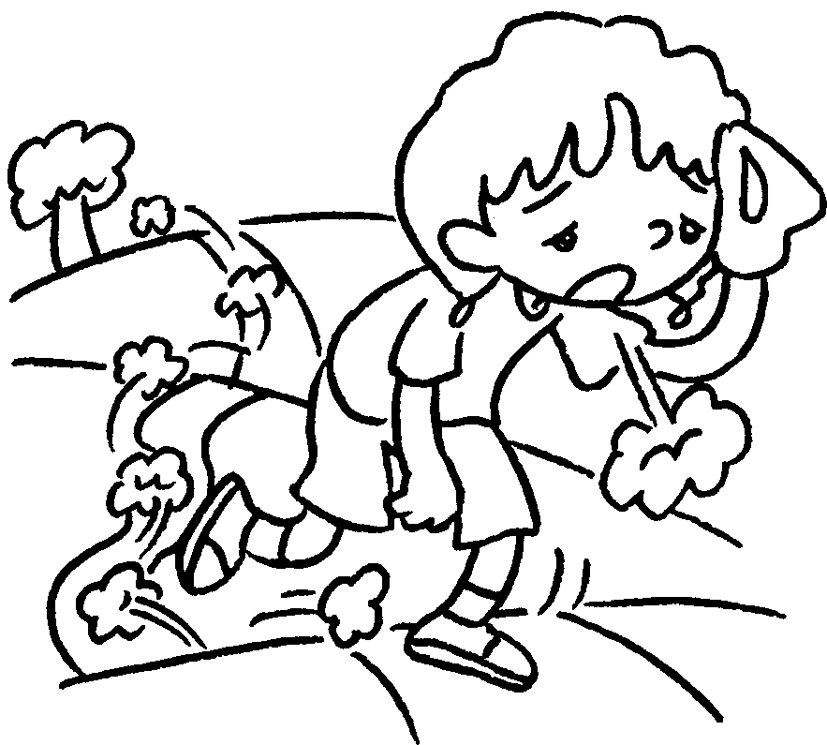 | 3 | 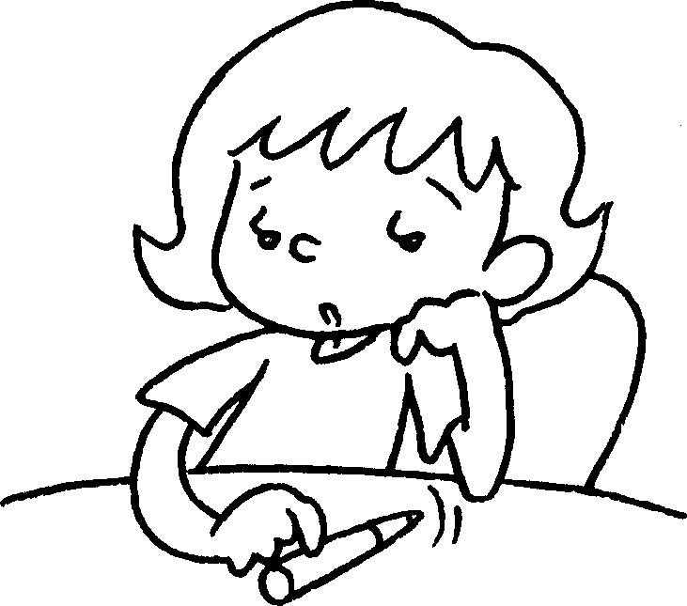 | 4 | 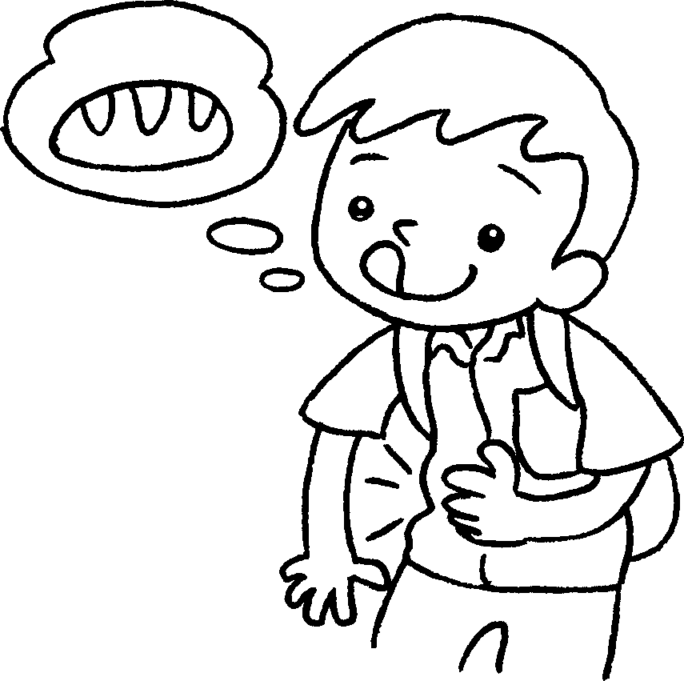

1 |  |  | 2
3 |  |  | 4

biscuits | comics | cakes | DVDs | juice | rest | water

 |  | 5 | 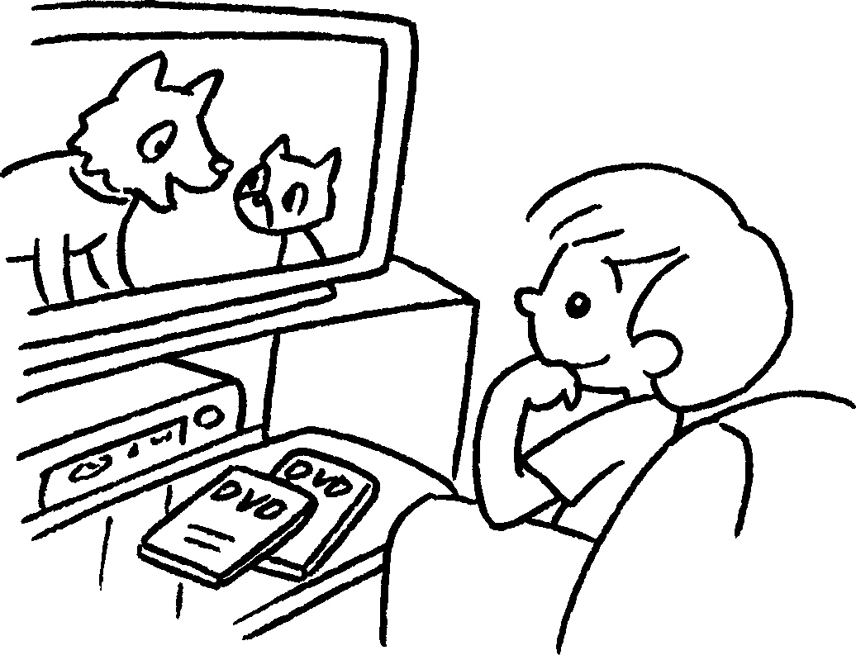 |  |  | 6 | 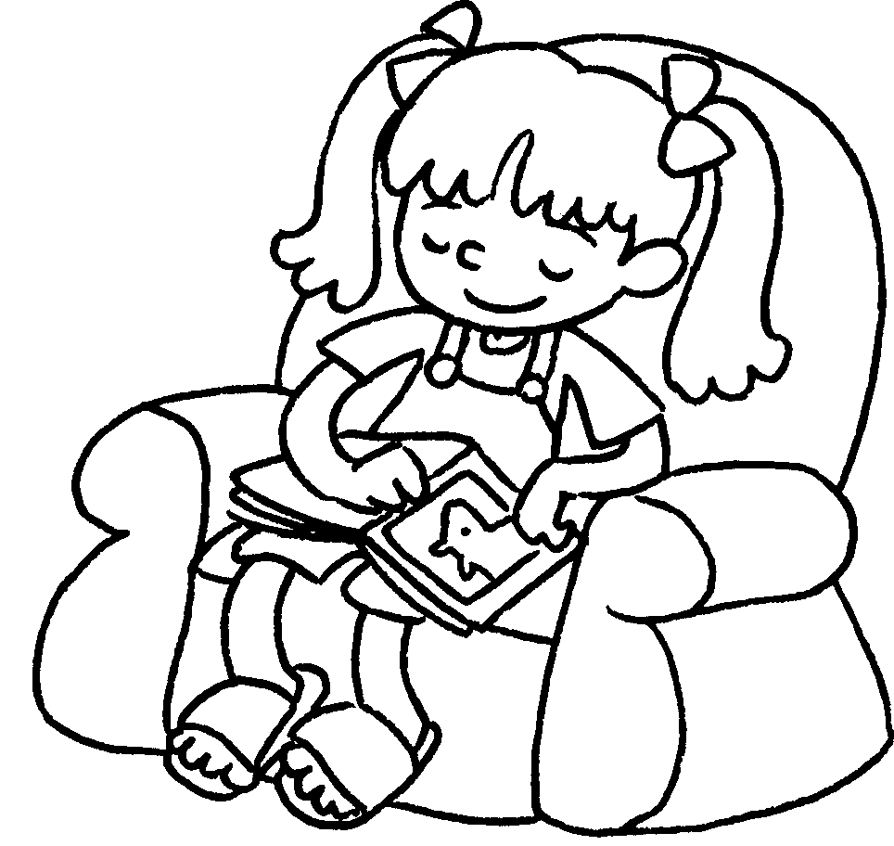 |  |  | 7 | 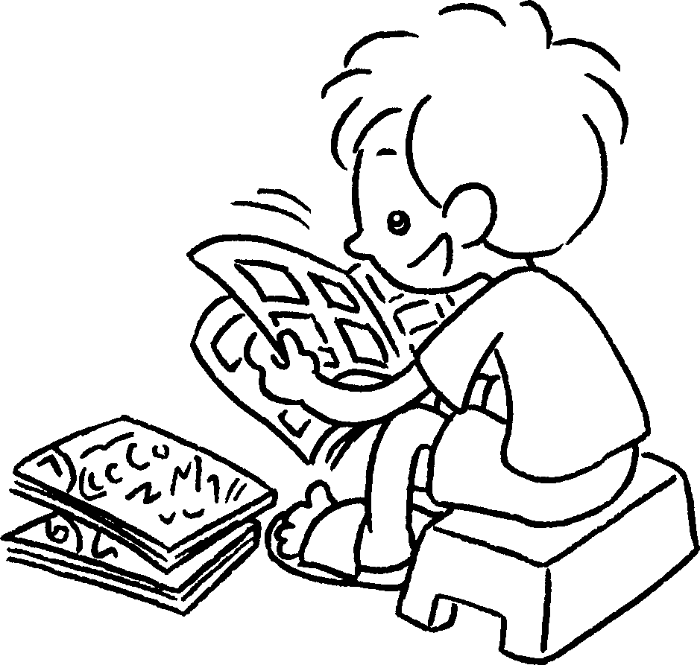
8 | 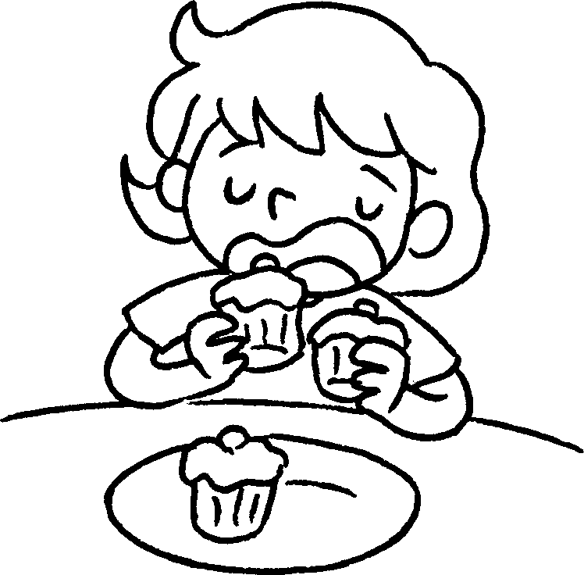 |  |  | 9 | 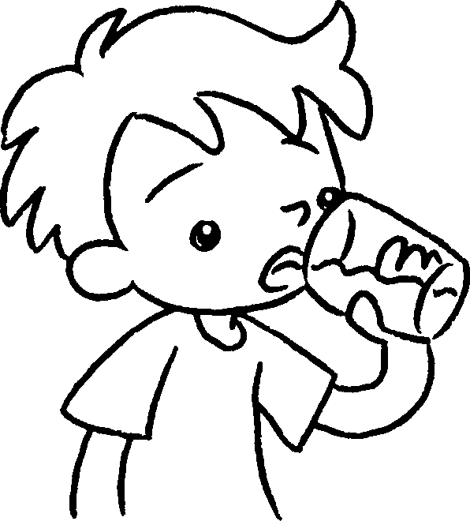 |  |  | 10 | 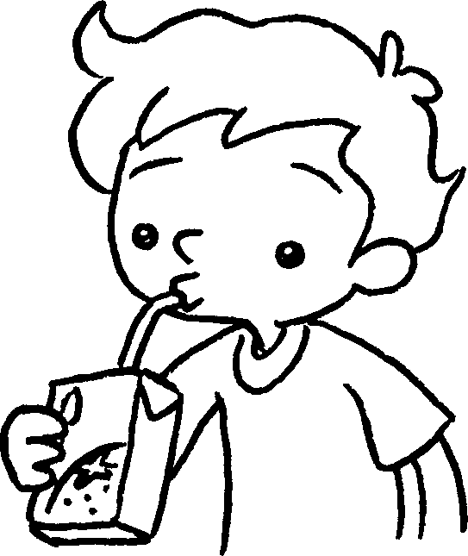 |  |  | 11 | 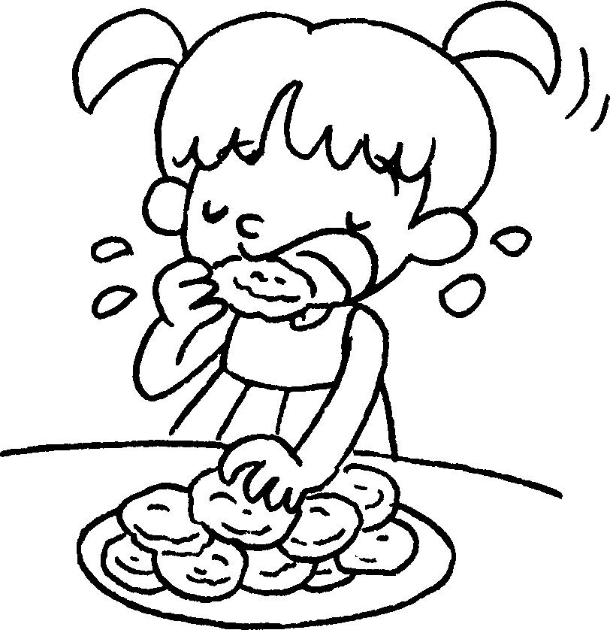

5 | watch |  | 6 | take a
7 | read |  | 8 | eat some
9 | drink some |  | 10 | drink some
11 | eat some

Book 2A Chapter 3 Graded Worksheets

Worksheet 1⬇
- thirsty 2 tired
3 bored 4 hungry
5 DVDs 6 rest
7 comics 8 cakes
9 water 10 juice
11 biscuits

