How do the children feel? Fill in the missing letters.

1 | 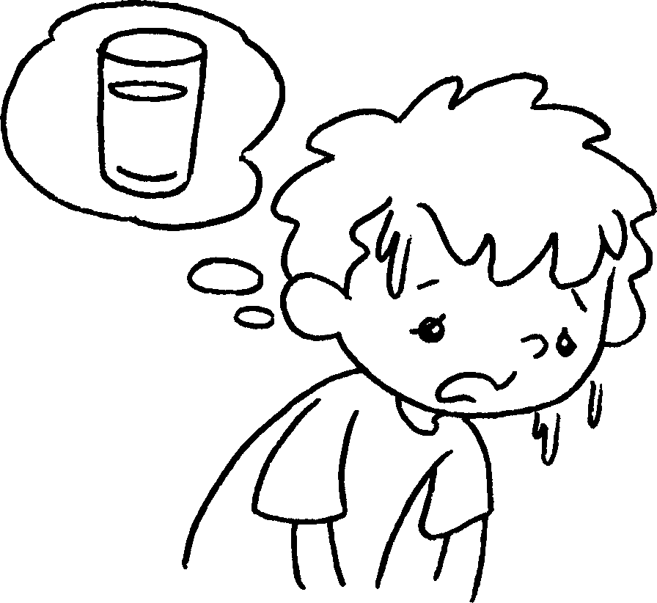 | 2 | 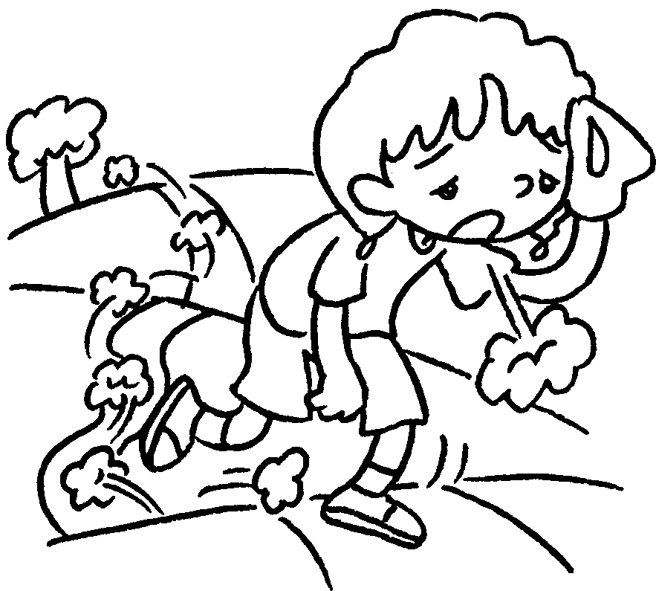 | 3 | 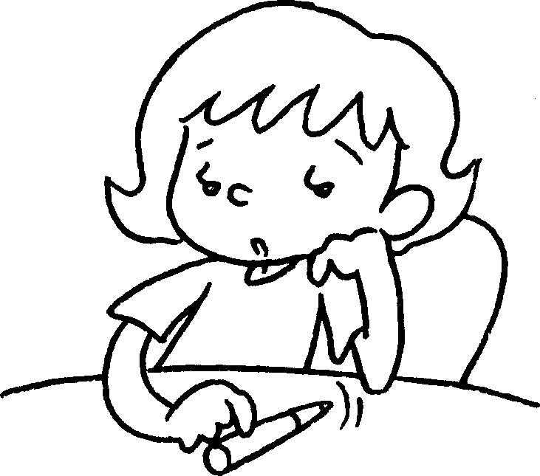 | 4 | 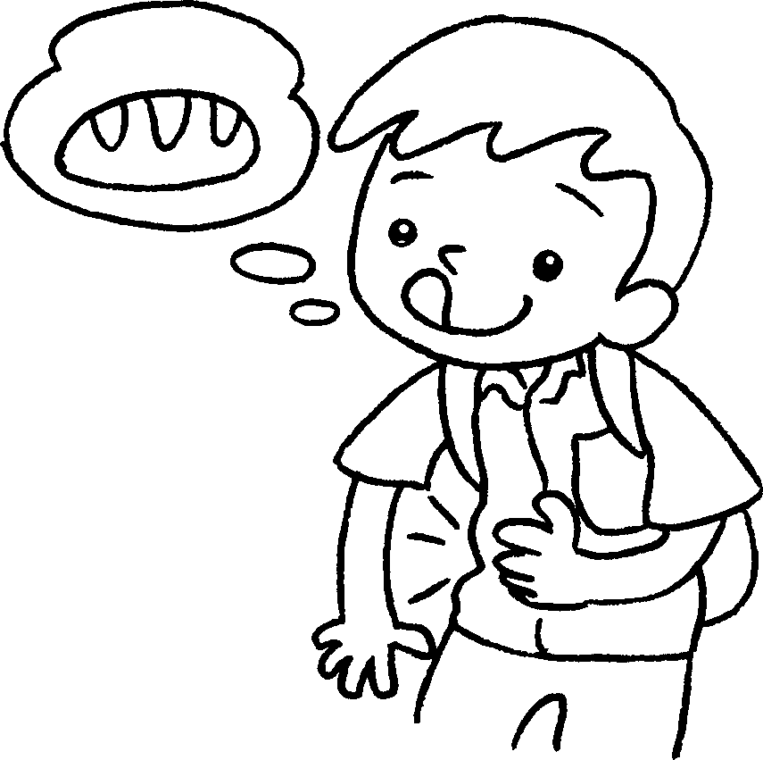

1 | t __ __ __ __ __ __ |  | 2 | t __ __ __ __
3 | b __ __ __ __ |  | 4 | h __ __ __ __ __

Look at the pictures and fill in the missing letters.

 |  | 5 | 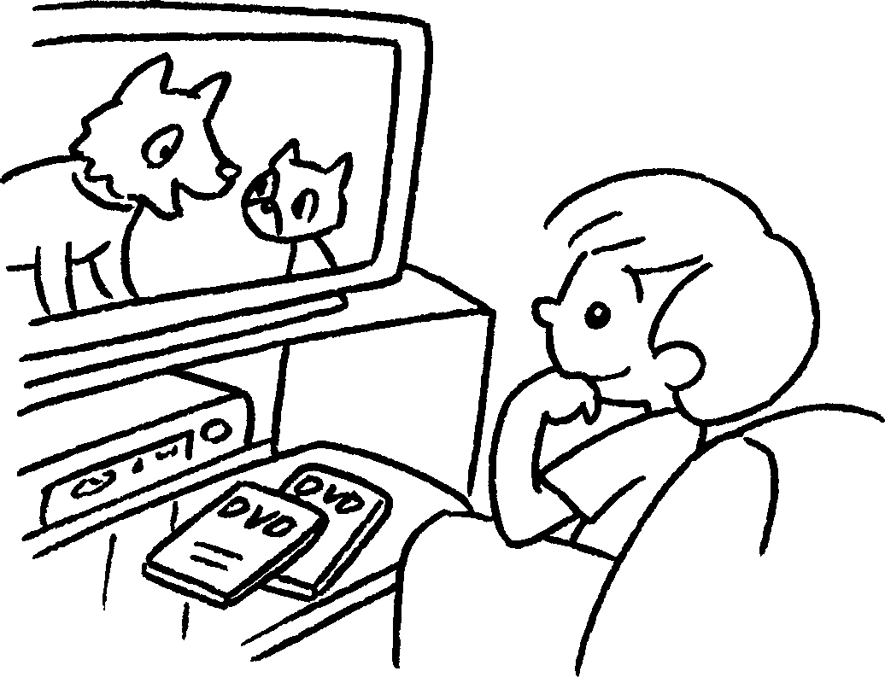 |  |  | 6 | 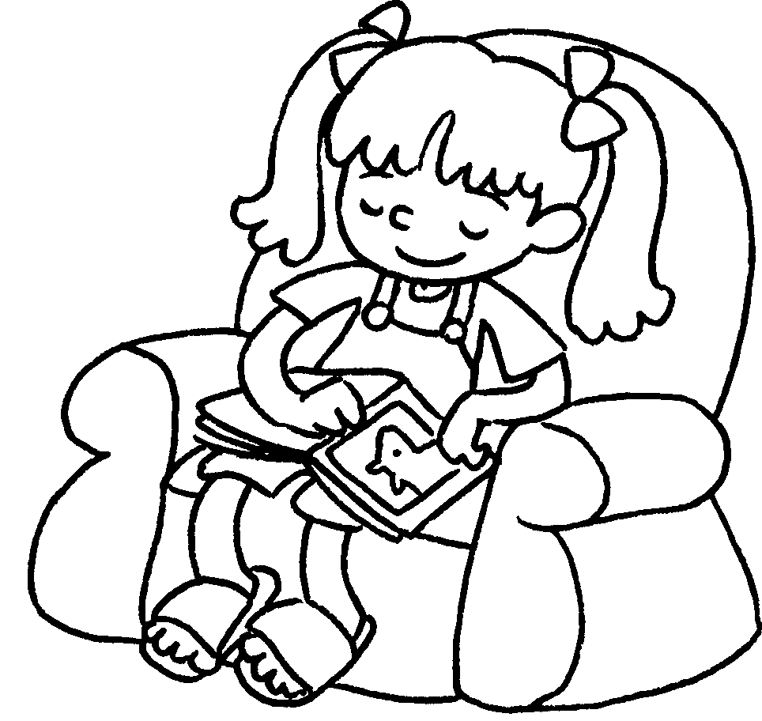 |  |  | 7 | 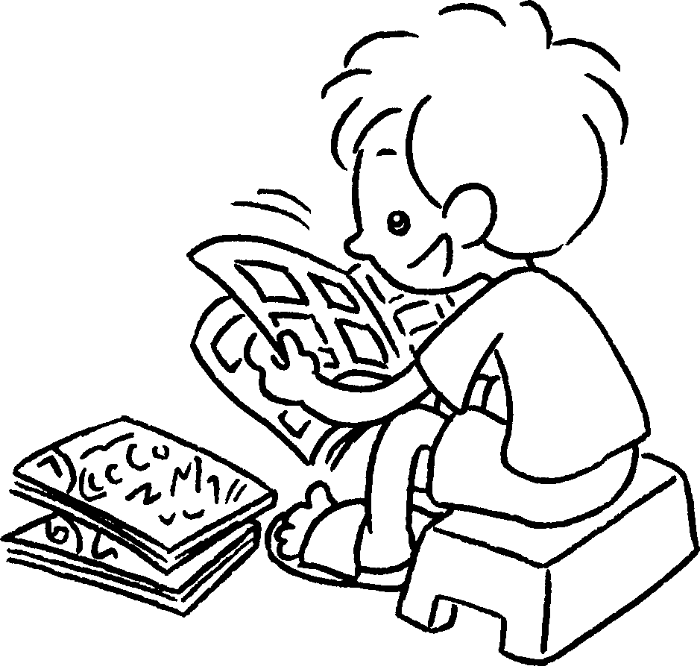
8 | 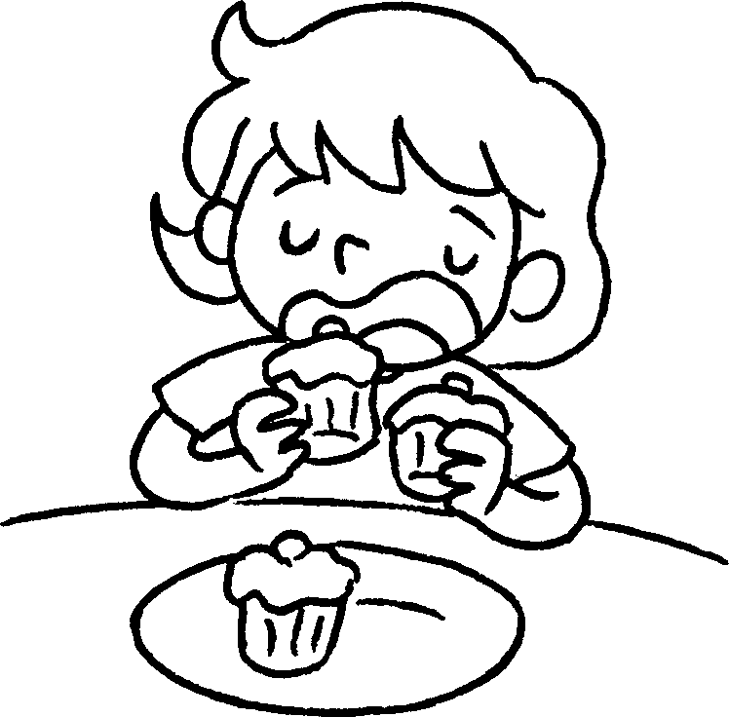 |  |  | 9 | 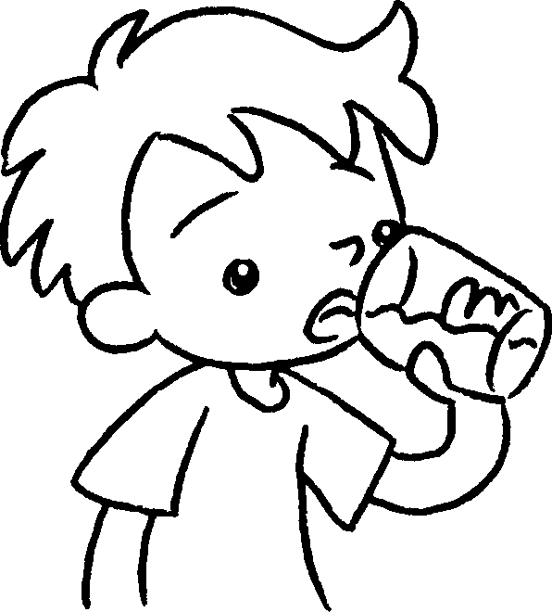 |  |  | 10 | 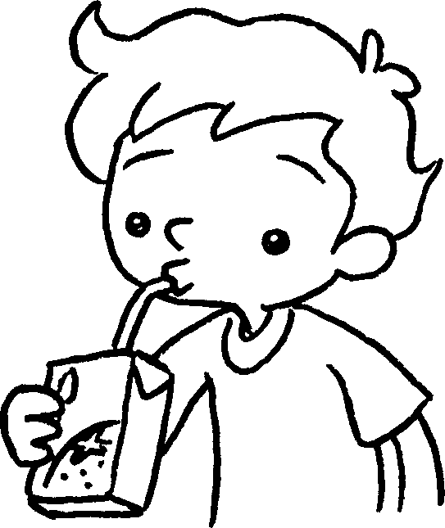 |  |  | 11 | 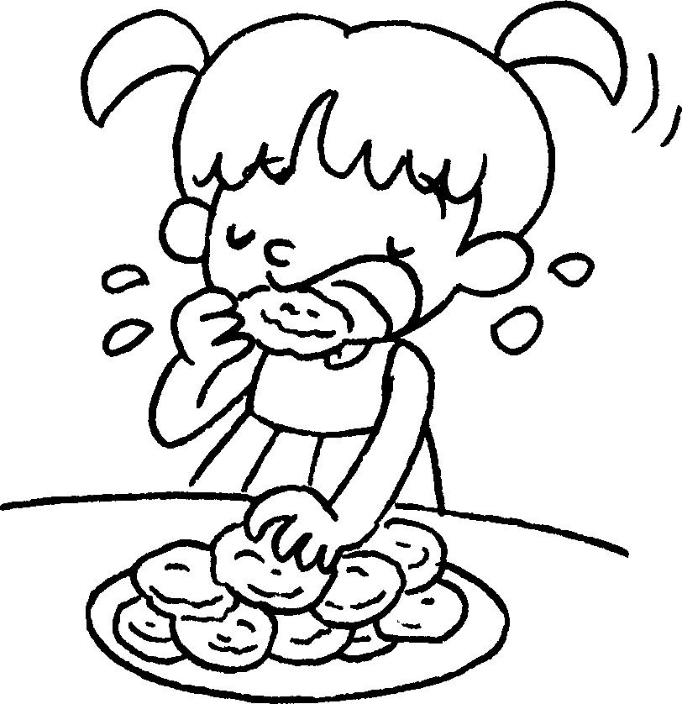

5 | watch D __ __ __ |  | 6 | take a r __ __ __
7 | read c __ __ __ __ __ |  | 8 | eat some c __ __ __ __
9 | drink some w __ __ __ __ |  | 10 | drink some j __ __ __ __
11 | eat some b __ __ __ __ __ __ __


Book 2A Chapter 3 Graded Worksheets
Worksheet 1⬇⬇
- t h i r s t y 2 t i r e d
3 b o r e d 4 h u n g r y
5 D V D s 6 r e s t
7 c o m i c s 8 c a k e s
9 w a t e r 10 j u i c e
11 b i s c u i t s

