Circle and write.
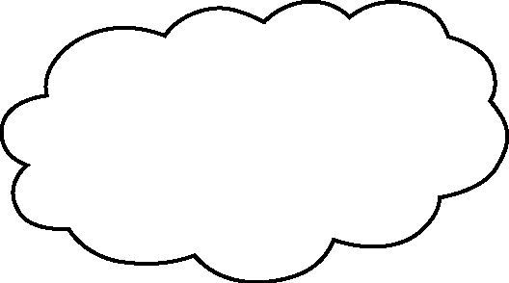
too

1 | 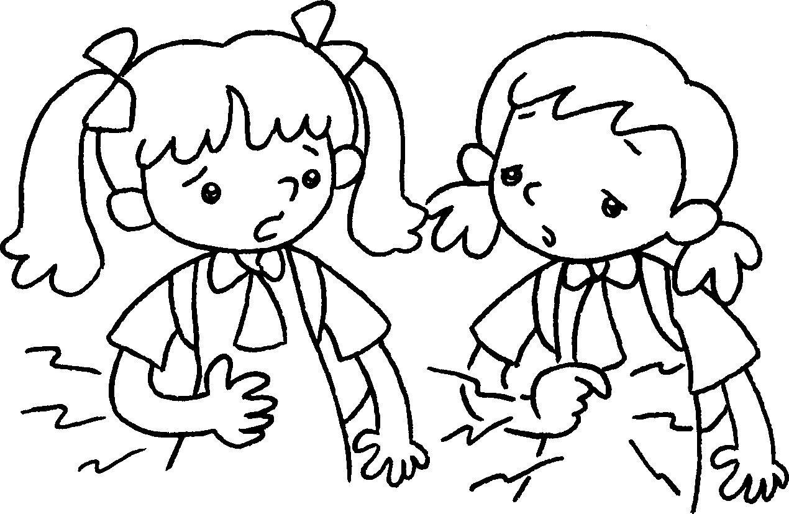  A  B  B  A | A : I’m ( hungry / thirsty ).  B : I’m .
2 | 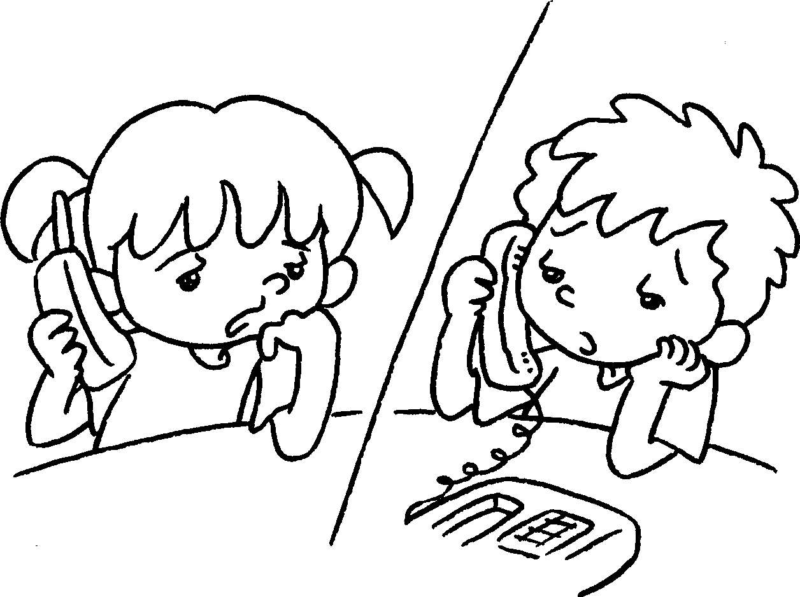 | A : I’m ( thirsty / bored ) .  B : I’m .
3 | 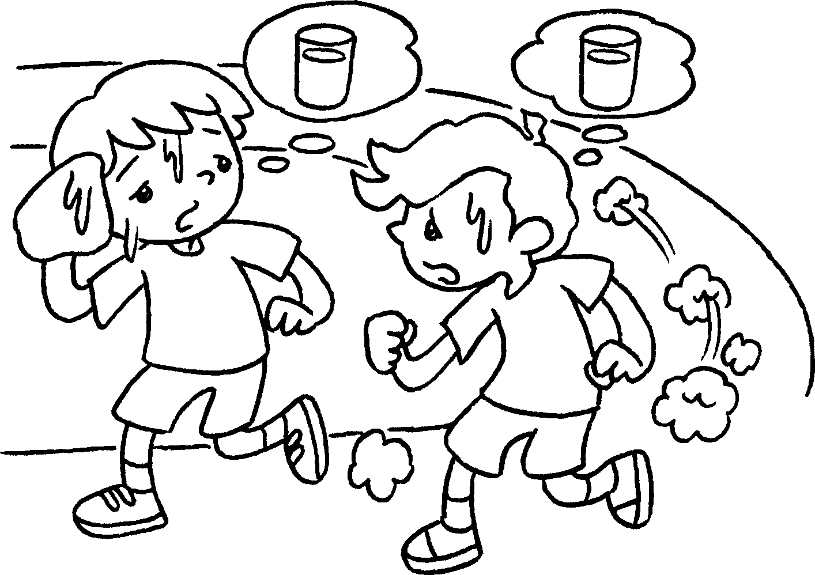  B  A  B  A | A : I’m ( thirsty / hungry ) .  B : I’m .
4 | 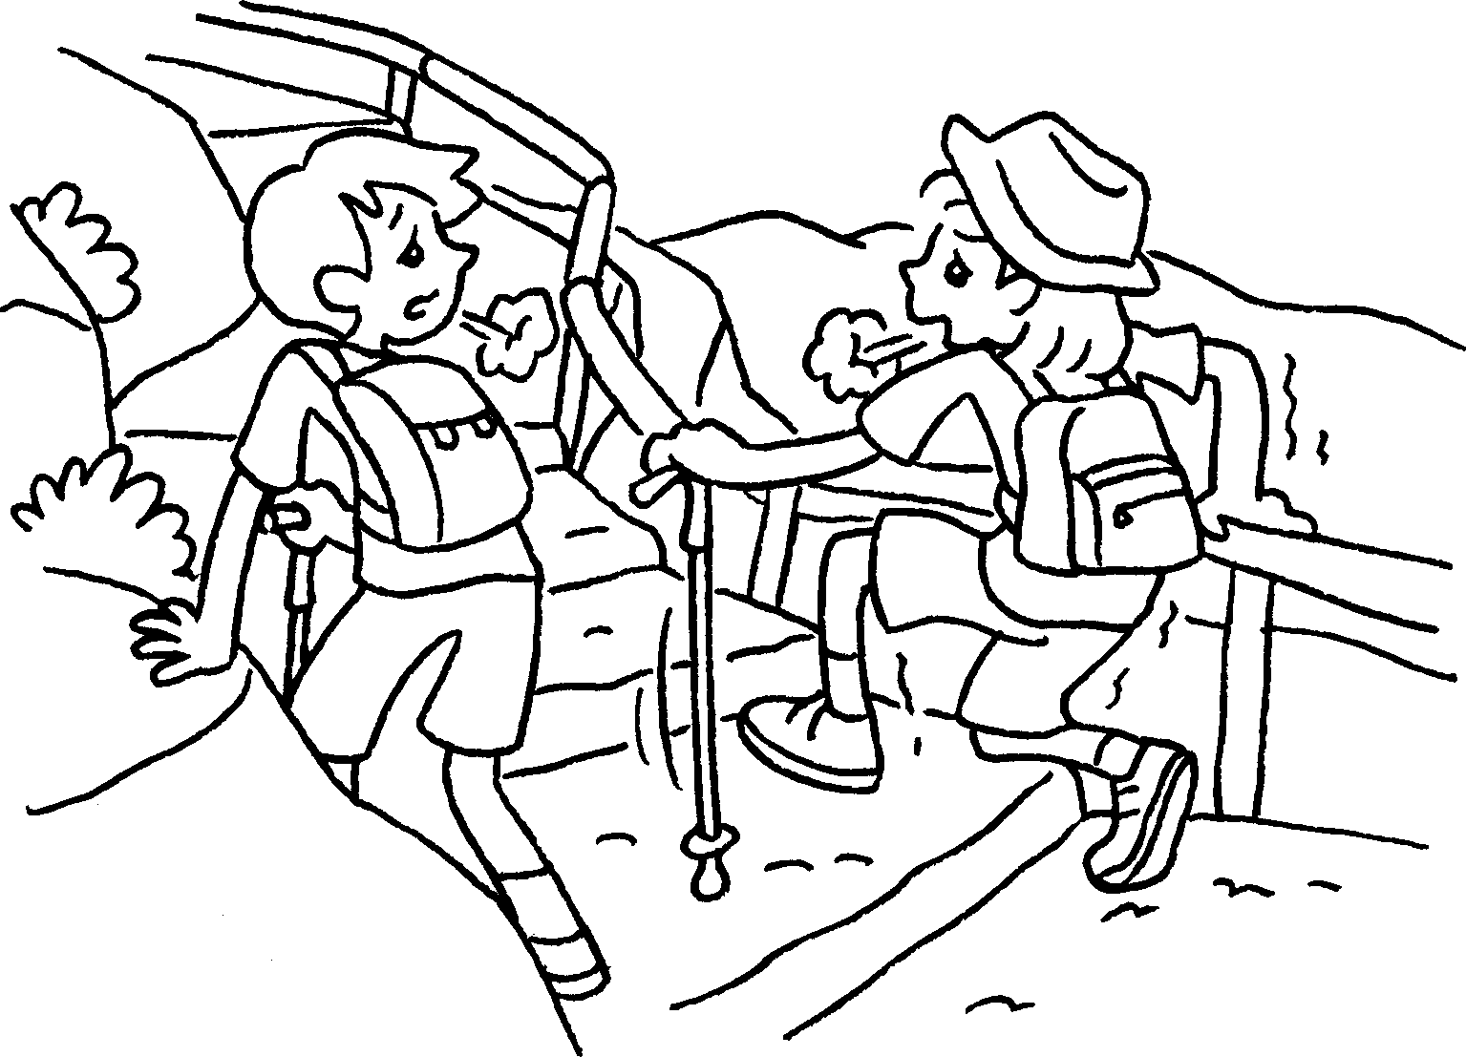 | A : I’m ( tired / bored ) .  B : I’m .

Book 2A Chapter 3 Graded Worksheets

Worksheet 2⬇
- ( hungry / thirsty )
hungry too
- ( thirsty / bored )
bored too
- ( thirsty / hungry )
thirsty too
- ( tired / bored )
tired too

