Choose and write.
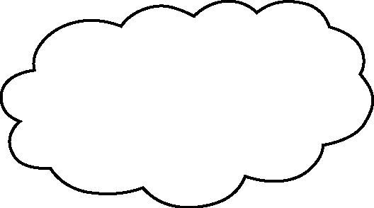  too | thirsty | tired | bored

1 | 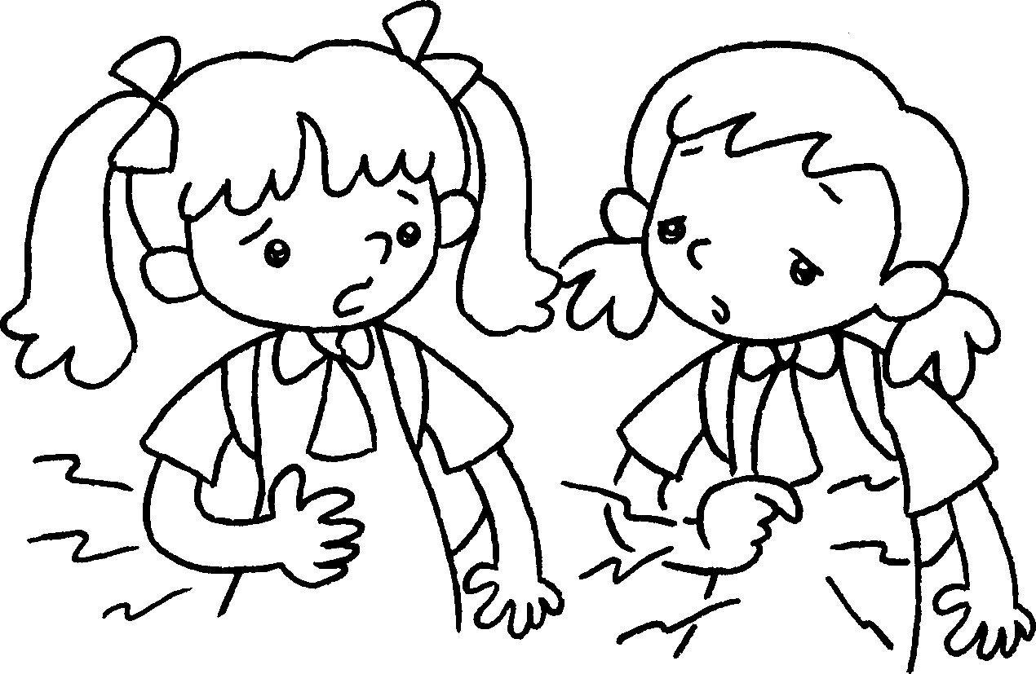  A  B  B  A | A : I’m hungry.  B : I’m hungry .
2 | 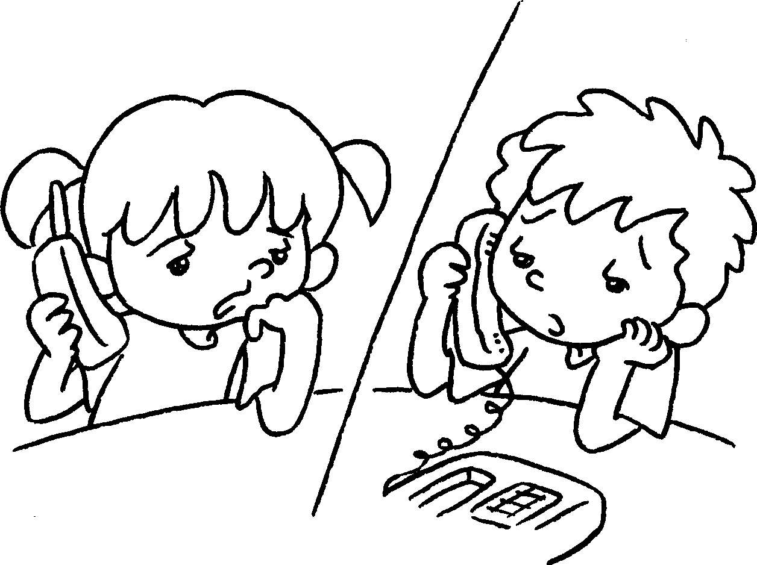 | A : I’m .  B : I’m .
3 | 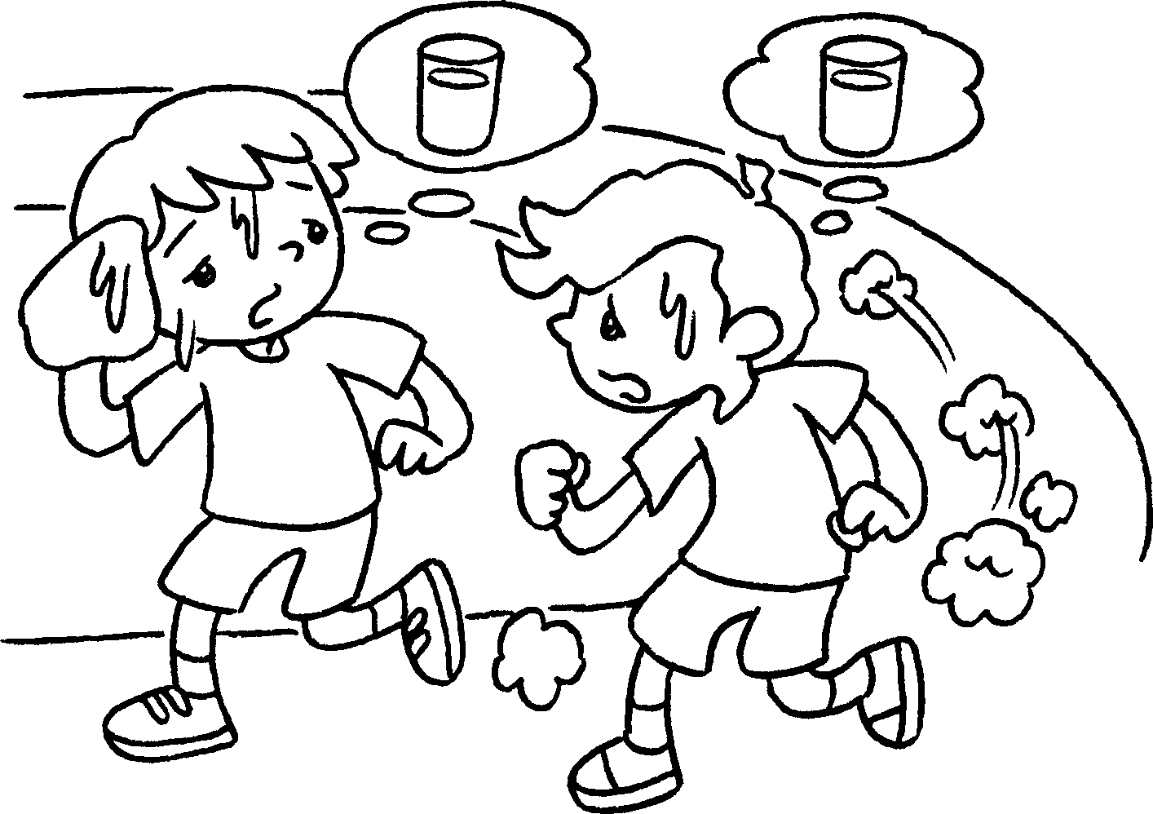  B  A  A  B | A : I’m .  B : I’m .
4 | 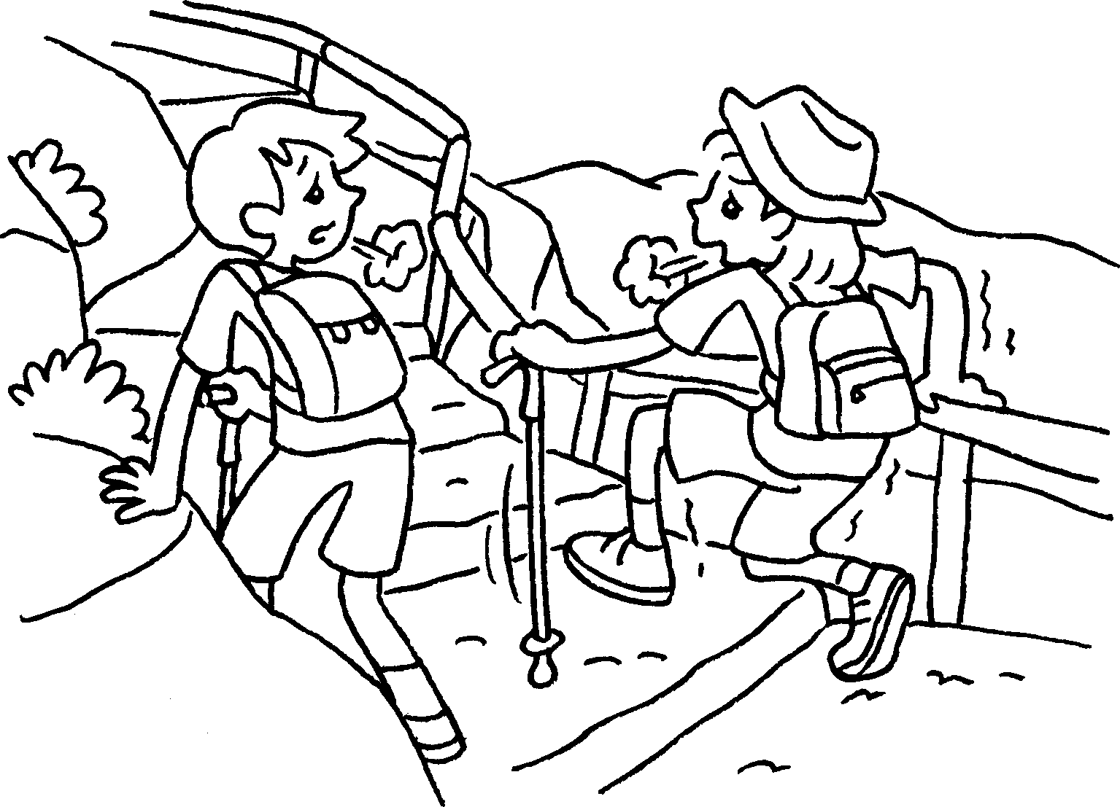 | A : I’m .  B : I’m .


Book 2A Chapter 3 Graded Worksheets
Worksheet 2⬇⬇
- too
- bored
bored too
- thirsty
thirsty too
- tired
tired too

