How do the people feel? Write.

1 | 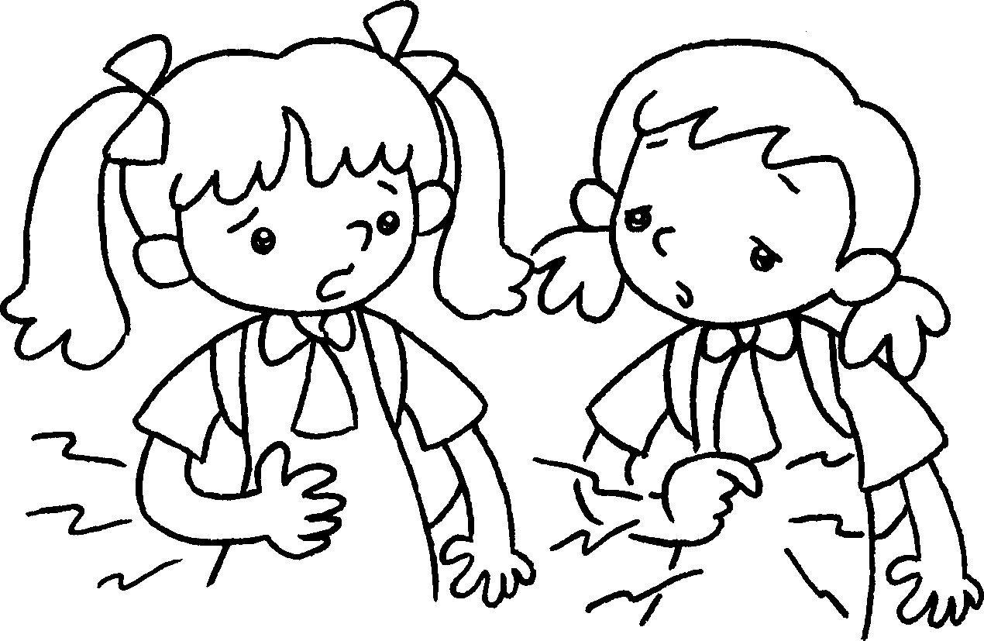  A  B  B  A | A : I’m hungry.  B : I’m .  too
2 | 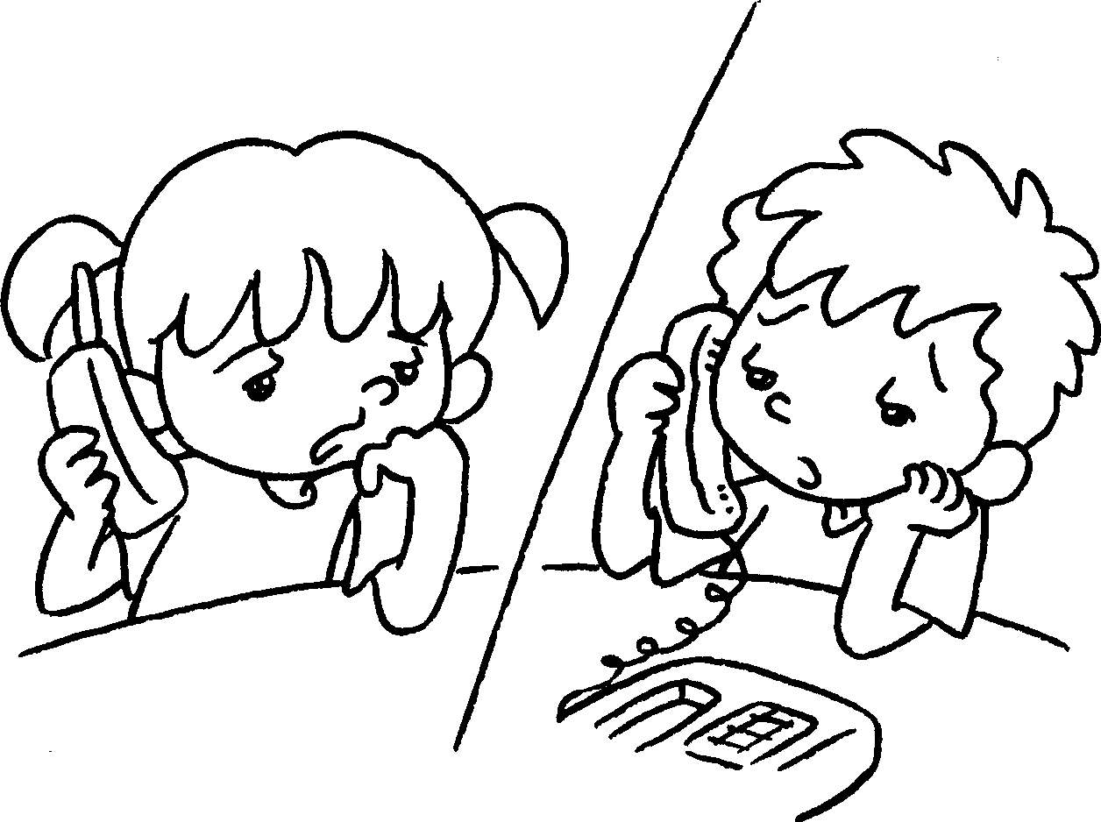 | A : I’m b .  B : I’m .
3 | 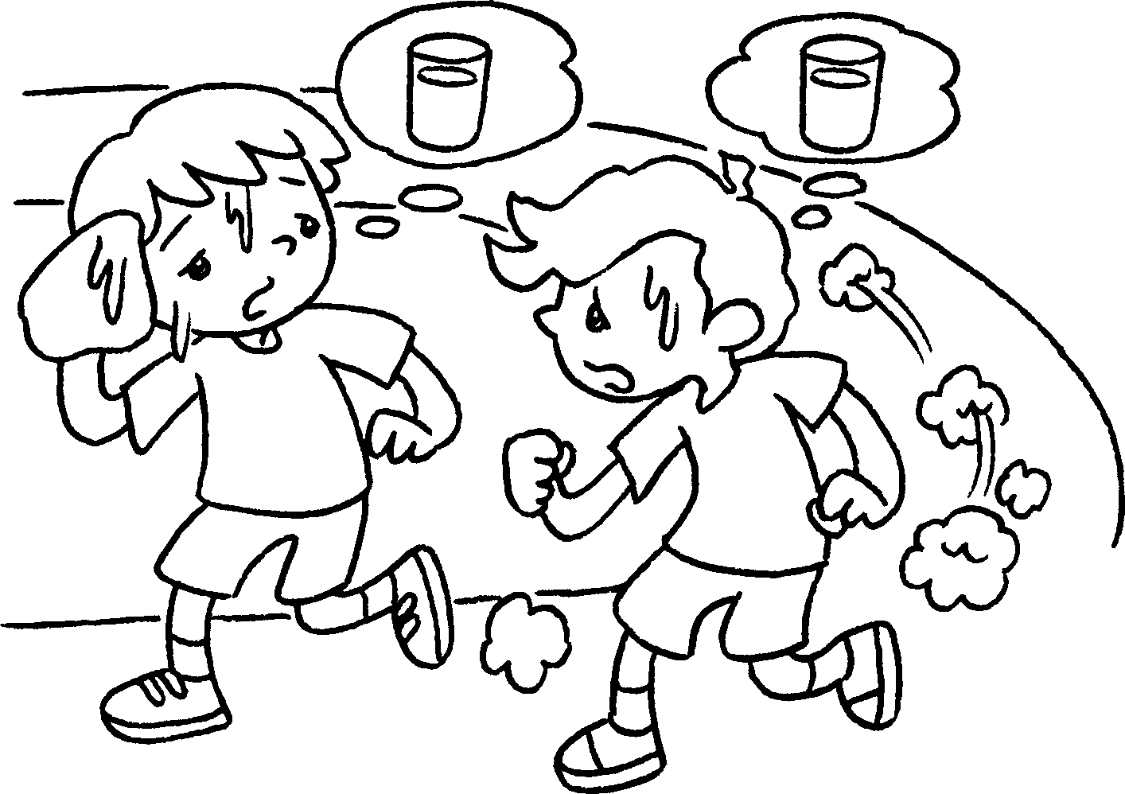  B  A  A  B | A : I’m t .  B : I’m .
4 | 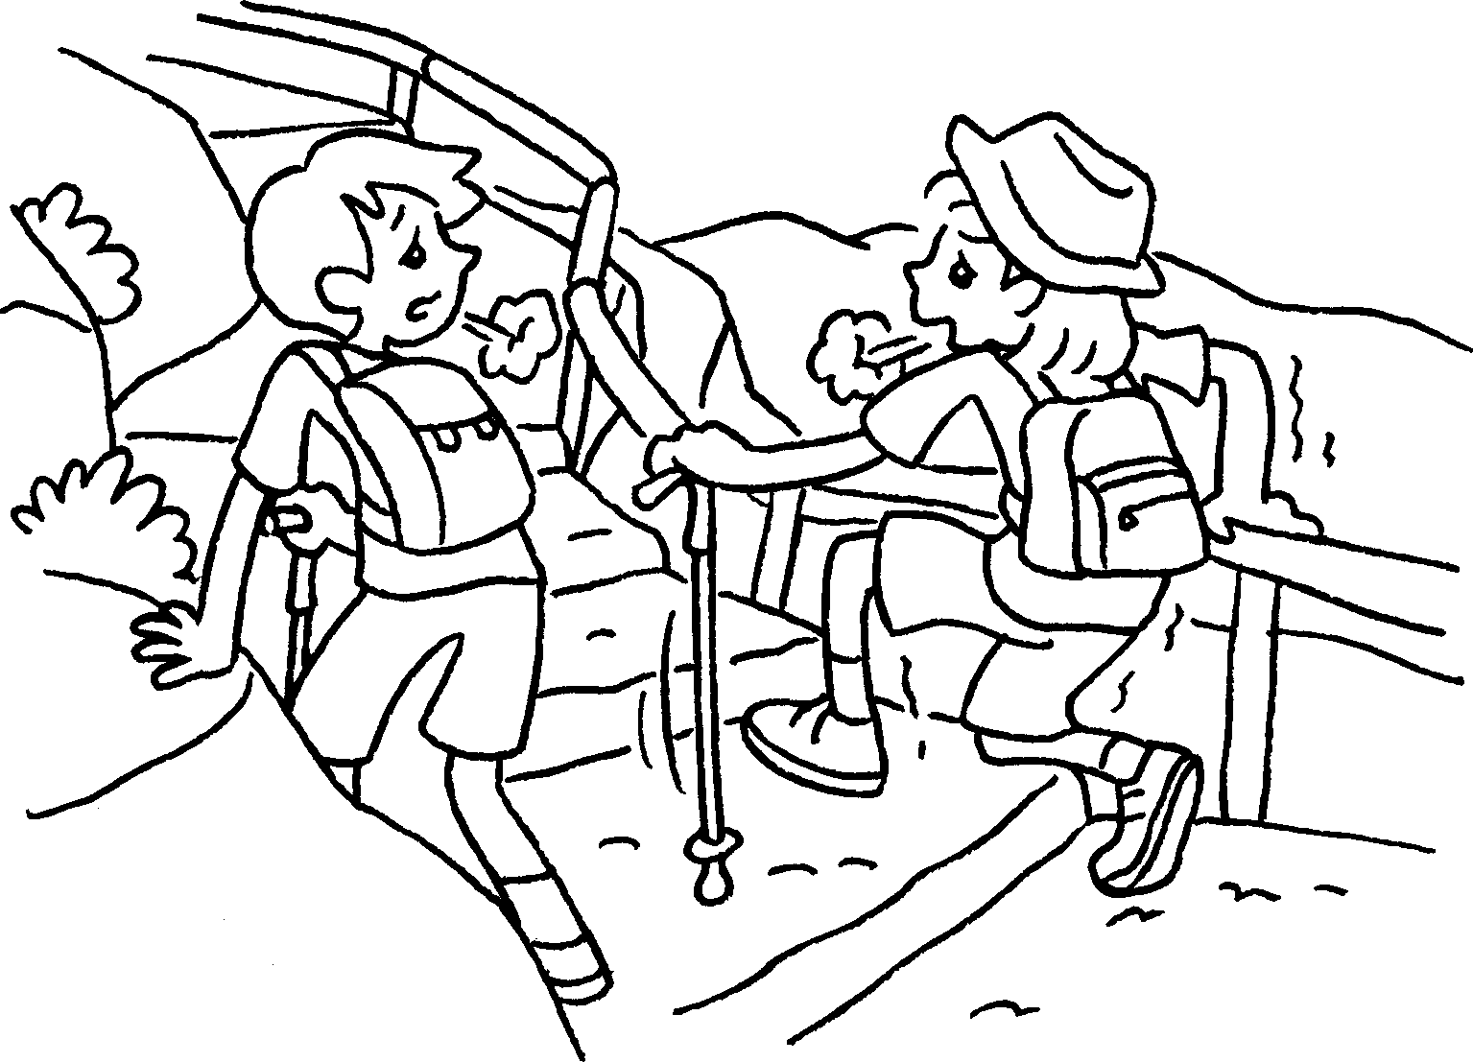 | A : I’m t .  B : I’m .

Book 2A Chapter 3 Graded Worksheets
Worksheet 2⬇⬇⬇
1 hungry
- bored
bored too
- thirsty
thirsty too
- tired
tired too

