B
A
B
A
B
A
B
A

Choose and write.
Are you | Yes | No | not
✓
✗
✗
✓
1 | 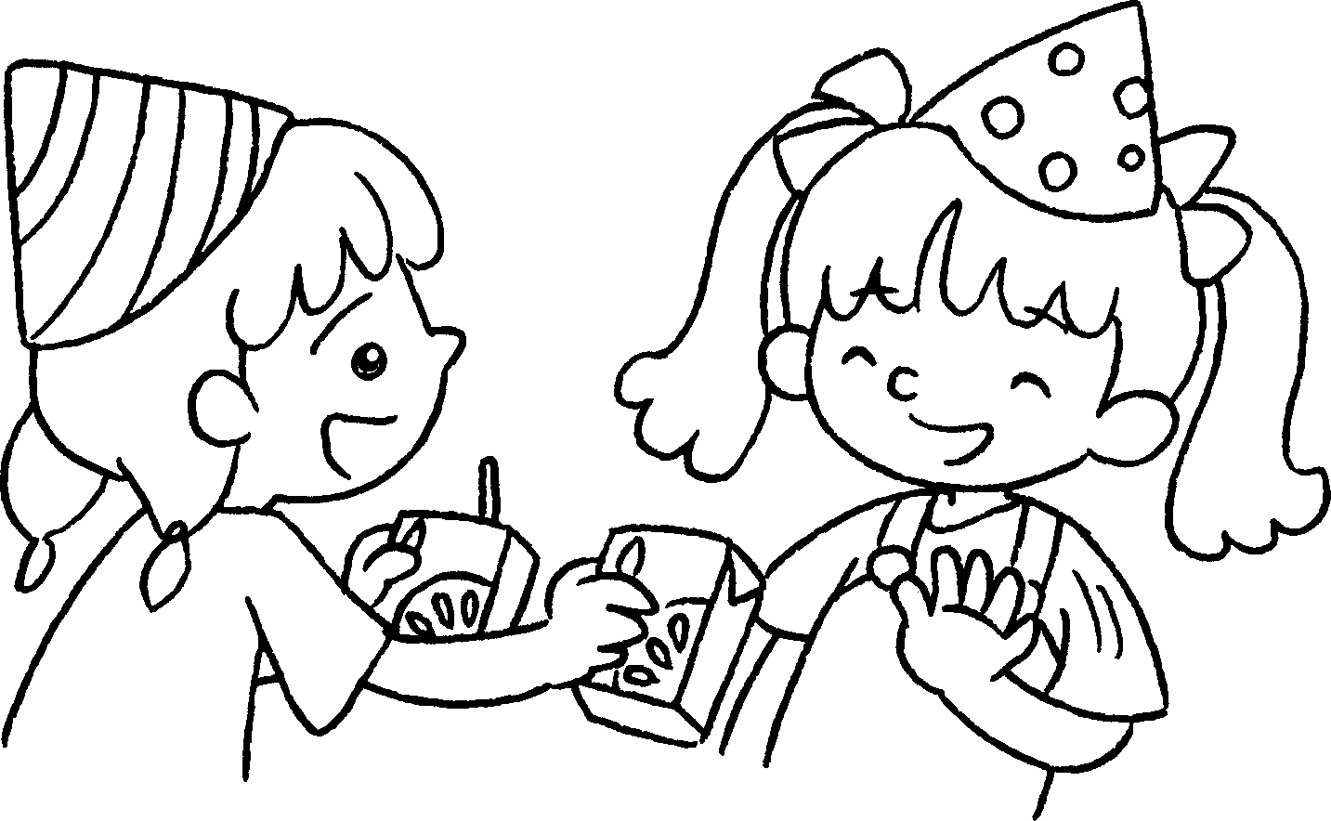 |  | A : thirsty?  B : No, I’m not. I’m fine.
2 | 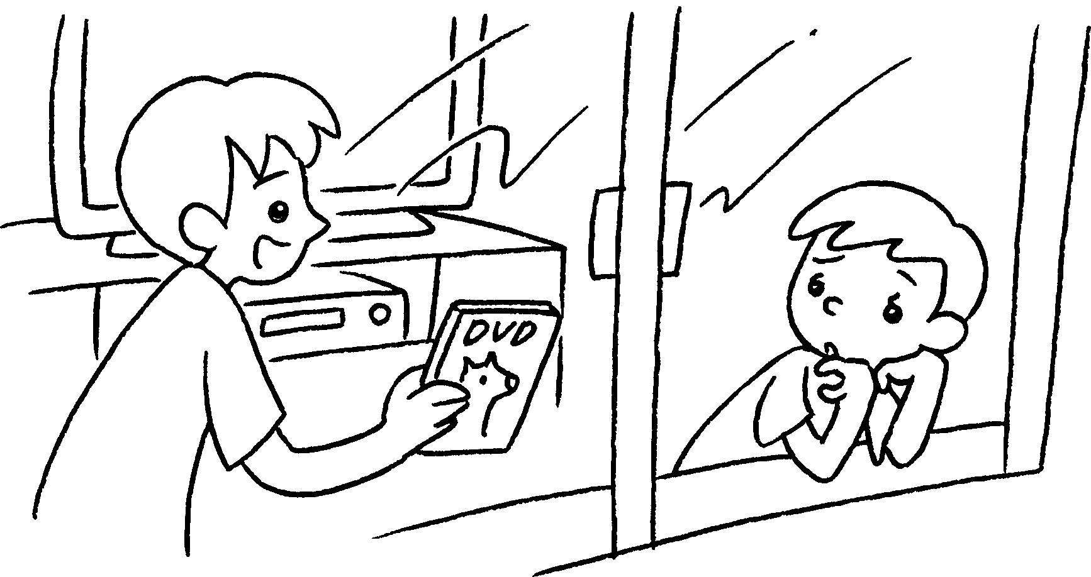 |  | A : Are you bored?  B : , I am.  A : Let’s watch DVDs.
3 | 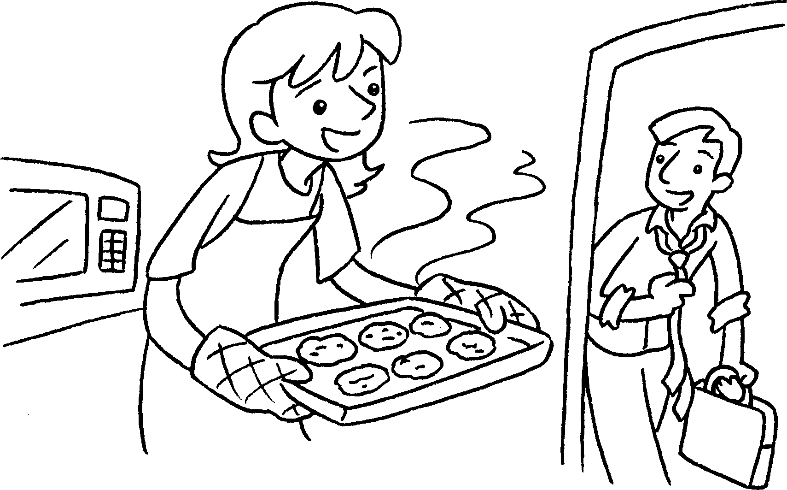 |  | A : hungry?  B : , I’m .  I’m fine.
4 | 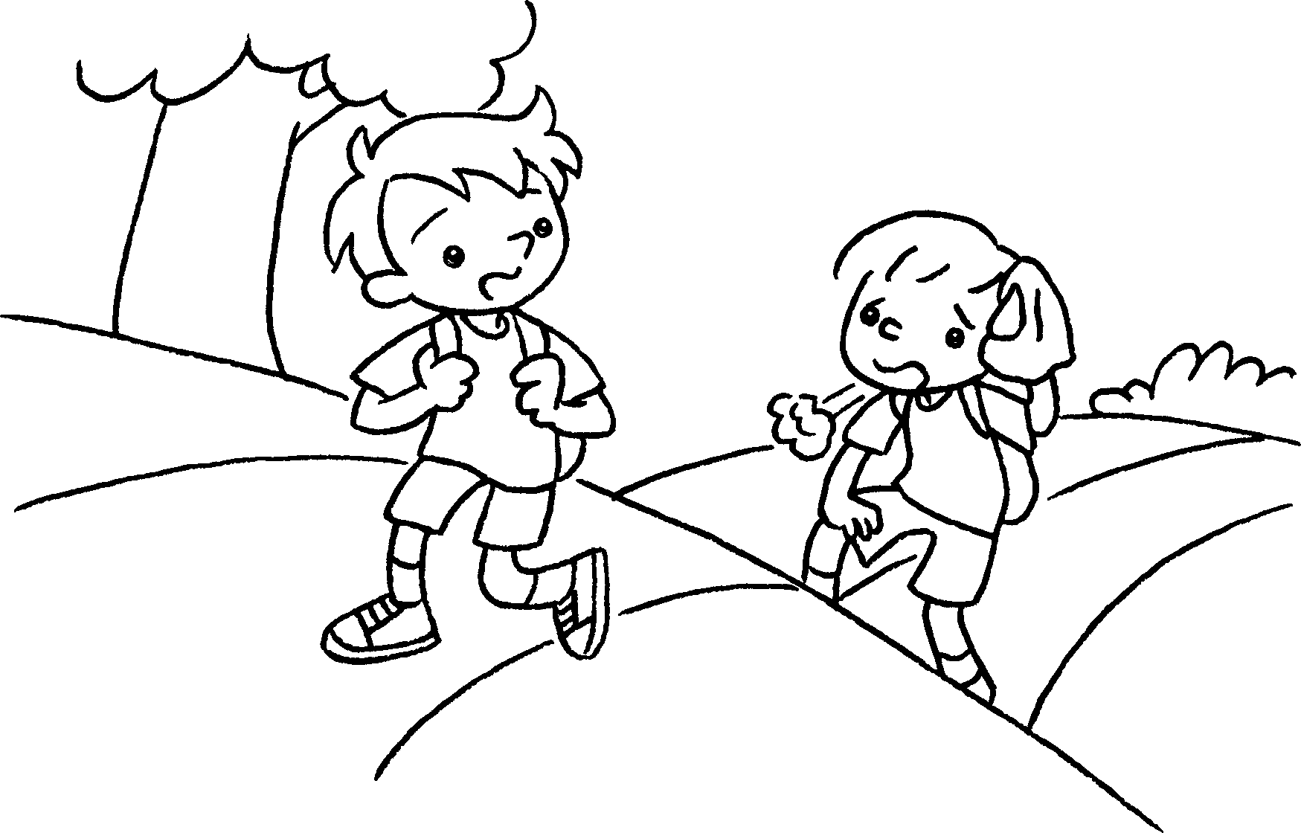 |  | A : tired?  B : , I am.  A : Let’s take a rest.

Book 2A Chapter 3 Graded Worksheets

Worksheet 3⬇
- Are you
- Yes
- Are you
No not
- Are you
Yes

