Choose and write.

banana | cherry | mango | peach
pear | potato | sandwich | strawberry

1 |  |  | 2 | 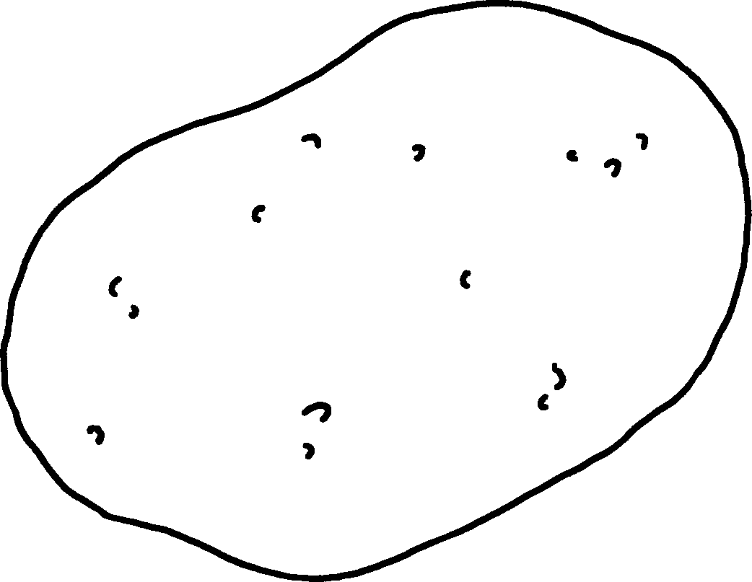
 | a |  |  | a
3 | 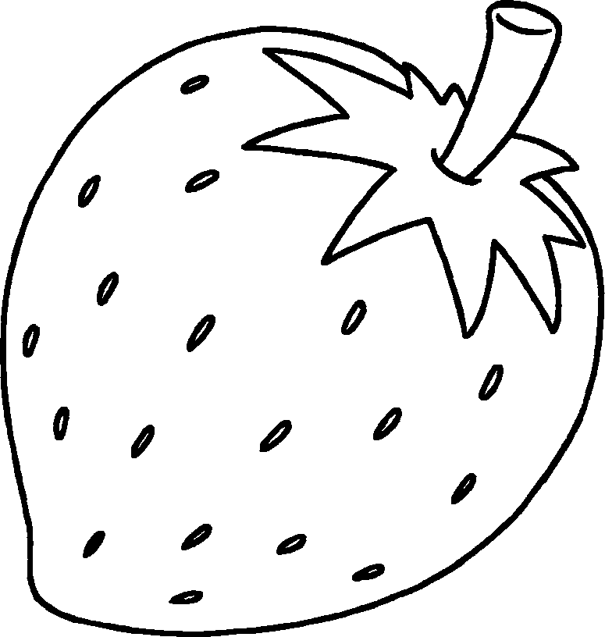 |  | 4 | 
 | a |  |  | a
5 | 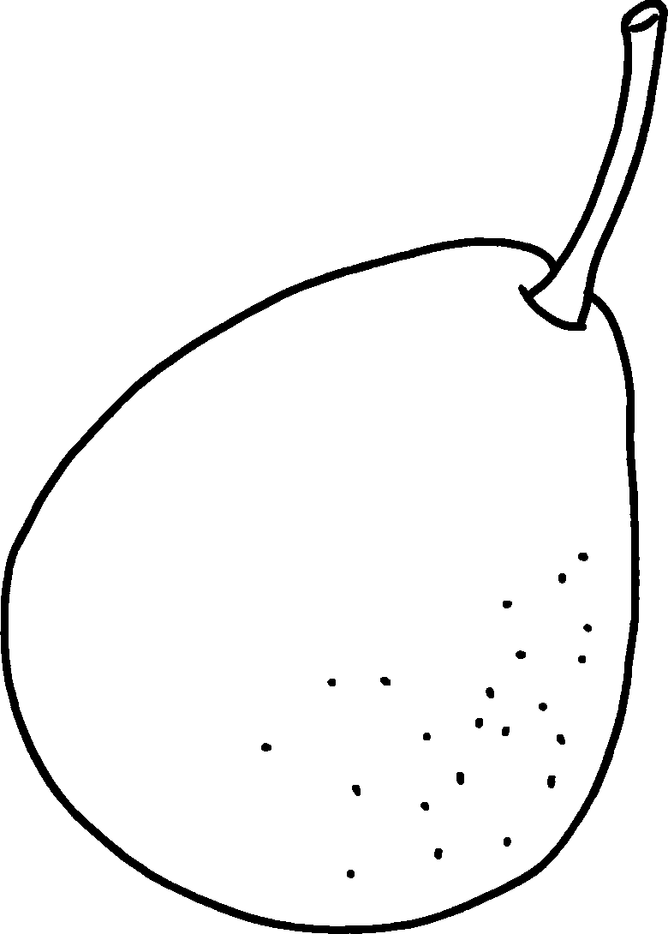 |  | 6 | 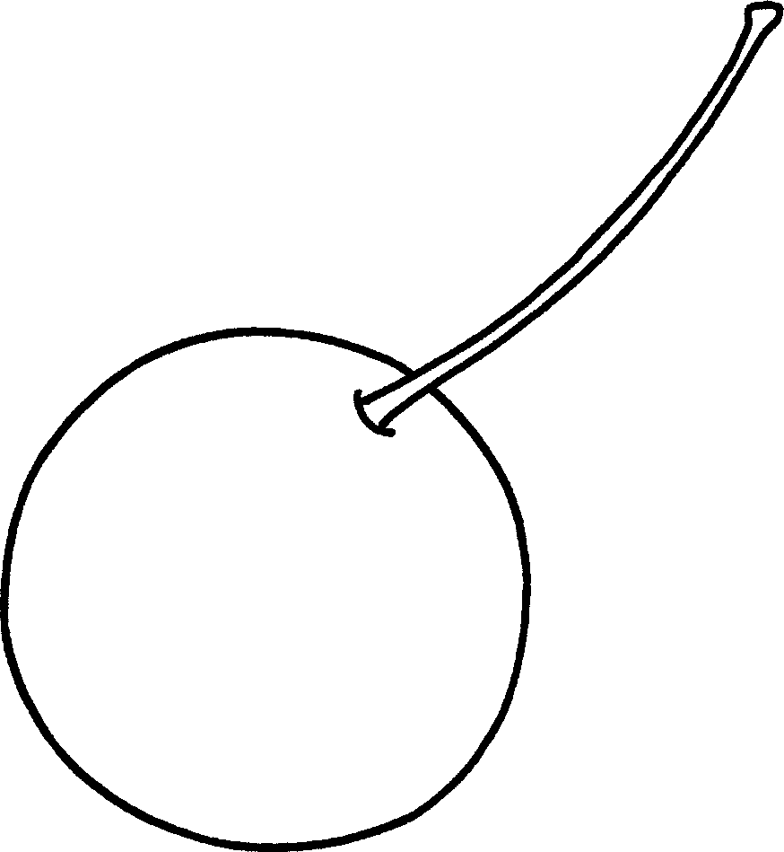
 | a |  |  | a
7 | 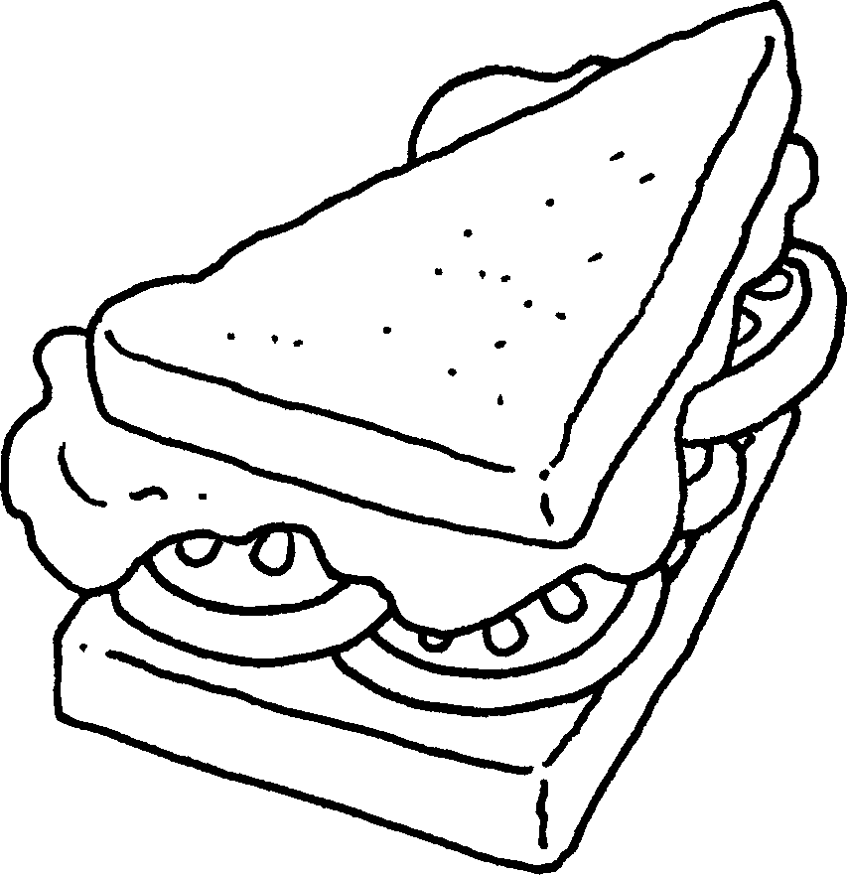 |  | 8 | 
 | a |  |  | a


Book 2A Chapter 4 Graded Worksheets
Worksheet 1⬇
1 mango 2 potato
3 strawberry 4 banana
5 pear 6 cherry
7 sandwich 8 peach

