Fill in the missing letters.

1 | 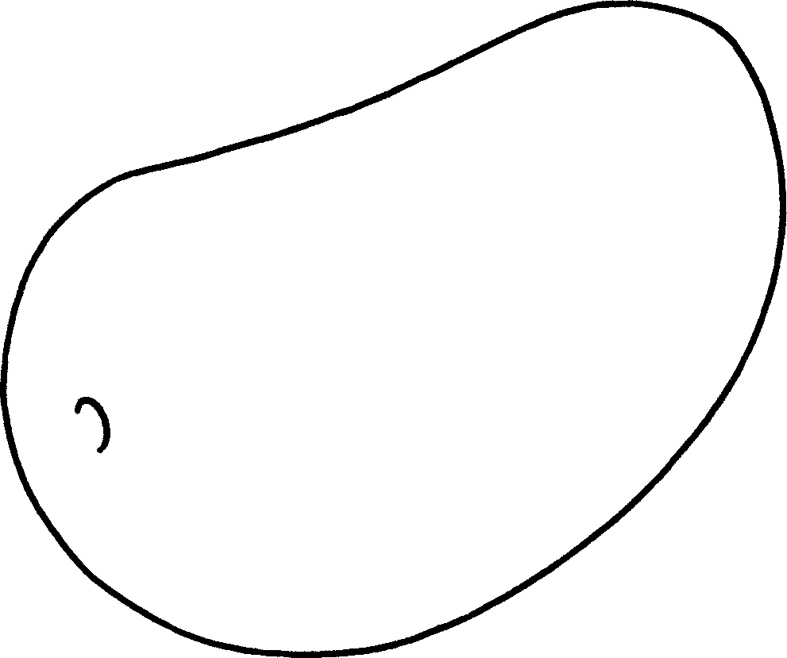 |  | 2 | 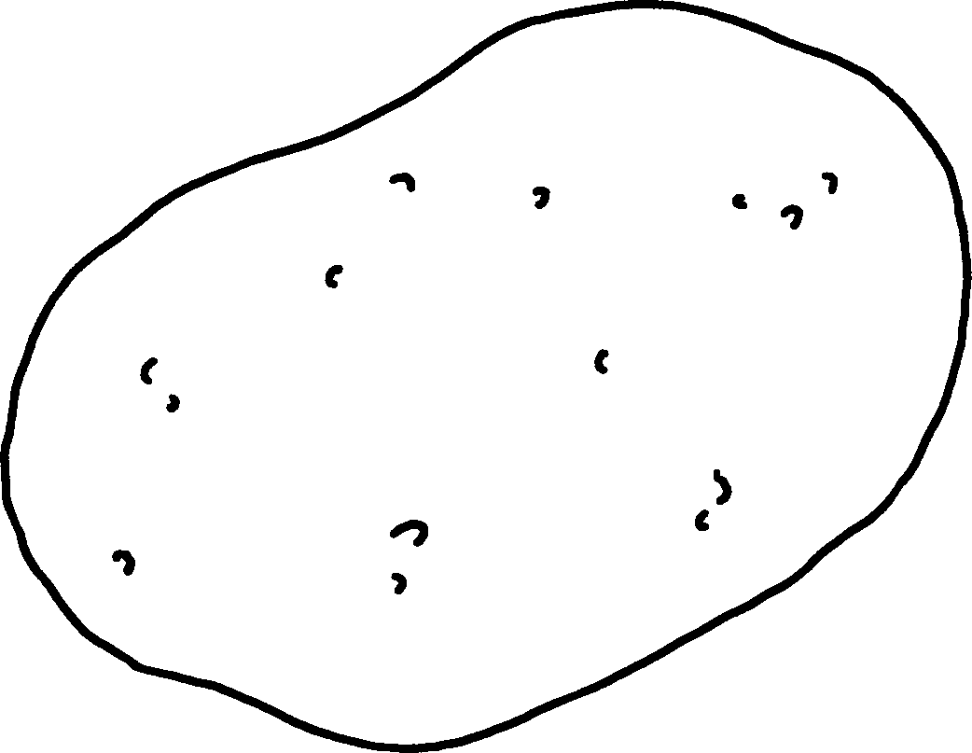
 | a m __ __ __ __ |  |  | a p __ __ __ __ __
3 | 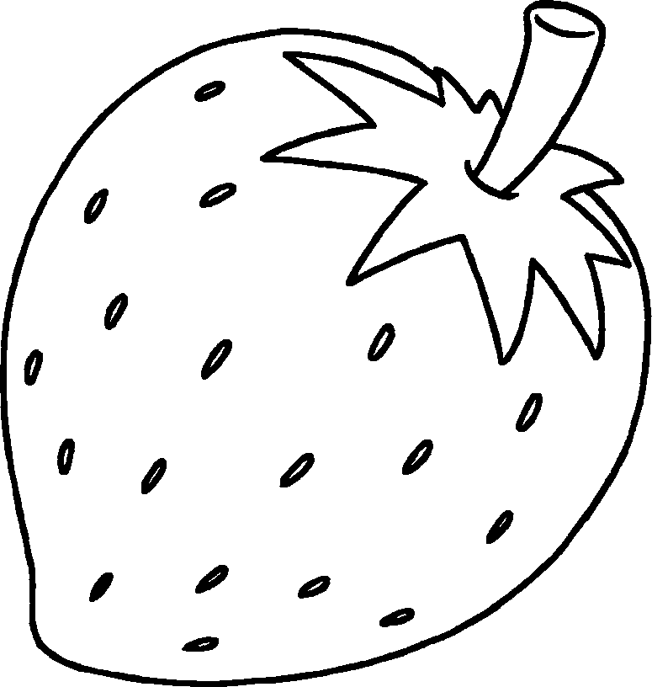 |  | 4 | 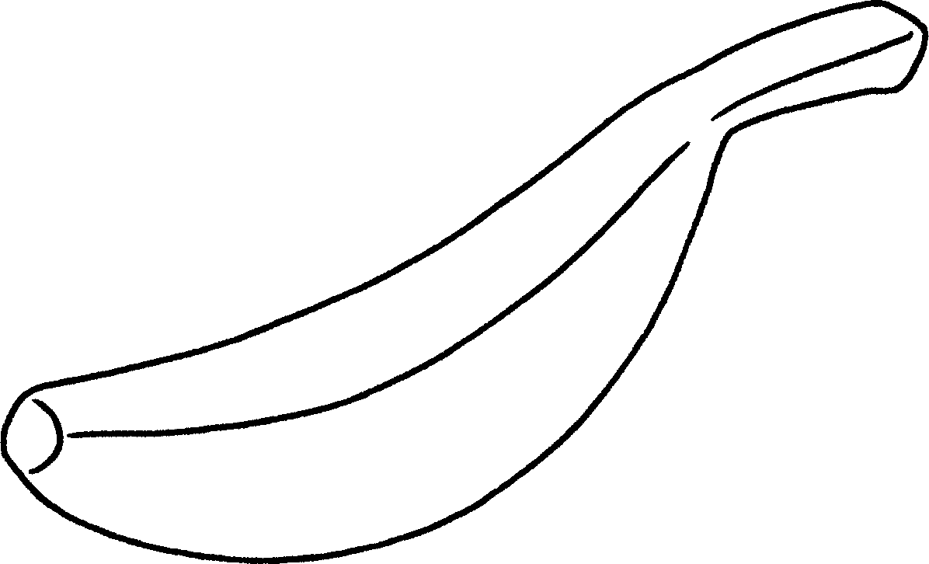
a st __ __ __ __ __ __ __ __ |  |  |  | a b __ __ __ __ __
5 | 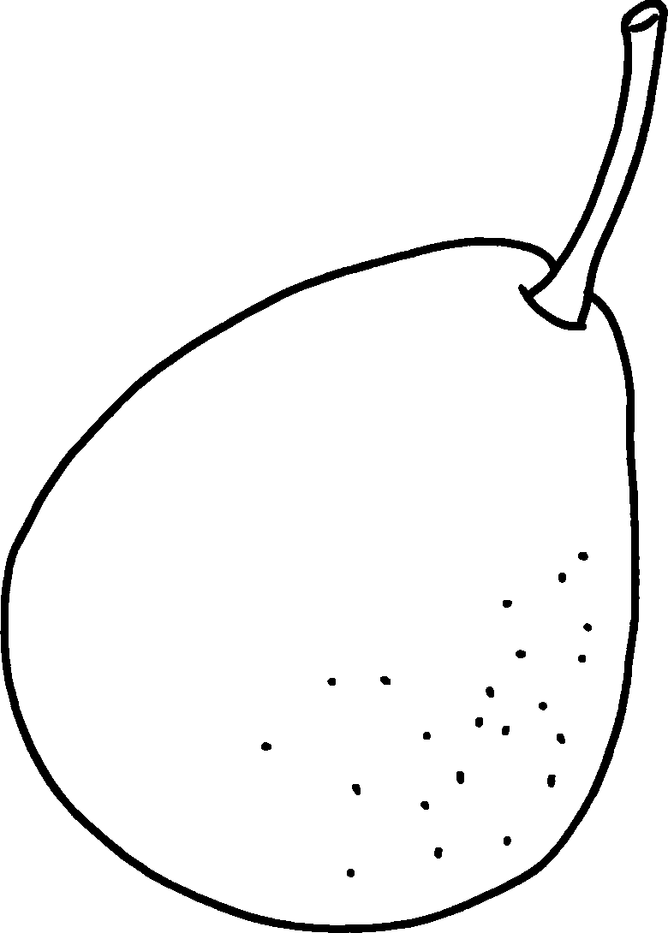 |  | 6 | 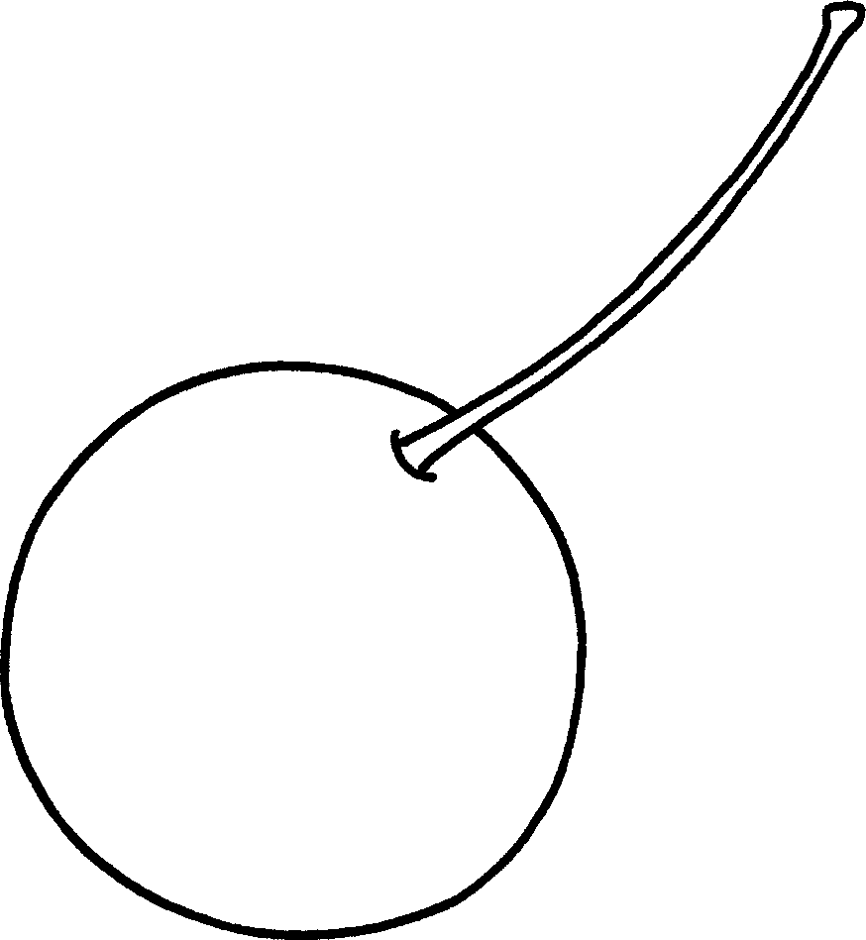
 | a p __ __ __ |  |  | a c __ __ __ __ __
7 | 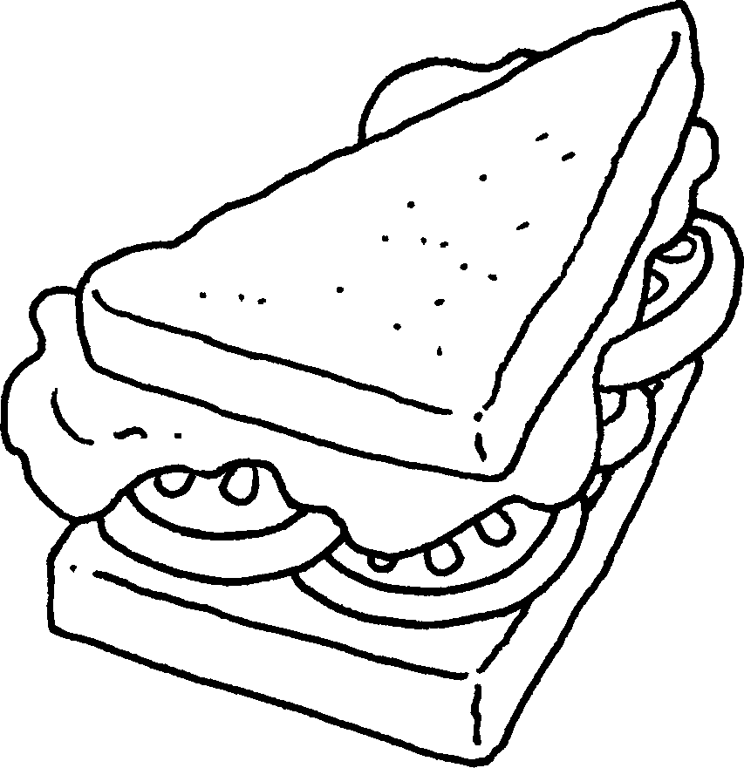 |  | 8 | 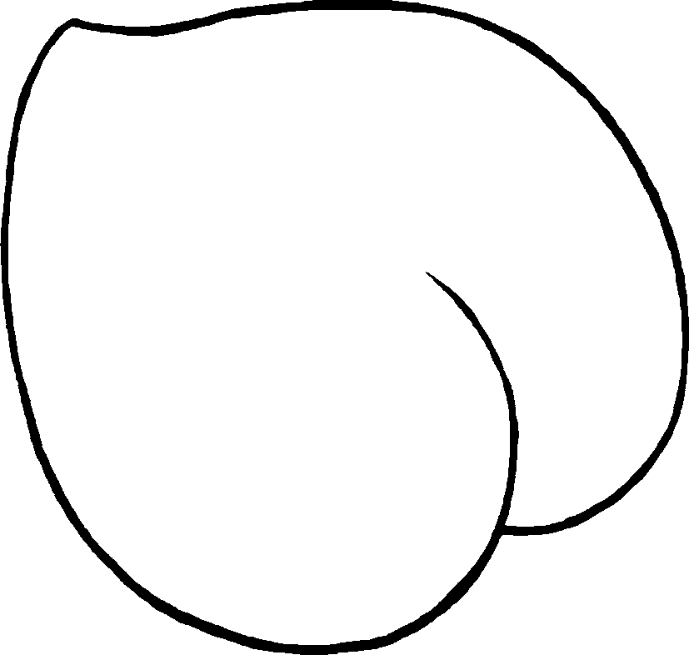
 | a s __ __ __ __ __ __ __ |  |  | a p __ __ __ __



Book 2A Chapter 4 Graded Worksheets
Worksheet 1⬇⬇
1 m a n g o 2 p o t a t o
3 st r a w b e r r y 4 b a n a n a
5 p e a r 6 c h e r r y
7 s a n d w i c h 8 p e a c h

