Fill in the blanks.
es s ies
1 | 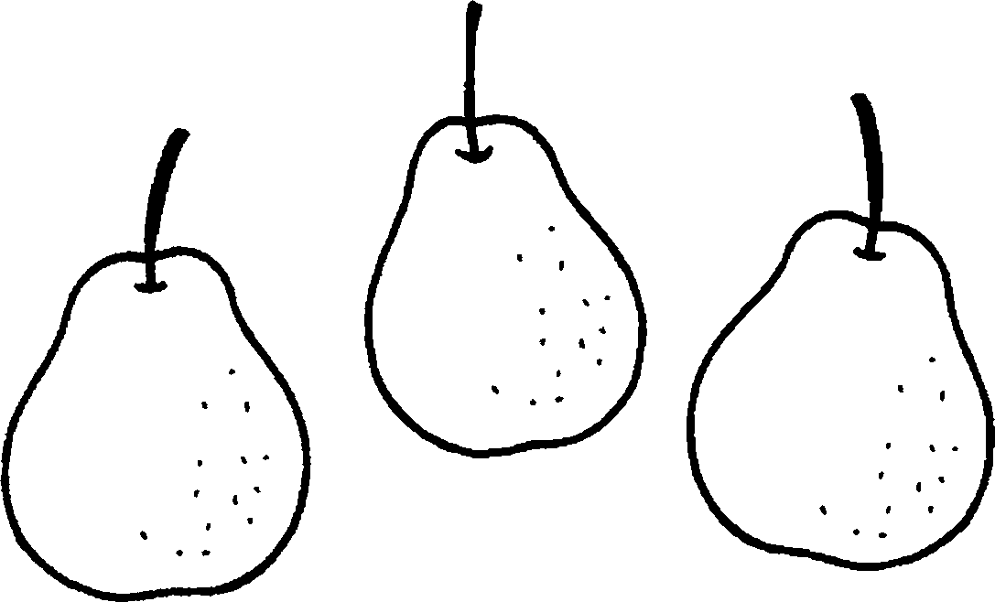 | 2 | 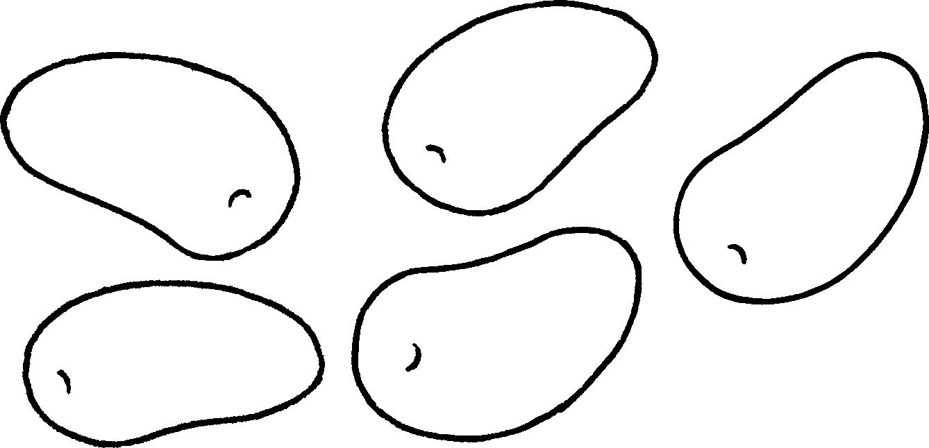
 | three p |  | five m
3 |  | 4 | 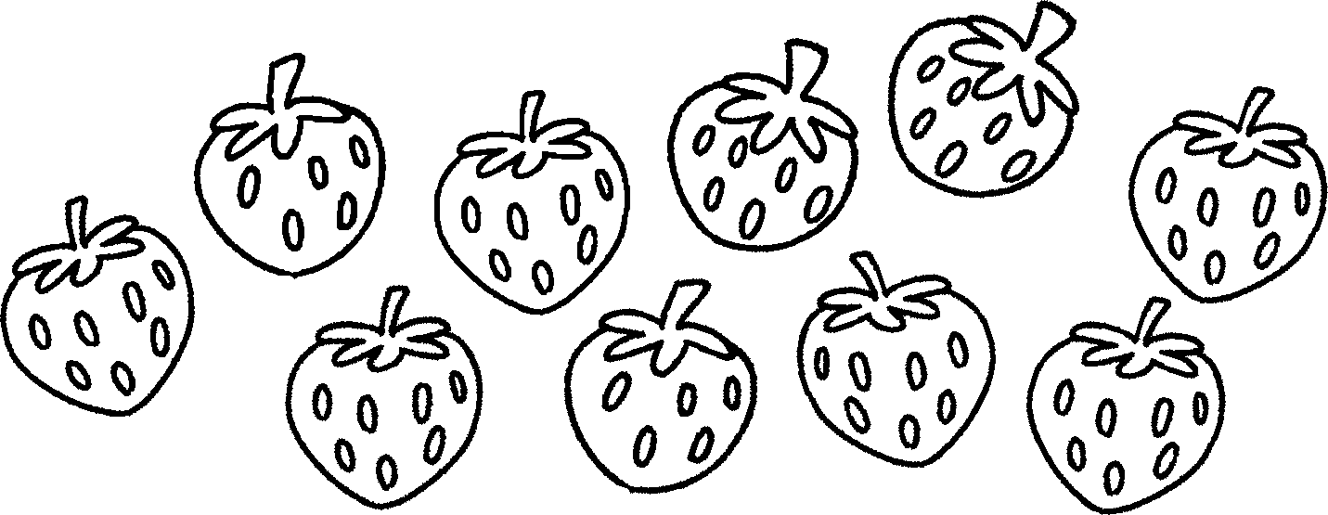
 | two p |  | ten s
5 | 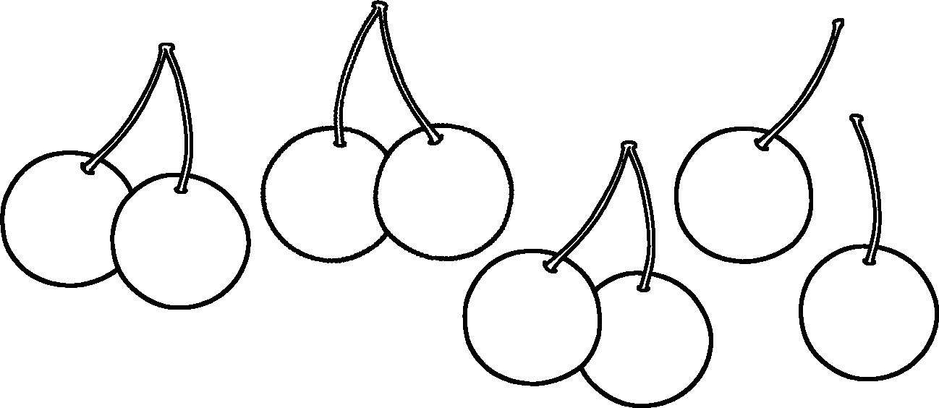 | 6 | 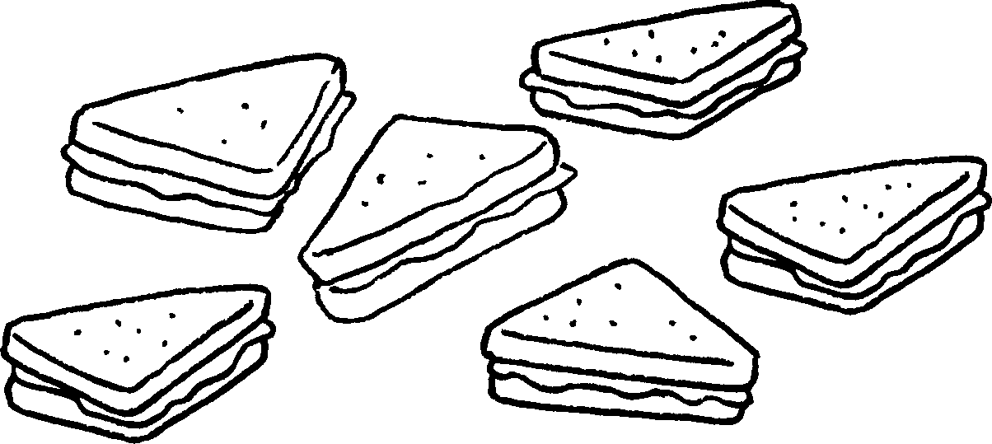
 | eight c |  | six s


Book 2A Chapter 4 Graded Worksheets
Worksheet 2⬇⬇
1 pears 2 mangoes
3 peaches 4 strawberries
5 cherries 6 sandwiches

