Count and write.

1 | 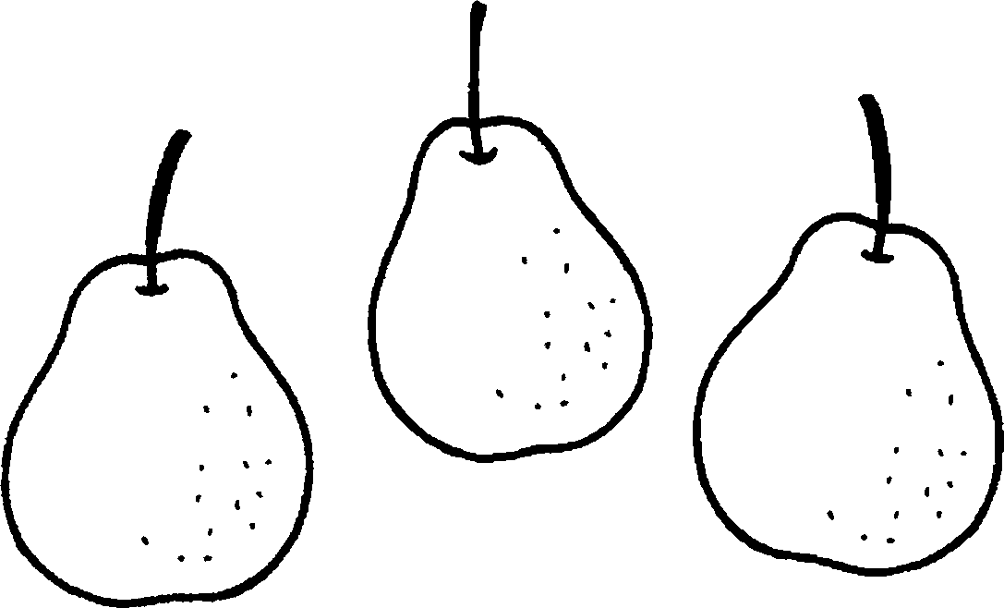 | 2 | 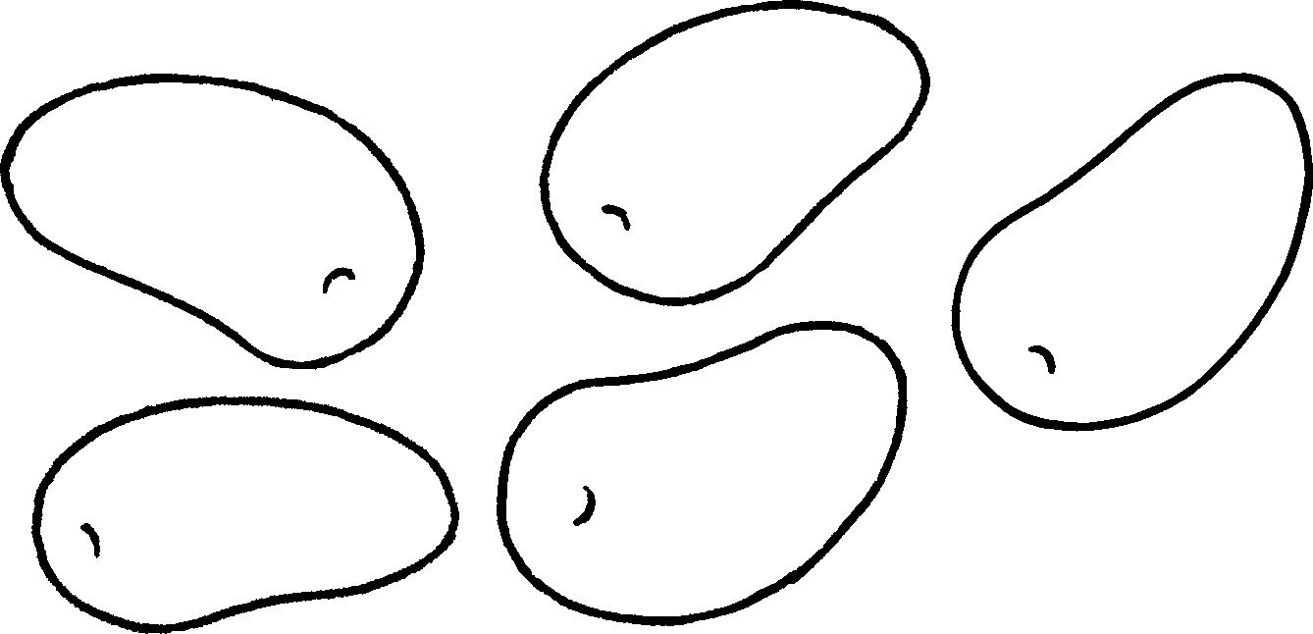
 | three
3 | 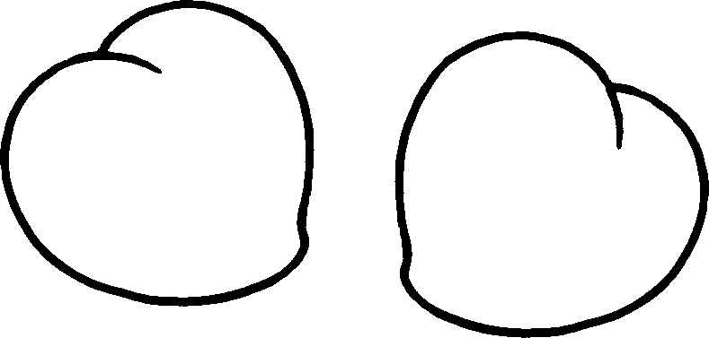 | 4 | 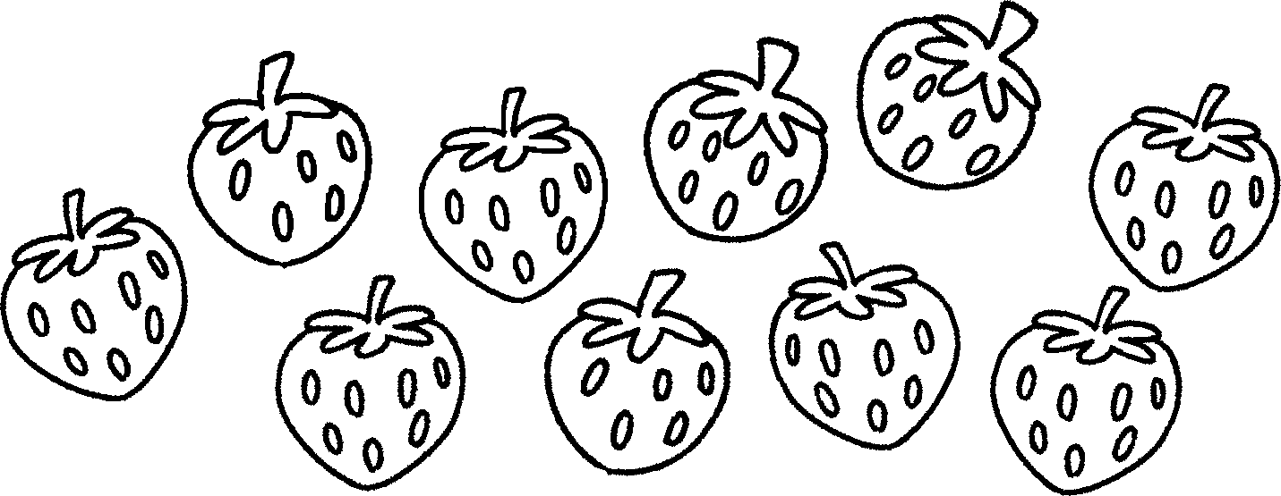
5 | 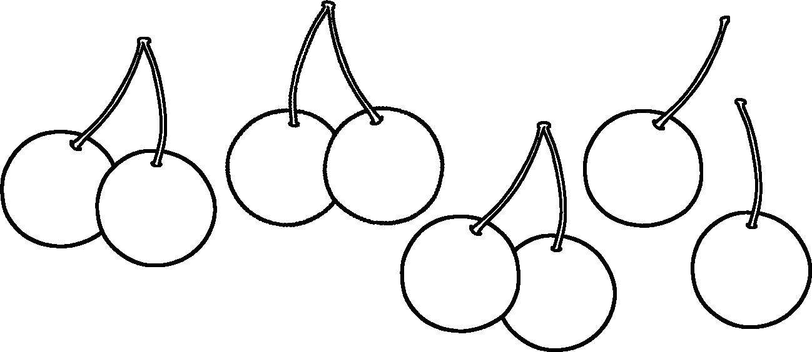 | 6 | 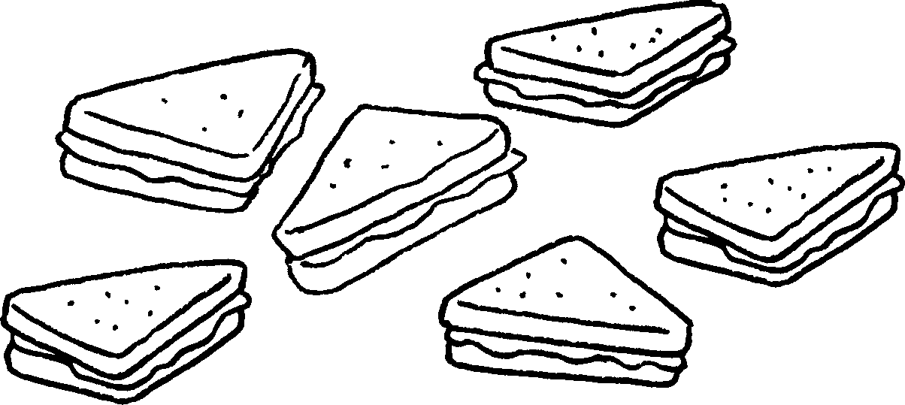


Book 2A Chapter 4 Graded Worksheets
Worksheet 2⬇⬇⬇
1 pears 2 five mangoes
3 two peaches 4 ten strawberries
5 eight cherries 6 six sandwiches

