Choose and write.

Do you | Yes, please. | No, thank you.
✗
1 | 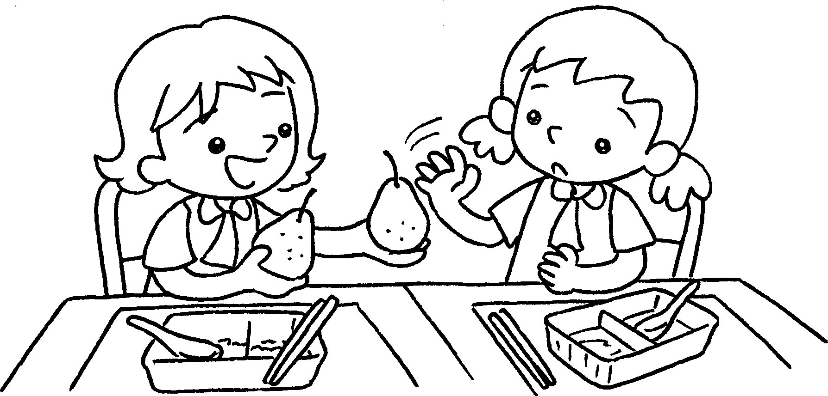 |  | A :  want some pears?  B : No, thank you. I’m fine.
2 | 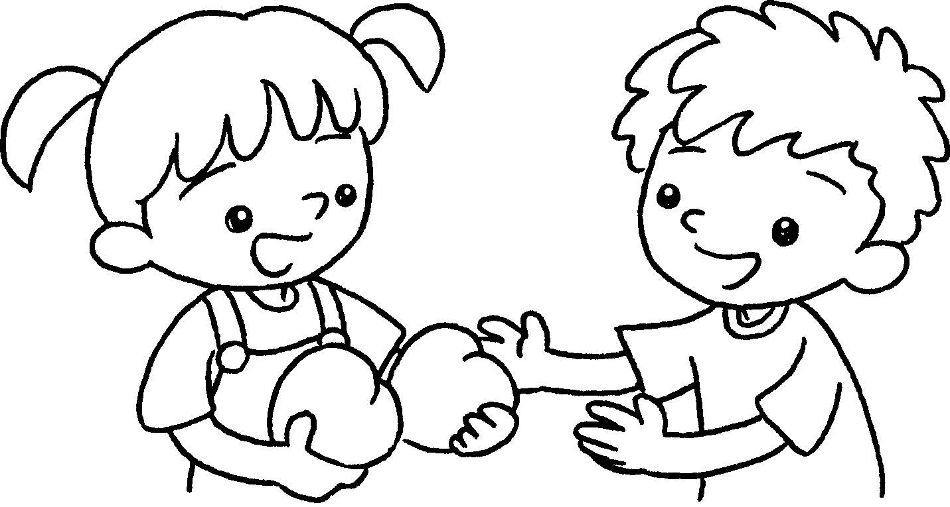  A  B  A  B  A  B  A  B | ✓ | A : Do you want some  peaches?  B : I’m hungry.
3 | 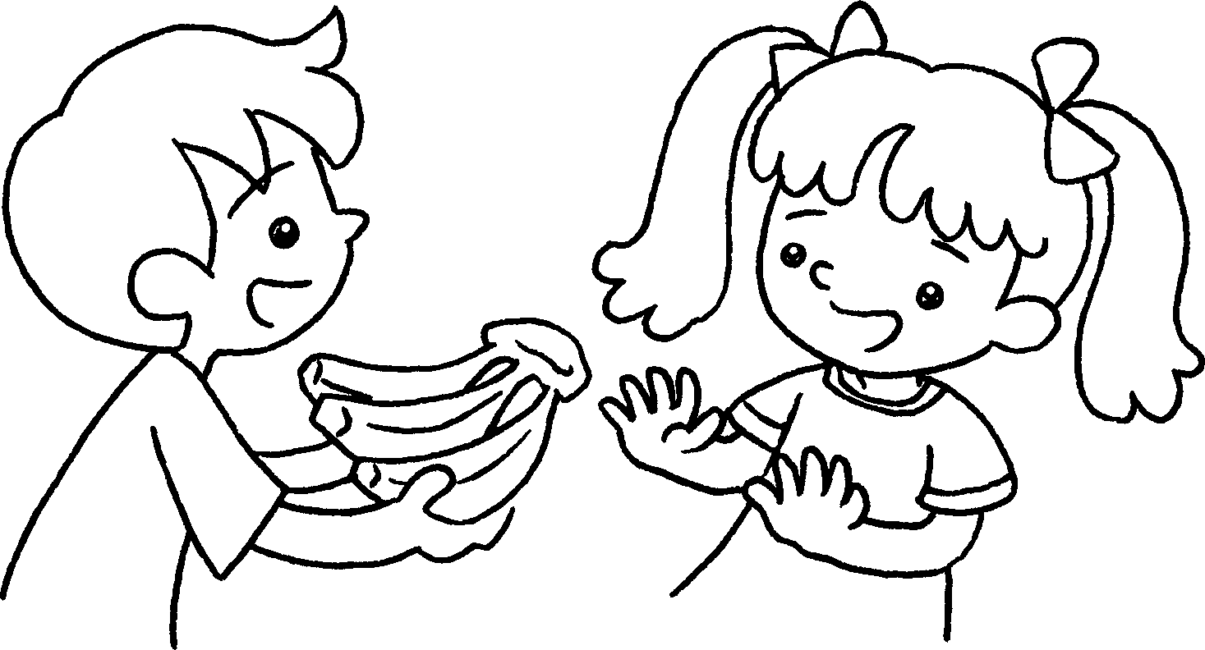 | ✗ | A : Do you want some  bananas?  B : I’m fine.
4 | 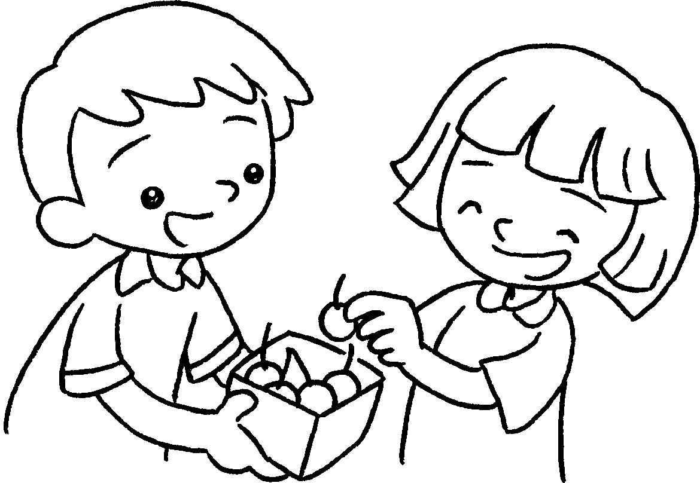 | ✓ | A :  want some cherries?  B : I’m hungry.


Book 2A Chapter 4 Graded Worksheets
Worksheet 3⬇
- Do you
- Yes, please.
- No, thank you.
- Do you
Yes, please.

