Finish what the children say.

Do you | Yes, please. | No, thank you.
✗
1 | 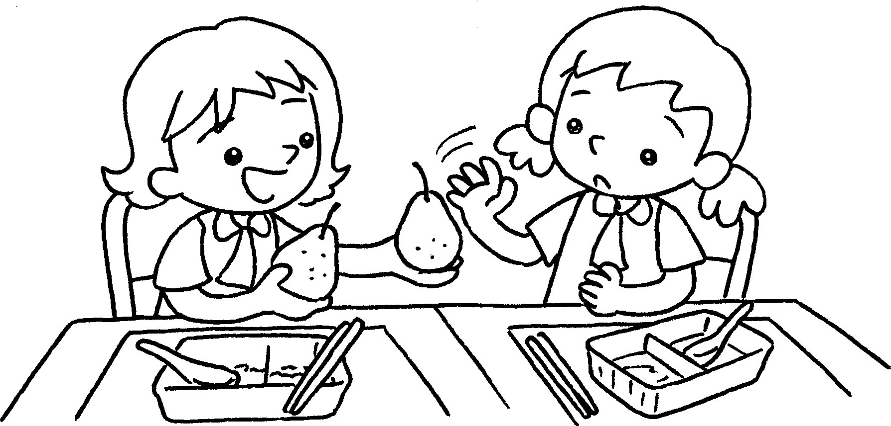 |  | A :  want some pears?  B : I’m fine.
2 | 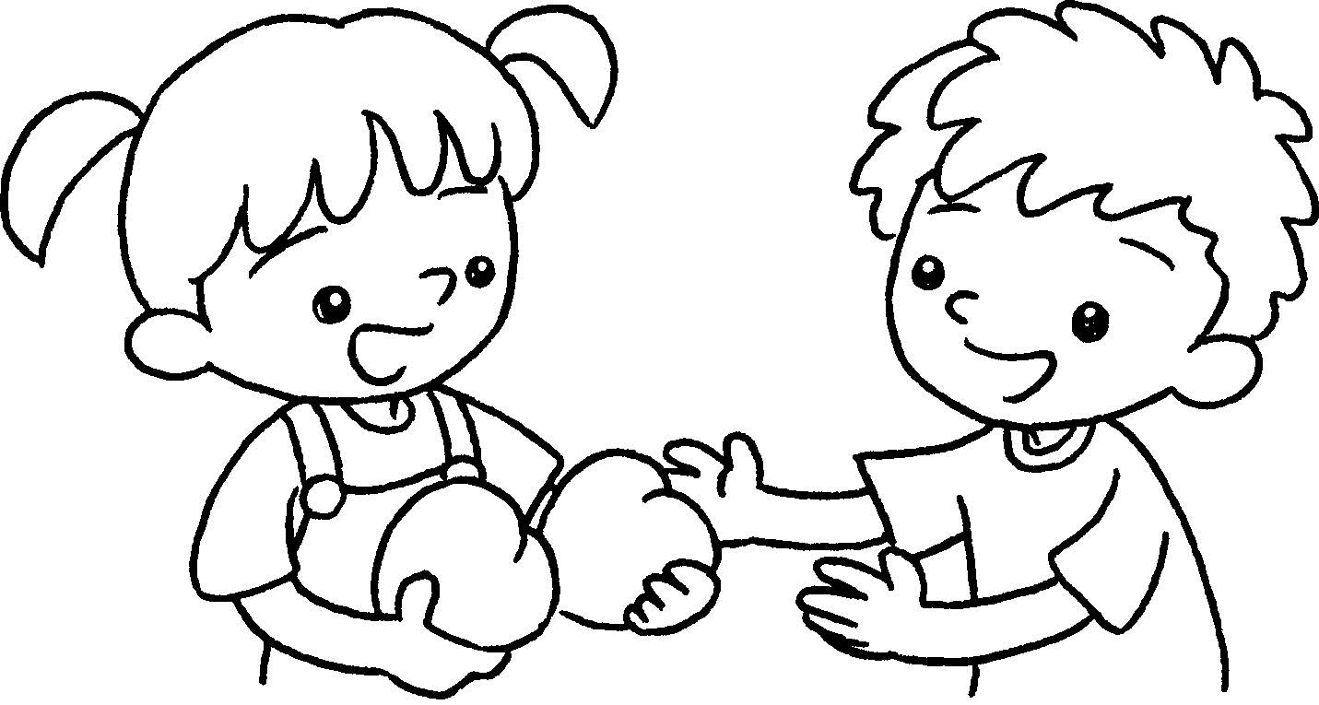  A  B  A  B  A  B  A  B | ✓ | A :  want some peaches?  B : I’m hungry.
3 | 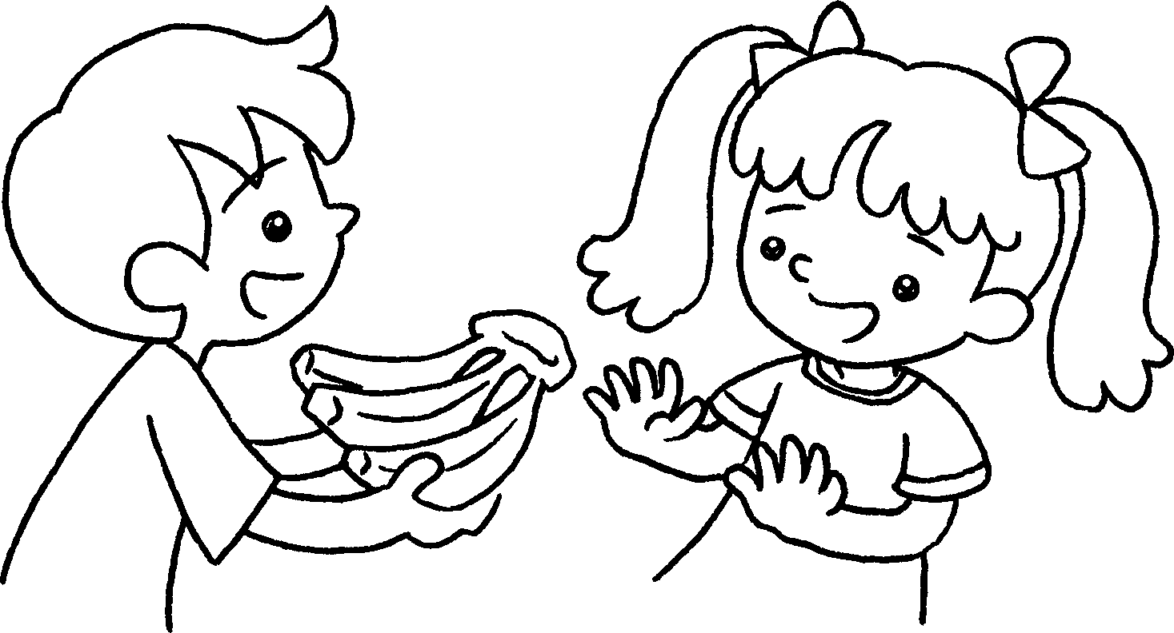 | ✗ | A :  some bananas?  B : I’m fine.
4 | 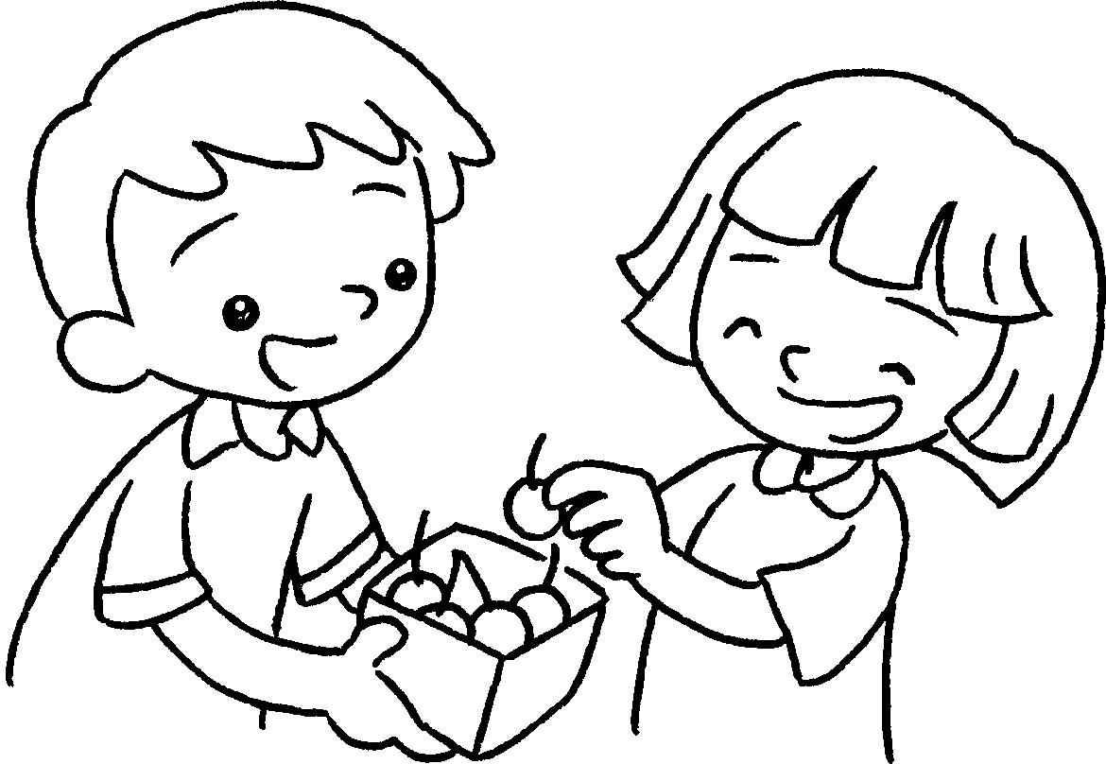 | ✓ | A :  some cherries?  B : I’m hungry.



Book 2A Chapter 4 Graded Worksheets
Worksheet 3⬇⬇
- Do you
No, thank you.
- Do you
Yes, please.
- Do you want
No, thank you.
- Do you want
Yes, please.

