Finish what the children say.

✗
1 | 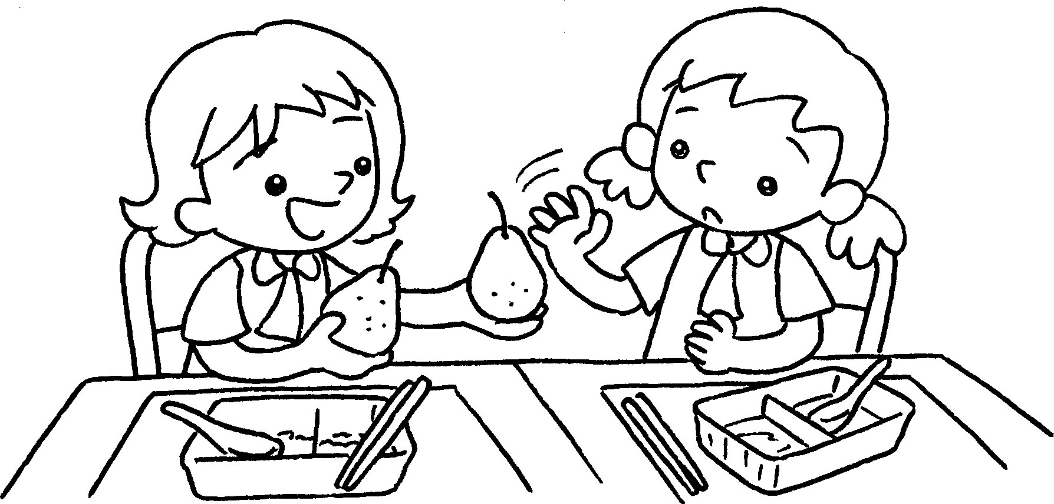 |  | Do you  A : want  some pears?  B : No, .  I’m fine.
2 | 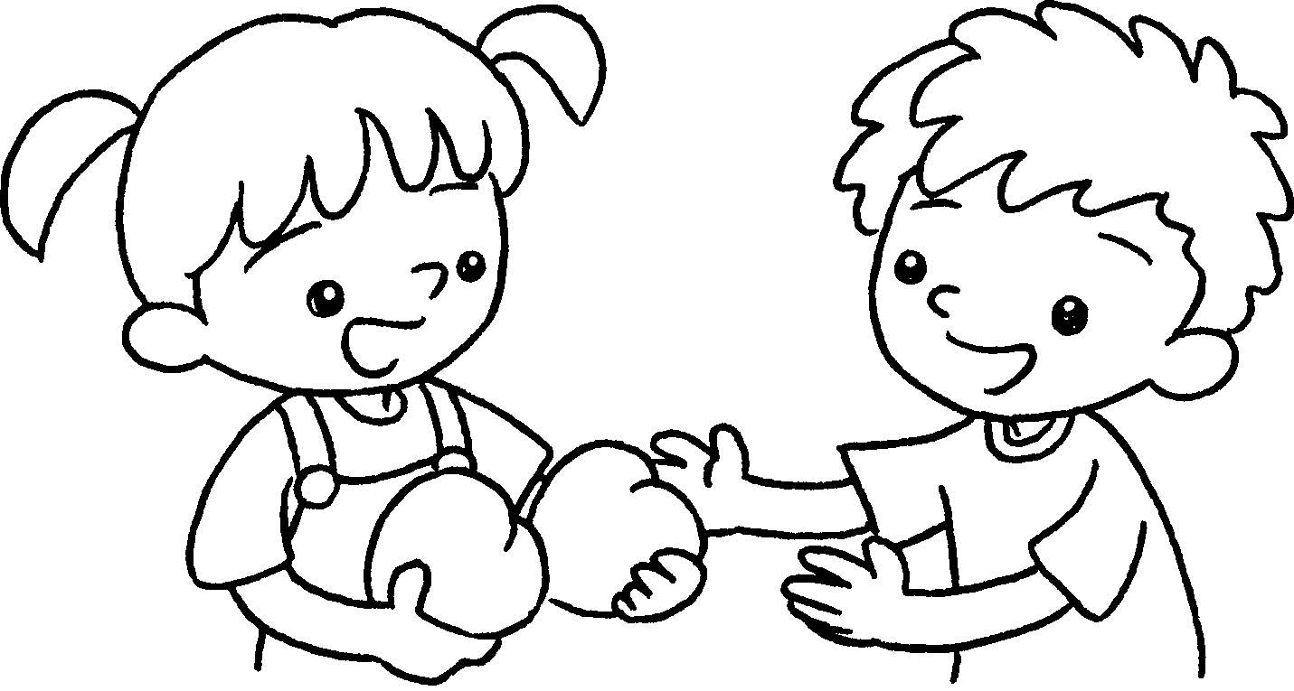  A  B  A  B  A  B  A  B | ✓ | A :  want some ?  B : Yes, . I’m hungry.
3 | 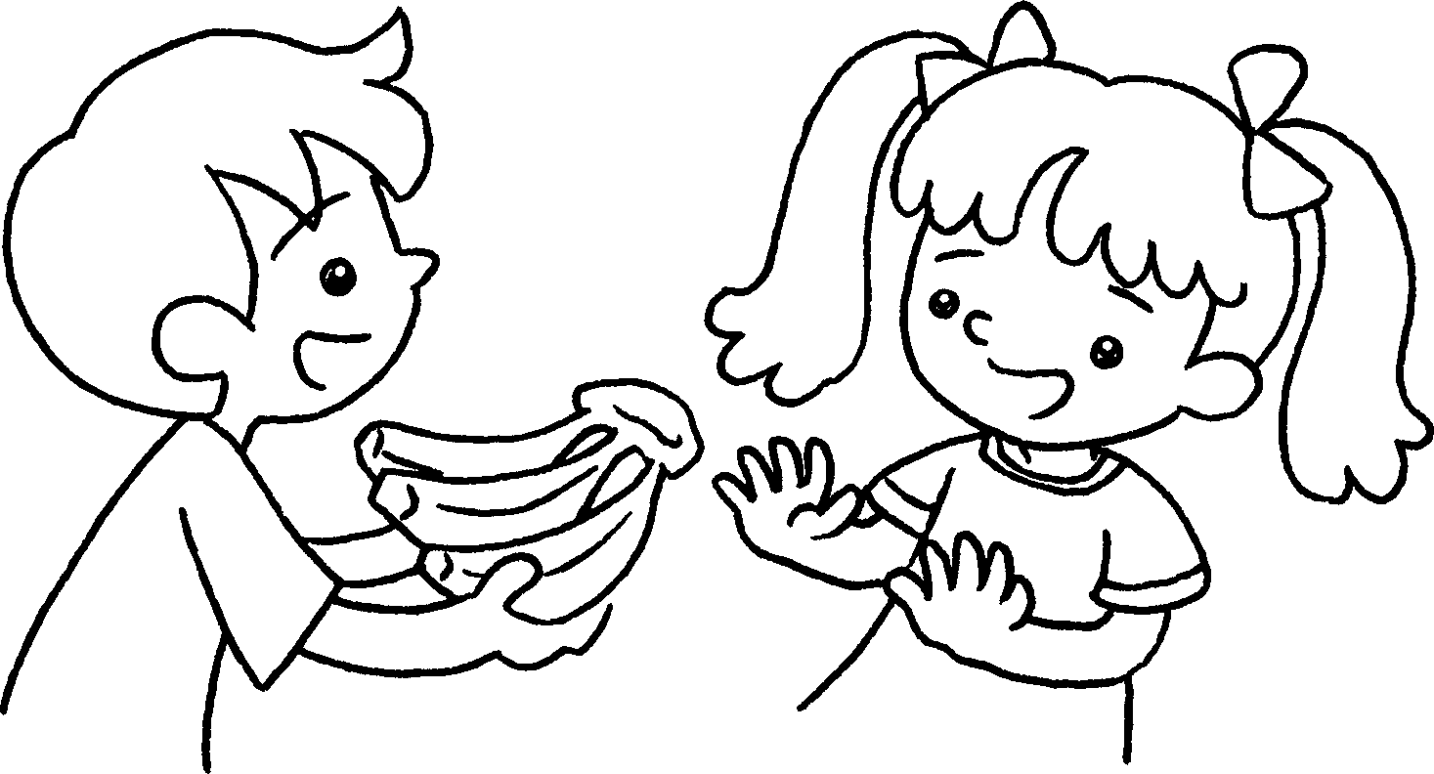 | ✗ | A :  want some ?  B : I’m fine.
4 | 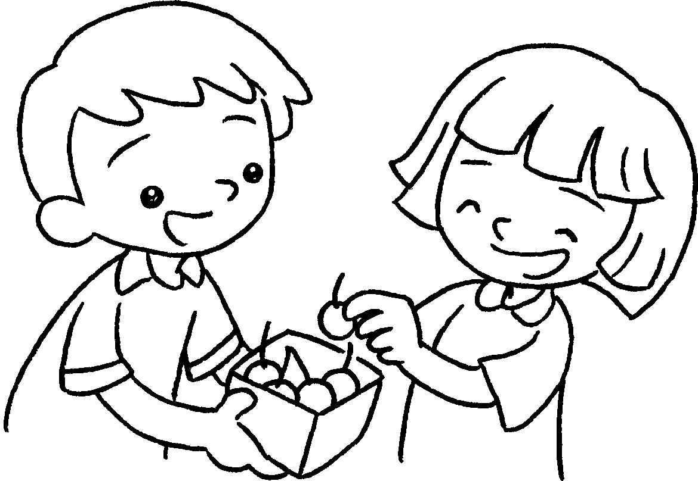 | ✓ | A :  some cherries?  B : I’m hungry.


Book 2A Chapter 4 Graded Worksheets
Worksheet 3⬇⬇⬇
- thank you
- Do you peaches
please
- Do you bananas
No, thank you.
- Do you want
Yes, please.

