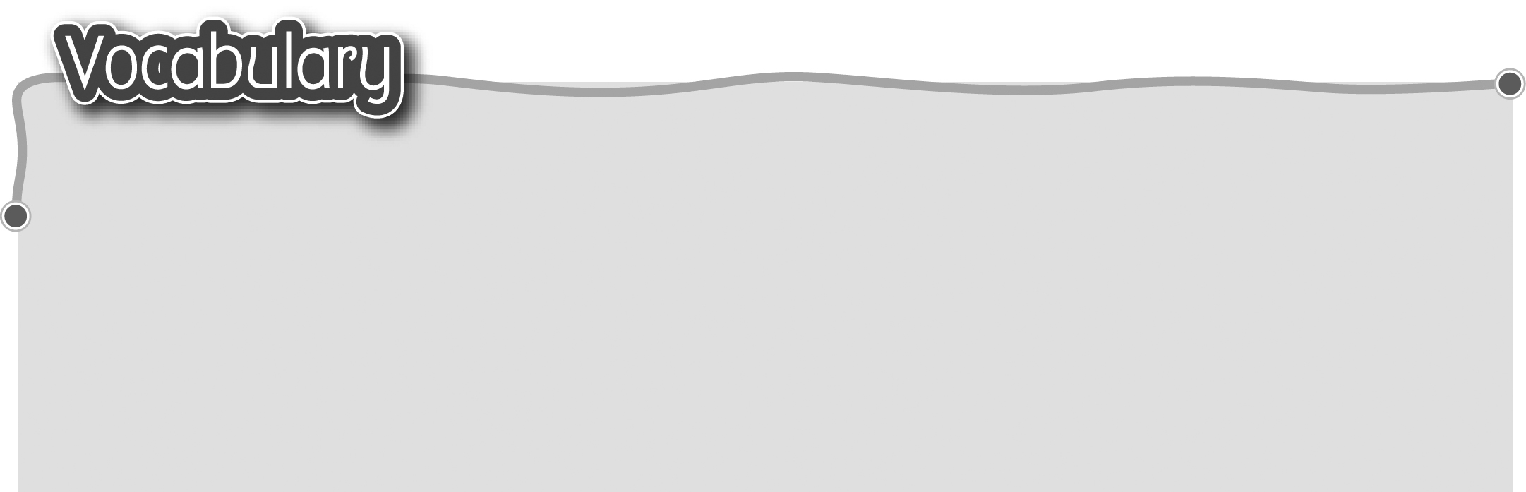
1 banana (bananas) 香蕉 5 peach (peaches) 桃
2 pear (pears) 梨 6 sandwich (sandwiches) 三文治
3 mango (mangoes) 芒果 7 cherry (cherries) 櫻桃
4 potato (potatoes) 馬鈴薯 8 strawberry (strawberries) 草莓
The words marked with * have different meanings in other
contexts. You can look up those meanings in a dictionary.
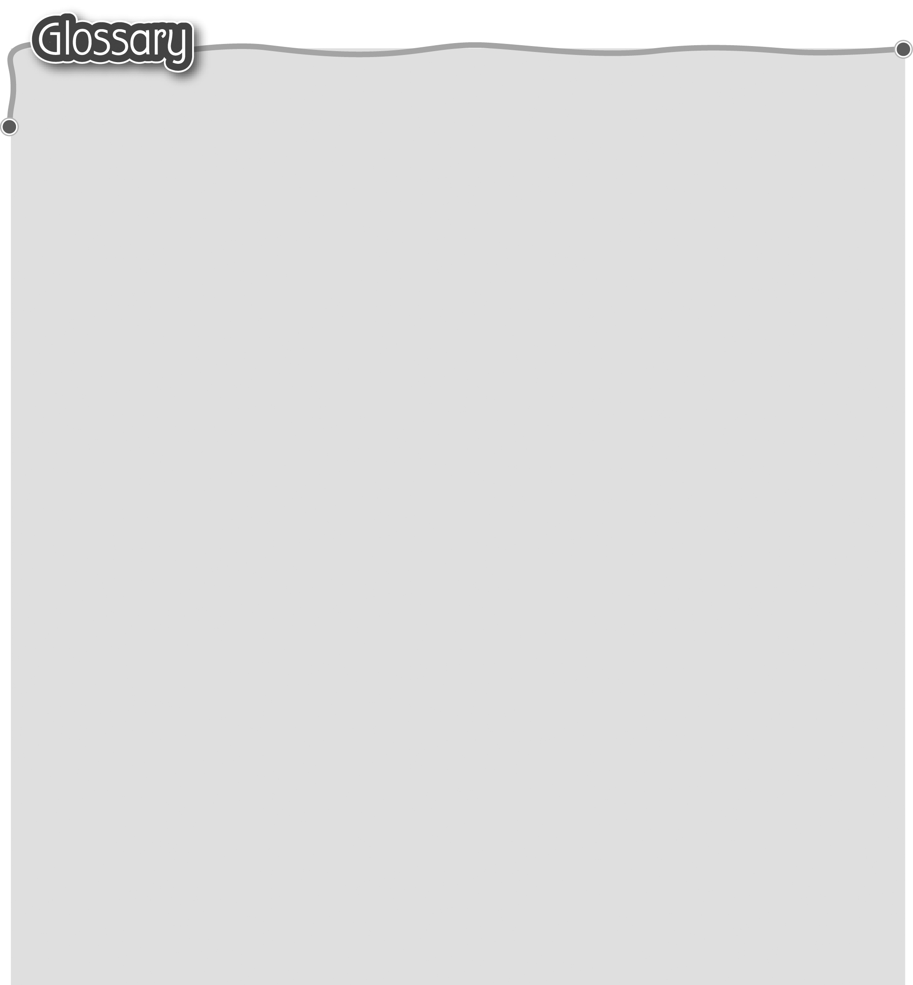
1 here (p.28) 這裏 9 come (p.29) 來
2 giant* (p.28) 巨人（名詞） 10 go (p.29) 去
3 they* (p.28) 它們 11 afraid (p.30) 害怕
4 sweet* (p.28) 甜（形容詞） 12 happy (p.30) 開心
5 so (p.28) 這麼/那麼 13 sad (p.30) 不開心
6 little* (p.29) 細小（形容詞） 14 angry (p.30) 生氣
7 king (p.29) 皇帝 15 castle (p.30) 城堡
8 kind* (p.29) 仁慈（形容詞） 16 dinning room (p.34) 飯廳


