Task — Finishing the comic ‘Ben in Giantland’

Look at the pictures carefully. Write about what happens next.
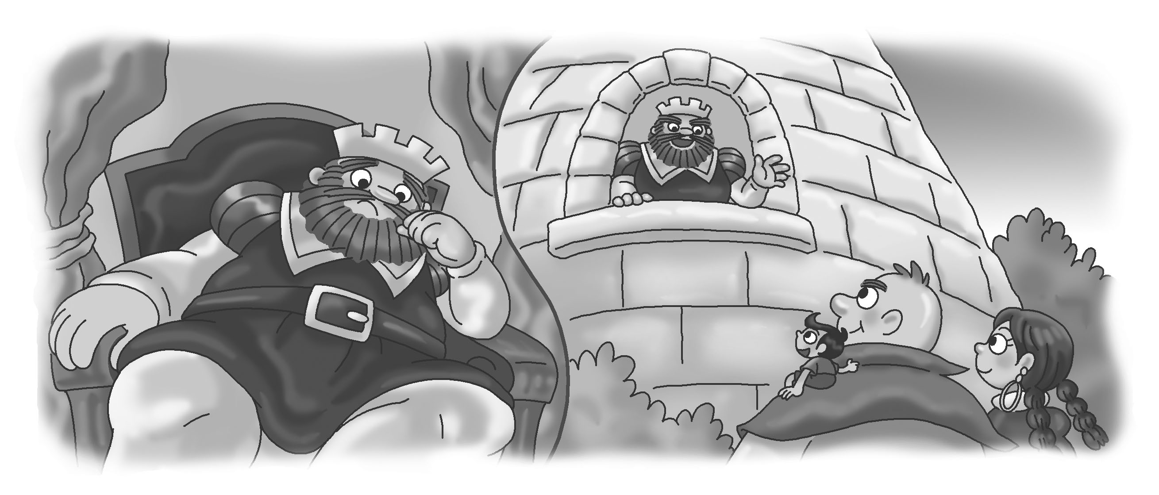
What is he saying?
1
__________________
__________________

Where is King Giant?
How does he feel?

______________________ in the castle. He _____________ .

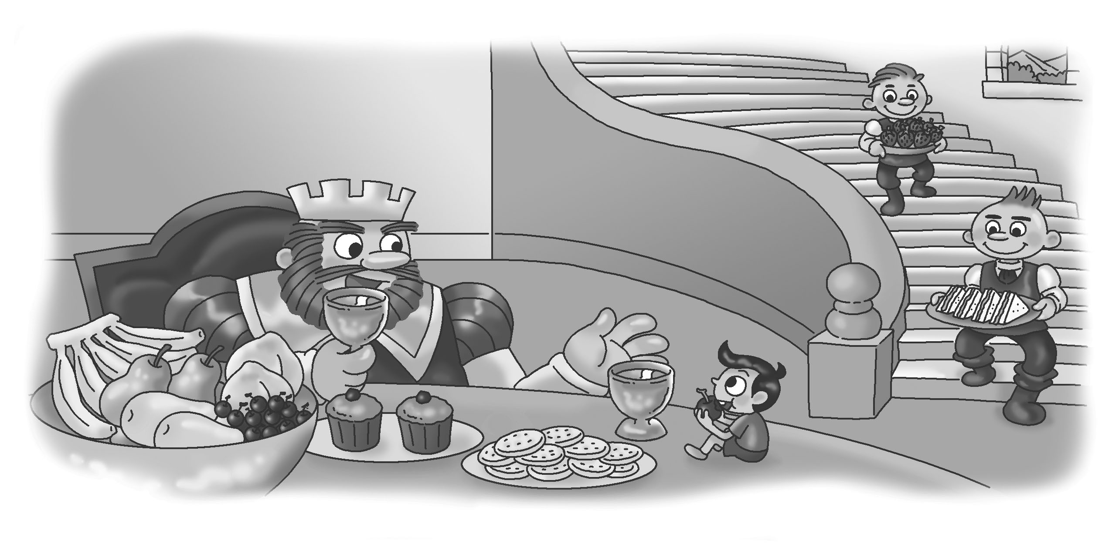
What are they saying?
__________________
__________________
2

_____________
_____________
Where are Ben and King Giant?
What are they doing?

______________________________________ in the dining room.
They ________________________________________________.
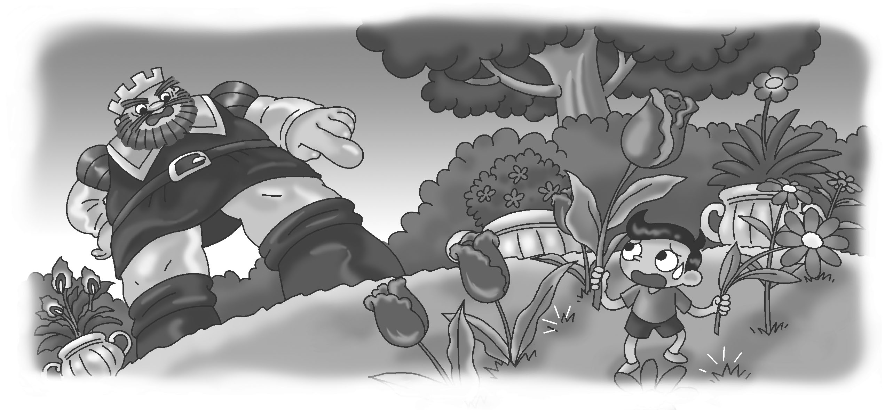
What is King Giant saying?
_____________
_____________

Where are Ben and King Giant? What is Ben doing? How does King Giant feel?

Now Ben and King Giant are ______________________________.
Oh no! Ben _____________________________________ flowers.
King Giant ___________.

What happens in the end? Choose (✓) a picture or think of your own idea.

 A.  B.  C. (Your idea)
_____________

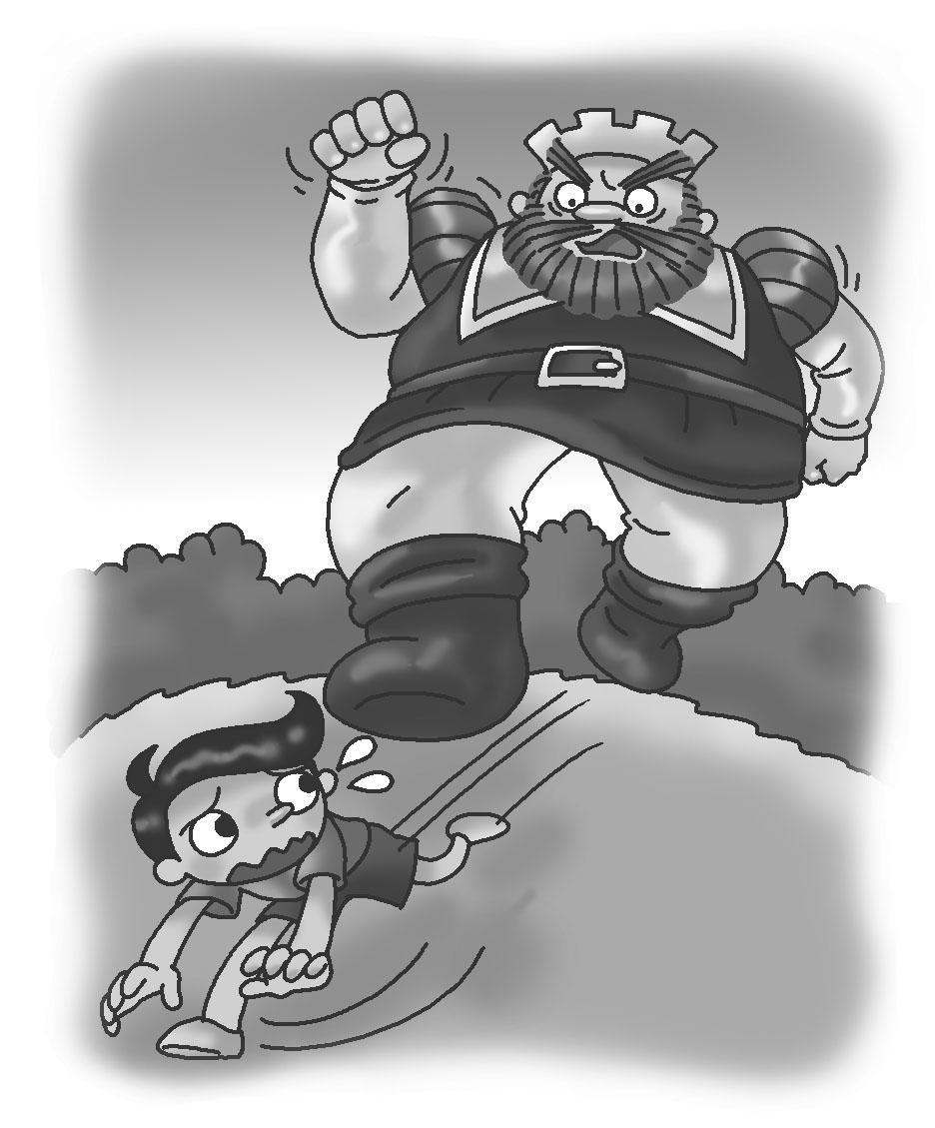

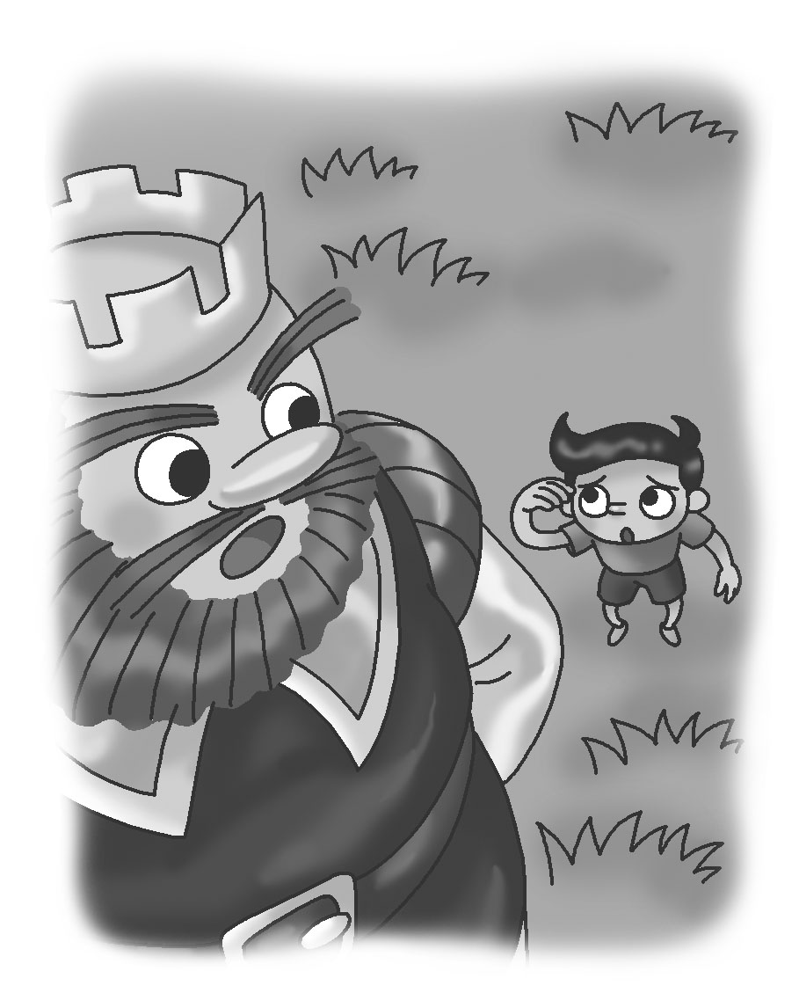

Help!
Don’t do that again.

Ben is __________.
He is running away.
Ben says sorry to King Giant.
_______________
_______________
_______________

Check your writing and tick (✓ ).

Checking for myself | ☺ ☺ | ☺ | ☹
- I can use my own words to write ideas.
- I can start each sentence with a capital letter (e.g. Welcome to my castle!).
- I can end each sentence with a full-stop (.), a question mark (?), or an exclamation mark (!).
- I can spell all the words (check spellings using the textbook).
- I can use capital letters to begin names of people and places (e.g. King Giant).
- I can make correct plural forms (e.g. some sandwiches).

Now ask your partner to check your writing and tick (✓ ).

Checking by ( _________________ ) | ☺ ☺ | ☺ | ☹
- Do I understand my partner’s writing?
- Does my partner write an interesting ending?
- Does my partner start each sentence with a capital letter?
- Does my partner end each sentence with a full-stop (.), a question mark (?), or an exclamation mark (!)?
- Does my partner spell all the words correctly?
- Does my partner make correct plural forms?

Remember to make changes to your writing before you hand it in.

