Choose and write.
bus |  | ferry |  | foot |  | Light Rail
minibus | school bus |  | taxi |  | MTR |  | tram

1 | 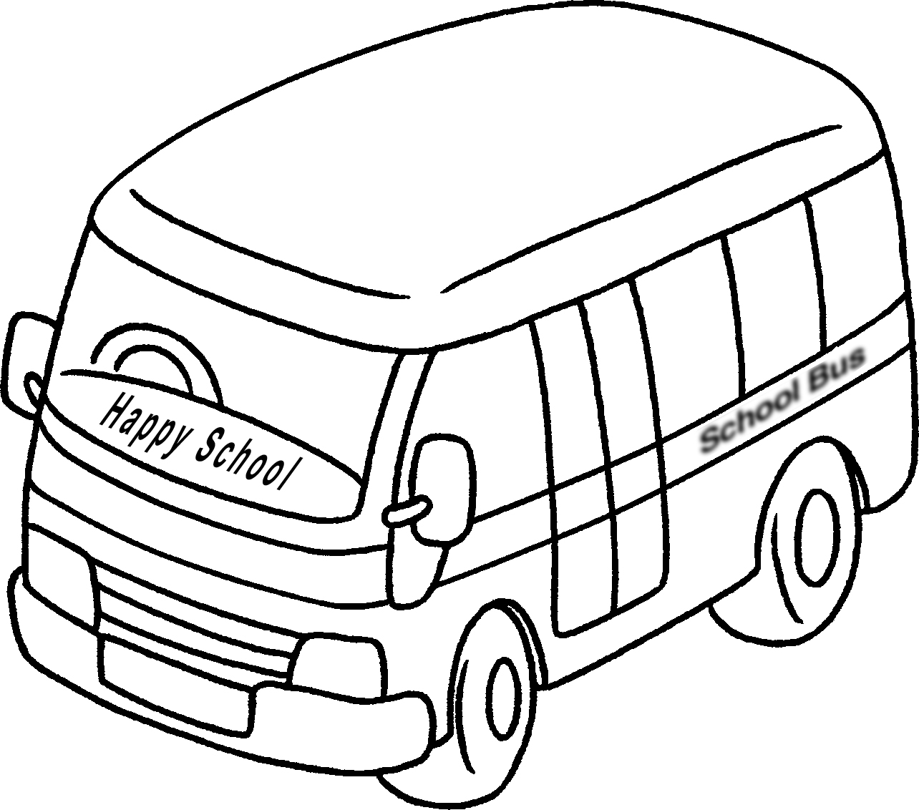 |  |  |  | 2 | 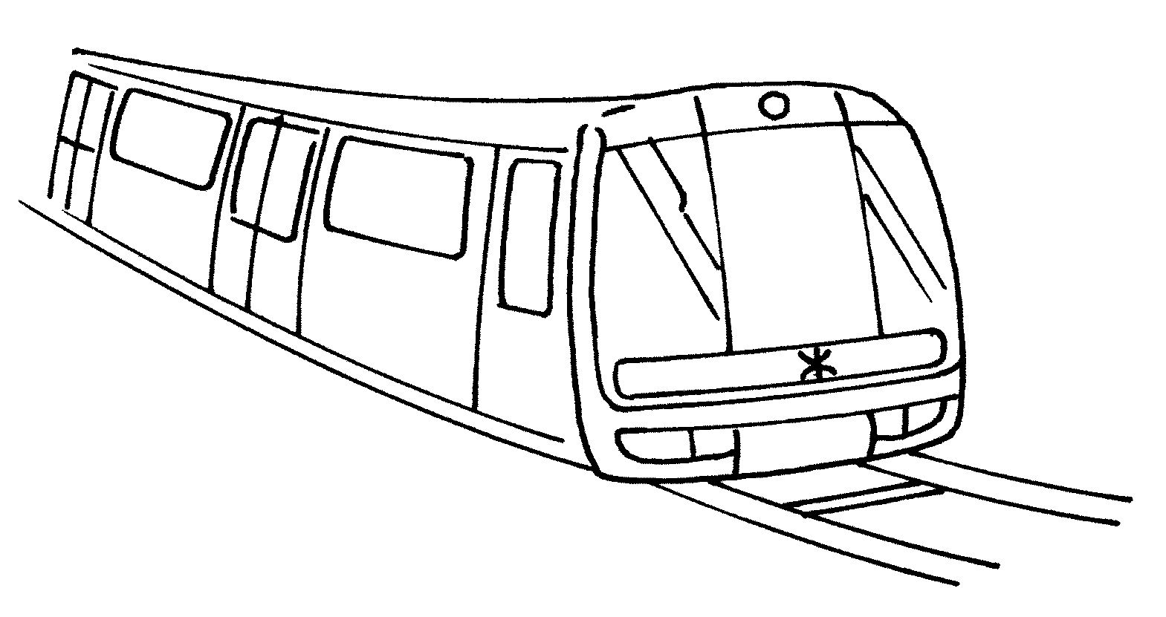
 | by |  |  |  |  | by
3 | 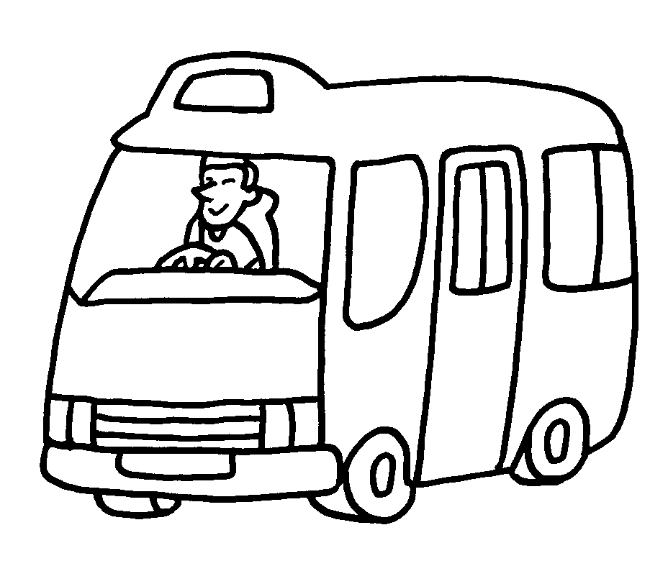 |  |  |  | 4 | 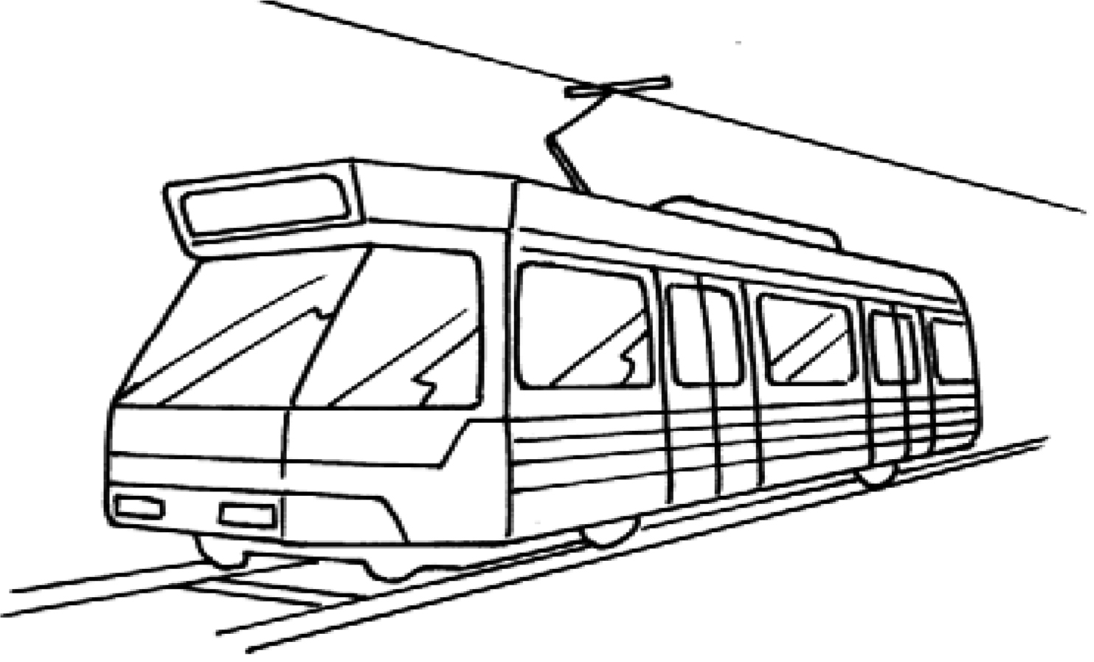
 | by |  |  |  |  | by
5 | 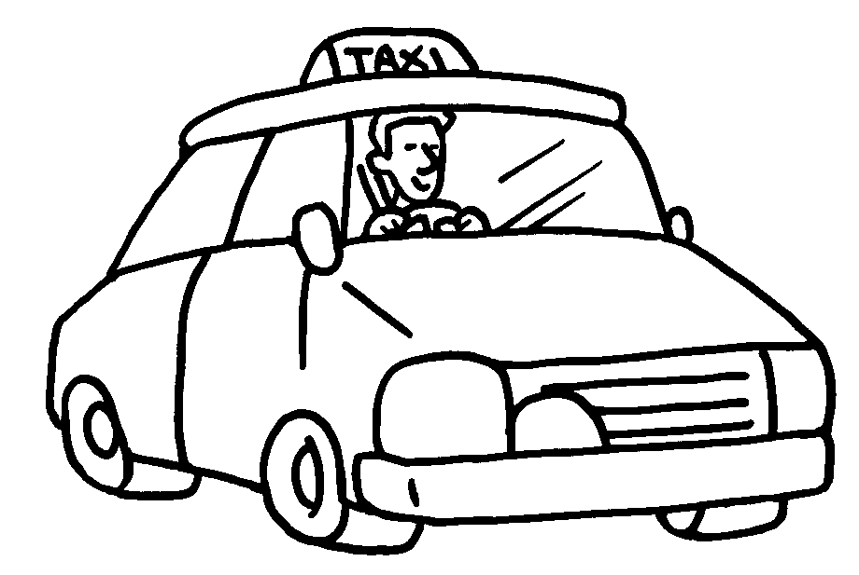 |  |  |  | 6 | 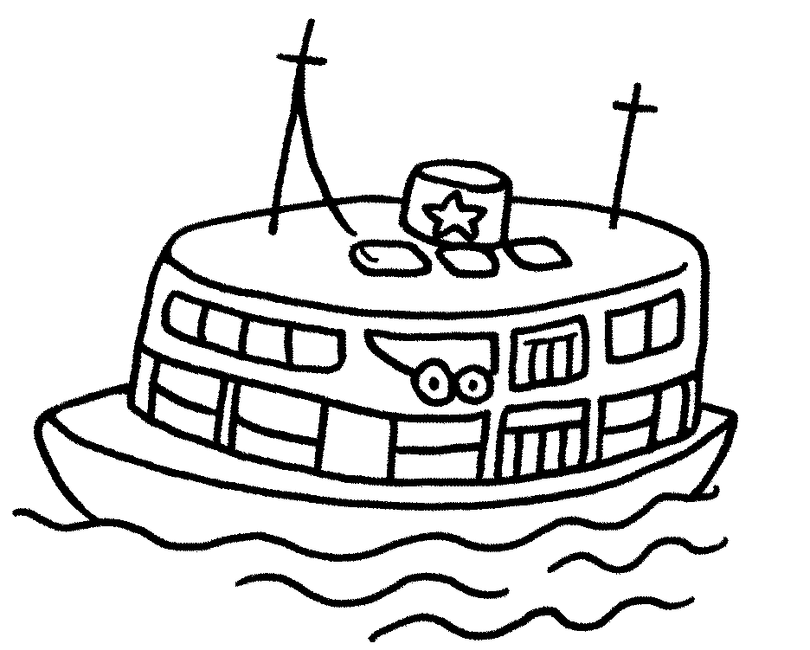
 | by |  |  |  |  | by
7 | 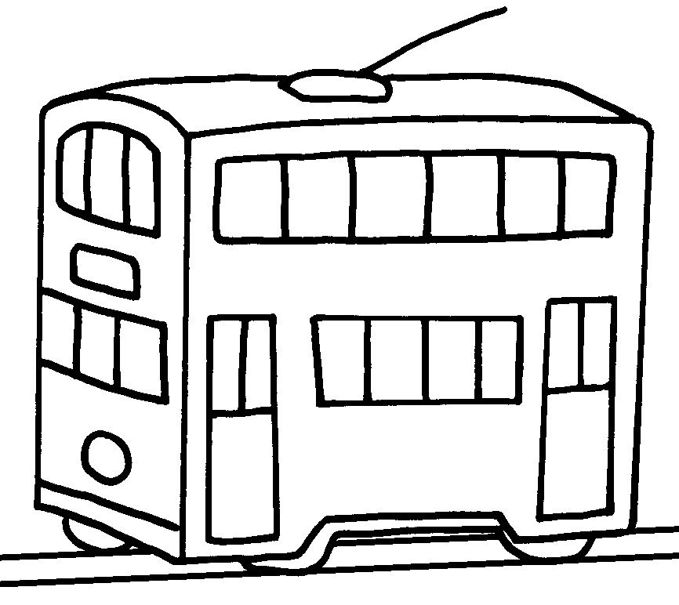 | 8 | 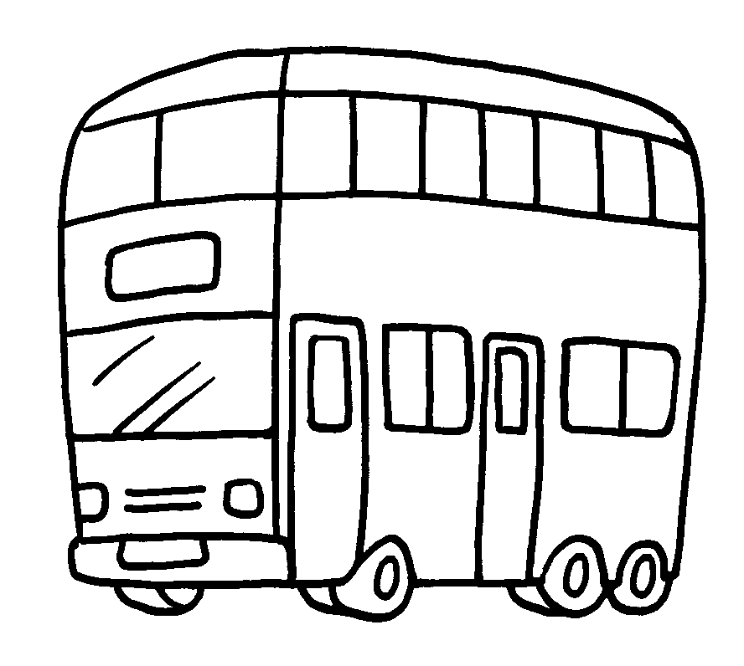 |  |  |  | 9 | 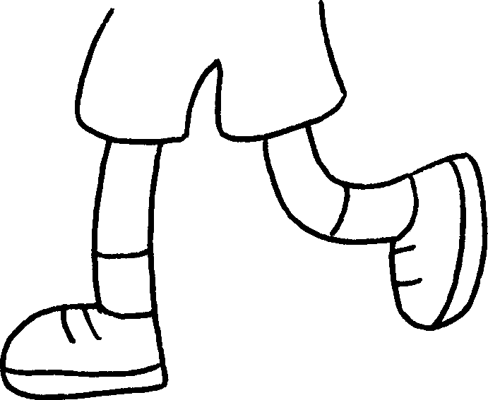
 | by |  | by |  |  |  |  | on


Book 2A Chapter 5 Graded Worksheets
Worksheet 1⬇
1 school bus 2 MTR
3 minibus 4 Light Rail
5 taxi 6 ferry
7 tram 8 bus 9 foot

