Fill in the missing letters.

1 |  |  |  |  |  |  | 2 | 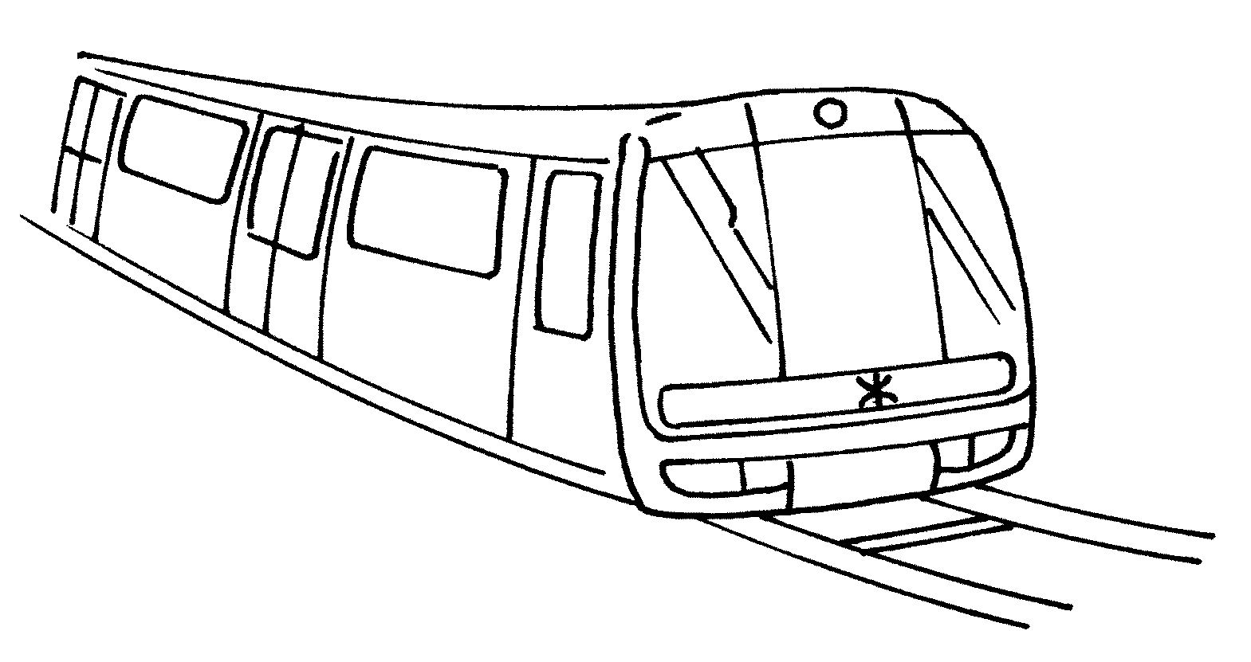
by s __ __ __ __ __ b __ __ |  |  |  |  |  |  |  | by M __ __
3 | 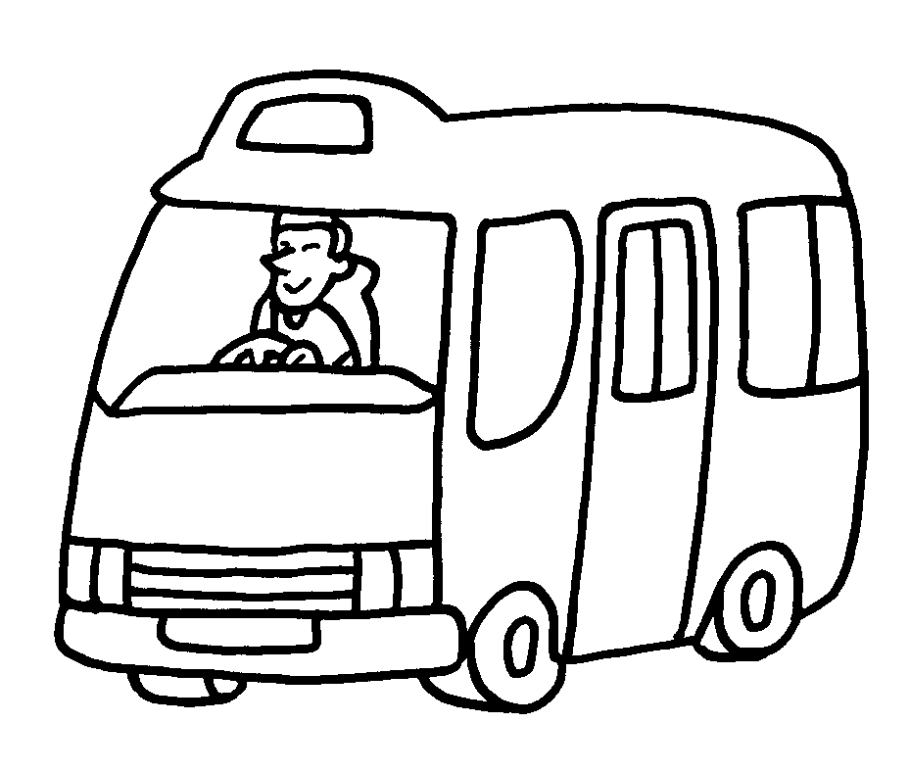 |  |  |  |  |  | 4 | 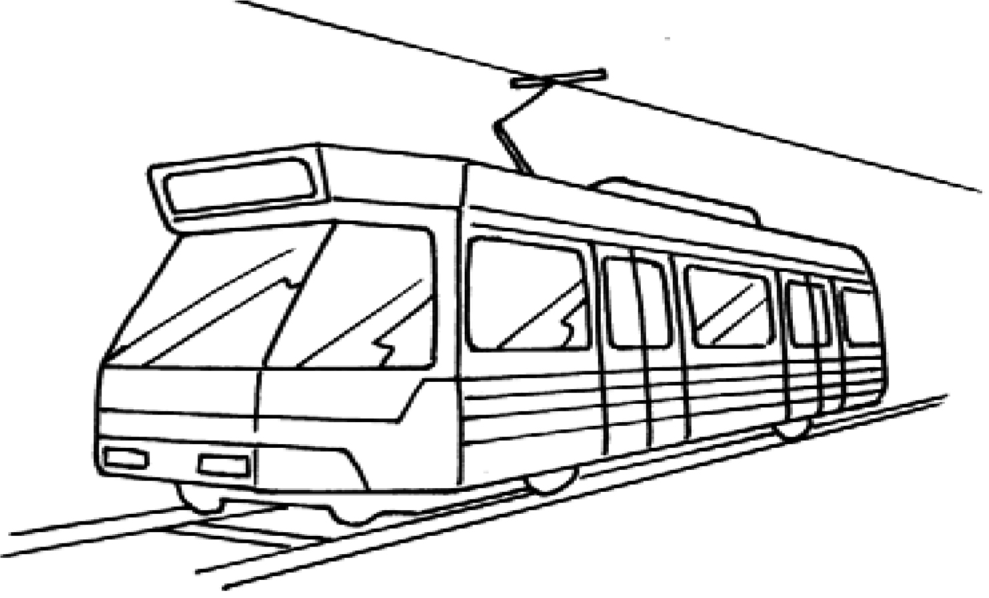
 |  | by m __ __ __ __ __ __ |  |  |  |  | by L __ __ __ __ R __ __ __
5 | 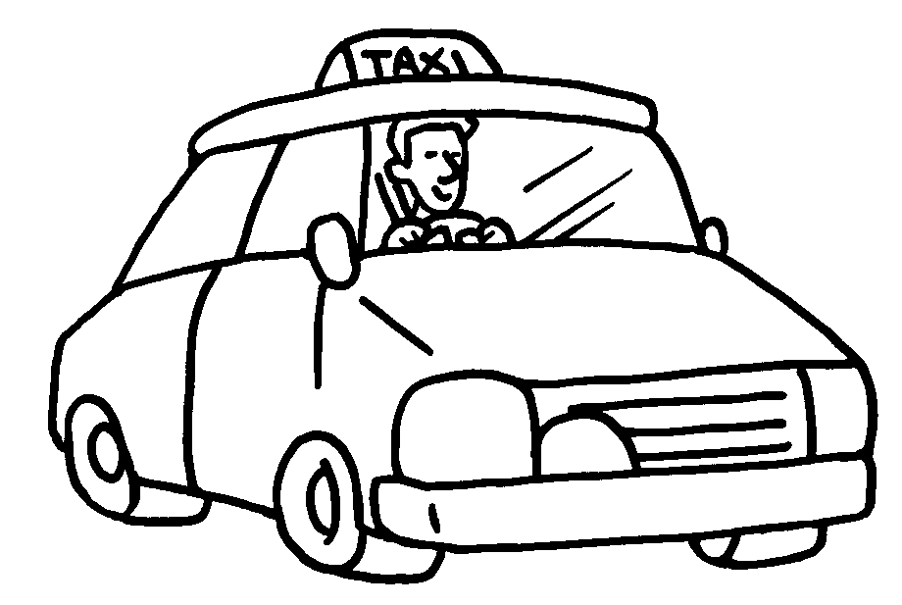 |  |  |  |  |  | 6 | 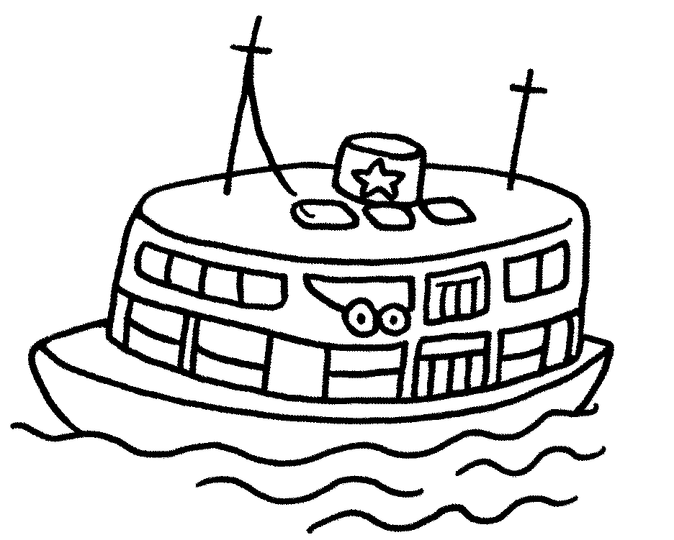
 | by t __ __ __ |  |  |  |  |  |  | by f __ __ __ __
7 | 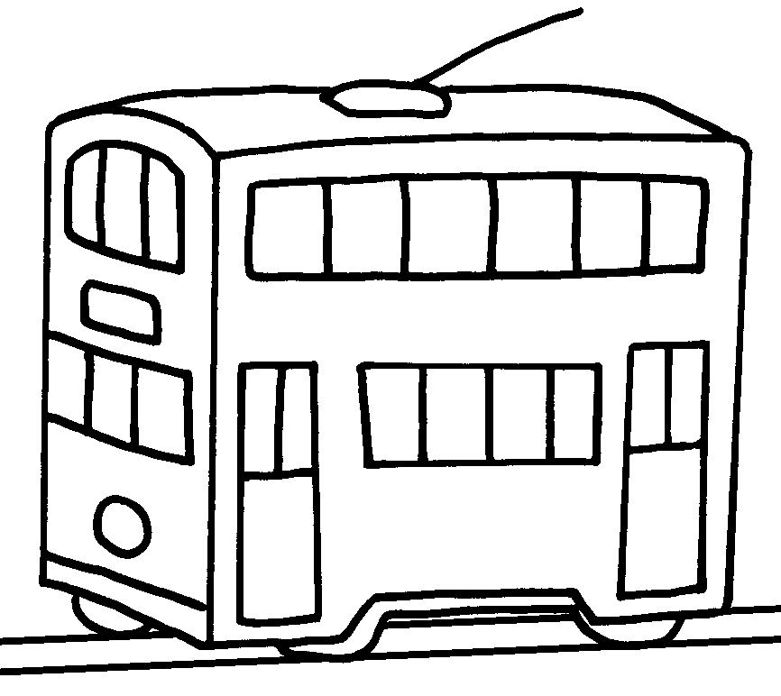 |  | 8 |  | 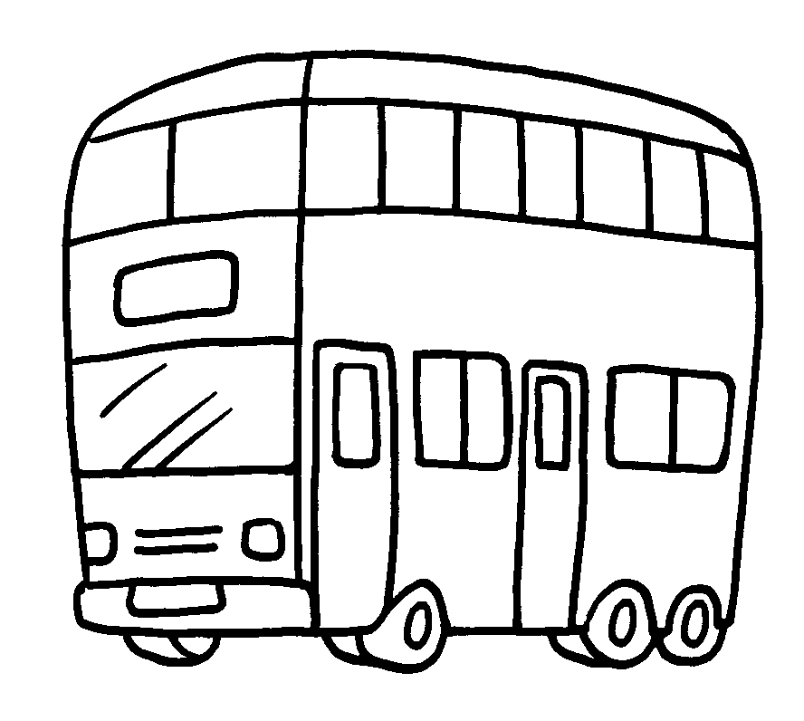 |  |  |  | 9 | 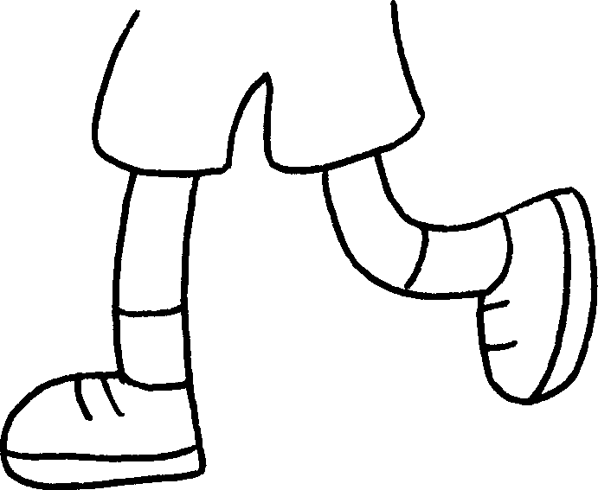
 | by t __ __ __ |  |  |  | by b __ __ |  |  |  |  | on f __ __ __


Book 2A Chapter 5 Graded Worksheets
Worksheet 1⬇⬇
1 s c h o o l b u s 2 M T R
3 m i n i b u s 4 L i g h t R a i l
5 t a x i 6 f e r r y
7 t r a m 8 b u s 9 f o o t

