Look at the pictures and write.

1 | 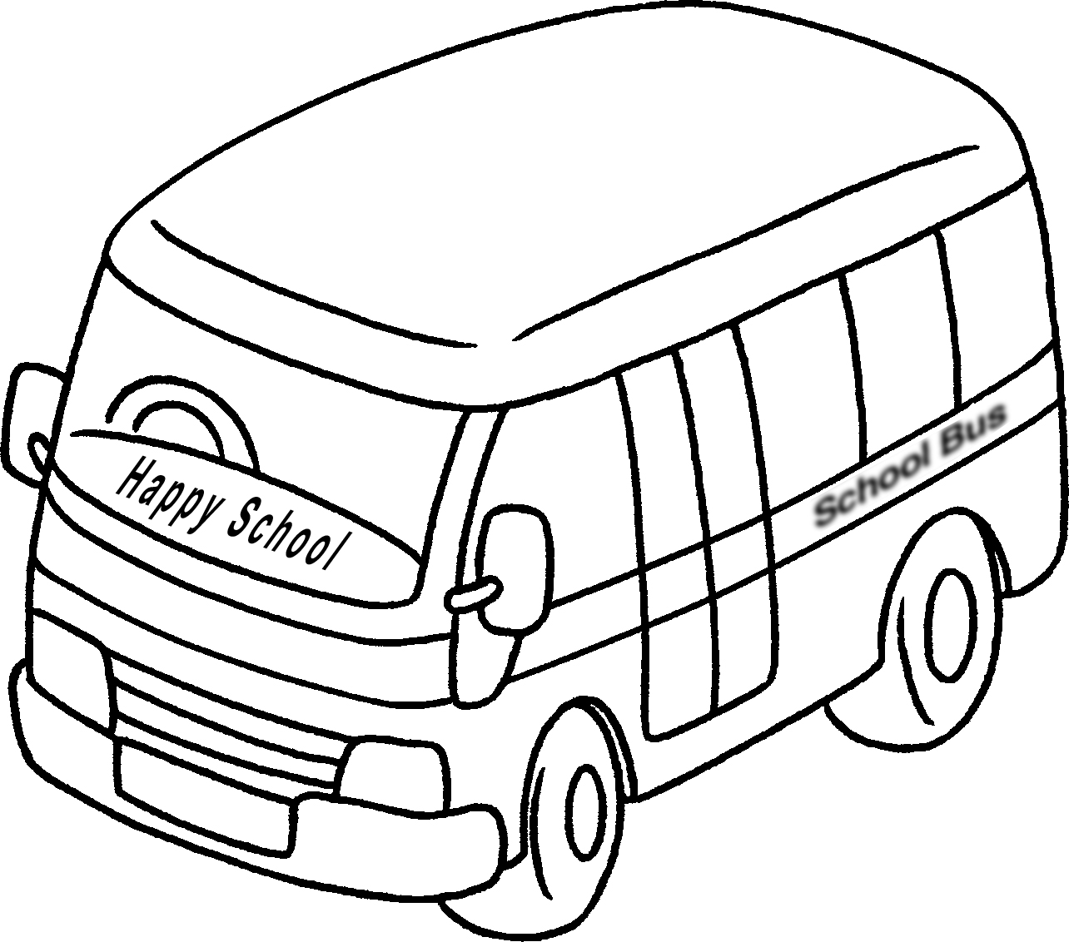 |  |  |  | 2 | 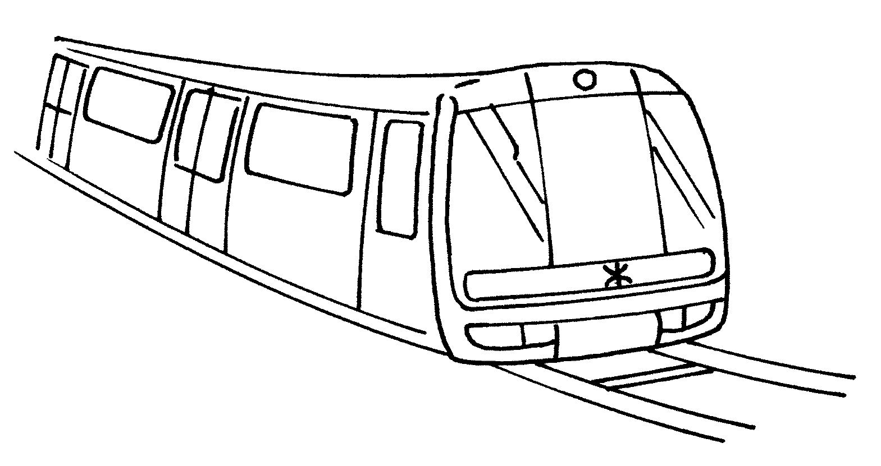
 | by |  |  |  |  | by
3 | 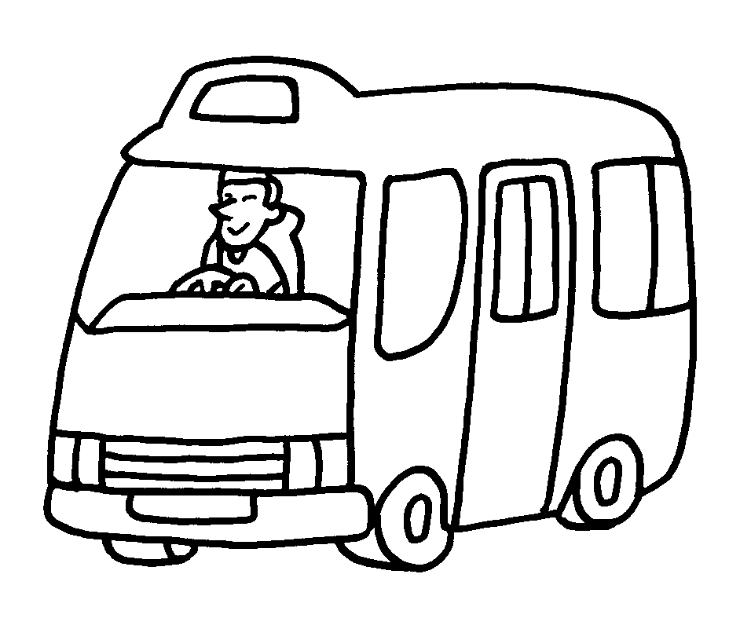 |  |  |  | 4 | 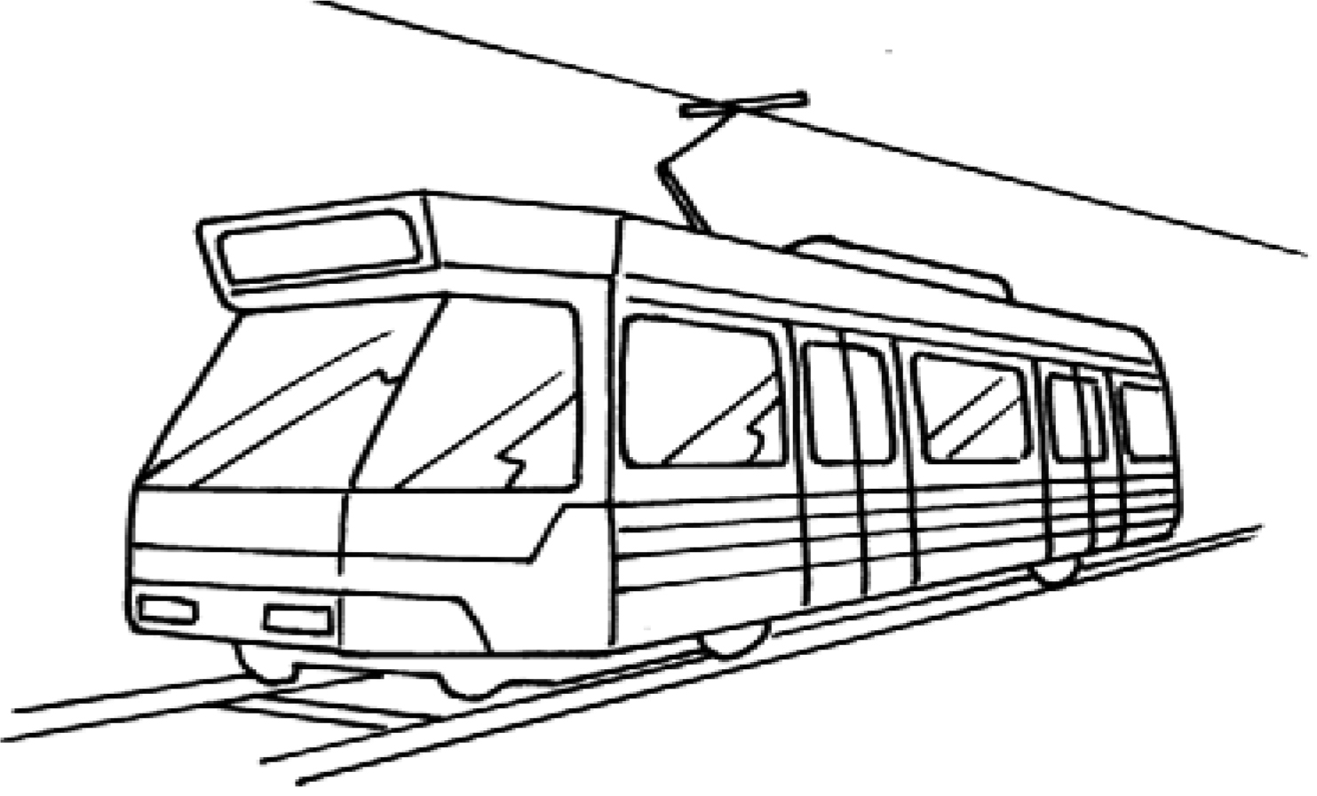
 | by |  |  |  |  | by
5 | 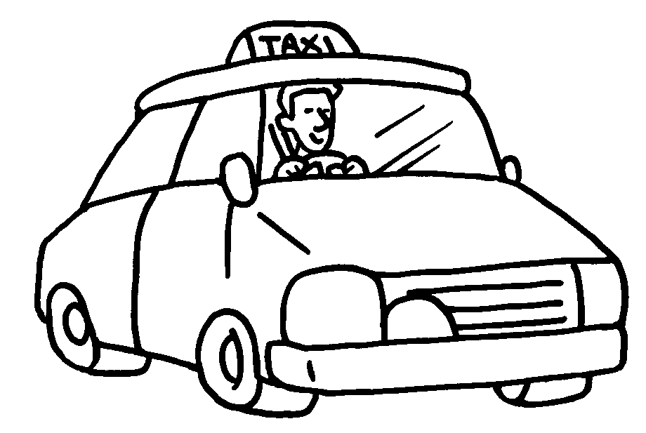 |  |  |  | 6 | 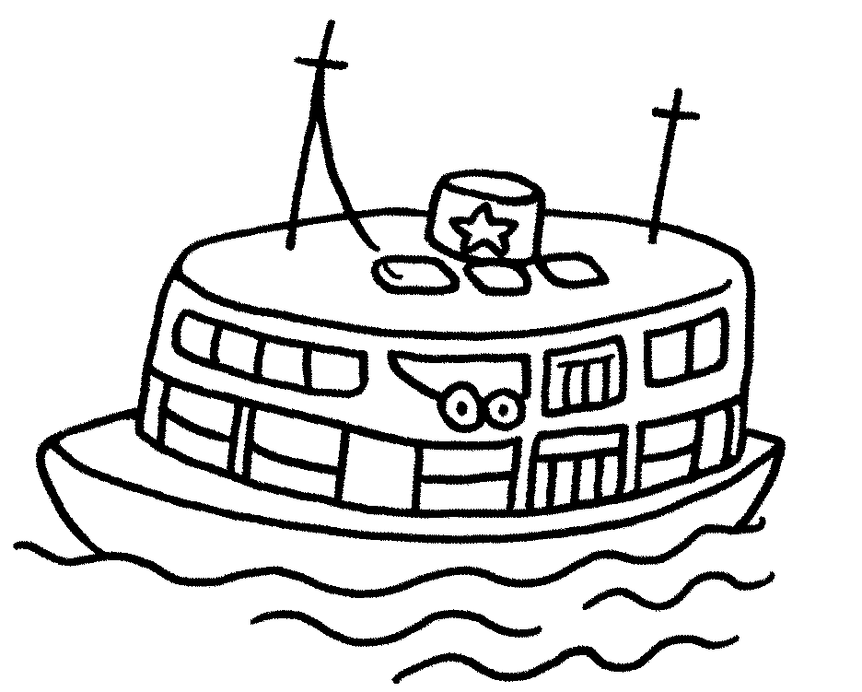
 | by |  |  |  |  | by
7 | 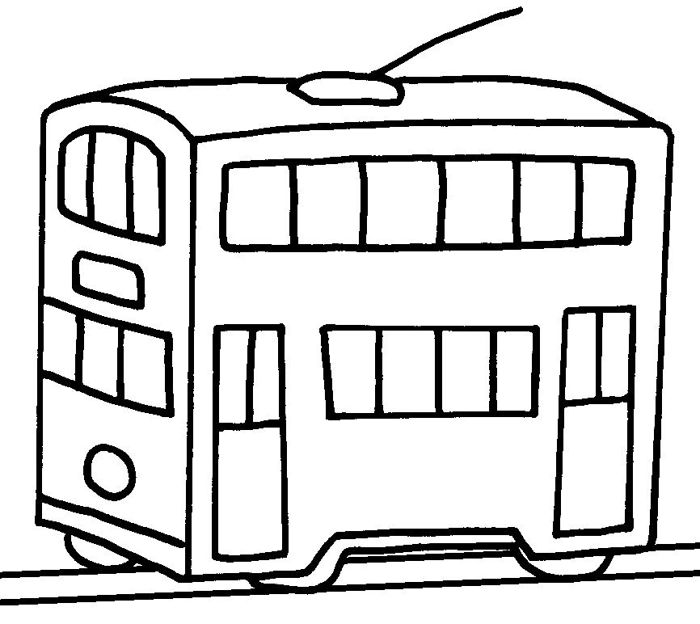 | 8 | 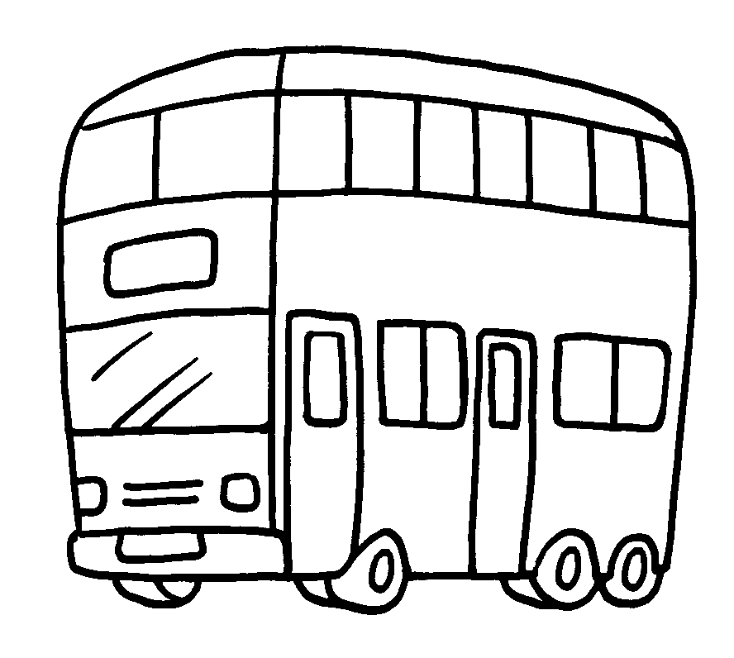 |  |  |  | 9 | 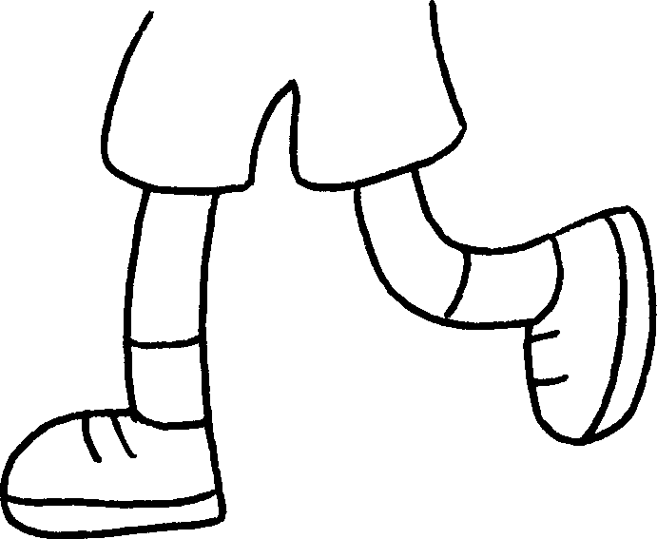
 | by |  | by |  |  |  |  | on


Book 2A Chapter 5 Graded Worksheets
Worksheet 1⬇⬇⬇
1 school bus 2 MTR / train
3 minibus 4 Light Rail
5 taxi 6 ferry
7 tram 8 bus 9 foot

