Choose and write.
  A  B  A  B  A  B  A  B | Where | in

1  Central  Chai Wan  Tuen Mun  Mong Kok  Tai Po | 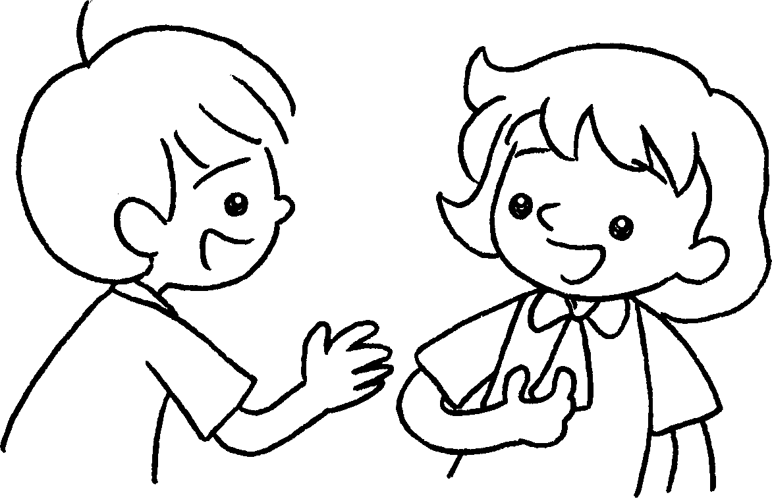 |  | A : do you live?  B : I live in Central.
2 |  |  | A : Where do you live?  B : I live Chai  Wan.
3 | 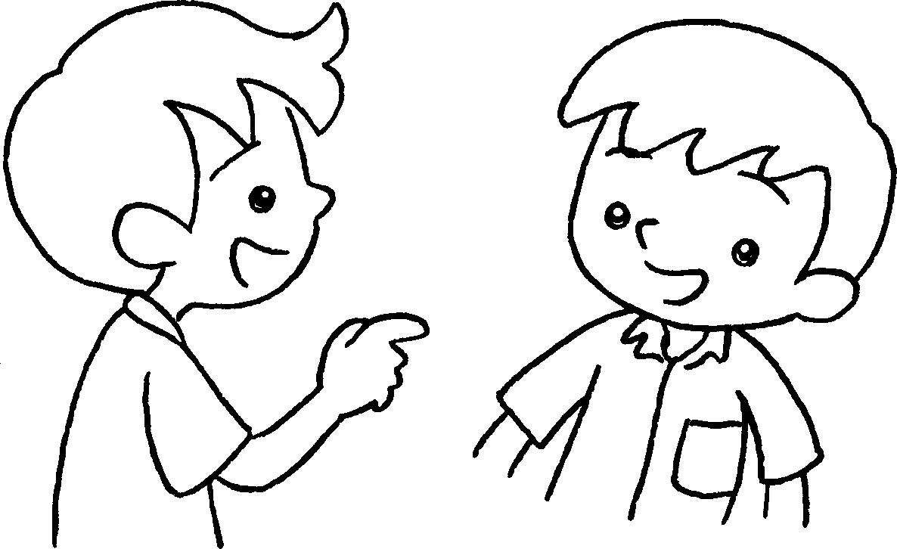 |  | A : do you live?  B : I live Tuen  Mun.
4 | 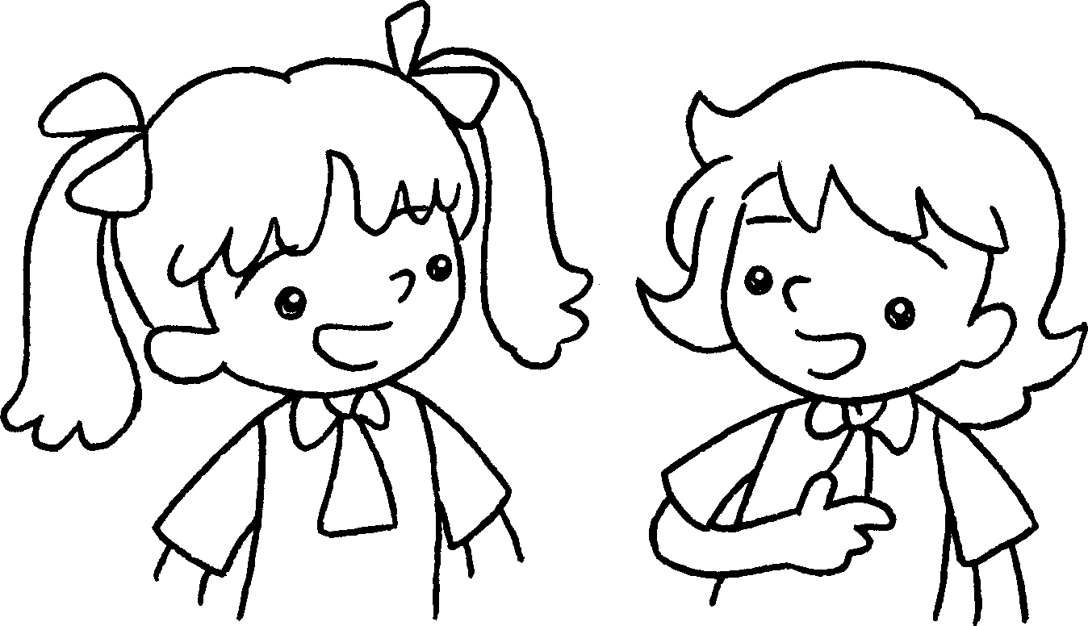 |  | A : I live Tai Po.  do you live?  B : I live Mong  Kok.


Book 2A Chapter 5 Graded Worksheets
Worksheet 2⬇
- Where
- in
- Where
in
- in
Where
in

